Exercise 1

Hou, Jue

014695647

1. Background
   1. Introduction to Machine Learning, Probabilistic model
   2. Statistics: 4
   3. Linear Algebra: 4
   4. I am interested in machine learning and would like to learn more.
   5. I hope to learn some more machine algorithms and have chances to actually implement some of them. Besides all the definition and algorithm, I would like to see some example of neural network.
2. Expectations
 $var\left(X\right)=E\left(X^{2}\right)-{\left[E\left(X\right)\right]}^{2}$

 $$var\left(Y\right)=E\left(Y^{2}\right)-{\left[E\left(Y\right)\right]}^{2}$$

 $$cov\left(X,Y\right)=E\left(XY\right)-E\left(X\right)E(Y)$$

$$var\left(X+Y\right)=E\left(({X+Y)}^{2}\right)-{\left[E\left(X+Y\right)\right]}^{2}=E\left(X^{2}+2XY+Y^{2}\right)-{\left[E\left(X\right)+E\left(Y\right)\right]}^{2}=E\left(X^{2}\right)+2E\left(XY\right)+E\left(Y^{2}\right)-{\left[E\left(X\right)\right]}^{2}-{\left[E\left(Y\right)\right]}^{2}-2E\left(X\right)E\left(Y\right)=E\left(X^{2}\right)-{\left[E\left(X\right)\right]}^{2}+E\left(Y^{2}\right)-{\left[E\left(Y\right)\right]}^{2}+2\left[E\left(XY\right)-E\left(X\right)E\left(Y\right)\right]=var\left(X\right)+var\left(Y\right)+2cov\left(X,Y\right)$$

$$∴var\left(X+Y\right)=var\left(X\right)+var\left(Y\right)+2cov\left(X,Y\right)$$

$P_{X}\left(x | α,β\right)=\frac{β^{α}}{Γ\left(α\right)}x^{\left(α-1\right)}e^{-βx}$

$$E\left(X\right)=\int{P_{X}\left(x | α,β\right)xdx}=\int{\frac{β^{α}}{Γ\left(α\right)}x^{α}e^{-βx}dx}$$

$$P_{X}\left(x | α+1,β\right)=\frac{β^{α+1}}{Γ\left(α+1\right)}x^{α}e^{-βx}=\frac{β}{α}*\frac{β^{α}}{Γ\left(α\right)}x^{α}e^{-βx}$$

$$∴E\left(X\right)=\frac{α}{β}*\int{P_{X}\left(x | α+1,β\right)dx}=\frac{α}{β}$$

$X\sim N(x|μ_{x},Σ_{x})$ 1. , $μ_{x}=0, Σ_{x}=E$

$y=Ax+b$, Therefore, $Y\sim N\left(y | μ_{y},Σ_{y}\right)$

$$μ_{y}=A*μ_{x}+b=b$$

$$Σ_{y}={AΣ_{x}A}^{T}=AA^{T}$$

$$p\left(y\right)=\frac{1}{{\left(2π\right)}^{\frac{D}{2}}{\left|AA^{T}\right|}^{\frac{1}{2}}}exp\left(-\frac{1}{2}{\left(y-b\right)}^{T}{\left(AA^{T}\right)}^{-1}(y-b)\right)$$

1. Eigen-value decomposition
   1. N=200, D=5
   2. Eigen value = (2.01264957, 0.22286198, 0.14290211, 0.01042867, 0.00925912)

$$cov=\left[\begin{matrix}0.409 & \begin{matrix}0.237 & 0.502 & 0.305\end{matrix} & 0.174 \\ \begin{matrix}0.329 \\ 0.502 \\ 0.305\end{matrix} & \begin{matrix}0.253 & 0.466 & 0.307 \\ 0.466 & 0.927 & 0.636 \\ 0.307 & 0.636 & 0.572\end{matrix} & \begin{matrix}0.109 \\ 0.272 \\ 0.302\end{matrix} \\ 0.174 & \begin{matrix}0.109 & 0.272 & 0.302\end{matrix} & 0.238\end{matrix}\right]$$

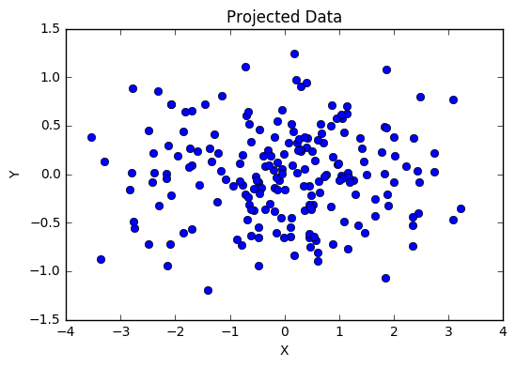

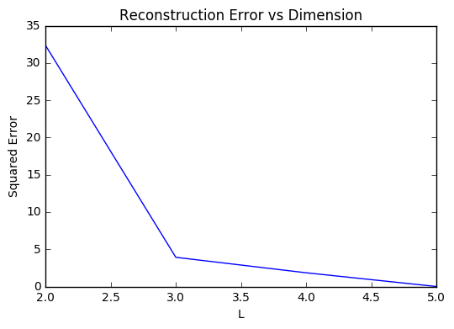

From the plot above, we can notice that the error rate is relatively high when L=2. When L=5, there is no error but no reduction at all as well. I think we can choose L=3 in this case if we actually want to reduce the dimension of original data. It not only has a lower dimensionality but also a reasonable error rate can be obtained if compared to other situations.

1. Derivatives, gradients and all that

$$\frac{∂s\left(θ^{T}x\right)}{∂θ_{i}}=\frac{∂{\left(1+e^{-θ^{T}x}\right)}^{-1}}{∂θ_{i}}={\left(1+e^{-θ^{T}x}\right)}^{-2}e^{-θ^{T}x}x_{i}$$

$$\frac{∂L}{∂θ_{i}}=\frac{-y}{s\left(θ^{T}x\right)}*\frac{∂s\left(θ^{T}x\right)}{∂θ_{i}}+\frac{1-y}{1-s\left(θ^{T}x\right)}*\frac{∂s\left(θ^{T}x\right)}{∂θ_{i}}=\left(\frac{-y}{s\left(θ^{T}x\right)}+\frac{1-y}{1-s\left(θ^{T}x\right)}\right){\left(1+e^{-θ^{T}x}\right)}^{-2}e^{-θ^{T}x}x_{i}=\left(-y\left(1+e^{-θ^{T}x}\right)+\left(1-y\right)\frac{1+e^{-θ^{T}x}}{e^{-θ^{T}x}}\right){\left(1+e^{-θ^{T}x}\right)}^{-2}e^{-θ^{T}x}x_{i}=\left(-ye^{-θ^{T}x}+1-y\right){\left(1+e^{-θ^{T}x}\right)}^{-1}x_{i}$$

$$\frac{∂^{2}L}{∂θ_{i}∂θ_{j}}=ye^{-θ^{T}x}x_{j}{\left(1+e^{-θ^{T}x}\right)}^{-1}x_{i}+{\left(1+e^{-θ^{T}x}\right)}^{-2}e^{-θ^{T}x}x_{j}\left(-ye^{-θ^{T}x}+1-y\right)x_{i}=\frac{e^{-θ^{T}x}x_{j}x_{i}}{{\left(1+e^{-θ^{T}x}\right)}^{2}}=\frac{x_{i}x_{j}}{e^{θ^{T}x}+e^{-θ^{T}x}+2}$$

$$\frac{∂L}{∂θ_{i}}=\left(-ye^{-θ^{T}x}+1-y\right){\left(1+e^{-θ^{T}x}\right)}^{-1}x_{i}=-e^{-1}{\left(1+e^{-1}\right)}^{-1}x_{i}$$

$$∇L\left(\left(x,y\right),θ\right)≈\left(\begin{matrix} 0.2689414 \\ -0.5378828\end{matrix}\right)$$

$$\frac{∂^{2}L}{∂θ_{i}∂θ_{j}}=\frac{x_{i}x_{j}}{e^{θ^{T}x}+e^{-θ^{T}x}+2}=\frac{x_{i}x_{j}}{e+e^{-1}+2}$$

$$H\left(L\left(\left(x,y\right),θ\right)\right)≈\left[\begin{matrix} 0.1966119 & -0.3932239 \\ -0.3932239 & 0.7864477\end{matrix}\right]$$

Estimated Completion Time: 3 hours