Exercise 5

Hou, Jue

014695647

1. Support vector machines

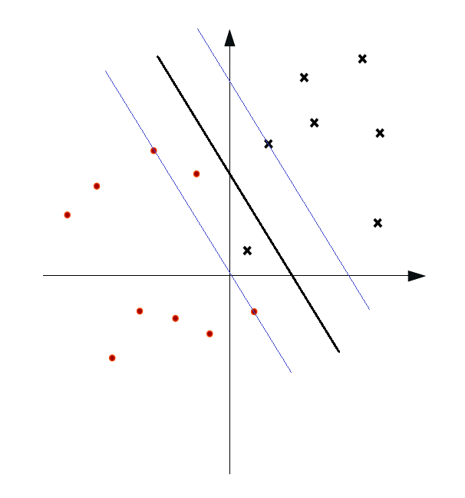

w

margin

margin

decision surface

$$ϵ>1$$

$$0<ϵ<1$$

$$L\left(w\right)=\frac{1}{2}w^{T}w-\sum_{i}{α_{i}\left[\left(w^{T}x_{i}+b\right)y_{i}-1\right]}$$

$$\frac{∂L\left(w\right)}{∂w_{d}}=\frac{1}{2}*2w_{d}-\sum_{i}{α_{i}x_{id}y_{i}}=0$$

$w_{d}=\sum_{i}{α_{i}x_{id}y_{i}}$ $∴w=\sum_{i}{α_{i}x_{i}y_{i}}$

$\frac{∂L\left(w\right)}{∂b}=-\sum_{i}{α_{i}y_{i}}=0$ $∴\sum_{i}{α_{i}y_{i}}=0$

$$∴\min{L\left(w\right)}=\min{\frac{1}{2}\sum_{i}{α_{i}x_{i}^{T}y_{i}}*\sum_{j}{α_{j}x_{j}y_{j}}}=\min{\frac{1}{2}\sum_{i,j}{α_{i}α_{j}y_{i}y_{j}x_{i}^{T}x_{j}}-\sum_{i}{α_{i}\left(\sum_{j}{α_{j}x_{j}^{T}y_{j}}\right)x_{i}y_{i}}-\sum_{i}{α_{i}by_{i}}+\sum_{i}{α_{i}}}=\min{\sum_{i}{α_{i}}-\frac{1}{2}\sum_{i,j}{α_{i}α_{j}y_{i}y_{j}x_{i}^{T}x_{j}}}$$

$$s.t. a_{i}≥0 ∀i \sum_{i}{α_{i}y_{i}}=0$$

Since SVM will only get internal product involved, so it is possible for us to kernelize it. We can replace $x_{i}^{T}x_{j}$ with $K\left(x_{i},x_{j}\right)$, which K denotes the kernels.

1. Decision trees and forests

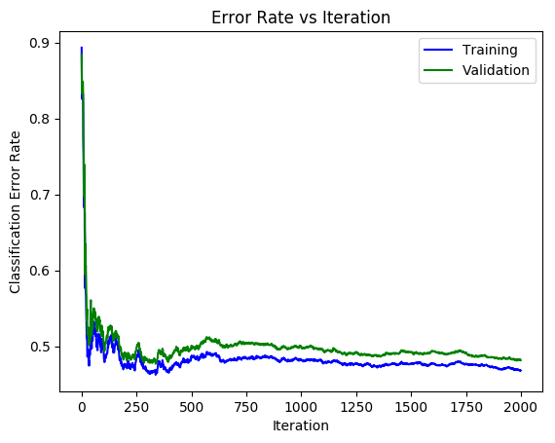

I do not think my forest is a good classifier, since the best of it still obtain around 50% classification error rate. I suppose that if more features can get involved in one decision tree, instead of decision stump, it can perform better.

Estimated complete time: 6 hours