Exercise 7

Hou, Jue

014695647

1. Playing with RNNs

(Programming)

1. Sparsity

$$L\left(θ_{1},θ_{2}\right)=\frac{{\left(θ_{1}-2\right)}^{2}}{4}+{\left(θ_{2}-2\right)}^{2}+λ\left|θ\right|={\left(\frac{1}{2}θ_{1}-1\right)}^{2}+{\left(θ_{2}-2\right)}^{2}+λ\left|θ\right|={\left(1-\frac{1}{2}θ_{1}-0*θ_{2}\right)}^{2}+{\left(2-0*θ_{1}-θ_{2}\right)}^{2}+λ\left|θ\right|$$

$∵$ The loss function for Lasso Regression is $L\left(θ\right)=\sum_{n}{{\left(y_{n}-θ^{T}x_{n}\right)}^{2}}+λ|θ|$

I can assume the previous loss function is a Lasso Regression loss function with

$$X=\left[\begin{matrix}\frac{1}{2} & 0 \\ 0 & 1\end{matrix}\right], y=\left[\begin{matrix}1 \\ 2\end{matrix}\right]$$

$$c_{d}=2\sum_{n}{X_{nd}(y_{n}-θ_{-d}^{T}}X_{n,-d})$$

$∴c_{1}=2\left(X_{11}\left(y_{1}-θ_{2}X_{12}\right)+X_{21}\left(y_{2}-θ_{1}X_{22}\right)\right)=1$*,*

$$c_{2}=2\left(X_{12}\left(y_{1}-θ_{2}X_{11}\right)+X_{22}\left(y_{2}-θ_{1}X_{21}\right)\right)=4$$

$$∵ θ_{d}=0, if c_{d}∈\left[-λ,λ\right]$$

$$∴ \left\{\begin{aligned}θ_{1}=θ_{2}=0, λ∈\left(-∞,-4\right]∪[4,+∞) \\ θ_{1}=0 θ_{2}≠0, λ∈\left(-4,-1\right]∪\left[1,4\right) \\ θ_{1}≠0 θ_{2}≠0, λ∈\left(-1,1\right)\end{aligned}\right.$$

1. AdaBoost

The first decision boundary and misclassified points are showed as follow:

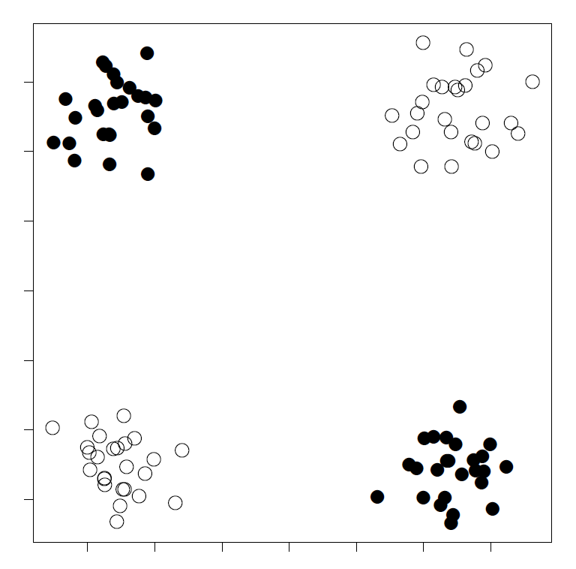

w

b

25 points are misclassified,

$$∴err_{1}=\frac{1}{4}, β_{1}=\frac{1}{2}\log\left(\frac{1-\frac{1}{4}}{\frac{1}{4}}\right)=log\sqrt{3}$$

Second decision boundary and misclassified points can be showed as follow:



w

b

$w_{1}=\sqrt{3}$, 25 points are misclassified in the previous classification,

$$∴err_{2}=\frac{25}{75+25\sqrt{3}}=\frac{1}{3+\sqrt{3}}, β_{2}=\frac{1}{2}\log\left(\frac{1-\frac{1}{3+\sqrt{3}}}{\frac{1}{3+\sqrt{3}}}\right)=log\sqrt{2+\sqrt{3}}$$

Third decision boundary and misclassified points can be showed as follow:



w

b

$w_{2}=\sqrt{2+\sqrt{3}}$, 25 points are misclassified in the previous classification,

$$∴err_{3}=\frac{25}{50+25\sqrt{3}+25\sqrt{2+\sqrt{3}}}=\frac{1}{2+\sqrt{3}+\sqrt{2+\sqrt{3}}}, β_{3}=\frac{1}{2}\log\left(\frac{1-err_{3}}{err_{3}}\right)=log\sqrt{1+\sqrt{3}+\sqrt{2+\sqrt{3}}}$$

According to $f\left(X\right)=sign\left(β_{1}f_{1}\left(X\right)+β_{2}f_{2}\left(X\right)+β_{3}f_{3}(X)\right)$,

the final decision boundary can be showed as follow:



w

b

w

As what is showed in the picture, all the points can be classified correctly. However, since all the decision boundaries of weaker classifiers are decided randomly, the error for future data may be still high. I will use more basic classifier to improve it final performance.