Linux Fundamentals-Week2

Hou, Jue

[jue,hou@helsinki.fi](mailto:jue,hou@helsinki.fi)

Exercise 1

Redirect stdout to one file and stderr to another file simultaneously:

ls ~/ 1>./ls-info.txt 2> ./ls-unsuccessful.txt

Count the number of line in a file:

wc -l 0> cat ls-info.txt

Screenshot from 2016-11-03 13:08:00.png

Command cat read all the contents from the file. By using 0>, all the contents is sent to my stdin.

Exercise 2

Two method for counting the number of files:

ls ~ | wc -l

ls ~ > ls-info.txt;wc -l ls-info.txt

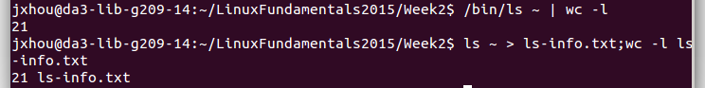

Count only the number of folders in your home directory:

ls -l ~/ |grep "^d" |wc -l

Screenshot from 2016-11-10 12:48:34.png

Pipeline ls to grep 'e' to wc in order to count the number of matching files:

ls ~/ |grep "e" |wc -l

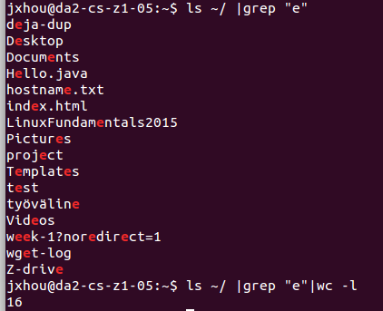

count-homedir.sh which counts the number of files in your home directory:

#!/bin/bash

echo `ls -la ~/ |wc -l`

Screenshot from 2016-11-10 12:59:45.png

Exercise 3

List all files and subdirectories from November 2011(The list is kept in a file).

#!/bin/bash

for((j=11;j<13;j++))

do

ls -R /cs/home/tkt_cam/public_html/2011/$j/>>exactum-kamera-from-nov2011-report.txt

done

for (( i=2012;i<`date +%Y`+1;i ++))

do

ls -R /cs/home/tkt_cam/public_html/$i/>>exactum-kamera-from-nov2011-report.txt

done

List only picture file ending with “*.jpg”

#!/bin/bash

for((j=11;j<13;j++))

do

ls -R /cs/home/tkt_cam/public_html/2011/$j/|grep .jpg>>exactum-kamera-from-nov2011-report.txt

done

for (( i=2012;i<`date +%Y`+1;i ++))

do

ls -R /cs/home/tkt_cam/public_html/$i/|grep .jpg>>exactum-kamera-from-nov2011-report.txt

done

Counts the number of picture files

#!/bin/bash

a=0

for((j=11;j<13;j++))

do

((a = $a + `ls -R /cs/home/tkt_cam/public_html/2011/$j/|grep .jpg|wc -l`))

done

for (( i=2012;i<`date +%Y`+1;i ++))

do

((a = $a + `ls -R /cs/home/tkt_cam/public_html/$i/|grep .jpg|wc -l`))

done

echo $a

Screenshot from 2016-11-03 15:13:23.png

List the number of image files of the current month:

#!/bin/bash

ls -R /cs/home/tkt_cam/public_html/`date +%Y`/`date +%m`/|grep .jpg|wc -l

Screenshot from 2016-11-10 13:20:55.png

Exercise 4

“Find” the image files corresponding to the current month and counts them

#!/bin/bash

find /cs/home/tkt_cam/public_html/`date +%Y`/`date +%m`/ -name "*.jpg"|wc -l



Exercise 5

Three variables in my shell environment and their meaning:

FULLNAME: record my full name

HOME: record user's home directory

HOSTNAME: record the hostname of the current computer

The script echoes what command-line arguments is back to it:

#! /bin/bash

echo "$*"

Screenshot from 2016-11-08 14:07:40.png

The script that illustrates variable visibility and print PID of the shell:

#! /bin/bash

echo $$ $1

I set variable a=first in one session. Then start another session. Run the script above on both sessions. The result is as followed:

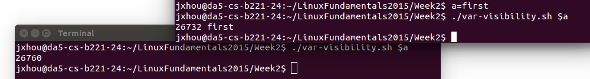

The script which will execute command at hostname and print out the output returned by the host(Key pair has already be set to support password-prompt-less login):

#! /bin/bash

echo `ssh $1 $2`

