Linux Fundamentals-Week5

Hou, Jue

[jue.hou@helsinki.fi](mailto:jue.hou@helsinki.fi)

Exercise 1:

The script which calculates the arithmetic mean of the input parameters.

#! /bin/bash

exp=0

for arg in $*

do

if [[ $arg =~ ^[-,0-9,.,0-9]+$ ]]

then

exp=$exp'+'$arg

else

echo 'Input Error'

exit 1

fi

done

exp='('$exp')/'$#

echo 'scale=2;'$exp|bc

Exercise 2:

Find the maximum and minimum temperqature for all the dataset in 10 seconds.

#! /bin/bash

max=0

min=100

find $1 -name hp-temps.txt -exec grep "PROCESSOR_ZONE" {} +|while read location sensor temp threshold

do

curr_date=${location:0-32:10}

curr_time=${location:0-21:5}

curr_temp=${temp%%C*}

if [ $max -lt $curr_temp ]

then

max=$curr_temp

echo 'New Max:'$curr_date $curr_time $curr_temp

fi

if [ $min -gt $curr_temp ]

then

min=$curr_temp

echo 'New Min:'$curr_date $curr_time $curr_temp

fi

done

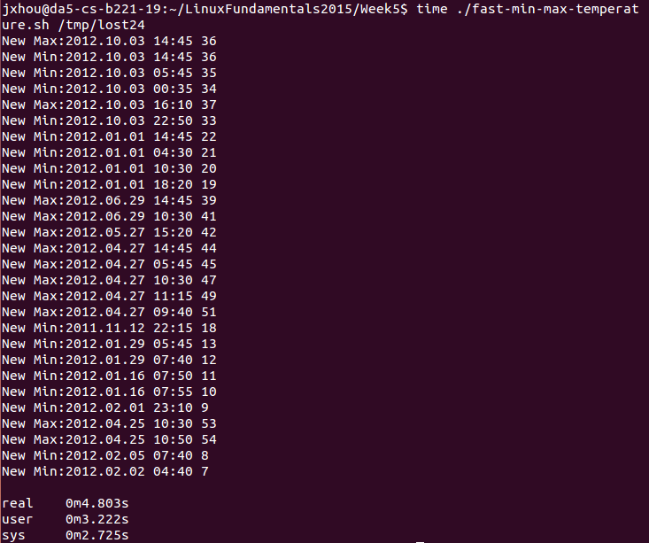

Exercise 3:

hipstafy-wait script:

#! /bin/bash

inotifywait -mq ~/LinuxFundamentals2015/Week5/hipstafy-dropbox -e MOVED_TO -e create|while read location event filename

do

if [[ $filename =~ ['.jpg','.png','.jpeg','.bmp']+$ ]]

then

inputfile=$location$filename

prefix=${filename%'.'*}

outputfile=$prefix-hipstah.jpg

echo $inputfile,$prefix,$outputfile

convert -sepia-tone 60% +polaroid $inputfile ~/LinuxFundamentals2015/Week5/hipstafy-dropbox/hipstafied/$outputfile

fi

done



The script for daemon and the snippets of interface

#! /bin/bash

case $1 in

start)

pid=''

if [ -e ~/LinuxFundamentals2015/Week5/pidfile.txt ]

then

pid=$(cat ~/LinuxFundamentals2015/Week5/pidfile.txt)

kill -0 $pid

if [ ! $? -eq 0 ]

then

nohup ~/LinuxFundamentals2015/Week5/hipstafy-wait.sh & 1>log.out 2>log.err

echo $! > ~/LinuxFundamentals2015/Week5/pidfile.txt

echo 'Started'

else

echo 'Running...'

fi

else

nohup ~/LinuxFundamentals2015/Week5/hipstafy-wait.sh & 1>log.out 2>log.err

echo $! > ~/LinuxFundamentals2015/Week5/pidfile.txt

echo 'Started'

fi

;;

stop)

if [ -e ~/LinuxFundamentals2015/Week5/pidfile.txt ]

then

pid=$(cat ~/LinuxFundamentals2015/Week5/pidfile.txt)

kill -0 $pid

if [ $? -eq 0 ]

then

pkill -P $pid

if [ -e ./nohup.out ]

then

rm ./nohup.out

fi

rm ~/LinuxFundamentals2015/Week5/pidfile.txt

rm ./log.out

rm ./log.err

echo 'Stopped'

else

echo 'Already Stopped'

fi

else

echo 'Not Running at all .....'

fi

;;

restart)

if [ -e ~/LinuxFundamentals2015/Week5/pidfile.txt ]

then

pid=$(cat ~/LinuxFundamentals2015/Week5/pidfile.txt)

kill -0 $pid

if [ $? -eq 0 ]

then

pkill -P $pid

if [ -e ./nohup.out ]

then

rm ./nohup.out

fi

rm ~/LinuxFundamentals2015/Week5/pidfile.txt

rm ./log.out

rm ./log.err

echo 'Stopped'

nohup ~/LinuxFundamentals2015/Week5/hipstafy-wait.sh & 1>log.out 2>log.err

echo $! > ~/LinuxFundamentals2015/Week5/pidfile.txt

echo 'Started'

else

echo 'Already Stopped'

fi

else

echo 'Not Running at all .....'

fi

;;

status)

if [ -e ~/LinuxFundamentals2015/Week5/pidfile.txt ]

then

pid=$(cat ~/LinuxFundamentals2015/Week5/pidfile.txt)

kill -0 $pid

if [ $? -eq 0 ]

then

echo 'Statue:Running...'

else

echo 'Statue:Stopped'

fi

else

echo 'Statue:Stopped'

fi

;;

*)

echo "Invalid Option"

;;

esac

