**Physical Therapy App**

**Addison Shiu, Adrian Liu, Harsha Jagarlamudi, Sam Toma**

**Computer Science and Software Engineering Periods 3 & 4, 2015 - 2016**

**Table Of Contents**

|  |  |
| --- | --- |
| **Title Page** | **1** |
| **Table of Contents** | **2** |
| **The Problem** | **3 - 4** |
| **Research** | **4- 9** |
| **Summary** | **9-10** |
| **Reflections** | **10-12** |
| **Citations** | **13-14** |

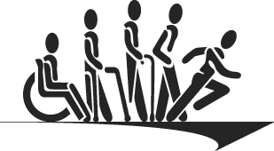



**The problem**

Injuries happen often, as often as daily. These daily injuries can proceed to more pain and worse symptoms if not treated quickly and correctly. These typical, everyday physical injuries have become the most common type of injuries acquired among the world's population. To try and solve this, we wanted to create a tool to allow the injured be in reach of quick and easy treatment. There are apps out there that provide this field of work, the problem being that they don’t provide the easy and interactive way to find this information. Many of these physical injuries need quick and informative attention that make it the easiest to heal through easy guidance. Many of these current ways are not effective, as no one with these physical symptoms have the motivation to use any of these apps. Usually these interfaces make the app confusing, not efficient and contains misleading information. If people don’t clearly understand what they are reading than they may misdiagnose their condition and not receive proper treatment the quickest. It’s sole purpose is to the user, as our app tries to tackle their injuries and problems. We have made a mobile app that is easy and smooth to use. It can help track your progress, benefits, and other ways to stay informed for current or future injuries. It can be used at any age, for different physical symptoms, that can range from being in need of minor to extensive medical care. It is the guidebook that tells you whether to look for further care. As many people rely on their medical professionals for help, the app can provide a big outlook on if any of this is necessary or not.

Physical Medical acquires are the most common type of medical problems, they take up mainly because of physical labor and duty such as constructions or sports. These take up a mere 80% of most type of sport injuries and work injuries. Our app has really stressed the fact of trying to acknowledge others with the best information possible, based on their needs and their symptoms. As many people in the world need accurate treatment. This app will soon be beneficial for this bigger expanded problem, as injuries happen daily.

**Research**

We came to the conclusion that we needed to use a mobile device in order to resolve the problem. As we started this project, we collaborated to work each other in making an app in which we would feel as acceptable if we were in need of physical therapy.

We continued finding other apps in this field of work as they were also trying to address this problem. The past apps themselves give a general mocking of what to do, while not explaining it in a clear, constructive way. Our app is fast and easy while others are not as sufficient in doing so. Other apps create the base foundation of this problem, as they first state the problem. The problem being, they don’t quite explain their injuries clearly. Most of the times they don’t explain it at all, they leave the user to look up what the injury or symptom means.

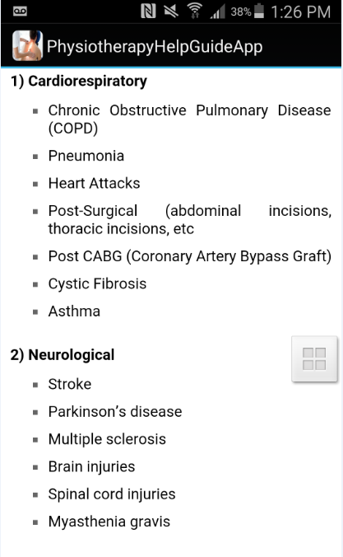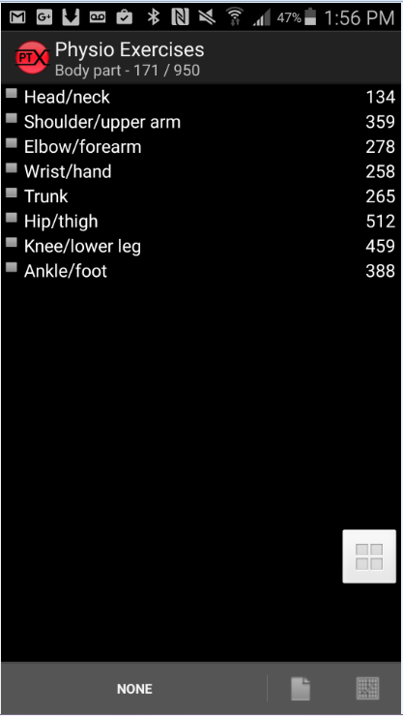*Current solutions, with non interactive interfaces. Not descriptive enough to be reliable. Not self explanatory.*

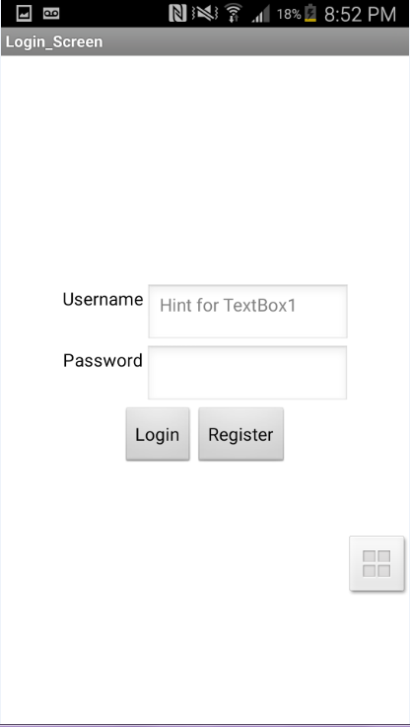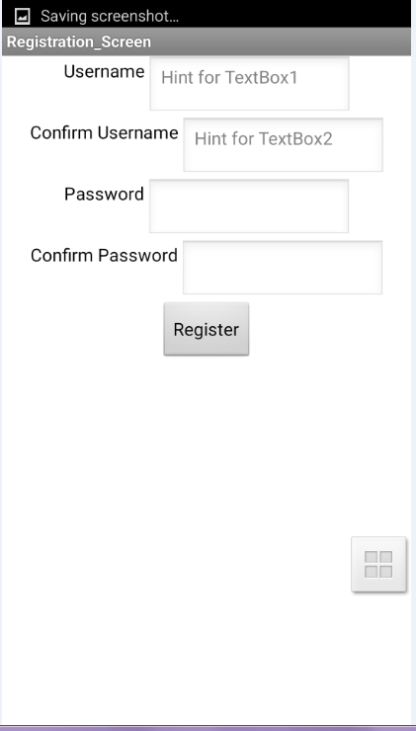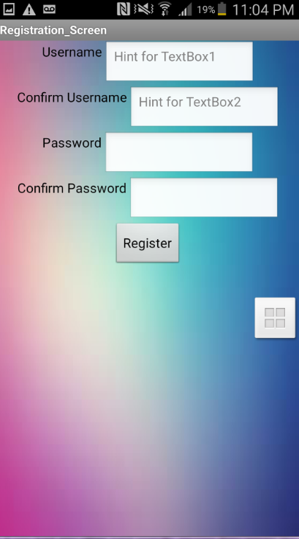

*Register and log-in screens for our app.*

Our app brings an easy GUI from the start as it asks for your username and password, as it saves on the device based on what information you imputed. It does this so the app can help personalize your symptoms based on your injuries from the last time you imputed information. Apps often forget progress, as it is important for us to know you from the first day to the next and leading until the last. Many of these apps give a disoriented outlook on your therapy .The app we made has given a way to branch from the fundamentals of the injury. These other apps are giving users confusing options, as some sub categories are classified as main categories. An app needs to be organized into an accurate solution starting from the beginning.

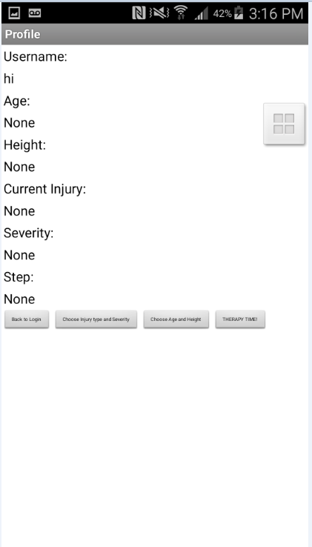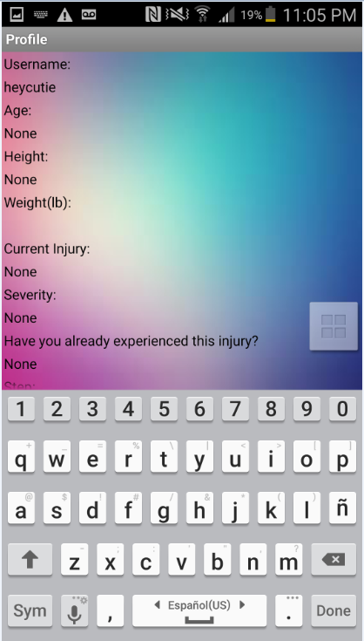

*Left is our app in development. The most right is the final. Starting screens of the two. Our screen provides a good way of keeping track of progress. It provides a first start of your account and develops overtime based on what you input.*

Other than rushing into a sign-in screen into a whole list of categories, it follows steps: It first would like to know if you had any other past specific injuries in the past. Step one is your personal information, your foundation, “how severe is your injury?” These questions will be asked to clarify your current status and past experiences. The app asks you your age and your height, to become more prone to your information. Step two asks where your injury is? What are some of the causes? The app asks if it is a “cut?”, or a “sprain?”, or did you break the bone in whole? After that, it gives information based on what your own data is and gives a description on what you can do to treat your injury. Most of all, it gives descriptions on what the injury is. Our physical therapy app helps organize the problem and minimize it into an accurate solution, using descriptions of what the injury is and what to do for the injury. Many apps show what possible options you could have and what broad exercise to do, they don’t tell you what it is and what caused it to happen.

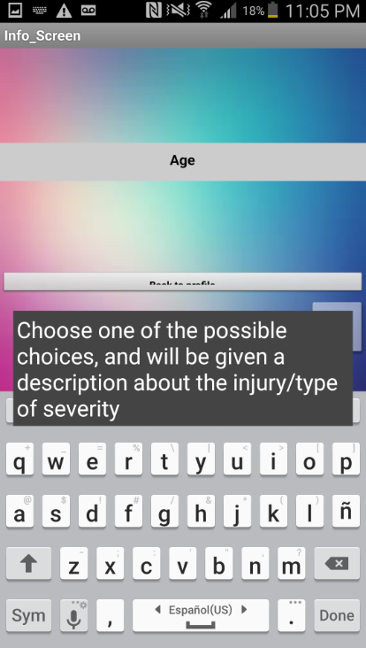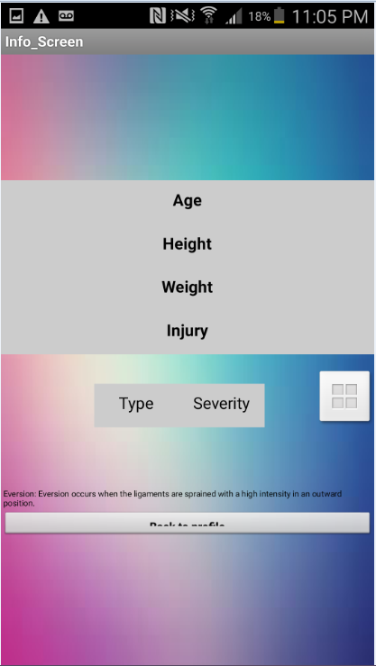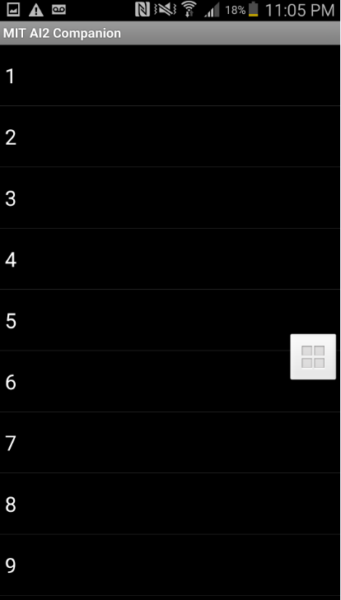

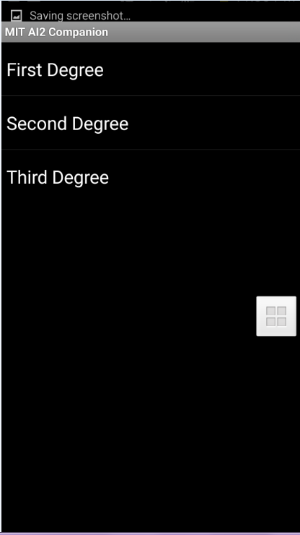

*These show you our way of breaking down information into a your data, we ask for you age, height, weight, and type of injury. Here we can see what age to pick, or what type of severity is your ankle sprain. It then adds this to your profile data.*

They throw around words that contain many documentary medical vocabulary, that can result to a very confusing therapy app for someone that is inexperienced or not knowledgeable in any medical field. Not everyone will know what exact disease they have, what type of disease each of the listed are. The app provides categories and descriptions of what they are. An app that has categories to be explained thoroughly gets the user be knowledgeable about what the injury is and what could've caused it. Many have wanted a way to get only the core aspects of their injury, as we would prescribe them using an app that gives quick care, and quick treatment based on what they have acquired. This app is being customizable to the user. During or after the injury, the user can acquire on what exercise to do. Remember, we want to accommodate after the injury to heal in a quick manner. That’s what makes the app more reliable and beneficial than other apps, as they don’t provide these features for a step one to step two process.

**Problem summary**

Our final goal was to make an app, which included all these inquires we had described above. Our purpose of this was to make this a tool, a tool of an easy and a reliable way of presenting information.The app alone, is an app with beneficial features of looking out on someone's physical injury, as continuing progress.We wanted to tackle the problem of allowing others to get easy access when needed. This feature was quite stressed, since many people have no use for many of the current physical therapy apps on the market. They find themselves hard to imply to and hard to try. Our solution was to make it a easy, simple and reliable source. It was used for anybody, as it shows a variety of information presented from the front page.

This app will be easily done and manufactured, as we only need one app to share to the market. It’s estimated that there is no further need for more funding but more experience for app capability and programming capabilities. There are multiple future improvements to add to the app. These improvements can include more parameters, medical issues and types of pain tolerance. We can also add step by step videos showing how to do each exercise, therefore making the app more reliable and accurate to our users.

App AIA:

[First Prototype](https://drive.google.com/file/d/0Bz2ddMPOb1koWWVRT2hBZ2ItVlE/view?usp=sharing)

[Second(Final) Prototype](https://drive.google.com/file/d/0Bz2ddMPOb1koN3lHcEVyU0dJdHc/view?usp=sharing)

**Individual Reflections**

Sam Toma

Sam was the primary researcher for the product. To gather all of the necessary information to make the app, he had to conduct large amounts of research, checking numerous sources and verifying the information. He compiled all of the information into a research sheet which was where the information included in the app came from. After researching he helped to create a large amount of the presentation. He was responsible for organizing the presentation, adding information to it and making sure that everything that was included in the presentation and app was factually correct. In addition, he also made certain changes to the documentation by fixing certain sentences which were originally unclear and adding information.

Addison Shiu

He was the one who primarily wrote the essay and the documentations. He wrote the paragraphs of the problem, the research, the final summary of the project as well as the pictures and descriptions. Addison did research such as cuts and sprains to help implement the further documentation and app. He created as well as starting and adding to a portion of the presentation, such as the introduction. There were also a few screens he had worked on to implement into the app. In addition, he added information and descriptions to the MIT App Inventor screens. These were screens such as sprains, cuts and types of ankle sprains. These three screens are the screens that show information about the injury and further leading injuries that could occur. After completing that, he fixed some of the formating and GUI of the app. He also added more for everyday’s project log. What he wrote in the project log was later used as resources for the final presentation. Addison was the person who kept track of progress and used all of the information gathered to write down the documentation and completing the essay.

Adrian Liu

Adrian did research on cuts and sprains as well as work on the app. He and the others create the first prototype of the app, which was basically a login system with information about each injury. And by himself, he created the second prototype that has a webdb login system where you can login throughout any device, it also has a built in profile page that is stored onto the webmd so that they can access their information. The app starts you off with a blank profile page, where you have to go step by step filling out each part with your age, height, injury, and severity. Then, when you save and log back into the app, a new functionality appears, “therapy time”, which provides clear steps on how to regain full control and strength of the limb. The step they left off on will also be stored on the webdb so that whenever they stop, they can come back and resume their therapy session. Adrian used information that Sam and Addison collected and implemented it onto the app database. The main role that Adrian played was the “programmer”, he mainly did programed on MIT App inventor platform and researched a bit about each injury. Adrian also was an information relayer, or a person who stated what was going to be put onto the app and how it was going to be built.

Harsha Jagarlamudi

Harsha was the team member that found all of the contributors to the project. He was also the final decision maker for the product idea. Harsha engaged the other group members in the project about what work each of them wanted to do and helped allot individual roles. The main role he played was a leadership role. Harsha constantly collaborated with group’s individuals, inquiring about the work they accomplished and telling them what work had to be done next. Harsha organized all of the groups work together by creating the project folder and placing the files that had already been created inside of it. In addition to the leadership role, Harsha also contributed to the presentation and the app itself. For the presentation. Harsha changed the formatting to make it more user friendly, added necessary information that the presentation was lacking, and editing the other group members work for grammar, spelling, and other issues. On the app, Harsha contributed greatly to adding in a lot of the information to the app. He also made the app far more user friendly than it initially was and modified the appearance of the user interface.

**Citations for data**

<Beresini, Erin. "The 14 Most Common Fitness Injuries..." *Outside Online*. Outside Live Bravely, 27 Feb. 2012. Web. 31 May 2016.>

<http://www.outsideonline.com/1897281/14-most-common-fitness-injuries%E2%80%A6>

<Rogers, Sabrina. "Top 10 Sports Injuries | Fox News." *Fox News*. FOX News Network, 19 June 2009. Web. 31 May 2016.>

<http://www.foxnews.com/story/2009/06/19/top-10-sports-injuries.html>

" Ankle Sprain." *Ankle Sprain*. American Orthopaedic Foot and Ankle Society, n.d. Web. 23 May 2016.

<http://www.aofas.org/footcaremd/conditions/ailments-of-the-ankle/pages/ankle-sprain-.aspx>

Haddad, Steven L. "Sprained Ankle-OrthoInfo - AAOS." *Sprained Ankle-OrthoInfo - AAOS*. N.p., n.d. Web. 23 May 2016.

<http://orthoinfo.aaos.org/topic.cfm?topic=a00150>

"High Ankle Sprain." *Wikipedia*. Wikimedia Foundation, n.d. Web. 23 May 2016.

<https://en.wikipedia.org/wiki/High_ankle_sprain>

"Eversion Ankle Sprain." *Eversion Ankle Sprain*. N.p., n.d. Web. 23 May 2016.

<http://www.sportsinjuryclinic.net/sport-injuries/ankle-achilles-shin-pain/eversion-ankle-sprain>

Hunter, Oregon K. "Cervical Sprain and Strain." *: Background, Pathophysiology, Epidemiology*. Medscape, n.d. Web. 23 May 2016.

<http://emedicine.medscape.com/article/306176-overview>

"Diseases and Conditions." *Cleveland Clinic*. The Cleveland Clinic Foundation, n.d. Web.

[http://my.clevelandclinic.org/health/diseases_conditions/hic_an_overview_of_neck_and_shoulde](http://my.clevelandclinic.org/health/diseases_conditions/hic_an_overview_of_neck_and_shoulder_pain/hic_neck_sprain)

[r_pain/hic_neck_sprain](http://my.clevelandclinic.org/health/diseases_conditions/hic_an_overview_of_neck_and_shoulder_pain/hic_neck_sprain)

Schubbe, Peter J. "Neck Strain: Causes and Remedies." *Spine-health*. N.p., 7 June 2010. Web. 23 May 2016.

<http://www.spine-health.com/conditions/neck-pain/neck-strain-causes-and-remedies>

"Whiplash Injury: Pain, Treatment, Symptoms, Causes, and More." *WebMD*. WebMD, n.d. Web. 23 May

2016.

<http://www.webmd.com/back-pain/neck-strain-whiplash>

"Neck Sprain-OrthoInfo - AAOS." *Neck Sprain-OrthoInfo - AAOS*. N.p., n.d. Web. 23 May 2016.

<http://orthoinfo.aaos.org/topic.cfm?topic=A00410>

"Wrist Sprains." *Handcare.org*. N.p., n.d. Web. 23 May 2016.

<http://www.assh.org/handcare/hand-arm-injuries/wrist-sprains>

Settergren, Curtis R. "Wrist Sprains-OrthoInfo - AAOS." *Wrist Sprains-OrthoInfo - AAOS*. Orthoinfo, Sept. 2010. Web. 23 May 2016.

<http://orthoinfo.aaos.org/topic.cfm?topic=a00023>

"Cuts or Lacerations Treatment: First Aid Information for Cuts or Lacerations." *WebMD*. WebMD,

n.d. Web. 24 May 2016.

<http://www.webmd.com/first-aid/cuts-or-lacerations-treatment>