Mounica Padakandla

Harsha Jagarlamudi

Text Adventure Project Log

|  |  |
| --- | --- |
| **Text Adventure Source Code** | [Link to Source Code](https://drive.google.com/open?id=0B1h-CQS3owyLRVFDcEdlcHlNVHc) |

[**Text Adventure Digital Flow Chart**](https://drive.google.com/open?id=1KFo1tdn6OnImGXD9BBsBrSiof1bwvmKMiWII61NtzBs)

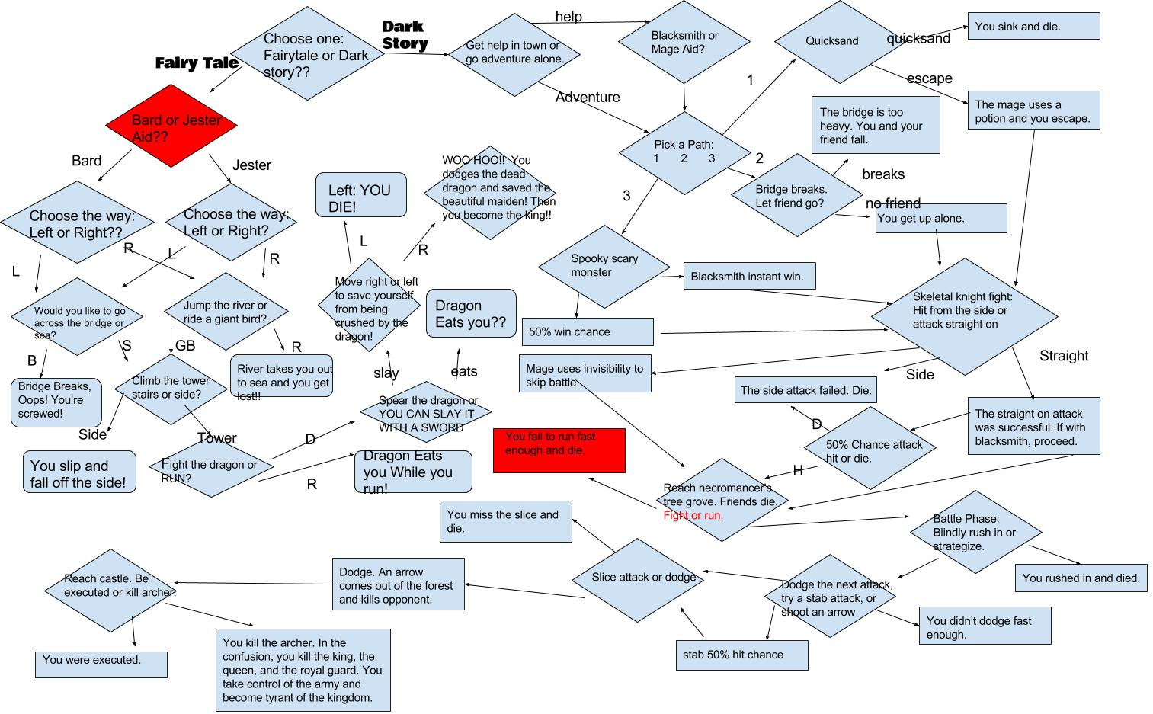

**Ideas:**

* The Heroic Knight: Choice of Stereotypical or Dark Story
  + Stereotypical:
    - princess captured
    - knight meets people, gets help
    - fights stuff, reaches tower
    - fights dragon, saves princess YASSS
  + Dark:
    - banished knight called back to castle to rescue the princess (all the others sent got rekt)
    - if the knight comes back with princess he will be allowed back into the kingdom
    - knight goes on the journey
    - meets people who help him (a lot die)
    - goes to lake in forest (finds dead necromancer)
    - fight zombie princess
    - goes back
    - kill king or be executed
* Dogzilla or Godzilla: Pick a Monster
* depending on the monster you pick, your adventure changes
* **Dogzilla:** starts off with you as a mouse; getting chased by dogzilla. You go through different obstacles like tables,sinks, or chairs.
* you eventually get eaten by dogzilla because you screw up at one point(get stuck on like glue or a mouse trap)
* **Godzilla:** you are an airplane and your goal is to shoot godzilla down
* you have 10 chances to beat the monster; eat chance is about 2 hits but each chance is in a different location in the sky; rain,clouds,sunny skies and etc….

Daily Accomplishments

**2/19/2016:**

* Created project log
* Begin developing ideas
* Collect flow chart

**2/20/2016 - 2/21/2016:**

* Finished first idea
* Finished flowchart

**2/22/2016:**

* Finished developing second idea
* Finish flowchart for idea 2

**2/23/2016**:

* Picked outcomes that could be functions
* Feedback
  + make the decisions less luck based and tell the player what you are doing
  + make it longer

**2/24/2016:**

* started coding; making basic functions and etc.
* Today, we completed the function for the start of the game. We also finished our miss and chance function.

**2/25/2016:**

* We created initiation functions for both stories.
* We created the introduction for the fairy tale and added who you can chose as an assistant.
* We also created a function to chose a path.

**2/26/2016:**

* We finished the left and right path functions.
* We also completed the tower climbing function and added failure code to some functions.

**2/28/2016:**

* Created checkpoints functions
* Embedded function in start

**2/29/2016:**

* Removed checkpoints function
* Completed tower function
* Began dragon fight function

**3/1/2016:**

* Finished all of the dragon fight functions
* Modified the text
* *completed fairy tale (yay)

**3/2/2016:**

* Began dark story code
* Finished ally function
* Made significant progress on pathways functions

**3/3/2016:**

* fixed ally bugs (ally was not assigned)
* finished the pathways function

**3/4/2016:**

* Linked all pathways function successes to cemetery function
* began working on cemetery function
* completed cemetery function

**3/6/2016:**

* Completed code for story
* Added extra ASCII art

**3/7/2016:**

* Added checkpoints to entire code

**Gallery Walk Instructions:**

To start the story, enter **start()** in the iPython

Then, follow the instruction presented. (All answers must be spelled **correctly**.)

**Gallery Walk Comments:**

* I liked how the game can start in multiple ways and allows you to select whether you want checkpoints or not
* The way the text is printed to the screen appears very organized
* I like how there are checkpoints so you don’t have to start from the beginning every time
* Functions are very organized but in the Python Style Guide it stated that code should not exceed line 79
* I liked the choices and it was pretty easy to navigate.
* I liked the fact that you indented the code and it is very easy for me to see - Pranav Dadi
* I liked the story overall, it was nice and complex
* I like the story, lots of reading though
* I wish it would explain what would happen when you made a wrong decision before you loaded the checkpoint.
* I also got caught in a never ending loop in the dark story
  + There was a loop with the rushing and the arrow and the princess
* The ending where you marry the princess kind of shocked me because I’m a girl, but the story went smoothly!
* Interesting how you used the brackets but didn’t really get what that meant
* Put in more comments on your code
* To make your ascii work, you need to put print statements on every line
* Good work! Just be careful with the loops. It’s impossible to quit the game after the dragon. Also, your raw_input functions will proceed even if an invalid answer is entered.
* It’s a good story, but the checkpoints make it confusing and tedious if you make a wrong choice and have to go all the way back.
* So when you have checkpoints, you will never die?
  + Because you can’t end the game unless you win which is a bit of a loop
  + Make it a checkpoint for a certain number of tries
* Story is detailed and makes sense. The only problem is that I keep getting teleported back to the checkpoint and don’t know why. There should be a sentence that at least states that I died, otherwise I have to assume that it’s a glitch.

**Conclusion - Harsha:**

1. The creative process we used was brainstorming through numerous generic ideas before picking one to use. When we picked that idea, we chose to use that idea as a small portion of our overall idea. The rest of our overall idea was the generic idea heavily modified and expanded to be original. This was useful because it allowed us to select an idea that we had experience seeing before.
2. The team was a moderately good collaboration. We worked well together because we relayed information to each other well. We also split up the work well until we reached the coding portion of the project. One issue the team had, was that i was selfish when it came to coding and I prioritized my own coding over directing my partner and had them work on the daily project log entries.

**Conclusion - Mounica**

1. In order to decide on one idea, my partner and I created two ideas, seperately at home. We wrote both wrote our story suggestions on our project log and discussed in class. We both were open to each story and if we were not comfortable with an idea, we would politely explain our perspective. This strategy helped us see the thought process of each story. Eventually, both of us were able to agree on one general idea and expand on that.
2. We both worked well together and were open to any concepts or ideas the other partner put forward. My partner and I were able to work very well good together because we both depended on each other for correction and ideas. Regularly, we alternated positions and made sure both of us were doing some work. But I did feel that I did not get to code as much as I wanted to in this project. It felt as if my partner was constantly volunteering to do the challenging parts of the code and volunteering to take it home, rather than splitting the work equally. Overall, our team was successful in working together.