1. case: Political communication from farmers

Who is the fat cat?
BY PETER ROSENDAL | 6. OCTOBER 2023

It is not agriculture but Ida Auken who fails to seek new hunting grounds - writes one of Sustainable Agriculture's board members

By Peter Rosendal, board member of Sustainable Agriculture, Knudsbølvej 31, Jordrup near Kolding

Ida Auken argues in several media outlets that the “fat cat” syndrome shows that agriculture should have a CO2 tax. By this she means that the fat cat knows where the food is put out and therefore doesn't bother looking for new hunting grounds.

I think the syndrome points back to Ida Auken herself.

Ida Auken wants to impose a CO2 tax on Danish agriculture. Danish agriculture will be the only country in the world to be burdened with such a tax, after New Zealand scrapped the idea earlier this year.

Danish agriculture must compete with all these other countries. Compete with other nations to be environmental and climate front runners - and then Ida Auken wants to burden Danish farmers with a rope around their legs in the form of a tax - so they can't run.

Danish farmers have come a long way in the real green transition - they are working, literally around the clock, to get even further and for the cream for the coffee at Borgen. These are the farmers Ida Auken wants to punish. Danish farmers are innovative and adaptable.
You could ask: Who is the fat cat - the adaptable agriculture that sells its products all over the world or the politician who strikes with the only tool she knows and has used for decades?

Ida Auken, think innovatively about the food of the future and think about hunting grounds other than taxes.

It's true that the fat and lean cat are forsaken when the bowl of cream is gone one day. But be careful, Ida Auken, that the bowl you drink from and put taxes on is not one day gone because it has worse conditions than all other cream bowls. Find new ways, find collaborative ways - and you will see a thriving green and climate-friendly agriculture that produces food for the world.

(The post has also been published as a letter to the editor in various daily newspapers and in the agricultural press, see for example the version from www.randersidag.dk plus the online version from Maskinbladet).

2. case: Astrology online forum

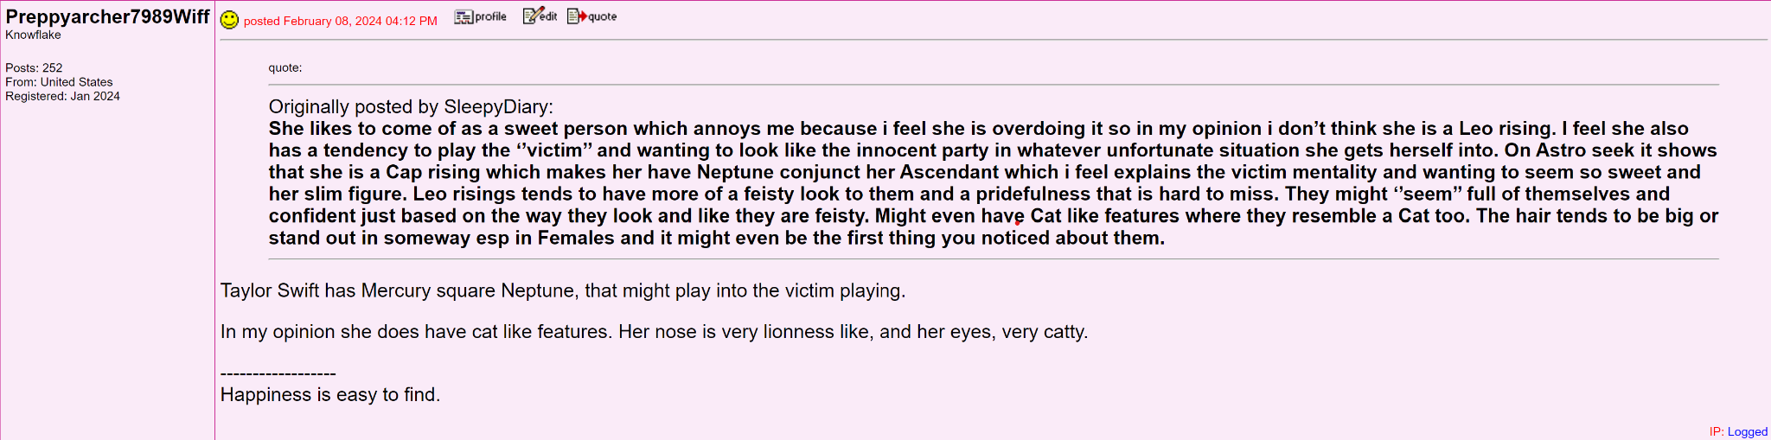

Librapurr  Knowflake  Posts: 2531  From:  Registered: Jul 2019 | posted January 03, 2023 12:27 PM Finally, somebody did it. 👏I thought we would be stuck in 2021 forever.  I got more into healthy habits last days of the last year. I think even little stretching early made my days better. I often have waken up feeling tense and aches. But I tried to manage it without pills and didn’t do much for my health last year. I usually struggle to do much in the first part of a day.  I noticed that fall my well-being went down. I think it was related to many retrogrades, my emotional state and lost of direction. In the end of year I got some hope I can improve my conditions. Oh, Jupiter got closer, that’s why.

teasel  Knowflake  Posts: 27192  From: Here  Registered: Apr 2009 | posted January 09, 2023 05:44 AM Okay, last week started out stressful, and threw me off all week. Fingers crossed this week is better. I don’t know my transits, but I’m going to take things easy, I’m going to be reading, and relaxing, and getting out of here, learning to use my camera.

Case 3 Depression subreddit

Im not even 30 yet and have felt like I hit a brick wall. I thought I always wanted some sort of great job that makes enough to be comfortable, friends, family, things. But over the past 5/6 years I’ve felt like a failure and disappointment. I feel lazy. I’ve both quit jobs and gotten fired because I call in so much because I can’t even be bothered to climb out of bed and then I get such bad anxiety that I took a personal day I end up taking multiple. I even thought my most recent job I accepted and moved for would be it but I fell into the same patterns. I’ve lost contact with most of my closest friends over the years. Mostly because I’ve tried moving and chasing different things in hopes of feeling something. But also because a lot of them we’re one sided and I just stopped trying to maintain anything. I’ve abandoned and strained certain family relationships because I can’t decide some days if I care and feel too much or nothing at all when they speak to me. I have lost meaningful relationships to me because I feel like I’m chasing this “love ideal” but I can’t fit in anyone’s mold because my imperfections. I feel like I’ve almost stopped caring about having a relationship with anyone. I have even given up on myself. I make every excuse in the book not to eat right or make my own food even though I’m a capable and good cook. I make excuses to not work out when I legit have a treadmill at home. I feel like I’m faking everything sometimes and most people still in my life just see a show. Or think I have a weak immune system because I’m sick all the time but in reality I keep my distance and fake a lot.

I know this is a long post but also my first. I legit feel alone and lost and I don’t know what to do. I feel like I’m tossing everything in my life away but I can’t break out of these cycles I put myself in. I guess I just want to know am I alone in this feeling and if anyone has advice.

I want to keep my job for more than I year. I want to loose weight and “look good”. I want friends and love. I want those things but I make every excuse to not. Help?

---

