Instructions for GradingMonkey

# Saving the Excel document as a csv-file

* Open the Excel document containing a list of grades for an assignment (or final grades) along with the kennitala of each student.
* Navigate to Office Button – Save As – Other Formats (or press F12).

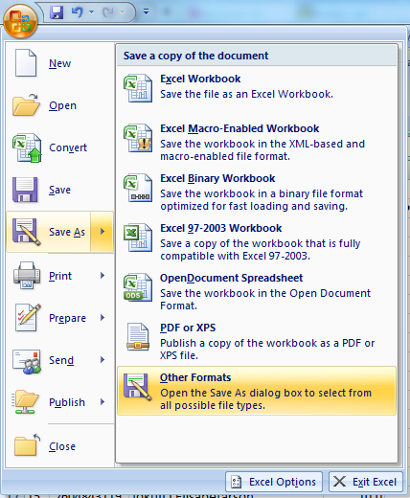

* Set “Save as type:” as CSV (Comma delimited) (*.csv)
* Save the CSV-file (and remember where)
* Excel will usually prompt you with a warning: “file.csv may contain features that are not compatible with CSV (Comma delimited). Do you want to keep the workbook in this format?”
  + Click Yes
  + Note that you are saving a copy of your Excel workbook. This does not alter the original document.
* Close the Excel document
* Excel will usually prompt you with a warning: “Do you want to save the changes you made to file.csv?”
  + Click No

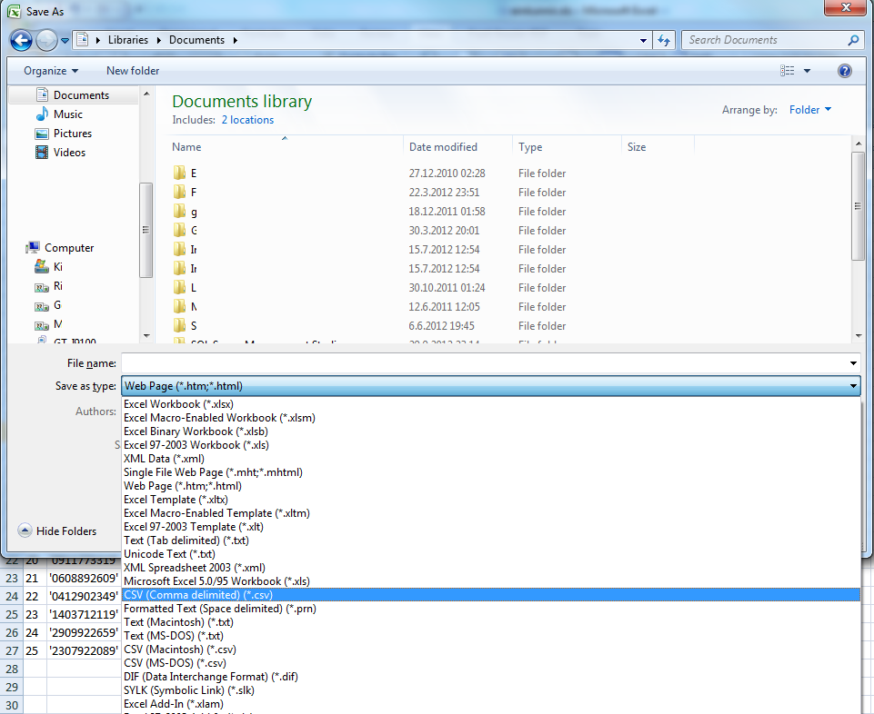

## Configuring GradingMonkey

* Start GradingMonkey (double-click *GradingMonkey.exe*)

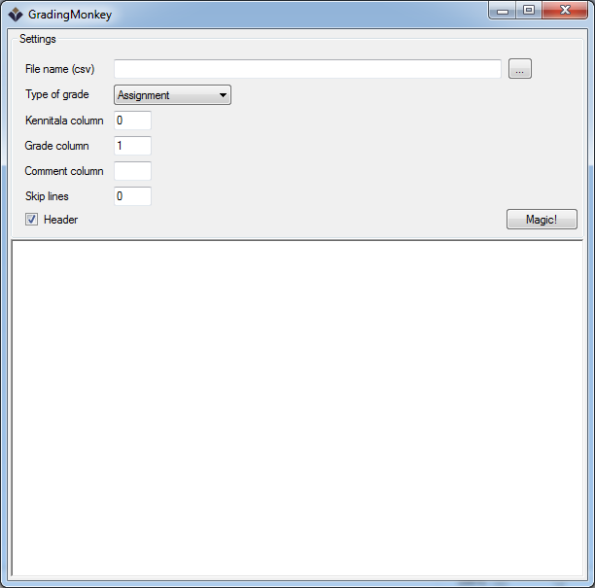

* You can configure the following
  + **File name (csv)**
    - This is the CSV-file you saved earlier. You can locate it by clicking the button “...”
  + **Type of grade**
    - This determines the type of the grade, which is either *Assignment* or *Final*. If this is an assignment (verkefni) you choose *Assignment.* If you are giving final grades in a course you choose *Final*.
  + **Kennitala column**
    - This is the column, in the Excel document, containing the kennitala of each student. Note that the first column is column 0, the second is column 1, and so forth.
  + **Grade column**
    - This is the column containing the grade you are moving to Myschool.
  + **Comment column**
    - This is an optional column that contains comments (athugasemd), for the student, that are added to Myschool along with the grade.
  + **Skip lines** 
    - This gives the number of lines that should be skipped in the Excel document. If your document starts with lines that does not contain data (i.e., grades) you specify how many those lines are here. Note that this does not include headers.
  + **Header**
    - This should be checked if your data contains headers.

# Grading an assignment

An Excel document containing grades might then look something like the following.

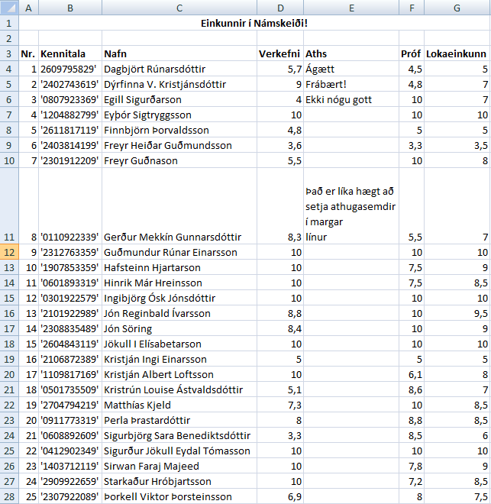

* To extract the grades for “Verkefni” from this document, configure GradingMonkey as follows (we assume we are grading an assignment).
  + Set **Kennitala column** to 1, since Kennitala is in the second column.
  + Set **Grade column** to 3, since the grade is contained in the 4th column.
  + Set **Comment column** to 4, since the comments are in the 5th column. Note that this is optional. You can just leave the Comment column box empty if you do not have any comments in your Excel document.
  + Set **Skip lines** to 2, since the first two lines of the document do not contain data. The first contains the title and the second line is empty.
  + Check the **Header** checkbox, since the data has headers (i.e., “Nr.”, “Kennitala”, “Verkefni”, etc.).
* Click “Magic!”
* If no errors occur, a piece of *JavaScript* code has been copied to the clipboard. The same code also appears in GradingMonkey.

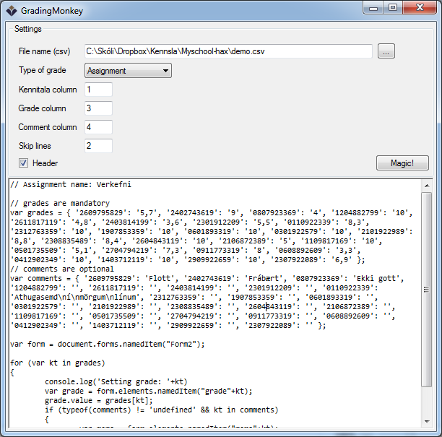

* The following instructions should work on most browsers, but they will assume you are using *Google Chrome*.
  + Open the assignment website on Myschool in Chrome.
  + Open the JavaScript console in Chrome by pressing (simultaneously) Ctrl+Shift+C.
  + Click “Console” in the window that appears.
  + Paste the JavaScript code into the console by pressing (simultaneously) Ctrl+V, while the cursor is in the console.

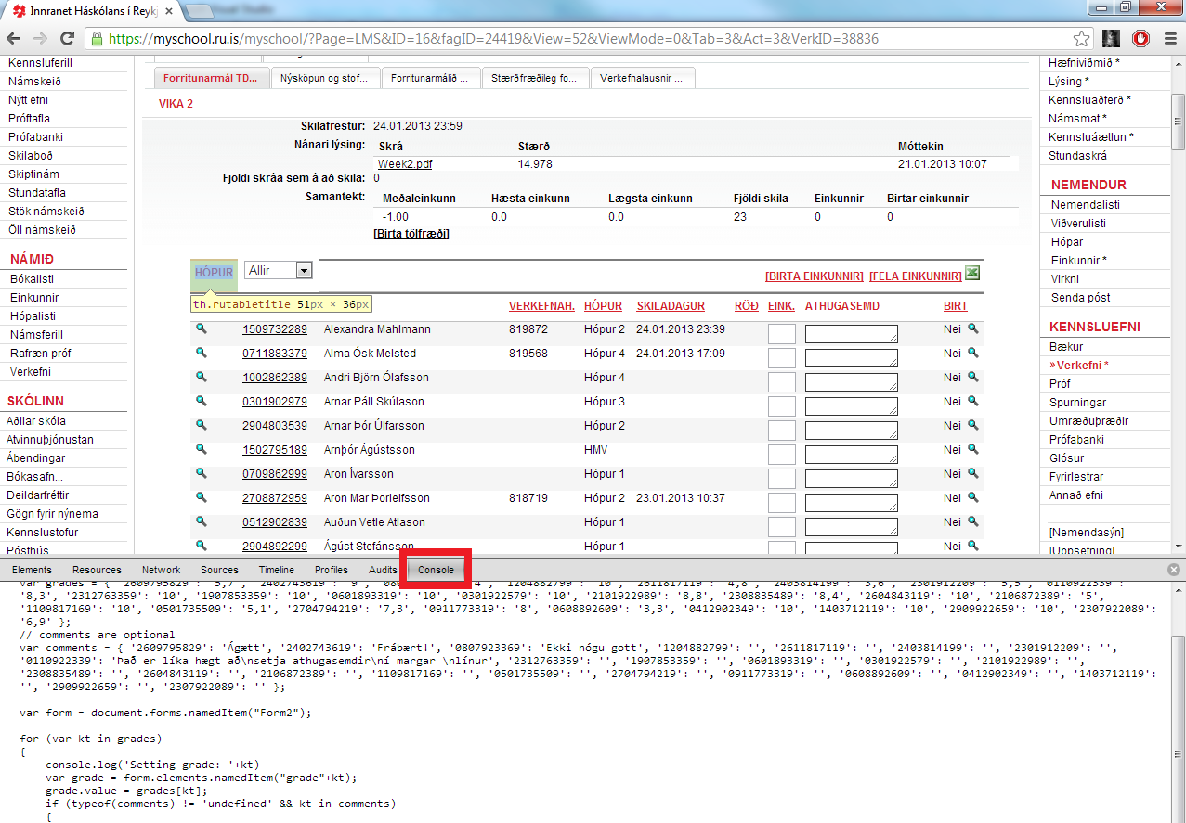

* + Press return (enter)
  + The grades (and comments) should now have been added to the assignment web site.
  + Close the JavaScript Console by clicking the x in the upper right corner of the bottom window.
  + Save the added grades by clicking “Staðfesta.”

# Giving final grades

Sometimes the final grade calculated by Myschool is not correct. E.g., if there are optional assignments or the lowest two grades out of some set of assignments are disgarded. GradingMonkey also provides the option of giving final grades.

Note that the final grade must be formatted to a single decimal place, and it can only contain 0 or 5. Grades like „9“ and „9,3“ are therefore not legal, and will cause the script to crash (don‘t worry thoug, this does no harm to your computer or the final grades). Note also that if you want to indicate that a student did not show up for the final exam, you can leave the final grade empty. To round grades like this in Excel, you can use the following formula (assuming that the final grade is in cell A1): ROUND(A1*2;0)/2

An Excel document containing final grades could look something like this.

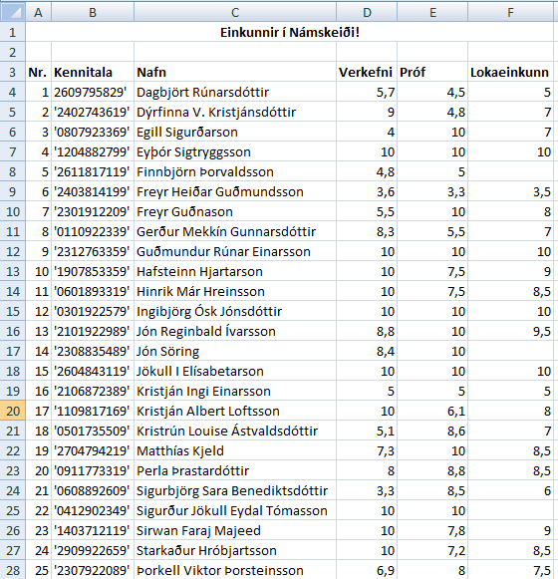

Here we indicate that the students in rows 8, 17 and 25 did not show up to the final exam. In Myschool they will receive the grade “Mætti ekki.”

* To extract the grades for the final grade “Lokaeinkunn” from this document, configure GradingMonkey as follows.
  + Set **Type of grade** to *Assignment*.
  + Set **Kennitala column** to 1, since Kennitala is in the second column.
  + Set **Grade column** to 5, since the final grade is contained in the 6th column.
  + Set **Skip lines** to 2, since the first two lines of the document do not contain data. The first contains the title and the second line is empty.
  + Check the **Header** checkbox, since the data has headers (i.e., “Nr.”, “Kennitala”, “Verkefni”, etc.).
* Click “Magic!”
* If no errors occur, a piece of *JavaScript* code has been copied to the clipboard. The same code also appears in GradingMonkey.
* The following instructions should work on most browsers, but they will assume you are using *Google Chrome*.
  + Open the final grades’ page (Einkunnir on the right hand side) on Myschool in Chrome.
  + Open the JavaScript console in Chrome by pressing (simultaneously) Ctrl+Shift+C.
  + Click “Console” in the window that appears.
  + Paste the JavaScript code into the console by pressing (simultaneously) Ctrl+V, while the cursor is in the console.

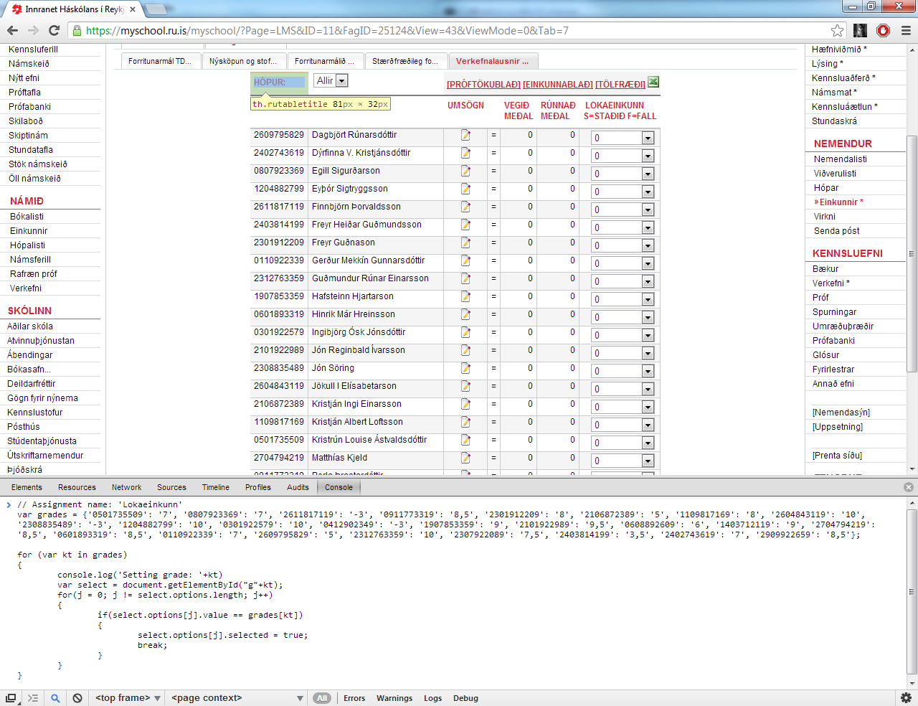

* + Press return (enter).
  + The grades (and comments) should now have been added to the final grades’ page.
  + Close the JavaScript Console by clicking the x in the upper right corner of the bottom window.
  + Save the added grades by clicking “Vista einkunnir.”