

University of Southeastern Philippines

*College of Teacher Education and Technology*

**REQUEST FOR STUDY ADVISER**

□ Thesis **□** Capstone Project

September 9, 2021

**Genna J. Carmelo**

College of Teacher Education and Technology

University of Southeastern Philippines

Sir/Madam:

Dhally A. Ilisan

This is to request for the services of Dr./Prof. **_________________________________________________________**

as adviser for our research study, entitled: **_____________________________________________________________**

**_____________________________________________________________________________________________**

Attached herewith is the copy of the concept paper for reference.

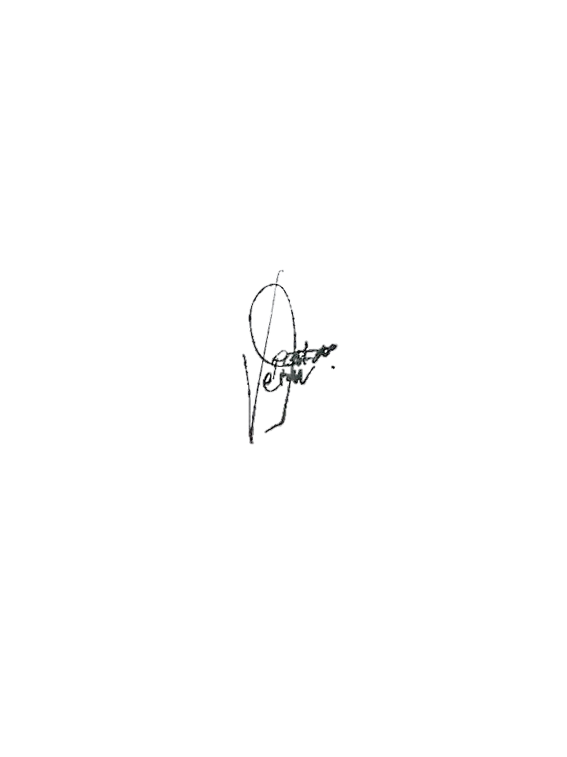

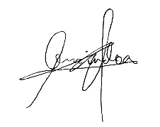Respectfully yours,

**James Bryan C. Fiel**

**Vern B. Patao Jr.**

**Abel June C. Lemindog**

**________________________ ________________________ ________________________**

Recommending Approval:

Dhally A. Ilisan

**________________________**

Program Head

Conformed:

Dhally A. Ilisan

**________________________**

Adviser

Approved by:

Genna J. Carmelo

**________________________**

Dean