

University of Southeastern Philippines

*College of Teacher Education and Technology*

# Dear Students,

Welcome to the Off-Semester 2021!

Please read our **Data Privacy Statement** before proceeding to the enrollment.

The right to privacy is a fundamental human right. Acknowledging this, the University of Southeastern Philippines, hereafter referred to as “University”, endeavors to safeguard its stakeholders’ data privacy by adhering to data privacy principles and employing standard safety measures in the collection, processing, disclosure and retention of personal data in accordance with the Data Privacy Act of 2012 (R.A. 10173), its Implementing Rules and Regulations (IRR) and to issuances of the National Privacy Commission.

This University Data Privacy Statement (the “UDPS”) contains an outline of the general practices of the University in the context of data collection and processing. All other data privacy statements released or to be released by the University specific to a particular office, function or procedure shall be in congruence with the UDPS. Designed for general knowledge, the UDPS may not include specific information pertaining to the data collection and processing mechanism of a specific office, function or procedure. Thus, whenever applicable, a more specific data privacy statement or notice should be consulted.

The full text of The Statement can be accessed through this link(http://www.usep.edu.ph/usep-data-privacy-statement/).

For a comprehensive and detailed view of the University’s data privacy policies, please refer to the *University’s Data Privacy Manual.

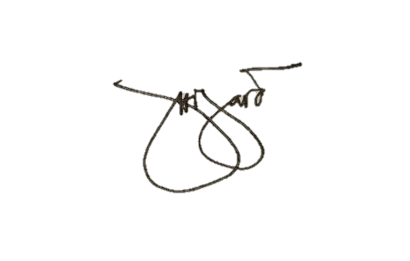By affixing your signature above your name, you agree to the University of Southeastern Philippines’ Data Privacy Statement.

______HIJARA, CHARELYN B._______

# Signature Above Printed Name

**WE BUILD DREAMS WITHOUT LIMITS**

Address:

University of Southeastern Philippines

Telephone: (08

4

)

645

-

3050

local

504

Tagum

-

Mabini Campus, Apokon, Tagum City

Website:

www.usep.edu.ph

Philippines 8000

E

-

mail:

registrar.tagum

-

mabini

@usep.edu.ph





University of Southeastern Philippines

*Tagum – Mabini Campus*

**PRE-REGISTRATION FORM**

Last Name , First Name, Middle Name (if applicable) : Hijara, Charelyn, Basuga

ID No.: 2018-00176

Birthdate: (mm-dd-yyyy): 06-04-2000

E-mail Address & Contact Number: [cbhijara@usep.edu.ph](mailto:cbhijara@usep.edu.ph) / 09096992656

College: College of Teacher Education and Technology

Degree Program : Bachelor of Science in Information Technology Specialization: Information Security

|  |  |  |  |  |
| --- | --- | --- | --- | --- |
| **Year Level** | **Semester** | **School Year** | **Sex** | **Scholarship** |
| 1st Year  2nd Year  3rd Year  4th Year  5th Year | 1st Sem  2nd Sem  Off Sem | 2021 – 2022 | Male Female | Kindly indicate:  TES-Listahanan |

|  |  |  |  |  |  |
| --- | --- | --- | --- | --- | --- |
| **COURSE CODE** | **COURSE DESCRIPTION** | **CREDIT UNITS** | | **Day** | **Time** |
| Lec | Lab |
| ITPR 401 | IT Practicum |  | 4.0 | TTh  Th | 01:00 PM-05:00 PM  08:00 AM-12:00 PM |
| ICE 414 | Professional Elective 4 | 3.0 |  | MW | 01:00 PM -04:00 PM |
| ICE 415 | Professional Elective 5 | 3.0 |  | MW | 01:00 PM –02:30 PM |
| ITCP 400 | IT Capstone Project* |  | 2.0 | F  F | 08:00 AM–12:00 PM  01:00 PM–03:00 PM |
| Total Number of Units | | 6.0 | 6.0 |  | |

CHECK THE BOX TO INDICATE THE TYPE OF STUDENT:

**NON-PAYING STUDENT** (Students who avail the free tuition and other benefits under RA 10931 and commit to comply with the return service under the act.)



 

**PAYING STUDENT** (Students who voluntarily opt out of the free higher education provision.)



 

 August 19, 2021

Student’s Signature & Date Signed

ctet@usep.edu.ph

Validated by:

Printed Name & Signature

of Enrolling Adviser & Date Signed

**WE BUILD DREAMS WITHOUT LIMITS**

Address: University of Southeastern Philippines

Telephone: (082) 227-81100 local 502

Tagum-Mabini Campus,

Website

[:](http://www.usep.edu.ph/)

[www.usep.edu.p](http://www.usep.edu.ph/)

[h](http://www.usep.edu.ph/)

Apokon, Tagum City, Philippines 8100

E-mail:

registrar.tagum-mabini@usep.edu.ph

