**FORM A**

# University of Southeastern Philippines

*College of Teacher Education and Technology*

**REQUEST FOR STUDY TITLE**

□ Thesis **□** Capstone Project

September 2, 2021

**Dr. Genna J. Carmelo**

College of Teacher Education and Technology University of Southeastern Philippines

Sir/Madam:

This is to submit our proposed study title which the panel committee may choose from. Hereunder are the proposed study titles:

1. **________Web-Based Training Systems and its Importance _______________**

**________________________________________________________________________**

1. **Web-based Health Center Child Immunization Management System**

**________________________________________________________________________**

1. **______Web-based Event Planner ____________________________**

**________________________________________________________________________**

Attached herewith are the concept papers of each proposal for your reference.

Respectfully yours,

**___ Asmina M. Abbas_______ ___ Kesia Joy C. Sasam____ ___Richard V. Comania___**

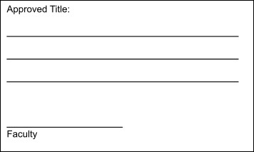Noted by:

**_____Dhally A. Ilisan________** Program Head

**__Dr. Genna J. Carmelo_____**

Dean