Version | Description | Changed By | Date
1.0 | First draft | Richard Ashwell | 7/9/06

Index

Index 1
1 Inputs 1
2 Outputs 1
3 Overview 1
4 Add Layers 2
5 Add Subsystem 4
6 Add Subsystem Interface 5
7 Add Subsystem Facade 6
8 Step Flow Activity Diagram 7

Inputs
System Analysis Model

Outputs
System Design Model
Layers
Subsystems
Subsystem Interfaces
Facades

Index

Overview
The layering of the system object model is essentially an arbitrary decomposition of the packages of the design. The upper three layers normally follow the traditional three layer schema. However, because the layering is of types in the design, rather than just instances, lower layers will normally be included for middleware and code level libraries.

Subsystems are created within layers to represent the design of components and the parts of components that may be reused between components. Each subsystem will have one or more interfaces that define the functionality to be provided by the components. Often these interfaces can be derived from GUI, control and system interface objects that were created during the system analysis stage.

Layers are created in the object model using packages with the <<layer>> stereotype to support the new functionality for the increment. Subsystems are added to the upper layers to support each new use case to be implemented and any subsystem factoring required in this increment. These are modelled using packages with the <<subsystem>> stereotype.

Subsystem interfaces are added to support each new piece of functionality for each subsystem required for this increment. Facade classes with the stereotype <<facade>> are added to each subsystem to implement each new interface.

Throughout, ensure there are no spaces in the names of any packages or classes as this will adversely affect code generation.

Index

Add Layers
If this is the first increment, version the System Analysis Model, export the System Analysis ‘Object Model’ using XMI and reverse it back into the new model file at the top as the ‘Design Object Model’.

Add a package diagram at the top of the design object model with the name ‘Design Object Model’. Add packages to this diagram for each layer using the stereotype <<layer>>. Add dependencies between the layers to show the hierarchy. For example:

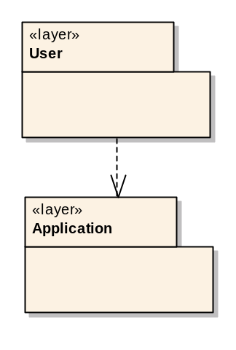
A default set of layers might be: user; application; data; middleware; code libraries.

Add package diagrams to each layer package, with the name of the layer, if they have not been created automatically. As new packages are added to the layer package, remember to update the layer package diagram.

Move the Logical Data Model package from the top of the design object model into the data layer and rename it ‘Entities’. For a large system, or one that will have more than one database, the entities package may be split into separate domains. Create a class diagram in each package with the name of the package and show the contents of the package plus any elements from outside the package to which the package elements link directly. For example:

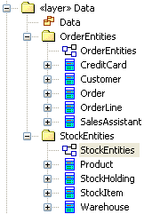

Index

Add Subsystem
Add a package in the appropriate layer for each new component that will be required for this iteration and give it the stereotype <<subsystem>>. This will normally include at least one subsystem in the user layer for each system actor user interface and one subsystem for the server side component to support it. Subsystems may be decomposed further for the purpose of factoring (re-using) common functionality. Ensure there are no spaces in any names.

If it does not exist, create a package diagram at the top of the design model called ‘package dependencies’. Add the new subsystems to this diagram. Also add them to the package diagram of the layer in which they have been created.

Move the actor interface and system interface classes in the design object model packages into their relevant subsystems. Add them to the diagram for the subsystem. Remove any spaces in the names.

For example:
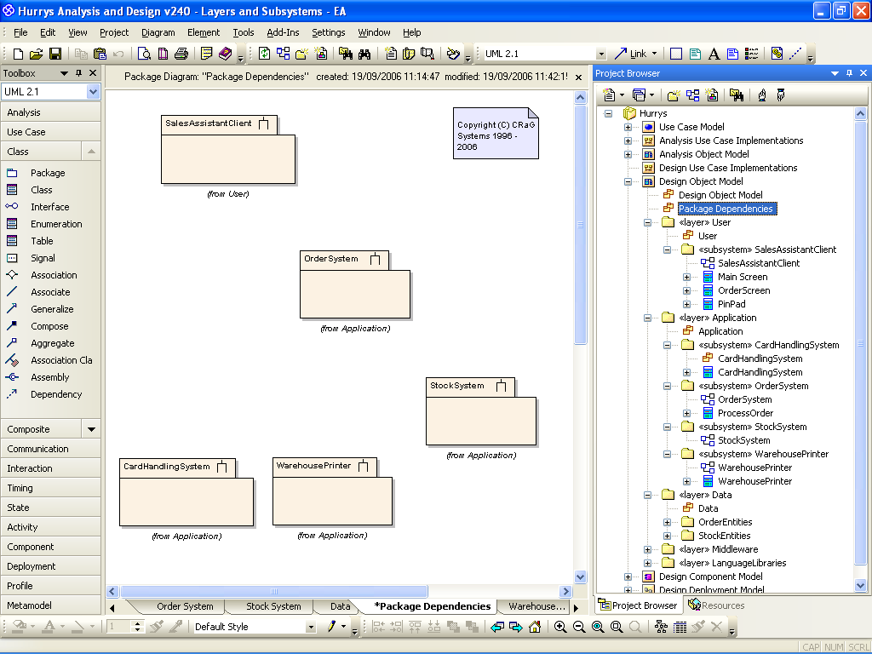

Index

Add Subsystem Interface
For each connection between subsystems, create an interface with the name ‘IClient_Server’ where Client and Server are the names of the participating subsystems on the package dependency diagram. Use the circle notation for the interface on the diagram.

Add a dependency from each subsystem to each interface that it will use and a realizes relationship form every subsystem to every interface that it will implement. Add the interfaces to all other diagrams on which the subsystems to which they are connected appear. Also add the interface to the main diagram of each subsystem that will realise it using the standard, rather than the circle, notation.

For example:

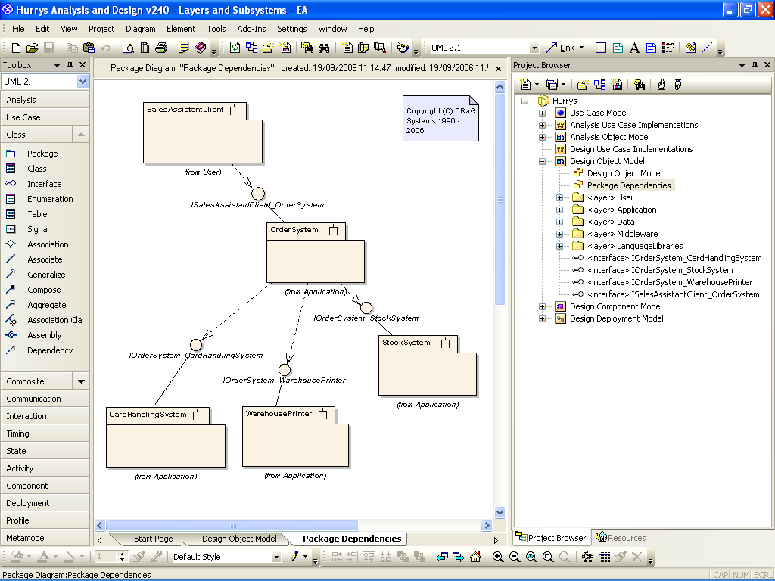

Note that the interfaces are created at the top of the design object model because they were created on the package dependency diagram. Eventually they will each be contained in their own package together with the ‘documentation’ that defines them. The important thing is to keep them outside of the subsystem packages so they can be change managed separately from the subsystems whose functionality they define and from the subsystems that will use them.

Index

Add Subsystem Facade
Create a singe concrete class with the same name as the subsystem to implement any new interfaces. Add the stereotype <<façade>>. Add a realizes relationship to each new subsystem interface to be implemented by that subsystem. Optionally, make the façade class a composite of any control classes from the system analysis. Move the operations that were created on the control class in the analysis onto the relevant subsystem interface. Depending on the tool, you may need to duplicate the operation signatures on the façade class in order, eventually, to generate the correct framecode.

For example:

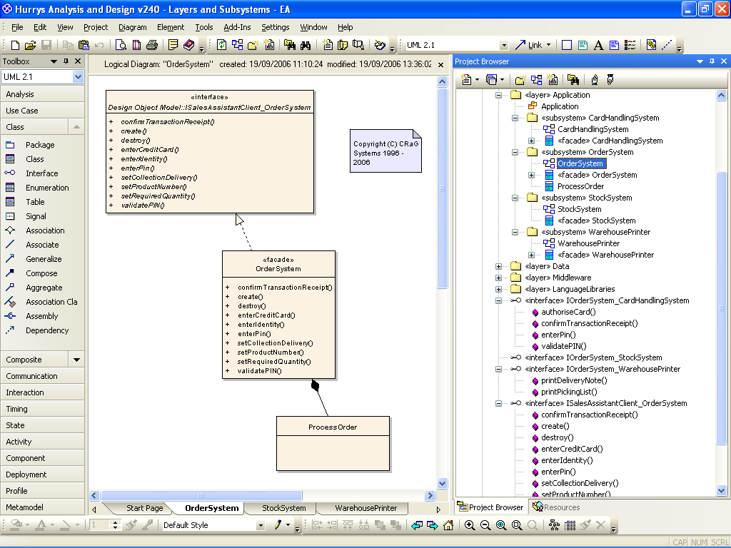

As more and more use cases are implemented, and the functionality of the subsystems reused, operations on interfaces that are common can be rationalised using generalisation between interfaces.

Index

Step Flow Activity Diagram
