A close up of a building

Description generated with high confidence

University of Petra

faculty of Information technology

selected topics

immortality

prepared by:

Hamzeh Mahmoud 201420334

Faisal Alsaadi 201411090

Sufian Hamdan 201320299

Amer atallah 210411144

Supervised by:

Dr.Shtaiwi

Date:

2017/2018

Second Semester

Contents

INTRODUCTION 3

PROJECT MILESTONES. 4

AVATAR **A.** 4

AVATAR **B.** 5

Creating the structural elements of the body. 6

Development of autonomous behavior. 6

Development of external control system via BCI. 6

AVATAR **C.** 7

AVATAR **D.** 7

# INTRODUCTION

Russian billionaire Dmitry Itskov seeks 'immortality' by uploading his brain to a computer.

Dmitry Itskov, who made his fortune in internet media, is the founder of the 2045 Initiative, an organization working with a network of scientists to develop 'cybernetic immortality' within the next few decades.

35-year-old Itskov acknowledges that without such technology, it's likely he could be dead by 2050. However, by perfecting the mapping of the human brain and transferring his consciousness into a computer, he could 'live' much longer - either in the computer, transplanted into a humanoid robot body, or as a hologram.

Itskov started his foundation in 2011, and is the subject of an upcoming BBC Horizon documentary, The Immoralist.

Speaking to the BBC, he said: "Within the next 30 years, I am going to make sure that we can all live forever. I'm 100 per cent confident it will happen. Otherwise I wouldn't have started it."

According to the 2045 Initiative's website, they see this reality beginning with the creation of 'avatars' by 2020 - robots which can be controlled by the mind and send feedback to the user's brain, through a brain-computer interface.

In the following five years, an avatar into which a human brain can be transplanted after death will be created. An avatar with an artificial brain which can host a human personality will be created by 2035, and a hologram-like avatar will follow by 2045 - heralding a new age for humanity.

It's certainly an ambitious goal, and there's debate in the scientific community over whether the intricacies of the human brain can even be replicated in a machine at all. What's more, many of the Initiative's ambitions rest on discoveries that humanity is not yet close to making.

However, he's already started planning for his digital immortality - he told Tristan Quinn that he sees himself having multiple bodies in different forms, living on Earth and in space while his consciousness moves between them.

# PROJECT MILESTONES.

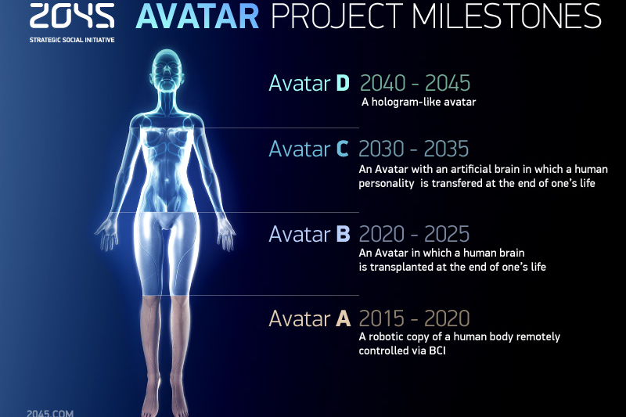

# AVATAR **A.**

A robotic copy of a human body remotely capable of interpreting commands directly from the mind, and sending information back to the mind in a form that can be interpreted via brain–computer interface. It is estimated to be popularized in or before 2020.

The first step toward achieving human immortality is to create a neurally controlled avatar—a humanoid robot with a human-like skeleton and a set of artificial muscles and sensors. It is expected that the avatar will be controlled by signals from the nervous system and the human brain that will be transmitted via various devices. It is also possible to effect direct control of artificial arms and legs using biosignals or to control avatar behavior using mental commands. Feedback providing notification of completed actions or behavior will be received through visual channels, i.e. through the vision of the person operating the avatar. Using such a control system, the avatar is not autonomous—the human operator will have complete control over its actions and behavior. Its internal control system will be severely limited in function, serving to produce and manage simple actions and skills that will be able to be controlled directly by the human operator

The emergence and widespread use of affordable android "avatars" controlled by a "brain-computer" interface. Coupled with related technologies “avatars’ will give people a number of new features: ability to work in dangerous environments, perform rescue operations, travel in extreme situations etc.

Avatar components will be used in medicine for the rehabilitation of fully or partially disabled patients giving them prosthetic limbs or recover lost senses.

# AVATAR **B.**

An avatar in which a human brain is transplanted at the end of one's life. Avatar B has an autonomous system providing life support for the brain and allowing it interaction with the environment, possibly mounted into an existing Avatar A Chassis. Deadline of this phase is year 2025.

The project consists of three main areas of research and development. Each includes the following projects:

1. Create structural elements of the body.

2. Develop autonomous behaviors for the body.

3. Develop a system of external control via neural interface.

## Creating the structural elements of the body.

Involves:

1. Creation of a body and its power components -- an arm, a hand, a bipod that includes the robot's legs, and a model head with facial features.
2. Creation of a sensory system (sensory organs): Sight, hearing, organs of chemoreception (smell and taste), artificial skin (capable of discerning texture and temperature). In the long term we expect to empower the robot with sensitivity to IR, UV, and magnetic fields, extending the sensory capabilities of a human operator.
3. Development of the robot’s power supply.

## Development of autonomous behavior.

Includes:

1. System of internal coordination: The system of maintaining equilibrium at rest and in motion, and a system to track objects in the external world.
2. Systems to harmonizing with the external environment: The system to mimic patterns and recognize of sensory images and the system to construct individual purposeful movements guided by and adapted to the synthesized model of the environment.
3. The system of purposeful autonomous behavior (including a system to simulate emotional behavior), implemented in a fully autonomous mode to meet general goals set by a human operator

## Development of external control system via BCI.

1. Control system via BCI, based on recognition of EEG indices that correspond to movements, detected from motor cortex.
2. Control system via BCI with biofeedback training.
3. System to provide the operator with sensory data from the robot.

Creation of an autonomous life-support system for the human brain linked to a robot, ‘avatar’, will save people whose body is completely worn out or irreversibly damaged. Any patient with an intact brain will be able to return to a fully functioning bodily life. Such technologies will greatly enlarge the possibility of hybrid bio-electronic devices, thus creating a new IT revolution and will make all kinds of superimpositions of electronic and biological systems possible.

# AVATAR **C.**

An avatar with an artificial brain to which a human personality is transferred for emulation at the end of one's life. The first successful attempt to upload one's personality to a computer is estimated to happen around 2035

Creation of a computer model of the brain and human consciousness with the subsequent development of means to transfer individual consciousness onto an artificial carrier. This development will profoundly change the world, it will not only give everyone the possibility of cybernetic immortality but will also create a friendly artificial intelligence, expand human capabilities and provide opportunities for ordinary people to restore or modify their own brain multiple times. The final result at this stage can be a real revolution in the understanding of human nature that will completely change the human and technical prospects for humanity.

# AVATAR **D.**

A hologram- or diagram-like avatar. This is the ultimate goal of this project but is optional since, assuming either the upload is involuntary or all humans chose to upload, biological diseases are prevented in the previous phase, and it is far away from current technological achievement and our understanding on physics.

2045 This is the time when substance-independent minds will receive new bodies with capacities far exceeding those of ordinary humans. A new era for humanity will arrive! Changes will occur in all spheres of human activity – energy generation, transportation, politics, medicine, psychology, sciences, and so on.

Today it is hard to imagine a future when bodies consisting of Nano robots will become affordable and capable of taking any form. It is also hard to imagine body holograms featuring controlled matter. One thing is clear however: humanity, for the first time in its history, will make a fully managed evolutionary transition and eventually become a new species. Moreover, prerequisites for a large-scale expansion into outer space will be created as well.

# CONSCLUSION**.**

Eventually dimotry said that we are not ready yet for the immortality, firstly we have to be ready mentally before we start to take actions toward it and it still an option for each one whether to take it or leave it.

Itskov is pouring his fortune into the initiative, but only time will tell whether he succeeds in his goals or not.