InsectExpress: multimodal cross-species prediction of tissue-resolved gene expression in insects
Abstract
Predicting tissue-resolved gene expression across insect species remains challenging because transcriptomic resources are limited and regulatory programs vary across taxa and tissues. Here we present InsectExpress, a compact multimodal deep-learning framework for cross-species prediction of gene expression across 14 standardized tissues in 12 insect species. InsectExpress integrates three complementary inputs for each gene: a 20 kb promoter-centered genomic sequence, RNA stability-associated features and ESM-2-derived protein embeddings. Under a stringent gene family cluster split, InsectExpress outperformed all evaluated baseline models, achieving an overall Pearson correlation of 0.702, compared with 0.578 for MLP and 0.566 for Vanilla Enformer. The performance advantage was retained across all species and remained evident across a broad range of expression abundances. Tissue-resolved analyses showed that the model captured informative expression structure across all 14 tissues, although predictive accuracy varied among tissues. Ablation experiments further demonstrated that promoter sequence, RNA stability features and protein-derived embeddings made distinct and complementary contributions to performance. At the gene level, moderately tissue-specific genes were more predictable than highly tissue-restricted genes, indicating that expression predictability depends on the structure of tissue specificity. Together, these results establish InsectExpress as an effective framework for multimodal, cross-species prediction of insect gene expression and provide a foundation for expression-informed target prioritization in non-model pest species.
Keywords: insect gene expression; tissue-resolved expression; cross-species prediction; multimodal deep learning; RNA stability; protein embeddings; RNAi target prioritization

Introduction
Understanding the regulatory code that governs gene expression remains a central challenge in genomics. The ability to predict mRNA abundance directly from DNA sequence would not only illuminate fundamental principles of transcriptional regulation but also enable functional annotation of genes in species lacking experimental expression data [1,2]. This capability is particularly critical for agricultural pest insects, where tissue-resolved expression profiles are critical for the rational prioritization of robust target genes in RNA interference (RNAi)-based pest management [3-8].

Recent advances in deep learning have demonstrated remarkable success in sequence-to-expression prediction [9], with architectures like Xpresso and Enformer establishing that promoter sequences and long-range chromatin interactions can explain substantial variation in mRNA abundance [10]. However, a critical limitation persists: the lack of cross-taxonomic validation severely restricts the applicability of these models to non-mammalian systems: existing sequence-to-expression models are trained almost exclusively on mammalian genomes, leaving their applicability to other taxonomic groups entirely unexplored.

Insects represent an ideal system for extending sequence-based expression prediction beyond mammals, given their immense species diversity and agricultural significance [11]. Yet, cross-species prediction in insects presents unique computational and biological challenges absent in mammalian studies. Insect orders diverged 150-300 million years ago, accumulating substantial cis-regulatory divergence [12,13] and distinct regulatory architectures [14]. Furthermore, insect transcriptomic datasets are characterized by extreme heterogeneity: expression data availability varies dramatically from comprehensive multi-tissue atlases in model organisms [15-17] to sparse, single-condition RNA-seq with incomplete untranslated region annotations in pest species. For application-oriented RNAi target ranking, preserving biologically meaningful quantitative abundance information is essential. Naive label transformations or imputations can distort tissue-specific learning and compromise prediction accuracy.

To overcome the limitations of relying on discrete species identifiers or phylogenetic embeddings that cannot generalize to unseen species [18], the emergence of protein language models (pLMs) offers a promising alternative. Models like ESM-2 encode evolutionary and functional information that transfers across species boundaries [19,20], allowing continuous species representations that leverage functional similarity rather than taxonomic identity.

Here, we present a unified cross-species, multi-tissue deep learning framework for gene expression prediction in insects, designed to bridge foundational regulatory genomics and practical RNAi target discovery. Our approach integrates several key methodological innovations that address the unique challenges of cross-species expression prediction:(1) a dual-tower architecture combining promoter sequence features with RNA stability determinants; (2) ESM-2 protein embeddings serving as gene-level species representations; (3) multi-task learning across 14 anatomically standardized tissues, utilizing a masked loss to explicitly handle unobserved tissues as missing labels rather than synthetic measurements ; and (4) modeling log-transformed expression values to preserve absolute abundance information critical for downstream candidate ranking.
By demonstrating robust cross-species generalization under stringent validation settings , this framework establishes that transfer learning for gene expression prediction is achievable through the integration of sequence models with protein language representations. This positions sequence-based expression modeling not merely as a benchmark machine-learning task, but as a scalable, biologically informed route to accelerate functional genomics and RNAi target discovery in non-model agricultural pests.

Materials and Methods
Species selection and multi-tissue expression data
We assembled a cross-species gene expression compendium spanning 12 insect species from six taxonomic orders (Figure 1): Tribolium castaneum, Drosophila melanogaster, Bombyx mori(Coleoptera, Diptera, Lepidoptera-three model organisms with comprehensive functional annotations [16,17]), Plutella xylostella, Helicoverpa armigera, Chilo suppressalis (Lepidoptera), Acyrthosiphon pisum, Nilaparvata lugens(Hemiptera), Locusta migratoria(Orthoptera), Frankliniella occidentalis(Thysanoptera), Anoplophora glabripennis, and Leptinotarsa decemlineata(Coleoptera). This selection encompasses divergence times spanning approximately 150–380 million years, representing major evolutionary transitions across insect orders [11,12,13], providing a stringent test of cross-species generalization.

Expression data were compiled from species-specific databases and public repositories. For the three model organisms, tissue-resolved expression profiles were obtained from established community databases: D. melanogaster RNA-seq expression values from the FlyBase gene expression matrix (release FB2024_05) [41]; T. castaneum tissue-specific FPKM values from BeetleAtlas (https://motif.mvls.gla.ac.uk/BeetleAtlas/) [42]; and B. mori multi-tissue developmental expression data from SilkDB 3.0 [43]. For the remaining species, RNA-seq datasets were retrieved from the NCBI Gene Expression Omnibus (GEO) [44] and Sequence Read Archive (SRA): L. migratoria (GSE123150, brain transcriptome; GSE78902, gut transcriptome), N. lugens (GSE113553, tissue-specific transcriptome), A. pisum (GSE42585, developmental and tissue expression), P. xylostella (GSE150559, tissue-specific transcriptome), and H. armigera (GSE190405, larval midgut; GSE86914, multi-tissue transcriptome). For C. suppressalis, F. occidentalis, A. glabripennis, and L. decemlineata, tissue-specific RNA-seq datasets were compiled from individual SRA studies (Supplementary Table S1).

Reference genome assemblies and gene structure annotations were obtained from NCBI RefSeq/GenBank [45]: T. castaneum (GCF_000002335.3), N. lugens (GCF_014356525.1), A. pisum (GCF_005508785.2), P. xylostella (GCF_932276165.1), H. armigera (GCF_030705265.1), and L. decemlineata (GCF_000500325.1); D. melanogaster Release 6 from FlyBase [41]; B. mori from SilkDB 3.0 [43]; L. migratoria (GCA_000516895.1) with gene models from the i5k Workspace [46]. Accessions for all 12 species are listed in Supplementary Table S1. For species where raw RNA-seq reads were obtained, quality filtering was performed with fastp [47], reads were aligned to reference genomes using HISAT2 [48], and gene-level expression was quantified with StringTie [49]. All expression values were uniformly converted to transcripts per million (TPM).

The complete data processing pipeline from raw inputs to training-ready samples comprised five stages (Figure 1). (1) Expression matrix construction: For each species, individual RNA-seq samples (identified by SRA run accessions) were mapped to one of 14 standardized tissue categories using manually curated sample-to-tissue annotation tables (Supplementary Table S2). When multiple biological replicates were available for the same tissue, per-gene TPM values were averaged across replicates, and the result was transformed as log₂(TPM + 1). Tissues with fewer than 100 expressed genes (TPM > 0) were excluded. Tissues lacking any RNA-seq data were assigned NaN values (not zero) to be handled by the masked loss during training. (2) TSS identification: Transcription start sites were determined from gene structure annotations (GFF/GTF files). Where 5′UTR annotations were available, the mRNA 5′ terminus was used as the TSS; otherwise, the annotated gene start coordinate was adopted with an enlarged stochastic jitter range (±200–500 bp depending on annotation quality) during training to improve robustness to TSS mis-annotation. (3) Genomic sequence extraction. For each gene, a 20 kb window centered on its TSS (15 kb upstream, 5 kb downstream) was extracted from the reference genome and one-hot encoded. (4) RNA stability feature computation. A 16-dimensional feature vector capturing post-transcriptional regulatory determinants was computed from gene structure annotations. (5) Protein embedding generation. Protein sequences were processed through ESM-2 to obtain 320-dimensional embeddings. Cross-species ortholog pairs were identified via reciprocal best hits on ESM-2 embedding cosine similarity, yielding pairwise ortholog maps for the ortholog consistency loss.

RNA-seq expression values were standardized across species into a unified panel of 14 anatomically defined tissues: nine adult tissues (Brain, Head, Midgut, Hindgut, Fat Body, Malpighian Tubule, Carcass, Ovary, Testis) and five larval tissues (Hindgut, Fat Body, Malpighian Tubule, Midgut, Carcass). These tissues were selected based on their established relevance to insect physiology and RNAi-based pest management. The midgut epithelium is the primary interface for orally delivered double-stranded RNA (dsRNA) and harbors well-validated RNAi targets including digestive enzymes, peritrophic matrix proteins, and Bt toxin receptors [50,51]. The fat body—the insect functional analog of the vertebrate liver—orchestrates intermediary metabolism, immune responses, and vitellogenin production; silencing fat body–expressed genes frequently produces lethal or sublethal phenotypes in pest species [52]. Malpighian tubules mediate osmoregulation and xenobiotic detoxification, and tubule-specific genes have been implicated in insecticide resistance mechanisms [53]. The brain and head encompass neuropeptide-producing neurons and chemosensory structures governing feeding behavior and host recognition, representing targets for behavioral disruption [54]. Carcass tissue captures cuticle and epidermal genes, including chitin synthases and cuticular proteins whose RNAi-mediated knockdown causes lethal molting defects [55]. Reproductive tissues (ovary, testis) enable identification of fertility-related targets for population suppression strategies [56]. Larval-stage tissues were included because larvae constitute the primary damaging life stage for most agricultural pests and represent the predominant targets of RNAi-based biopesticide applications [57].
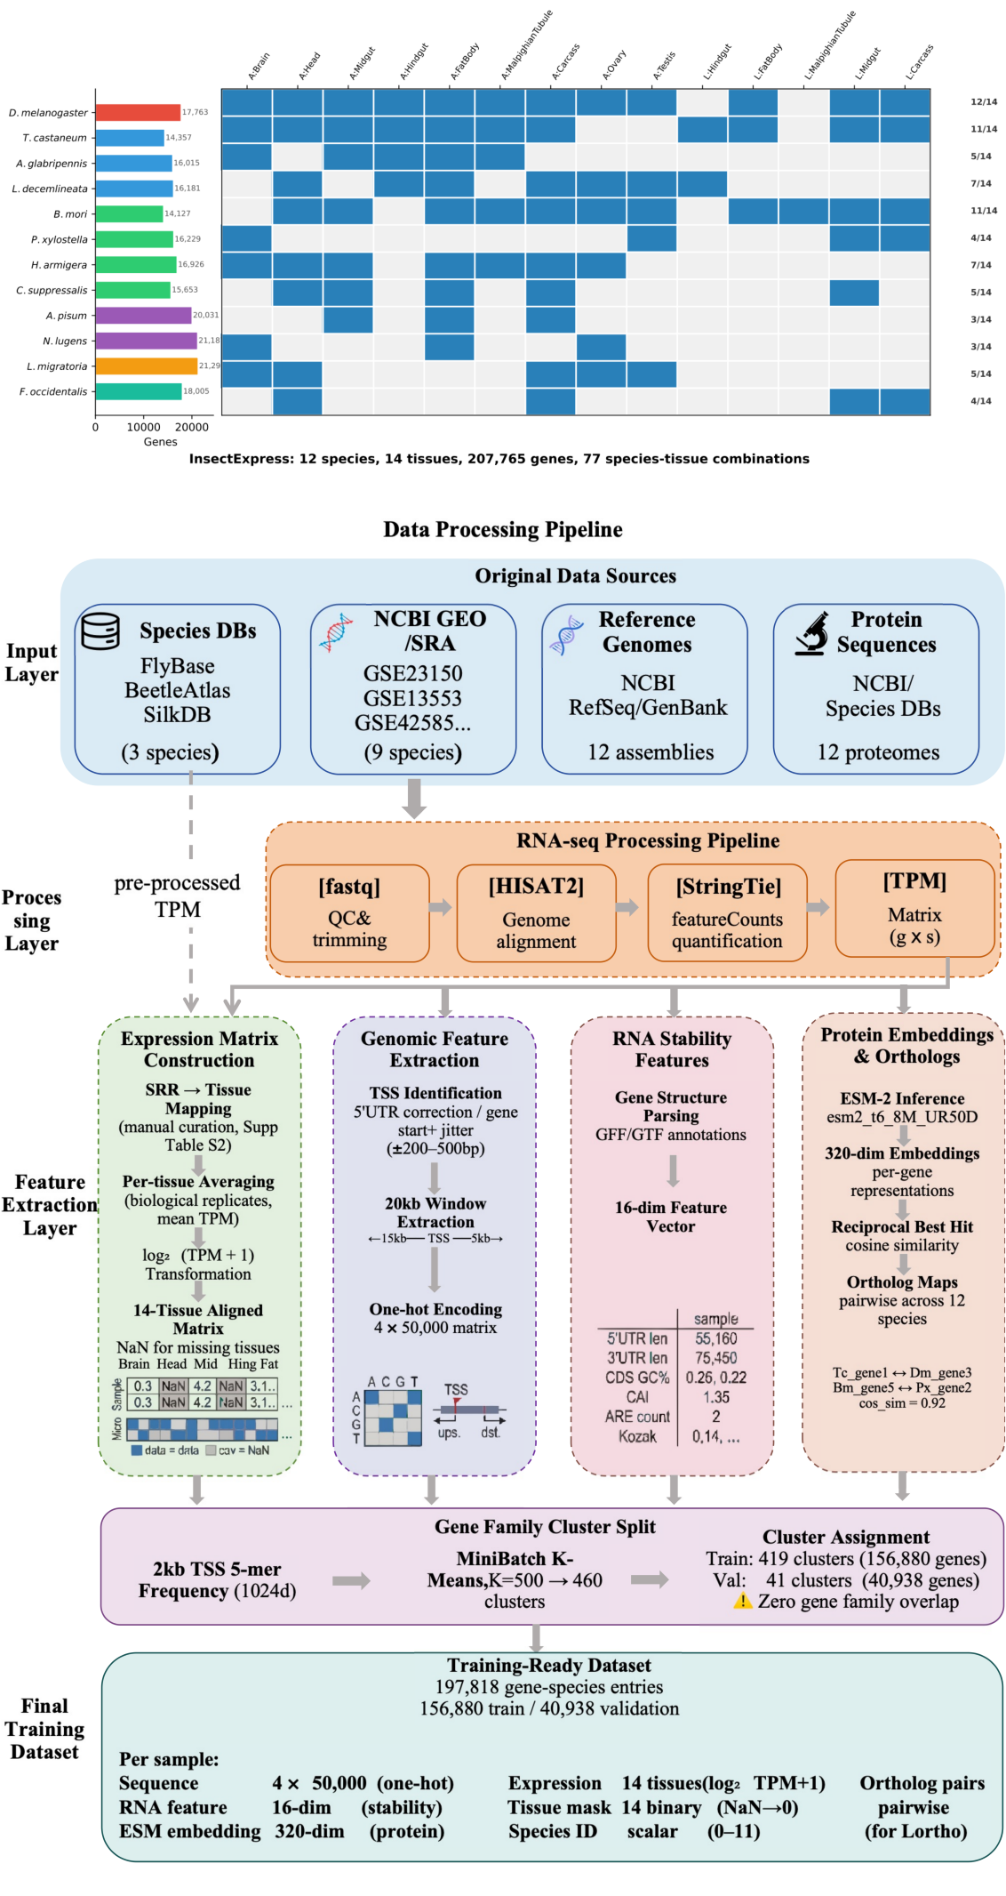
Figure 1. Overview of the InsectExpress multi-species gene expression dataset and data processing pipeline. (A) Species–tissue expression coverage matrix for the 12 insect species spanning six taxonomic orders. Horizontal bars indicate the number of protein-coding genes per species; colored cells denote available tissue expression data (77 species–tissue combinations in total); gray cells indicate missing tissues assigned as NaN during training. Tissue counts per species are annotated at right (e.g., 12/14). (B) End-to-end data processing pipeline from heterogeneous raw inputs to training-ready samples. Input data were collected from three categories of sources: species-specific databases (FlyBase, BeetleAtlas, SilkDB) for model organisms, NCBI GEO/SRA for nine pest species, and NCBI RefSeq/GenBank for reference genome assemblies and proteomes. For species with raw RNA-seq data, reads were quality-filtered with fastp, aligned with HISAT2, and quantified with StringTie to obtain gene-level TPM matrices. Four parallel feature extraction branches produced: (i) a 14-tissue aligned expression matrix via manual SRR-to-tissue curation (Supplementary Table S2) with per-tissue replicate averaging and log2(TPM + 1) transformation; (ii) one-hot encoded genomic sequences from 20 kb TSS-centered windows; (iii) 16-dimensional RNA stability feature vectors parsed from gene structure annotations; and (iv) 320-dimensional ESM-2 protein embeddings with reciprocal best-hit ortholog maps. A gene family cluster-based split using 5-mer frequency MiniBatch K-Means clustering (K = 500, yielding approximately 460 non-empty clusters) partitioned 197,818 gene-species entries into 156,880 training samples (419 clusters) and 40,938 validation samples (41 clusters) with zero gene-family overlap between splits.

Genomic sequence representation
For each gene, a 20 kb genomic window centered on the transcription start site (TSS) was extracted (15 kb upstream, 5 kb downstream), substantially exceeding the ~2 kb promoter-proximal windows used by prior sequence-to-expression models [1,10]. This extended context captures distal cis-regulatory elements including enhancers, silencers, and insulator boundaries, which frequently reside within 10–20 kb of their target promoters in insect genomes [22]. Sequences were one-hot encoded into a 4 × 20,000 matrix (channels: A, C, G, T). During training, stochastic reverse-complement augmentation was applied with probability 0.5 to enforce strand-invariant feature learning [23].

RNA stability feature engineering
A 16-dimensional feature vector encoding mRNA stability and translational efficiency determinants was computed for each gene from its structural annotation: (i) 5′UTR and 3′UTR lengths; (ii) CDS length and GC content; (iii) intron count and total intronic length; (iv) exon count; (v) codon adaptation index (CAI); (vi) AU-rich element (ARE) count in the 3′UTR; (vii) Kozak sequence strength; (viii) third-position GC content (GC3); (ix) rare codon fraction; (x) 5′UTR and 3′UTR GC content; and (xi) total gene and mRNA lengths. Length-based features were log₂(x + 1)-transformed and scaled to unit order to prevent magnitude-driven dominance. These features capture post-transcriptional regulatory signals orthogonal to cis-regulatory sequence motifs, forming the second tower of our dual-tower architecture.

Protein language model embeddings
To obtain continuous, gene-level species representations that transfer across taxonomic boundaries, we generated ESM-2 protein embeddings for each protein-coding gene. Protein sequences were processed using the esm2_t6_8M_UR50D model (6 Transformer layers, 8 million parameters) [19], yielding 320-dimensional per-protein mean-pooled representations. Unlike discrete species identifiers or phylogenetic distance matrices, ESM-2 embeddings encode evolutionary and functional information at the individual gene level, naturally clustering orthologous proteins across species while distinguishing paralogous copies [24]. For genes lacking annotated protein products, a learnable species embedding (64-dimensional) served as a fallback, selected via a per-sample gating mechanism to avoid systematic bias from zero-valued placeholder vectors.

Model architecture
To effectively integrate heterogeneous input modalities, we designed InsectExpress, a three-tower encoder–fusion architecture with approximately 5.2 million trainable parameters (Figure 2). The model accepts three inputs per gene: (i) a 4 × 20,000 one-hot encoded genomic sequence centered on the TSS, (ii) a 16-dimensional RNA stability feature vector, and (iii) a 320-dimensional ESM-2 protein embedding. These heterogeneous inputs are processed by dedicated encoding towers and fused for multi-tissue expression prediction.

Sequence tower: convolutional stem with hierarchical downsampling. The one-hot sequence is processed by a seven-stage convolutional stem achieving 64× spatial compression (20,000 → 312 positions at 64 bp resolution), inspired by the 128× downsampling strategy of Enformer [10]. Stage 1 applies multi-scale parallel convolutions with kernel sizes of 7, 11, 15, and 21 bp, each contributing 32 channels (128 total), capturing regulatory motifs at multiple characteristic lengths (transcription factor binding sites of ~6–20 bp) [25], followed by 2× max-pooling. Stage 2 performs a transitional convolution (kernel size 7, 128 channels) with 2× pooling. Stage 3 consists of five dilated residual blocks (dilation rates 1, 2, 4, 8, 16) at 128 channels, each containing two convolutional layers (kernel size 3) with a skip connection; their exponentially growing receptive field (~500 bp aggregate) captures higher-order motif syntax without additional downsampling [26]. Stages 4–6 each apply a convolution (kernel size 5) followed by 2× max-pooling, with Stage 4 expanding channel dimensionality from 128 to 256. Stage 7 applies a final 2× max-pooling without convolution. All convolutional layers employ batch normalization [27], GELU activation [28], and dropout (p = 0.2).

Sequence tower: Transformer encoder. The compressed 312-position feature map is augmented with learnable positional embeddings and processed by four pre-norm Transformer encoder layers [29], each with 8 attention heads, a model dimension of 256, and a feed-forward expansion factor of 4 (intermediate dimension 1,024). The pre-norm design (LayerNorm applied before attention and FFN, respectively) improves gradient flow and training stability for deep models. Multi-head self-attention enables the model to learn long-range dependencies between distal regulatory elements and promoter-proximal sequences spanning up to ~20 kb. The encoded sequence is reduced to a single 256-dimensional vector via global average pooling.

RNA stability tower. The 16-dimensional feature vector is encoded via a two-layer MLP (16 → 128 → 64) with layer normalization and GELU activation at each layer.

Protein embedding tower with adaptive gating. The 320-dimensional ESM-2 embedding is encoded via a two-layer MLP (320 → 128 → 64) with layer normalization and GELU activation. In parallel, a learnable species embedding table (12 species × 64 dimensions) provides a fallback representation. For genes with available ESM-2 embeddings, a per-sample binary gate selects the ESM-derived representation; for genes lacking annotated protein products (where the ESM-2 embedding is absent), the gate switches to the species embedding. This gating mechanism avoids the systematic bias that would arise from substituting zero-valued placeholder vectors for missing protein information.
Feature fusion and multi-tissue prediction. The three tower outputs—sequence representation (256-d), RNA stability encoding (64-d), and protein/species encoding (64-d)—are concatenated into a 384-dimensional vector and passed through a two-layer fusion network (384 → 512 → 256) with layer normalization [30], GELU activation, and dropout (p = 0.2). A linear output head projects the fused representation to 14 tissue expression values. A learnable species–tissue bias term (12 × 14, initialized to zero) is added to the output, allowing the model to capture species-specific baseline expression offsets for each tissue at minimal parameter cost (168 additional parameters).
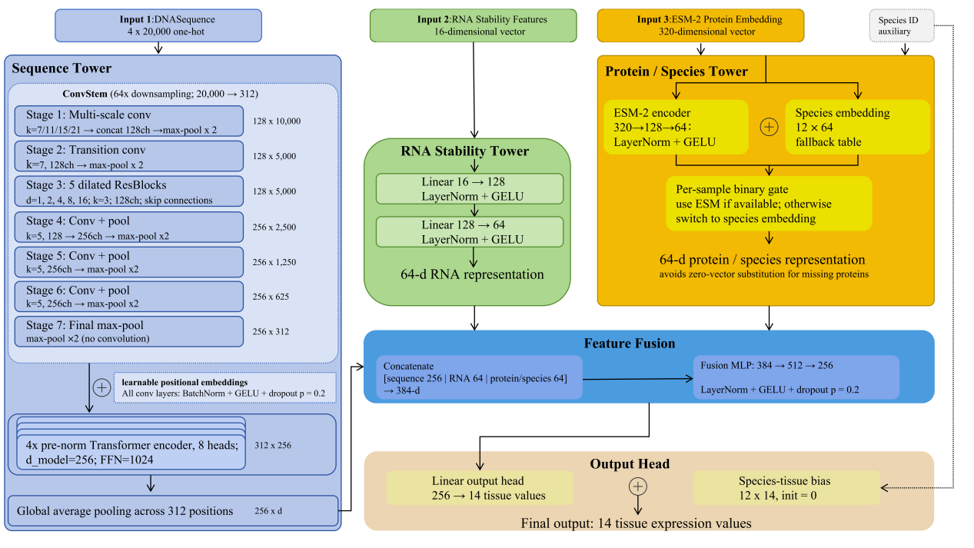
Figure 2. Schematic overview of the InsectExpress architecture. InsectExpress employs a three-tower encoder-fusion framework to predict gene expression across 14 tissues from genomic sequence, RNA stability features, and protein-level representations. A convolutional stem and Transformer encoder extract long-range cis-regulatory information from a 20-kb sequence centered on the transcription start site, whereas two multilayer perceptron branches encode RNA stability features and ESM-2 protein embeddings. For genes lacking protein embeddings, a species embedding is used as a fallback through a binary gating mechanism. The resulting sequence, RNA, and protein/species representations are fused and projected to multi-tissue expression outputs with an additional species-tissue bias term.

Loss function
Training employed a composite loss function designed for the heterogeneous, zero-inflated structure of multi-species expression data:
$$ℒ=ℒ_{MSE}+λ_{corr}⋅ℒ_{corr}+λ_{ortho}⋅ℒ_{ortho}$$
Masked weighted MSE loss: The primary reconstruction term is a tissue-weighted, mask-aware mean squared error: L_MSE = [sum_{i,t} m_it w_t s_i z_it (yhat_it - y_it)^2] / [sum_{i,t} m_it w_t s_i z_it].
Here, yhat_it and y_it denote the predicted and observed log2(TPM + 1) values for sample i in tissue t.
$$ℒ_{MSE}=\frac{\sum_{i,t}{w_{t}}⋅m_{i,t}⋅z_{i,t}⋅s_{i}⋅({\hat{y}}_{i,t}−y_{i,t})^{2}}{\sum_{i,t}{w_{t}}⋅m_{i,t}⋅z_{i,t}⋅s_{i}}$$
Here, m_it is the tissue observation mask (1 for observed tissues and 0 for unobserved tissues), w_t is the tissue importance weight (with adult midgut and larval midgut upweighted to emphasize application-relevant tissues), s_i is the species-level loss weight, and z_it is a zero-expression adjustment factor.
Specifically, z_it = lambda_zero for zero-expression targets (y_it = 0) and z_it = 1 otherwise, with lambda_zero = 0.3, thereby downweighting the disproportionate influence of constitutively silent genes that dominate expression matrices [31].

Pearson correlation loss: To encourage preservation of expression rank order across tissues, we include a differentiable Pearson penalty, L_corr = 1 - corr(yhat_obs, y_obs), computed over all observed (masked-in) tissue-sample pairs. This term complements MSE by explicitly optimizing correlation structure, which is robust to systematic bias in absolute predictions [32].
$${\text{L}}_{\text{corr}}\text{=1-}\text{r}\text{(}{\hat{\text{y}}}_{\text{masked}}\text{,}{\text{y}}_{\text{masked}}\text{)}$$

Ortholog consistency regularization: To encourage conserved internal representations across species, we impose a regularization loss on orthologous gene pairs identified from pre-computed pairwise ortholog mappings: L_ortho = (1 / |P|) sum_{(g_a,g_b) in P} ||h_a - h_b||_2^2, where h_a and h_b are the fused representations of orthologous genes g_a and g_b, respectively.
$${\text{L}}_{\text{ort}\text{h}\text{o}}\text{=1-}\frac{{\text{h}}_{\text{a}}\text{⋅}{\text{h}}_{\text{b}}}{\text{‖}{\text{h}}_{\text{a}}\text{‖‖}{\text{h}}_{\text{b}}\text{‖}}$$
This term is averaged over all ortholog pairs co-occurring within a mini-batch and encourages the model to learn species-invariant functional representations, analogous to cross-domain representation alignment in transfer learning [33].

Training procedure
Models were trained using the AdamW optimizer [34] (learning rate = 1.5 × 10^-4, weight decay = 0.02). A warmup-cosine annealing schedule linearly increased the learning rate over the first 15 epochs, followed by cosine decay to 1 × 10^-7 [35]. Gradient norms were clipped at 1.0 to prevent training instabilities in the Transformer layers. The batch size was 8, and training proceeded for up to 150 epochs with early stopping (patience = 30 epochs, minimum improvement = 5 × 10^-4 in validation Pearson correlation).

Mixup data augmentation [36] was applied within species (α = 0.2): for each mini-batch, pairs of samples from the same species were linearly interpolated across their sequence encodings, RNA features, expression targets, and ESM embeddings, with interpolation coefficients drawn from Beta(0.2, 0.2). This intra-species constraint prevents the generation of biologically implausible chimeric expression profiles from cross-species interpolation.

All experiments were conducted on NVIDIA A40 GPUs (48 GB). The complete model (5,193,910 parameters) required approximately 62 minutes per epoch and converged within 60–90 epochs.

Gene family–aware data splitting
A major concern in cross-species expression prediction is data leakage through paralogous and orthologous gene families: if members of the same gene family appear in both training and validation sets, performance estimates are inflated by sequence similarity rather than genuine regulatory logic learning [37]. To address this, we implemented a gene family cluster–based splitting strategy.

For each gene, we extracted the 2 kb region centered on its TSS and computed a 1,024-dimensional 5-mer frequency vector. MiniBatch K-Means clustering [38] (K = 500, batch size = 1,000, 3 random initializations) was applied to the 197,818 frequency vectors, yielding 460 non-empty clusters. Genes within the same cluster—enriched for members of the same gene family by virtue of shared k-mer composition—were assigned exclusively to either the training or validation set. Cluster-level assignment was performed by sequentially filling the validation set (target ratio: 15%) until the target size was reached, ensuring zero gene family overlap between splits. This yielded 156,880 training samples (419 clusters) and 40,938 validation samples (41 clusters) with strictly disjoint gene family membership.

Baseline models
To contextualize InsectExpress performance, we compared against seven baseline approaches spanning three methodological tiers.

Machine learning baselines. Four models were trained on a concatenation of RNA stability features (16-d) and ESM-2 protein embeddings (320-d), totaling 336 input features per gene: (i) ElasticNet regression (α = 0.1, L1 ratio = 0.5); (ii) Random Forest (500 trees, max depth = 20); (iii) XGBoost [39] (500 boosting rounds, max depth = 8, learning rate = 0.05); and (iv) a three-layer MLP (336 → 512 → 256 → 14, with batch normalization, ReLU, and dropout = 0.3). An additional MLP variant using only RNA features (16 → 128 → 64 → 14) served as an ablation to quantify the contribution of ESM-2 embeddings.

Deep learning baselines. Two sequence-based architectures were trained on identical data splits with matched hyperparameters: (v) Xpresso [1], a CNN-based model using promoter sequence and mRNA half-life features. Our reimplementation adapted the original architecture to accept 50 kb inputs and predict 14 tissues simultaneously, with species-specific bias terms. (vi) Vanilla Enformer, a simplified Enformer-like architecture with the same 64× convolutional downsampling stem as InsectExpress but without the RNA stability tower, ESM-2 embeddings, correlation loss, or ortholog regularization—using only DNA sequence input with standard MSE loss. This baseline isolates the contribution of InsectExpress's multi-modal integration and loss formulation.

Evaluation metrics
Model performance was evaluated using four complementary metrics. Pearson correlation coefficient measures the linear association between predicted and observed log2(TPM + 1) values, serving as the primary metric for model comparison and early stopping. Spearman rank correlation (rho) assesses monotonic agreement and is robust to nonlinear distortions. Root mean squared error (RMSE) quantifies absolute prediction accuracy in the log2(TPM + 1) scale. Precision@k (k = 50) measures the fraction of true top-50 highly expressed genes recovered among the predicted top-50, directly relevant to RNAi target prioritization where recovering highly expressed candidates is paramount. Additionally, NDCG@50 (Normalized Discounted Cumulative Gain) evaluates the quality of the predicted ranking for the top-50 genes, weighting hits by their position in the ranking [40].

All metrics were computed per species and per tissue, then aggregated as unweighted means to prevent species with larger gene sets from dominating overall performance. Evaluation was performed on the held-out validation set under the gene family cluster–based split described in Gene family–aware data splitting.
Statistical analysis
Pearson and Spearman correlations were computed on masked observed values only. For per-species and per-tissue summaries, metrics were first calculated within each unit and then aggregated as unweighted means to avoid dominance by species with larger gene sets. For repeated-seed stability analyses, mean ± standard deviation and 95% bootstrap confidence intervals were computed across seeds, and paired model comparisons were assessed using Wilcoxon signed-rank tests when matched repeated measurements were available.

Results
InsectExpress achieves superior performance across global, cross-species, and tissue-resolved evaluations
As shown in Fig. 3A, InsectExpress achieved the highest overall performance among all tested models under the gene family cluster split, reaching a Pearson correlation of 0.702—substantially exceeding the strongest baselines, including MLP (0.578), XGBoost (0.575), and Vanilla Enformer (0.566), as well as simpler approaches such as ElasticNet, MLP-RNA, and Xpresso. These results demonstrate that the proposed three-tower architecture, which jointly integrates promoter sequence, RNA stability features, and protein-derived representations, provides a clear advantage over both shallow feature-based and sequence-only modeling strategies.

This advantage was consistent across multiple complementary metrics. As shown in Fig. 3C, InsectExpress ranked first in Pearson correlation, Spearman correlation, coefficient of determination (R²), RMSE, and MAE. Simultaneous improvement across both correlation- and error-based criteria indicates a broad enhancement in predictive fidelity, rather than narrow optimization toward a single objective.

We further examined whether performance gains were maintained across expression-abundance regimes. As shown in Fig. 3D, prediction error increased with expression level for all models, as expected given the broader dynamic range and lower representation of highly expressed genes. Nevertheless, InsectExpress retained the most favorable error profile across nearly the entire abundance range, with clear separation from baselines at medium-to-high expression levels. This indicates that its predictive advantage extends beyond the most common low-expression regime.

To assess whether the overall improvement was broadly shared across taxa, we compared species-level performance against MLP, the strongest baseline identified in the global benchmark. As shown in Fig. 3B, InsectExpress improved Pearson correlation in every evaluated species, with no taxon showing a reduction. Although the magnitude of improvement varied, this systematic pattern supports the view that the model captures regulatory signals transferable across phylogenetically diverse insects.

A more detailed species-wise comparison reinforced this conclusion. As shown in Fig. 3E, InsectExpress consistently ranked at or near the top across all 12 species, despite substantial differences in genome quality, annotation completeness, and tissue coverage. The cross-species heatmap in Fig. 3F further confirmed uniformly positive gains over competing models across the species panel. These results demonstrate that the model retains robust predictive power within individual species—a property particularly important for non-model pest insects with limited transcriptomic resources.

Because the target task is inherently tissue-resolved, we next examined performance at the joint species-by-tissue level. As shown in Fig. 3G, prediction accuracy varied considerably across tissue–species combinations, yet informative signal was retained across a wide range of contexts. Tissues such as larval carcass, larval midgut, adult ovary, and adult midgut showed relatively strong performance in multiple species, whereas others displayed greater variability. This heterogeneity is biologically plausible and likely reflects differences in tissue-specific regulatory complexity and data quality.

Pooling performance across species (Fig. 3H), larval carcass exhibited the highest Pearson correlation, followed by larval midgut, adult midgut, and adult ovary, while tissues such as larval Malpighian tubule and adult testis ranked lower. These differences suggest that some tissues harbor more stable and predictable expression programs, potentially reflecting variation in regulatory conservation, annotation consistency, or transcriptomic depth.

Finally, we assessed whether tissue-level prediction difficulty was associated with expression coverage. As shown in Fig. 3I, tissues with a higher non-zero expression fraction generally exhibited better pooled Pearson correlation, but this relationship was not strictly linear, with several tissues deviating from the trend. This suggests that expression coverage is an important but not exclusive determinant of tissue-level difficulty, and that additional biological and technical factors also shape model performance.
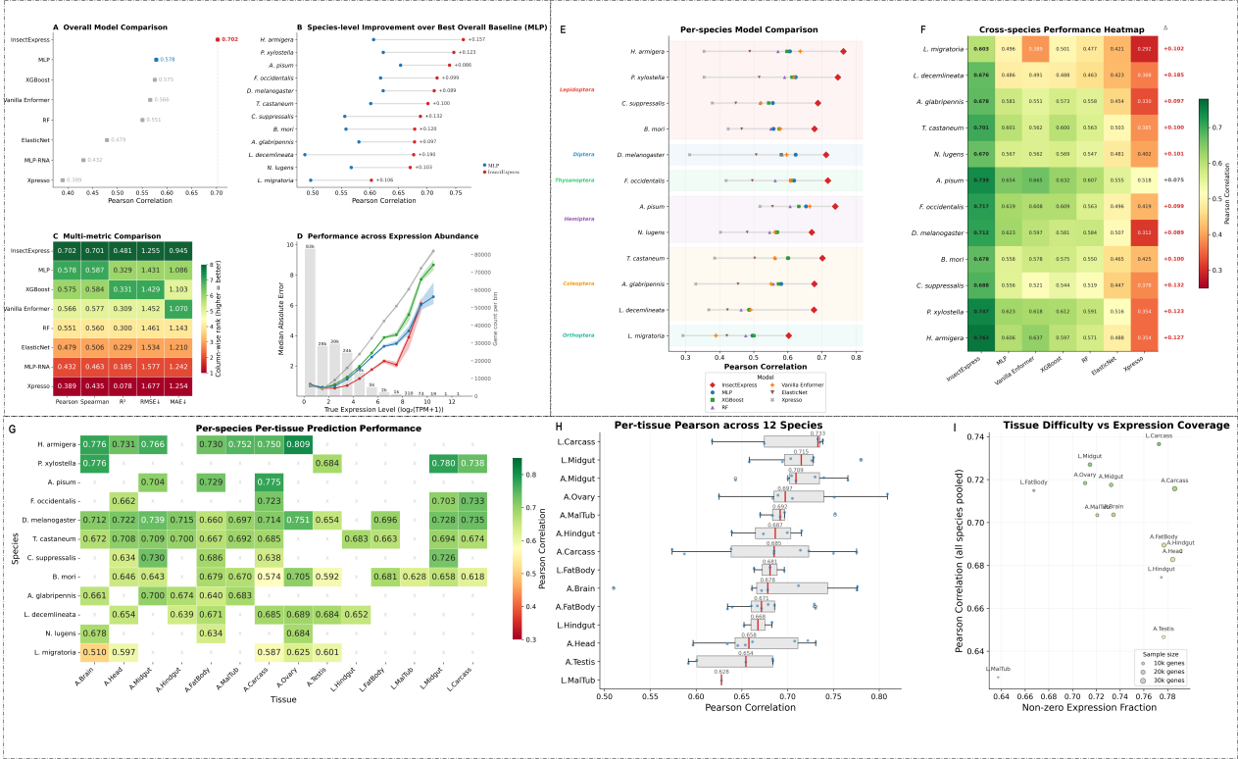
Figure 3. Comprehensive evaluation of InsectExpress across global, cross-species, and tissue-resolved prediction settings. Region 1 summarizes global benchmark performance. As shown in A, InsectExpress achieves the highest overall Pearson correlation among all tested models. B shows the species-level improvement of InsectExpress over the best overall baseline (MLP), demonstrating uniformly positive gains across the species panel. C compares multiple evaluation metrics, including Pearson, Spearman, R², RMSE, and MAE, and shows that the advantage of InsectExpress is consistent across complementary criteria. D evaluates prediction error across expression-abundance bins, indicating that the model remains robust across a broad dynamic range of transcript expression.Region 2 summarizes cross-species generalization. E presents per-species model comparisons across the 12 insect species, showing that InsectExpress consistently ranks at or near the top within individual taxa. F shows a cross-species performance heatmap, further illustrating the stable advantage of InsectExpress over competing methods.Region 3 summarizes tissue-resolved predictive performance. G presents a per-species per-tissue heatmap of Pearson correlation, showing heterogeneous but informative prediction across tissue-species combinations. H summarizes pooled per-tissue Pearson correlation across all 12 species, revealing that some tissues are consistently easier to predict than others. I shows the relationship between tissue-level predictive performance and non-zero expression coverage, indicating that tissues with broader measurable expression tend to be more predictable, although coverage alone does not fully explain tissue difficulty.

Predicted and observed expression values show strong concordance across all 14 tissues
To evaluate whether the model captured within-tissue expression structure beyond favorable pooled statistics, we compared predicted and observed expression values separately for each tissue. As shown in Fig. 4, all 14 tissues exhibited clear positive associations, although concordance strength varied. The highest correlations were observed for larval carcass (r = 0.737), larval midgut (r = 0.727), adult ovary (r = 0.718), adult midgut (r = 0.717), adult carcass (r = 0.716), and larval fat body (r = 0.715), whereas adult testis (r = 0.647) and larval Malpighian tubule (r = 0.628) showed lower but still substantial correlations, representing comparatively more difficult predictive contexts.
Beyond correlation coefficients, the scatter plots revealed that the model successfully recovered the overall gene expression ordering across a broad abundance range in all tissues. Fitted trends consistently followed the positive direction of the identity relationship, indicating that InsectExpress preserved biologically meaningful differences between lowly and highly expressed genes within each tissue. The dispersion around the fitted line varied across tissues, consistent with the pooled tissue-level analysis in Fig. 3H, further confirming that tissue-specific prediction difficulty is heterogeneous.

Notably, high concordance was observed in both larval and adult tissues, indicating that the model captures regulatory features informative across distinct developmental and physiological contexts. These results provide direct evidence that InsectExpress yields tissue-resolved predictions that remain quantitatively informative across the complete 14-tissue panel, rather than merely optimizing global summary metrics.
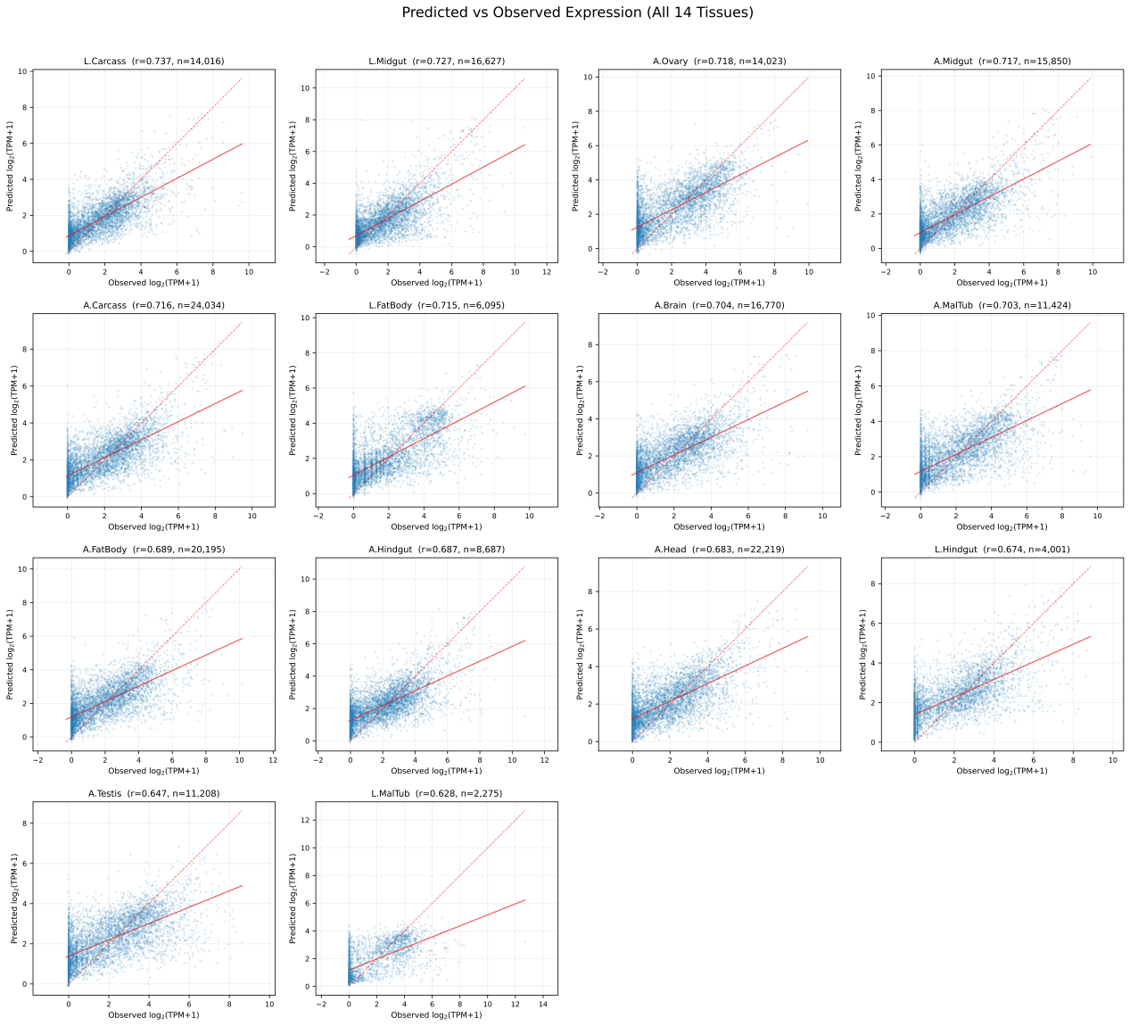
Figure 4. Concordance between predicted and observed expression across the 14-tissue panel. Scatter plots compare predicted and observed expression values for each tissue across all evaluated genes with available measurements. Each panel reports the Pearson correlation coefficient and sample size for the corresponding tissue. Strong positive associations are observed across all tissues, with the highest concordance in larval carcass, larval midgut, adult ovary, and adult midgut, and lower but still substantial agreement in tissues such as adult testis and larval Malpighian tubule. These results show that InsectExpress captures biologically meaningful tissue-resolved expression variation rather than only improving pooled summary metrics.
Modality ablation reveals complementary contributions from all three input branches
To dissect the relative contribution of each input branch, we performed a modality ablation analysis by selectively removing DNA sequence, RNA stability features, or protein-derived embeddings from the full model. As shown in Fig. 5B, the complete InsectExpress model achieved the best Pearson correlation (0.701), and removal of any modality led to measurable performance decline. The most severe drop occurred in the DNA-only setting (r = 0.221, Δ = −0.480), indicating that promoter sequence alone is far from sufficient to explain multi-tissue expression variation in this task.

Removal of individual non-sequence modalities also produced substantial losses: excluding RNA features reduced correlation to 0.492, while excluding ESM-derived protein information reduced it to 0.539. Notably, the RNA+ESM-only configuration still reached 0.611, demonstrating that these non-sequence modalities carry strong predictive signal even without promoter input. Nevertheless, the full model remained superior to all reduced variants, confirming that optimal performance requires integrating sequence, RNA-level, and protein-level information within a unified framework.

The tissue-resolved ablation further demonstrated that this multimodal benefit was not confined to a few tissues. As shown in Fig. 5C, the full model consistently achieved the highest correlation across nearly all 14 tissues, while each reduced variant showed broad performance deterioration. The severe loss in the DNA-only configuration confirms that expression prediction in this multi-species setting depends heavily on information beyond local promoter sequence, and the additional reductions upon removing RNA or ESM features indicate that these branches provide complementary biological signal rather than redundant information.

Together, these results show that the predictive strength of InsectExpress arises not from a single dominant feature source, but from the joint contribution of cis-regulatory sequence, transcript-associated features, and protein-derived functional representations.
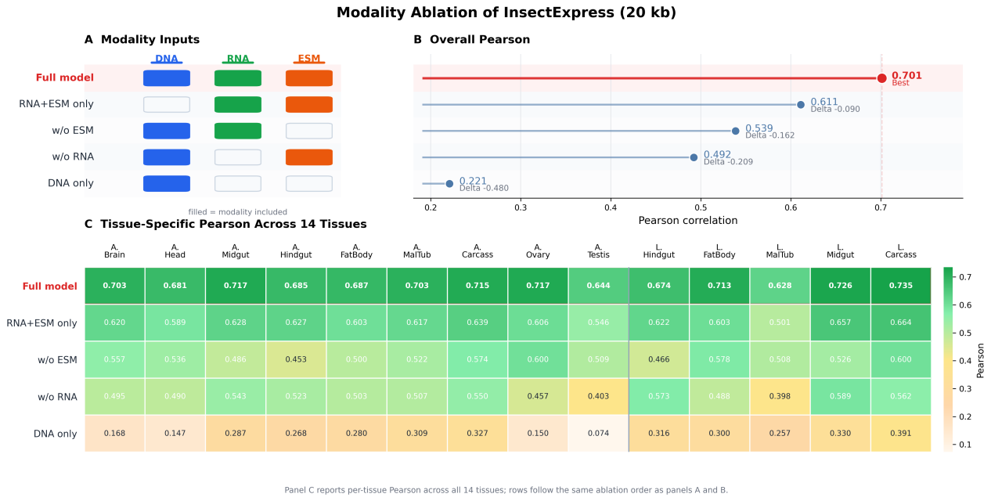
Figure 5. Modality ablation analysis of InsectExpress. A, schematic summary of the ablation settings, indicating which input modalities were retained in each model variant. B, overall Pearson correlation of the full model and each ablated variant. The complete model achieves the best performance, whereas removal of any modality leads to a marked decline in predictive accuracy. C, tissue-specific Pearson correlation across all 14 tissues for each ablation setting, showing that the benefit of multimodal integration is broadly consistent across the tissue panel. Together, the results demonstrate that promoter sequence, RNA stability features, and protein-derived embeddings provide strong and complementary contributions to model performance.

We further examined model behavior at the gene level as a function of tissue specificity. As shown in Fig. 6A, prediction accuracy was not monotonically related to tissue specificity. Instead, genes with moderate tissue specificity tended to show the highest per-gene correlation across tissues, whereas highly tissue-specific genes were more difficult to predict. This pattern was further supported by the category-wise comparison in Fig. 6B, in which genes with moderate specificity showed the highest median per-gene Pearson correlation, followed by housekeeping genes, while highly specific genes displayed the lowest median performance. These results suggest that extremely tissue-restricted expression patterns remain more challenging to model than broadly expressed or moderately biased transcriptional programs.
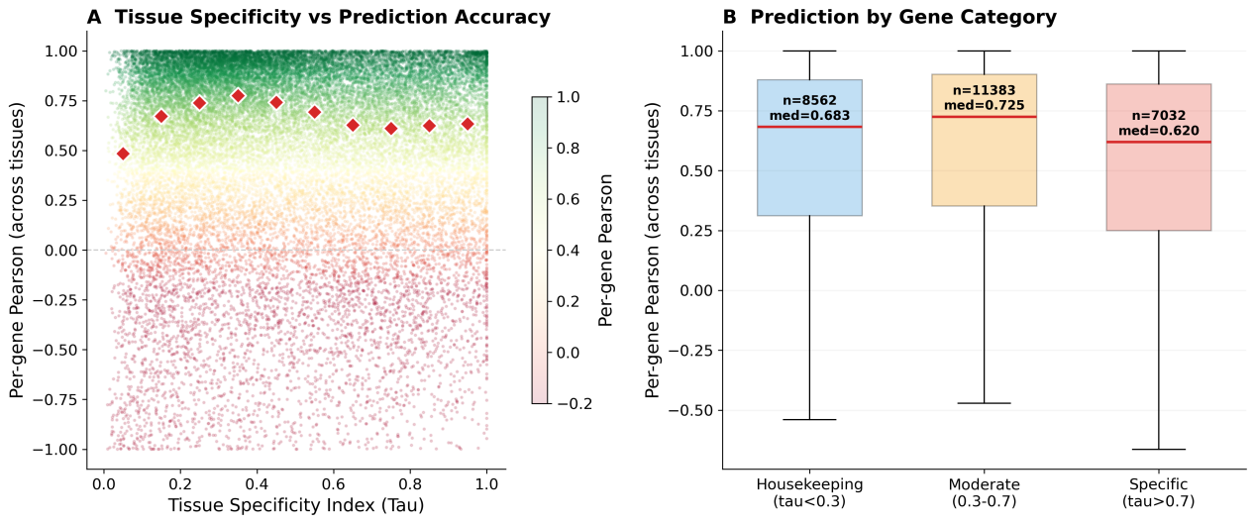
Figure 6. Gene-level predictability varies with tissue specificity. (A) Scatter plot of tissue specificity index (Tau) versus per-gene Pearson correlation across tissues, with red diamonds indicating median correlation within Tau bins. (B) Distribution of per-gene Pearson correlation for housekeeping, moderately tissue-specific, and highly tissue-specific genes. Moderately tissue-specific genes show the highest median predictive accuracy, whereas highly tissue-specific genes are comparatively more difficult to predict.

In silico mutagenesis reveals shared promoter grammar and tissue-biased regulatory syntax learned by InsectExpress
To determine whether InsectExpress learned biologically coherent cis-regulatory features rather than only optimizing predictive accuracy, we performed in silico mutagenesis (ISM) across the 20-kb TSS-centered input sequence and summarized the resulting score-weighted motif landscape across all 14 tissues (Fig. 7) [63]. As shown in Fig. 7A, the highest-impact sequence perturbations were concentrated around the transcription start site in most tissues, indicating that promoter-proximal sequence remains a major determinant of model output. However, the distribution of hotspots was clearly tissue dependent, with several tissues showing additional upstream or downstream peaks beyond the immediate core promoter. This pattern suggests that the model does not rely on a single invariant sequence window, but instead learns tissue-sensitive positional rules distributed across the promoter-centered context, consistent with the known role of core promoters in integrating transcription initiation cues together with additional proximal and distal regulatory inputs [64,65].

As shown in Fig. 7B, score-weighted regional decomposition further revealed substantial heterogeneity in the genomic zones emphasized by the model. Core-promoter-dominant profiles were observed for adult midgut, adult testis, larval midgut, larval Malpighian tubule, and larval carcass, in which approximately 44.7-69.0% of the total motif score was concentrated within ±200 bp of the TSS. By contrast, adult ovary displayed the strongest upstream bias, with a score-weighted centroid at -1.57 kb, whereas adult fat body (+1.98 kb), adult hindgut (+1.81 kb), adult Malpighian tubule (+1.40 kb), and larval hindgut (+0.95 kb) showed downstream-shifted centroids. These results indicate that the sequence determinants used by InsectExpress differ across tissues not only in composition but also in positional organization, implying that tissue-resolved prediction is supported by distinct regulatory “zones” within the 20-kb sequence input.

Figure 7C showed that the learned regulatory lexicon contains both broadly shared and tissue-restricted elements. Across the 14 tissues, we identified 111 exact 12-mer motifs recurrent in at least two tissues. The two most widely shared motifs, ATTATCTTATCT and TTTCTTTTTATT, were detected in 10 tissues each and were localized predominantly to the proximal upstream region, with mean positions of -351 bp and -313 bp, respectively. A third recurrent motif, CTGTTCTTATCA, was detected in 9 tissues and mapped close to the TSS (+40 bp). The recurrence of these short, predominantly A/T-rich sequence words across adult and larval tissues suggests that InsectExpress captured a common promoter grammar superimposed on tissue-specific regulatory programs, in line with the modular architecture of metazoan core promoters and cis-regulatory control [64-66].

To visualize tissue-biased sequence syntax more explicitly, we next selected one tissue-enriched exact 12-mer signature for each tissue on the basis of strong within-tissue ISM score together with limited cross-tissue recurrence (Fig. 7D). Notably, 10 of the 14 selected signatures were confined to a single tissue among the top motif sets, whereas the remaining 4 recurred in only one additional tissue. Representative examples included AATGAAAGTTAA in adult brain (+1.08 kb; score = 3.52), ATATAATAACGC in adult fat body (+3.97 kb; score = 5.60), ATTATCAATATT in adult ovary (-1.77 kb; score = 8.30), GTTATCTTATCT in larval Malpighian tubule (-56 bp; score = 9.56), and TGATAAGGAGTG in larval midgut (-33 bp; score = 10.83). Limited sharing was still evident for a subset of motifs: for example, TAACGCATATGC was enriched in adult Malpighian tubule but also detected in adult hindgut, whereas TGATAAAGAATC was enriched in adult midgut with a weaker secondary occurrence in larval Malpighian tubule. The 14-tissue footprint shown at the bottom of each card makes this specificity explicit: a single colored tile indicates that the selected exact 12-mer was detected only in the focal tissue, whereas two colored tiles indicate recurrence in one additional tissue. Together, these observations indicate that InsectExpress learns a hybrid regulatory representation composed of shared promoter-associated sequence patterns and tissue-biased exact-motif signatures, thereby providing mechanistic support for the tissue-resolved predictive behavior of the model.
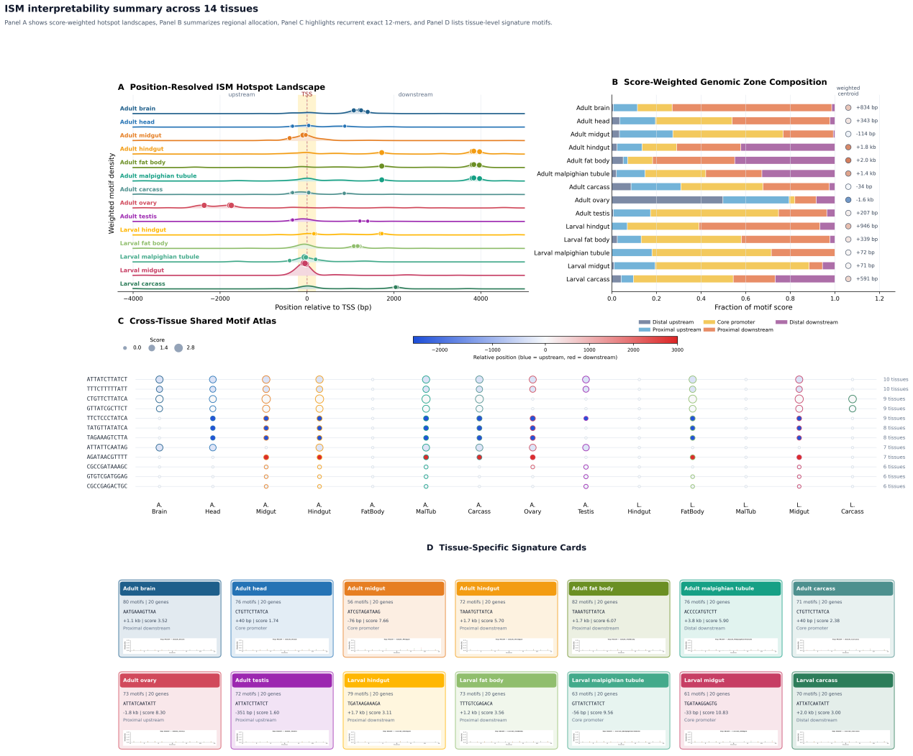
Figure 7. In silico mutagenesis reveals shared and tissue-biased regulatory signatures learned by InsectExpress.(A) Score-weighted ISM hotspot landscapes across the 14 tissues, showing that the most influential sequence positions are concentrated around the TSS but exhibit tissue-dependent upstream and downstream secondary peaks.(B) Score-weighted allocation of motif importance across five genomic zones relative to the TSS, together with the score-weighted positional centroid for each tissue.(C) Cross-tissue atlas of recurrent exact 12-mer motifs, in which point size denotes motif importance score and color denotes position relative to the TSS.(D) Tissue-enriched exact 12-mer signature cards. For each tissue, one representative signature motif is selected from the ISM-derived motif set and annotated by its sequence, best-scoring position, genomic region, ISM score, and cross-tissue prevalence. The bottom 14-tissue footprint summarizes the presence and relative strength of the same motif across all tissues; one colored tile indicates detection only in the focal tissue, whereas two colored tiles indicate recurrence in one additional tissue. Together, these panels show that InsectExpress captures both a shared promoter-associated motif grammar and tissue-biased regulatory syntax.

True external independent validation on unseen species
To assess whether InsectExpress generalizes beyond the species represented in the training set, we performed true external validation on two phylogenetically distinct insect species that were entirely excluded from model training and assembled from independent expression resources after explicit tissue harmonization and quality-controlled gene matching (Fig. 8). In Spodoptera frugiperda, using an independent control RNA-seq aggregation mapped to three standardized tissues, the model achieved an overall Pearson correlation of 0.542 and a Spearman correlation of 0.556 across 16,308 evaluable genes. Tissue-level performance remained consistent, with Pearson correlations of 0.615 for adult ovary, 0.482 for larval fat body, and 0.578 for larval midgut (Fig. 8C). In Helicoverpa armigera, using an independent GEO-derived tissue expression atlas spanning seven standardized adult tissues, InsectExpress achieved an overall Pearson correlation of 0.612 and a Spearman correlation of 0.649 across 16,749 genes. Tissue-specific agreement was uniformly strong, ranging from 0.568 in adult fat body to 0.691 in adult ovary, with adult brain also reaching 0.640 (Fig. 8C). Importantly, both validation datasets underwent external audit steps including expression-table loading, annotation matching, and promoter-sequence extraction before inference, while retaining a high proportion of genes for evaluation (Fig. 8D). Together, these results demonstrate that InsectExpress captures regulatory signals that transfer across independently generated datasets and previously unseen insect lineages.
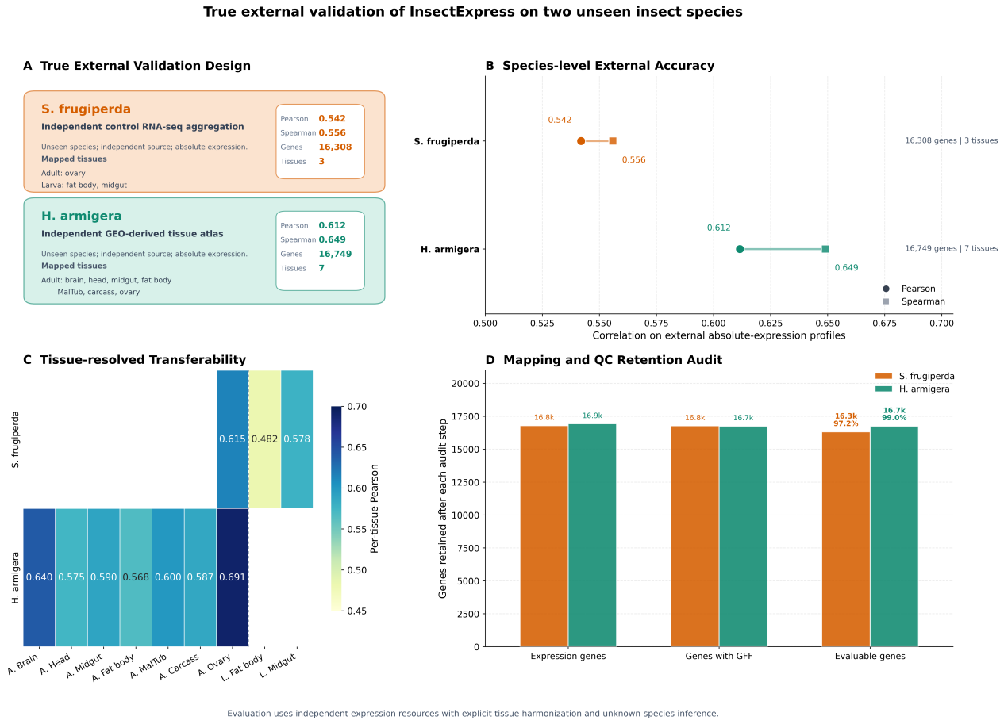
Figure 8. True external independent validation of InsectExpress on two unseen insect species.(A) Validation design and data provenance for the two external species used in the main analysis. Spodoptera frugiperda was evaluated using independently aggregated untreated/control RNA-seq data harmonized to adult ovary, larval fat body, and larval midgut, whereas Helicoverpa armigera was evaluated using an independent GEO-derived tissue expression atlas harmonized to seven adult tissues. (B) Species-level external performance measured by Pearson and Spearman correlations between predicted and observed expression profiles. (C) Tissue-resolved Pearson correlations for all standardized tissues available in each external dataset. Blank cells indicate tissues not represented in that species-specific resource. (D) Retention of genes after external audit steps, including expression-table loading, annotation matching, and promoter-sequence extraction, showing that both datasets remained large after harmonization and quality control.

Discussion
Our results show that tissue-resolved gene expression across diverse insect species can be predicted with appreciable accuracy using a compact multimodal architecture. Across global benchmarking, cross-species evaluation, tissue-level analyses, and modality ablation, InsectExpress consistently outperformed conventional machine-learning baselines and sequence-based deep-learning alternatives (Figs. 3-5). These findings suggest that robust expression modeling in insects does not require extremely large mammalian-style architectures, but instead benefits from a biologically structured integration of complementary regulatory signals.

A key result of this study is that the advantage of InsectExpress is driven by multimodal complementarity rather than by any single dominant feature source. The sequence branch captures cis-regulatory information in the promoter-proximal region, the RNA stability branch contributes transcript-associated determinants of steady-state abundance, and the protein-derived branch provides functional information that is likely more transferable across species than promoter sequence alone. This interpretation is strongly supported by the ablation analysis (Fig. 5), in which removal of any modality reduced performance, while the full model consistently remained optimal. The poor performance of the DNA-only setting further indicates that local promoter sequence alone is insufficient to explain tissue-resolved expression variation in this multi-species context.

The cross-species results are also biologically informative. Previous comparative transcriptomic studies have shown that expression programs are often constrained by organ function and biological role, and that such constraints can remain partially conserved across species despite substantial evolutionary divergence [58,59]. The stable species-level gains observed for InsectExpress are consistent with this view. Rather than simply learning species-specific average expression patterns, the model appears to capture regulatory and functional signals that generalize across taxa. In this respect, the protein-derived embeddings may play an important role by introducing a function-aware prior that helps bridge sequence divergence among orthologous or functionally related genes. This is particularly relevant for non-model pest insects, where transcriptomic resources are often sparse and species-specific models are difficult to train reliably.
The true external validation on Spodoptera frugiperda and Helicoverpa armigera strengthens this interpretation further. Because both species were completely excluded from training and evaluated using independently assembled expression resources after explicit tissue harmonization, the retained correlations in Fig. 8 indicate that the model is not simply exploiting within-dataset regularities. At the same time, the expected reduction relative to the internal cluster-split benchmark highlights the continuing impact of annotation quality, tissue matching granularity, and experiment-specific expression bias on real-world transfer. For practical deployment, this means that external predictions are sufficiently informative for target prioritization, but should still be interpreted together with dataset provenance and followed by focused experimental validation.

The tissue-resolved analyses further show that prediction difficulty is heterogeneous across the 14-tissue panel. Some tissues, such as larval carcass and larval midgut, were consistently more predictable than others, whereas tissues such as adult testis or larval Malpighian tubule remained more challenging (Figs. 3 and 4). This heterogeneity is unlikely to be purely technical. Tissues differ in cellular complexity, developmental heterogeneity, and annotation consistency, all of which can influence predictive accuracy. At the same time, the observed positive relationship between tissue-level performance and expression coverage suggests that sparsity of measurable expression is one contributor to prediction difficulty, although not the only one. The scatter plots in Fig. 4 are important in this regard, because they show that the model captures within-tissue expression structure rather than only performing well on pooled summary statistics.

Our gene-level analysis adds a further layer of interpretation. Genes with moderate tissue specificity showed the highest median predictive accuracy, whereas highly tissue-specific genes were more difficult to predict (Fig. 6). This pattern suggests that moderately biased transcriptional programs may retain sufficient cross-tissue structure to be learnable, while extremely tissue-restricted genes are likely to depend on sharper, more context-specific regulatory mechanisms that are harder to recover from the current input representation alone. Thus, predictability appears to be shaped not simply by whether a gene is broad or specific, but by the degree and structure of its tissue restriction.

From an application perspective, InsectExpress is best interpreted as a prioritization tool rather than a substitute for functional validation. For RNAi-based pest control, tissue-resolved expression provides a useful first-pass filter for identifying genes that are plausibly actionable in biologically relevant tissues. In species lacking comprehensive expression atlases, such a model can substantially narrow the search space before downstream experimental validation. Its practical value therefore lies not only in predictive performance, but also in enabling expression-informed target selection in non-model pest systems where direct transcriptomic evidence is incomplete.

Several limitations should be considered. First, prediction remains more difficult for weakly expressed or sparse-expression genes, which inherently suffer from lower signal-to-noise ratios. Second, the model depends on annotation quality, especially accurate TSS localization and gene structure, because these directly determine the extracted sequence context and associated features. Third, the current framework does not incorporate epigenomic or chromatin-level information, which is likely to explain additional variance in tissue-specific transcription. Fourth, although the present dataset spans 12 insect species, it still represents a limited fraction of insect diversity. Finally, interpretability should be framed cautiously: attention- or attribution-related signals can be descriptively useful, but they do not by themselves establish mechanism, and stronger claims will require perturbation-based validation or more rigorous attribution strategies [60-62].

Taken together, these results support a general conclusion: cross-species, tissue-resolved expression prediction in insects becomes substantially more tractable when cis-regulatory sequence, RNA-associated features, and protein-derived functional information are modeled jointly. This provides both a conceptual framework for future multi-species regulatory modeling and a practical basis for expression-guided RNAi target prioritization.

A further strength of InsectExpress is that the learned sequence representation is at least partially interpretable. The ISM analysis revealed that model sensitivity was not diffusely distributed across the 20-kb input sequence, but instead organized into a structured combination of TSS-centered promoter sensitivity, recurrent A/T-rich motifs shared across tissues, and tissue-specific shifts toward upstream or downstream regulatory zones (Fig. 7). This pattern is consistent with the functional heterogeneity of eukaryotic core promoters and the combinatorial organization of cis-regulatory programs [64-66]. At the same time, these sequence patterns should be interpreted as model-derived candidate regulatory signatures rather than validated cis-elements, because attribution analyses identify sequence features that strongly influence model output but do not by themselves establish direct biochemical mechanism or causal transcriptional activity [62,63].

Conclusions
InsectExpress provides a compact yet effective framework for predicting tissue-resolved gene expression across diverse insect species. By integrating promoter-centered DNA sequence, RNA stability features, and protein-derived embeddings, the model achieves robust performance across global, cross-species, tissue-level, and ablation evaluations, and consistently outperforms representative baseline approaches.

Beyond predictive accuracy alone, the framework offers a practical route toward expression-informed target prioritization in non-model pest insects. The present results therefore establish InsectExpress as both a useful computational tool and a proof of principle that multimodal, cross-species expression modeling can support downstream RNAi-oriented applications even in systems with limited transcriptomic resources.
Supplementary Materials
Table S1 lists the genome assemblies, annotation files, and public expression resources used for the 12 insect species. Table S2 provides the manually curated sample-to-tissue harmonization table used to align RNA-seq libraries to the 14 standardized tissues. Figure S1 shows training and validation convergence behavior. Figure S2 summarizes predictive performance stratified by expression abundance. Figure S3 presents additional analyses of tissue specificity and gene-level predictability.
Data availability
All public datasets used in this study are identified by accession number in Supplementary Table S1 and were obtained from FlyBase, BeetleAtlas, SilkDB 3.0, NCBI GEO/SRA, and NCBI RefSeq/GenBank. The harmonized tissue annotation tables, processed expression matrices, model predictions, and external validation summary files generated in this work are available from the corresponding author upon reasonable request and will be deposited in a public repository upon publication.
Code availability
Code used for data preprocessing, model training, inference, and figure generation is available from the corresponding author upon reasonable request. A public version of the codebase will be released upon publication.
Author contributions
[Please replace the placeholders below with the actual author initials required by the target journal.] Conceptualization, methodology, software, formal analysis, data curation, visualization, and writing—original draft preparation: [Author initials]. Writing—review and editing, supervision, and project administration: [Author initials]. Funding acquisition: [Author initials]. All authors have read and agreed to the published version of the manuscript.
Funding
[Please insert the funding agency names and grant numbers here. If no external funding applies, replace this sentence with: This research received no external funding.]
Acknowledgements
[Please insert acknowledgements here if needed; for example, technical assistance, computational support, or helpful discussion. If not needed, this section may be deleted.]
Competing interests
The authors declare no competing interests.

References
[1] Agarwal, V.; Shendure, J. Predicting mRNA abundance directly from genomic sequence using deep convolutional neural networks. Cell Rep. 2020, 31 (7), 107663.
[2] Kelley, D. R. Cross-species regulatory sequence activity prediction. PLoS Comput. Biol. 2020, 16 (7), e1008050.
[3] Baum, J. A.; et al. Control of coleopteran insect pests through RNA interference. Nat. Biotechnol. 2007, 25, 1322–1326.
[4] Zotti, M.; et al. RNA interference technology in crop protection against arthropod pests, pathogens and nematodes. Pest Manag. Sci. 2018, 74 (6), 1239–1250.
[5] Cedden, D.; Bucher, G. The quest for the best target genes for RNAi-mediated pest control. Insect Mol. Biol. 2024 (Advance Print 2025), 34 (4), 505–517.
[6] Zhang, J.; Li, M.; Lian, J.; et al. Genome-wide selection of potential target candidates for RNAi against Nilaparvata lugens. BMC Genomics 2024, 25, 1036.
[7] Li, X.; Fu, L.; et al. A targeted RNAi-of-RNAi strategy to overcome nuclease-mediated RNAi suppression and enhance RNAi efficacy in Lepidoptera pest, Cydia pomonella. J. Agric. Food Chem. 2025.
[8] Xu, S.; Zhang, X.; et al. Targets selection and field evaluation of an RNA biopesticide to control Phyllotreta striolata. Pestic. Biochem. Physiol. 2025, 209, 106330.
[9] Sweeney, M. D.; Kang, H. M. Practical utility of sequence-to-omics models for improving the reproducibility of genetic fine-mapping. bioRxiv 2026, DOI: 10.64898/2026.02.04.703796.
[10] Avsec, Ž.; et al. Effective gene expression prediction from sequence by integrating long-range interactions. Nat. Methods 2021, 18, 1196–1203.
[11] Misof, B.; et al. Phylogenomics resolves the timing and pattern of insect evolution. Science 2014, 346, 763–767.
[12] Wiegmann, B. M.; et al. Episodic radiations in the fly tree of life. Proc. Natl. Acad. Sci. U.S.A. 2011, 108, 5690–5695.
[13] McKenna, D. D.; et al. The evolution and genomic basis of beetle diversity. Proc. Natl. Acad. Sci. U.S.A. 2019, 116, 24729–24737.
[14] Honeybee Genome Sequencing Consortium. Insights into social insects from the genome of the honeybee Apis mellifera. Nature 2006, 443, 931–949.
[15] Leader, D. P.; et al. FlyAtlas 2: a new version of the Drosophila melanogaster expression atlas. Nucleic Acids Res. 2018, 46, D809–D815.
[16] Herndon, N.; et al. Enhanced genome assembly and a new official gene set for Tribolium castaneum. BMC Genomics 2020, 21, 47.
[17] Lu, F.; et al. SilkDB 3.0: visualizing and exploring multiple levels of data for silkworm. Nucleic Acids Res. 2020, 48, D453–D460.
[18] Theodoris, C. V.; et al. Transfer learning enables predictions in network biology. Nature 2023, 618, 616–624.
[19] Lin, Z.; et al. Evolutionary-scale prediction of atomic-level protein structure with a language model. Science 2023, 379, 1123–1130.
[20] Rives, A.; et al. Biological structure and function emerge from scaling unsupervised learning to 250 million protein sequences. Proc. Natl. Acad. Sci. U.S.A. 2021, 118, e2016239118.
[21] Zrimec, J.; Börlin, C. S.; Buric, F.; et al. Deep learning suggests that gene expression is encoded in all parts of a co-evolving interacting gene regulatory structure. Nat. Commun.2020, 11, 6141.
[22] Kvon, E. Z.; Kazmar, T.; Stampfel, G.; et al. Genome-scale functional characterization of Drosophila developmental enhancers in vivo. Nature 2014, 512, 91–95.
[23] Shrikumar, A.; Prakash, E.; Kundaje, A. GkmExplain: fast and accurate interpretation of nonlinear gapped k-mer SVMs. Bioinformatics 2019, 35, i173–i182.
[24] Elnaggar, A.; Heinzinger, M.; Dallago, C.; et al. ProtTrans: toward understanding the language of life through self-supervised learning. IEEE Trans. Pattern Anal. Mach. Intell. 2022, 44, 7112–7127.
[25] Weirauch, M. T.; Yang, A.; Albu, M.; et al. Determination and inference of eukaryotic transcription factor sequence specificity. Cell 2014, 158, 1431–1443.
[26] Yu, F.; Koltun, V. Multi-scale context aggregation by dilated convolutions. In Proc. ICLR 2016.
[27] Ioffe, S.; Szegedy, C. Batch normalization: accelerating deep network training by reducing internal covariate shift. In Proc. ICML 2015, 448–456.
[28] Hendrycks, D.; Gimpel, K. Gaussian error linear units (GELUs). arXiv 2016, 1606.08415.
[29] Vaswani, A.; Shazeer, N.; Parmar, N.; et al. Attention is all you need. In Advances in Neural Information Processing Systems 2017, 30, 5998–6008.
[30] Ba, J. L.; Kiros, J. R.; Hinton, G. E. Layer normalization. arXiv 2016, 1607.06450.
[31] Silverman, J. D.; Roche, K.; Mukherjee, S.; David, L. A. Naught all zeros in sequence count data are the same. Comput. Struct. Biotechnol. J. 2020, 18, 2789–2798.
[32] Chicco, D.; Warrens, M. J.; Jurman, G. The coefficient of determination R-squared is more informative than SMAPE, MAE, MAPE, MSE and RMSE in regression analysis evaluation. PeerJ Comput. Sci. 2021, 7, e623.
[33] Conneau, A.; Lample, G. Cross-lingual language model pretraining. In Advances in Neural Information Processing Systems 2019, 32, 7059–7069.
[34] Loshchilov, I.; Hutter, F. Decoupled weight decay regularization. In Proc. ICLR 2019.
[35] Loshchilov, I.; Hutter, F. SGDR: stochastic gradient descent with warm restarts. In Proc. ICLR 2017.
[36] Zhang, H.; Cisse, M.; Dauphin, Y. N.; Lopez-Paz, D. mixup: beyond empirical risk minimization. In Proc. ICLR 2018.
[37] Washburn, J. D.; Mejia-Guerra, M. K.; Ramstein, G.; et al. Evolutionarily informed deep learning methods for predicting relative transcript abundance from DNA sequence. Proc. Natl. Acad. Sci. U.S.A. 2019, 116, 5542–5549.
[38] Sculley, D. Web-scale k-means clustering. In Proc. WWW 2010, 1177–1178.
[39] Chen, T.; Guestrin, C. XGBoost: a scalable tree boosting system. In Proc. KDD 2016, 785–794.
[40] Järvelin, K.; Kekäläinen, J. Cumulated gain-based evaluation of IR techniques. ACM Trans. Inf. Syst. 2002, 20, 422–446.
[41] Gramates, L. S.; Agapite, J.; Attrill, H.; et al. FlyBase: a guided tour of highlighted features. Genetics 2022, 220, iyac035.
[42] Naseem, M. T.; Shippy, T. D.; Gilles, A. F.; et al. A comprehensive tissue-specific gene expression atlas of the red flour beetle Tribolium castaneum. BMC Genomics 2023, 24, 780.
[43] Lu, F.; Wei, Z.; Luo, Y.; et al. SilkDB 3.0: visualizing and exploring multiple levels of data for silkworm. Nucleic Acids Res. 2020, 48, D453–D460.
[44] Barrett, T.; Wilhite, S. E.; Ledoux, P.; et al. NCBI GEO: archive for functional genomics data sets—update. Nucleic Acids Res. 2013, 41, D991–D995.
[45] Sayers, E. W.; Bolton, E. E.; Brister, J. R.; et al. Database resources of the National Center for Biotechnology Information. Nucleic Acids Res. 2022, 50, D13–D16.
[46] Wang, X.; Fang, X.; Yang, P.; et al. The locust genome provides insight into swarm formation and long-distance flight. Nat. Commun. 2014, 5, 2957.
[47] Chen, S.; Zhou, Y.; Chen, Y.; Gu, J. fastp: an ultra-fast all-in-one FASTQ preprocessor. Bioinformatics 2018, 34, i884–i890.
[48] Kim, D.; Paggi, J. M.; Park, C.; Bennett, C.; Salzberg, S. L. Graph-based genome alignment and genotyping with HISAT2 and HISAT-genotype. Nat. Biotechnol. 2019, 37, 907–915.
[49] Pertea, M.; Pertea, G. M.; Antonescu, C. M.; et al. StringTie enables improved reconstruction of a transcriptome from RNA-seq reads. Nat. Biotechnol. 2015, 33, 290–295.
[50] Joga, M. R.; Zotti, M. J.; Smagghe, G.; Christiaens, O. RNAi efficiency, systemic properties, and novel delivery methods for pest insect control: what we know so far. Front. Physiol. 2016, 7, 553.
[51] Palli, S. R. RNA interference in Colorado potato beetle: steps toward development of dsRNA as a commercial insecticide. Curr. Opin. Insect Sci. 2014, 6, 1–8.
[52] Arrese, E. L.; Soulages, J. L. Insect fat body: energy, metabolism, and regulation. Annu. Rev. Entomol. 2010, 55, 207–225.
[53] Dow, J. A. T.; Davies, S. A. The Malpighian tubule: rapid insights from post-genomic biology. J. Insect Physiol. 2006, 52, 365–378.
[54] Verlinden, H.; Vleugels, R.; Marchal, E.; et al. The role of octopamine in locusts and other arthropods. J. Insect Physiol. 2010, 56, 854–867.
[55] Merzendorfer, H.; Zimoch, L. Chitin metabolism in insects: structure, function and regulation of chitin synthases and chitinases. J. Exp. Biol. 2003, 206, 4393–4412.
[56] Swevers, L.; Smagghe, G. Use of RNAi for control of insect crop pests. In Arthropod-Plant Interactions; Smagghe, G., Diaz, I., Eds.; Springer: Dordrecht, 2012; pp 177–197.
[57] Zhu, K. Y.; Palli, S. R. Mechanisms, applications, and challenges of insect RNA interference. Annu. Rev. Entomol. 2020, 65, 293–311.
[58] Breschi A, Djebali S, Gillis J, et al. Gene-specific patterns of expression variation across organs and species. Genome Biology. 2016;17:151.
[59] Fukushima K, Pollock DD. Amalgamated cross-species transcriptomes reveal organ-specific propensity in gene expression evolution. Nature Communications. 2020;11:4459.
[60] Jain S, Wallace BC. Attention is not Explanation. In: Proceedings of the 2019 Conference of the North American Chapter of the Association for Computational Linguistics: Human Language Technologies. 2019;3543-3556.
[61] Wiegreffe S, Pinter Y. Attention is not not Explanation. In: Proceedings of the 2019 Conference on Empirical Methods in Natural Language Processing and the 9th International Joint Conference on Natural Language Processing. 2019;11-20.
[62] Koo PK, Majdandzic A, Ploenzke M, Anand P, Paul SB. Global importance analysis: An interpretability method to quantify importance of genomic features in deep neural networks. PLoS Computational Biology. 2021;17:e1008925.
[63] Zhou, J.; Troyanskaya, O. G. Predicting effects of noncoding variants with deep learning-based sequence model. Nat. Methods 2015, 12, 931–934. DOI: 10.1038/nmeth.3547.
[64] Haberle, V.; Stark, A. Eukaryotic core promoters and the functional basis of transcription initiation. Nat. Rev. Mol. Cell Biol. 2018, 19, 621–637. DOI: 10.1038/s41580-018-0028-8.
[65] Spitz, F.; Furlong, E. E. M. Transcription factors: from enhancer binding to developmental control. Nat. Rev. Genet. 2012, 13, 613–626. DOI: 10.1038/nrg3207.
[66] Ohler, U.; Liao, G.-C.; Niemann, H.; Rubin, G. M. Computational analysis of core promoters in the Drosophila genome. Genome Biol. 2002, 3, research0087.1. DOI: 10.1186/gb-2002-3-12-research0087.

