Title: Database queries, design and development
Unit Title: Introduction to Databases (COM417)
Final Assessment
Student Name: My Name (Do not enter your name if you wish your submission to be anonymously marked)
Date: 03/05/2024

Contents page
Part 1- Retrieving Data using SQL
Question a 3
Question b 3
Question c 4
Question d 4
Part 2 – Database Design, Implementation and Integrity
Question a 6
Question b 6
Question c 6
Question d 6
Part 3 – Programming for Databases 8
Bibliography 9

PART 1 - Retrieving Data using SQL
- QUESTION:

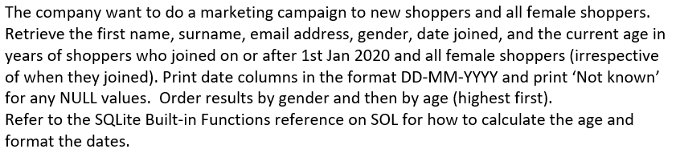
SQL CODE:
SELECT
shopper_first_name,
shopper_surname,
shopper_email_address,
gender,
strftime('%d-%m-%Y' , date_joined) AS date_joined,
CAST((julianday('now') - julianday(date_of_birth)) /365.25 AS INTEGER) AS age
FROM shoppers;
EXPLANATION:
This code provided is designed to query a database and retrieve several pieces of information from the “shoppers” table, specifically targeting details that are crucial for customer relationship management and demographic analysis. The query selects the first name, surname, email address, and gender of each shopper, directly extracting this information to be used in various business processes such as communication or marketing campaigns. Additionally, the query reformats the “date_joined” field using the “strftime” function to present it in a more readable format (DD-MM-YYYY), enhancing the clarity of the data for reporting purposes. Moreover, it calculates the age of each shopper by using the “julianday “function to find the difference in days between the current date and the shopper’s date of birth, and then dividing this number by 365.25 to account for leap years. This result is then cast as an integer to provide the age in whole years.

SCREENSHOT:
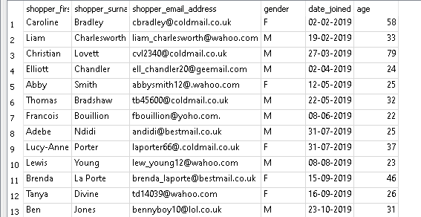
TESTING:
These images is to serve as evidence that the date formatting and age calculations are functioning as expected.
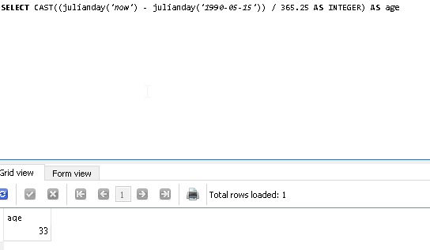
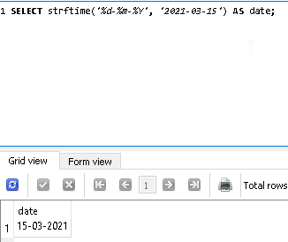
b) QUESTION:

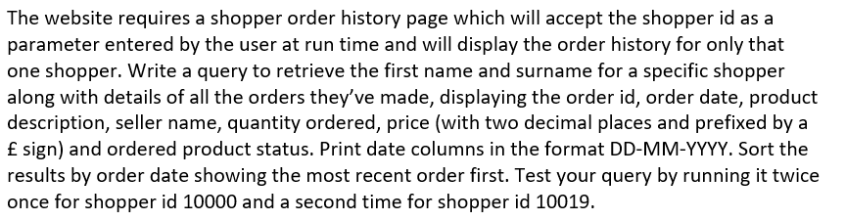

SQL CODE:
SELECT
sh.shopper_first_name AS first_Name,
sh.shopper_surname AS shopper_surname,
so.order_id AS order_id,
strftime('%d-%m-%Y', so.order_date) AS order_date,
p.product_description AS product_description,
s.seller_name AS seller_name,
op.quantity AS quantity,
'£' || printf("%.2f", op.price) AS price,
op.ordered_product_status AS ordered_product_status
FROM
shoppers sh
JOIN
shopper_orders so ON sh.shopper_id = so.shopper_id
JOIN
ordered_products op ON so.order_id = op.order_id
JOIN
products p ON op.product_id = p.product_id
JOIN
sellers s ON op.seller_id = s.seller_id
WHERE
sh.shopper_id = 10019
ORDER BY
so.order_date DESC;

//for reference 10000
SELECT
sh.shopper_first_name AS first_Name,
sh.shopper_surname AS shopper_surname,
so.order_id AS order_id,
strftime('%d-%m-%Y', so.order_date) AS order_date,
p.product_description AS product_description,
s.seller_name AS seller_name,
op.quantity AS quantity,
'£' || printf("%.2f", op.price) AS price,
op.ordered_product_status AS ordered_product_status
FROM
shoppers sh
JOIN
shopper_orders so ON sh.shopper_id = so.shopper_id
JOIN
ordered_products op ON so.order_id = op.order_id
JOIN
products p ON op.product_id = p.product_id
JOIN
sellers s ON op.seller_id = s.seller_id
WHERE
sh.shopper_id = 10000
ORDER BY
so.order_date DESC;

EXPLANATION:
The code provided is to display information about the orders placed by a specific shopper I By using SQL inner joins, it integrates data from various tables—namely shoppers, shopper orders, ordered products, products, and sellers—based on related columns. This allows for a comprehensive view of each order, including shopper details, product descriptions, and seller information. Furthermore, the query enhances the data's readability by formatting dates to the 'DD-MM-YYYY' format using the strftime function and appending a pound sign to properly formatted prices using a combination of the concatenation operator (||) and the printf function. It filters the results to only include orders from a designated shopper, identified by their unique ID, ensuring the output is tailored and relevant. Lastly, the data is sorted by the order date in descending order, prioritizing the most recent orders, which is especially useful for reviewing the latest customer transactions or managing recent order statuses effectively. This SQL setup is crucial for providing clear, organized, and specific transaction data critical for customer relationship management and operational analysis in an e-commerce environment.

SCREENSHOT:
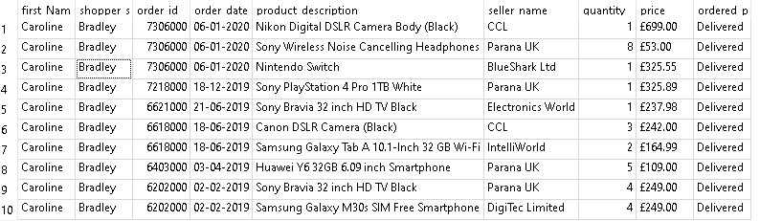

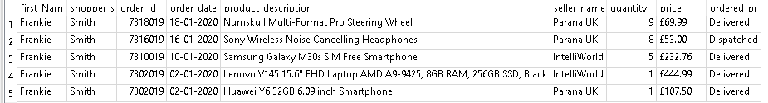
TESTING:
These images showing to check the date and currency is correctly formatted
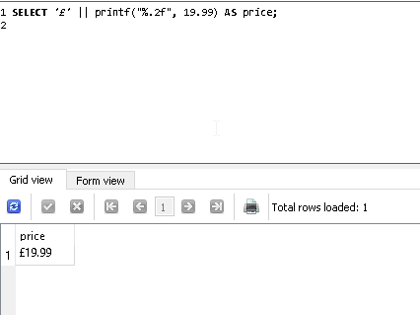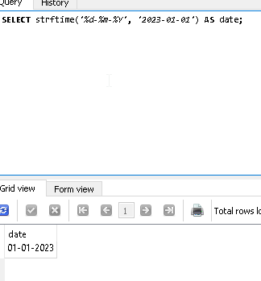

c) QUESTION:

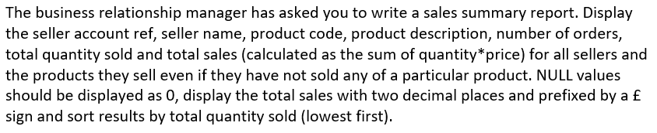
SQL CODE:
SELECT
s.seller_account_ref,
s.seller_name,
p.product_code,
p.product_description,
COUNT(DISTINCT op.order_id) AS num_orders,
COALESCE(SUM(op.quantity), 0) AS total_quantity_sold,
ROUND(COALESCE(SUM(op.quantity * op.price), 0), 2) AS total_sales
FROM sellers s
LEFT JOIN product_sellers ps ON s.seller_id = ps.seller_id
LEFT JOIN products p ON ps.product_id = p.product_id
LEFT JOIN ordered_products op ON ps.seller_id = op.seller_id AND ps.product_id = op.product_id
GROUP BY s.seller_account_ref, s.seller_name, p.product_code, p.product_description
ORDER BY total_quantity_sold ASC;
EXPLANATION:
The SQL code provided creates a sales summary report by combining data from multiple tables using LEFT JOINs. It calculates aggregate values such as the number of orders, total quantity sold, and total sales using functions like COUNT, SUM, and ROUND. The DISTINCT function is used within the COUNT function to ensure that only distinct order IDs are counted for each seller-product combination. The results are grouped by seller and product, ensuring accurate summarization, and sorted by total quantity sold in ascending order for easy comparison. Special functions like COALESCE handle NULL values gracefully, and formatting ensures the presentation of total sales with two decimal places and prefixed by a £ sign.

SCREENSHOT:
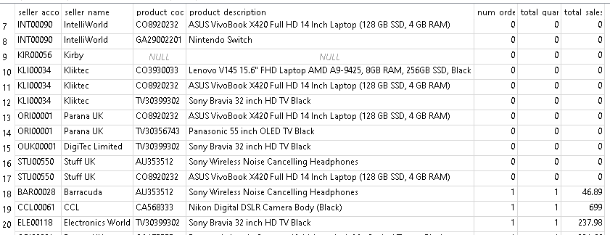
TESTING:

d) QUESTION:

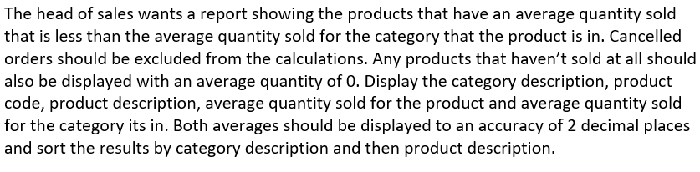
SQL CODE:
SELECT
c.category_description,
p.product_code,
p.product_description,
IFNULL(printf("%.2f", AVG(op.quantity)), '0.00') AS avg_quantity_sold_product,
(
SELECT printf("%.2f", AVG(op2.quantity))
FROM products p2
INNER JOIN ordered_products op2 ON p2.product_id = op2.product_id
WHERE p2.category_id = p.category_id
AND op2.ordered_product_status != 'Cancelled'
GROUP BY p2.category_id
) AS avg_quantity_sold_category
FROM
categories c
JOIN
products p ON c.category_id = p.category_id
LEFT JOIN
ordered_products op ON p.product_id = op.product_id AND op.ordered_product_status != 'Cancelled'
GROUP BY
p.product_id
HAVING
avg_quantity_sold_product < avg_quantity_sold_category
ORDER BY
c.category_description, p.product_description;
EXPLANATION:
The query compares the average quantity sold of each product to the average sales of its respective category. It utilizes LEFT joins to integrate data from categories, products, and ordered products tables, excluding cancelled orders. The query calculates average sales figures using the avg function, formats these figures to two decimal places, and replaces null values with '0.00'. Products with sales below their category average are filtered and listed, helping identify underperformers for further analysis. The results are organized by category and product description for clarity.

SCREENSHOT:
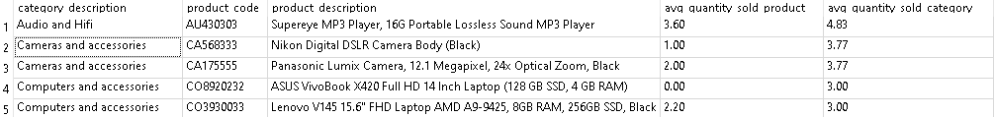

TESTING:

PART 2 – Database Design, Implementation and Integrity
- QUESTION:



Describe the though process in coming up with the design

The design of the `ProductReview` and `SellerReview` tables utilised a logical design approach, focusing on defining how the database would be structuredand the relationships between entities. This stage involved detailing the attributes of each table, including fields for ratings, textual comments, and ensuring each attribute was assigned with the correct data type. The logical design also meticulously planned the relationships between these new tables and existing entities such as Products, Shoppers, and Sellers, assuming an implicit relational link through shopper and product or seller IDs. This was done without altering the existing database structure, adhering to constraints that no modifications should be made to existing tables. The approach ensured that multiple reviews could be linked to individual products and sellers, as well as submitted by individual shoppers.

- QUESTION:

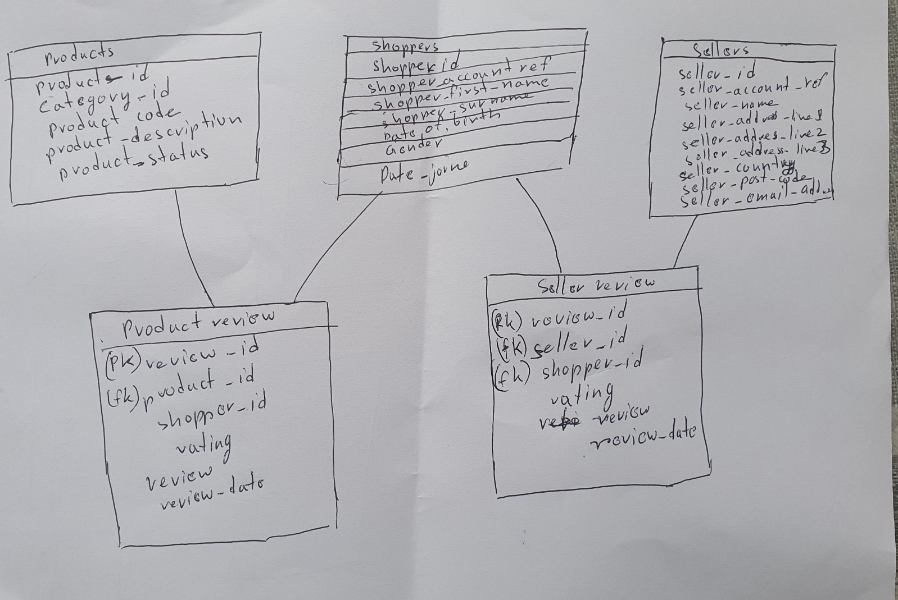

- QUESTION:

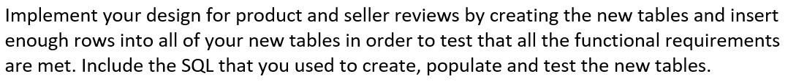

CREATE TABLE ProductReview (
review_id INTEGER PRIMARY KEY AUTOINCREMENT,
product_id INTEGER NOT NULL,
shopper_id INTEGER NOT NULL,
rating INTEGER NOT NULL CHECK (rating BETWEEN 1 AND 5),
review_text TEXT,
review_date TEXT DEFAULT CURRENT_DATE

CREATE TABLE SellerReview (
review_id INTEGER PRIMARY KEY AUTOINCREMENT,
seller_id INTEGER NOT NULL,
shopper_id INTEGER NOT NULL,
rating INTEGER NOT NULL CHECK (rating BETWEEN 1 AND 5),
review_text TEXT,
review_date TEXT DEFAULT CURRENT_DATE
);

);

INSERT INTO ProductReview (product_id, shopper_id, rating, review_text, review_date)
VALUES
(101, 201, 5, 'Excellent product! Highly recommend.', '2023-05-01'),
(102, 202, 4, 'Very good, but could be cheaper.', '2023-05-02'),
(103, 203, 3, 'Decent quality, nothing exceptional.', '2023-05-03'),
(104, 204, 2, 'Not what I expected, slightly disappointed.', '2023-05-04'),
(105, 205, 1, 'Poor quality, would not buy again.', '2023-05-05');

INSERT INTO SellerReview (seller_id, shopper_id, rating, review_text, review_date)
VALUES
(1, 1, 5, 'Outstanding service, highly recommended!', '2023-05-01'),
(2, 1, 4, 'Good experience overall, but shipping was slow.', '2023-05-02'),
(3, 2, 3, 'Average service, nothing special.', '2023-05-03'),
(1, 3, 2, 'Below expectations, needs improvement.', '2023-05-04'),
(2, 4, 1, 'Very poor service, will not buy again.', '2023-05-05');
- QUESTION:



This image of the testing to show that above 5 star review cant be shown as it is limited 1-5 star reviews
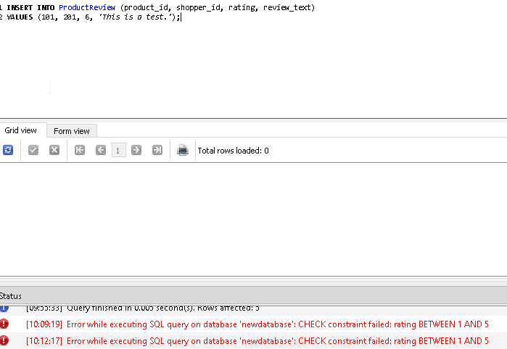

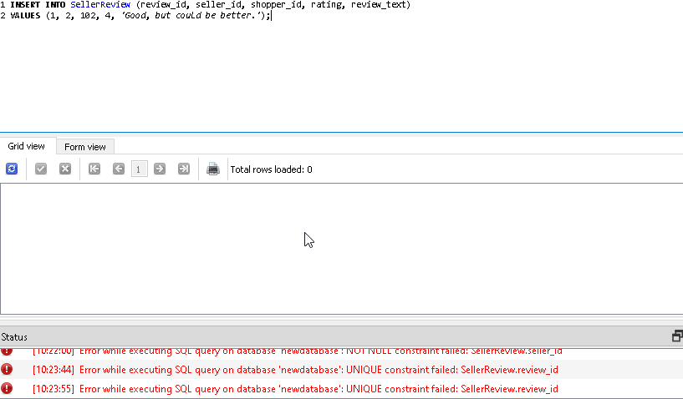

PART 3 – Programming for Databases
The script successfully prompts users for a shopper_id, using this ID to fetch the shopper's details from the database—this aspect is well-implemented. When a shopper_id is found, the script appropriately prints a welcome message including the shopper's name, aligning with the requirements. However, if the shopper_id is not found, it correctly displays an error message ("Error: Shopper with shopper_id {shopper_id} not found.") and additionally its print and displays a main menu to meet the requirement and closes the program.
import sqlite3
db_file = "C:/Users/Ramsey/Desktop/newdatabase.db"
db = sqlite3.connect(db_file)
cursor = db.cursor()
db.close()
conn = sqlite3.connect('newdatabase.db')
def get_shopper_name(cursor, shopper_id):
"""Query the shoppers table to check if the shopper_id exists and get the shopper's name."""
cursor.execute("SELECT shopper_first_name, shopper_surname FROM shoppers WHERE shopper_id = ?", (shopper_id,))
return cursor.fetchone()
def print_main_menu():
"""Prints the main menu."""
print("PARANÁ – SHOPPER MAIN MENU")
print("1. Display your order history")
print("2. Add an item to your basket")
print("3. View your basket")
print("4. Change the quantity of an item in your basket")
print("5. Remove an item from your basket")
print("6. Checkout")
print("7. Exit")
def main():
db_file = "C:/Users/Ramsey/Desktop/newdatabase.db"
conn = sqlite3.connect(db_file)
cursor = conn.cursor()
# Input for shopper ID
shopper_id = input("Enter shopper_id: ")
try:
shopper_id = int(shopper_id)
shopper_name = get_shopper_name(cursor, shopper_id)
if shopper_name:
full_name = f"{shopper_name[0]} {shopper_name[1]}"
print(f"Welcome, {full_name}!")
print_main_menu()
else:
print(f"Error: Shopper with shopper_id {shopper_id} not found.")
except ValueError:
print("Invalid input. Please enter a valid numeric shopper ID.")
finally:
conn.close()
if __name__ == "__main__":
main()

Testing of the code
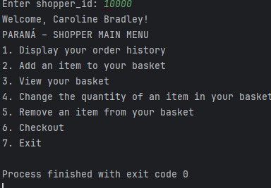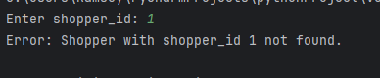

Bibliography

List any Internet sources of information that you used in order to help complete your assessment. You do not need to include references to any of the learning materials provided on SOL for this module, just other external sources.

For instance, if you consulted an article on the SQLite online documentation page on AUTOINCREMENT, you would list it here along with the date you accessed it as shown below:

SQLite (2017) SQLite Autoincrement. Available at https://www.sqlite.org/autoinc.html (Accessed 29th April 2023)

IONOS editorial team (2023) SQLite3 in Python. https://www.ionos.co.uk/digitalguide/websites/web-development/sqlite3-python/.
GeeksforGeeks (2021) Python SQLite. https://www.geeksforgeeks.org/python-sqlite/.

Corey Schafer (2017) Python SQLite tutorial: Complete Overview - Creating a database, table, and running queries. https://www.youtube.com/watch?v=pd-0G0MigUA.

Avery (2020) Learn SQLite with Python: A Tutorial for Beginners. https://www.youtube.com/watch?v=COfSeLoFNH8.

Parwiz Forogh (2019) Python Sqlite Database | for Beginners | CRUD Operations. https://www.youtube.com/watch?v=wgIgdIyItIc.

