Network Servers - Acme Network Training Package

Done by : Ramsey Lewis

Table of Contents
Introduction 3
1.1 Concept of Network Servers 3
Exploration of Network Server types 3
2.1 DHCP Server 3
2.2 DNS Server 9
2.2 Web server 10
Support material and slides theme summary 14
Multiple Choice Quiz 14
DHCP Server 14
DNS Server 15
IIS Web Server 17
Multiple Choice Quiz Answers 18
DHCP Server 18
DNS Server 18
IIS Web Server 19
Further Material and sources 20
Appendices 21
Appendix A 21
DHCP Server – Appendix B 21
Appendix B 21
DNS Server -Appendix C 21
Appendix C 21
IIS Web Server -Appendix D 21
Multiple Choice Quiz Answers 22
DHCP Server – Appendix E 22
DNS Server -Appendix F 22
IIS Web Server -Appendix G 22

Introduction

In this network Server training package, the report will focus on three vital network servers: DHCP, DNS, and Web servers. Our primary emphasis is on using practical applications and real-life scenarios, to meet the requirements of Acme Company. This will encourage non technical understanding the basic of the servers and basics of how to use it.

Concept of Network Servers

What are Network Servers
According to the research (Paessler AG, n.d) says that A server is a computer or system that provides resources, services, or data to other computers, also known as clients, over a network. (Paessler AG, n.d). Each Server types or roles have their own specific tasks or functions that performs in a network environment. So , As for Acme company it requires three server roles such as DHCP, DNS, and Web servers to serve to their particular needs for the clients to use the network smoothly for their business growth.

Exploration of Network Server types

There are three important types of Microsoft windows based servers can be added for the acme company called DHCP,DNS and Web Server these three have different functions which I will explaining further below.

2.1 DHCP Server
A DHCP server, which stands for Dynamic Host Configuration Protocol server, is a system that (Microsoft ,2021)automatically gives each device connected to a network with its own unique ip address so they can communicate with each network. (Microsoft ,2021). As for the Acme case study scenario One of the important requirement of (2) II) implementation of the Dynamic Host Configuration Protocol (DHCP) to manage and create automatic IP address allocation for the workstations. By using DHCP server for the acme will help them to assign IP addresses to the workstations such as Bournemouth’s office admin would not need to manually configure the ip address for Acme company. (Wynn, 2021) DHCP server will be highly beneficial as it simplifies managing IP addresses for workstations across various locations, ultimately reducing configuration issues and administrative costs and time. (Wynn, 2021) By installing a DHCP server at each site, ACME can ensure that their servers maintain static IP addresses while efficiently managing the dynamic allocation of IP addresses for workstations. (InfoBlox, 2017)This setup allows employees to connect to the network easily, without any technical difficulties. (InfoBlox, 2017) Additionally, configuring the DHCP server to provide the necessary DNS server and router information ensures that workstations have access to both internal and external websites.
Process
How does DHCP works
The Dora Process of DHCP
Figure 1.1 primarily addresses Requirement 2) from the case study, which states:"IP addresses must be allocated to workstations on each LAN dynamically to reduce administration overhead, but servers must have static IP addresses.” This requirement highlights the need for dynamic IP address allocation to simplify management and reduce the workload for network administrators. The DHCP DORA process directly supports this by automating the the IP addresses to workstations at each of ACME’s locations.
Figure 1.1 image used from youtube (Networks,2023)
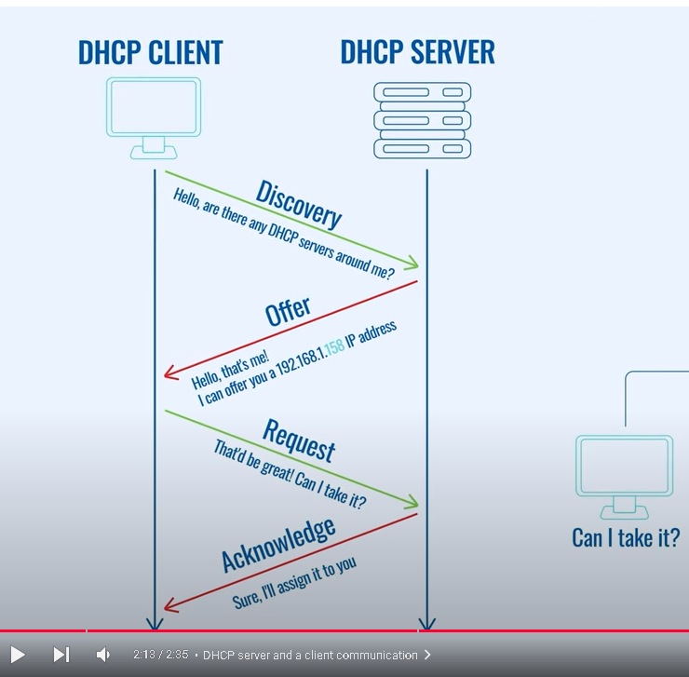

At ACME, the DHCP process—also known as DORA (Discovery, Offer, Request, Acknowledge)—is vital in managing device connections across multiple locations, ensuring employees can easily connect to the company's network. Below The following explains the DORA process in detail:
Discovery: When an ACME employee switches on their computer or device in any office location, such as Bournemouth or Swindon, their device needs an IP address to join the local network. (Pramatarov, 2021) The device broadcasts a message asking for a DHCP server that can provide an IP address. (Pramatarov, 2021)This message is received by the nearest DHCP server.
Offer: The DHCP server responds with an "Offer," proposing an IP address for the device. This offer includes additional network information, (Pramatarov, 2021)like gateway and DNS settings, enabling the device to access both internal and external resources. Essentially, the server says, "You can use the IP address 192.168.1.158 to connect."
Request: The device sends a "Request" message to confirm its acceptance of the offered IP address, essentially replying, "I'll use this address."
Acknowledge: The DHCP server sends an "Acknowledgment" message, officially (Pramatarov, 2021) assigning the IP address to the device. (Pramatarov, 2021)This final step verifies the address assignment and allows the device to connect to ACME's network seamlessly.
Implementing DHCP at all locations ensures that employees can connect to the network without needing manual configuration, reducing administrative tasks, and simplifying network management. This setup fulfills Requirement 2 by automating IP address allocation, Requirement 6 by providing easy network access for employees, and Requirement 7 by improving network reliability. As a result, ACME's network becomes more efficient and easier to maintain for both employees and IT departments.

Setting up a DHCP server on Acme's Windows server environment can be done through the Server Manager, as demonstrated in Figure 1

In requirement 2 Acme requires us to install and configure DHCP So Installing DHCP from the DHCP server roles from the server is the first step for the process for the Acme company as you can see in figure 2, 2.1 and 2.2 next you can create a name of the scope in this case acme
Figure 1

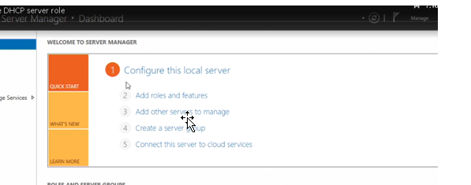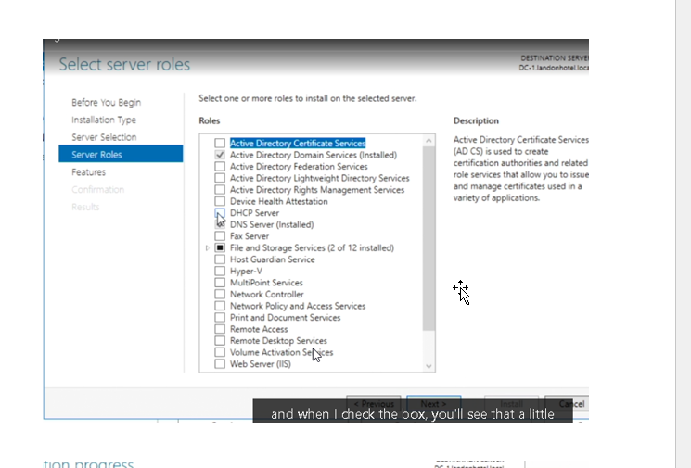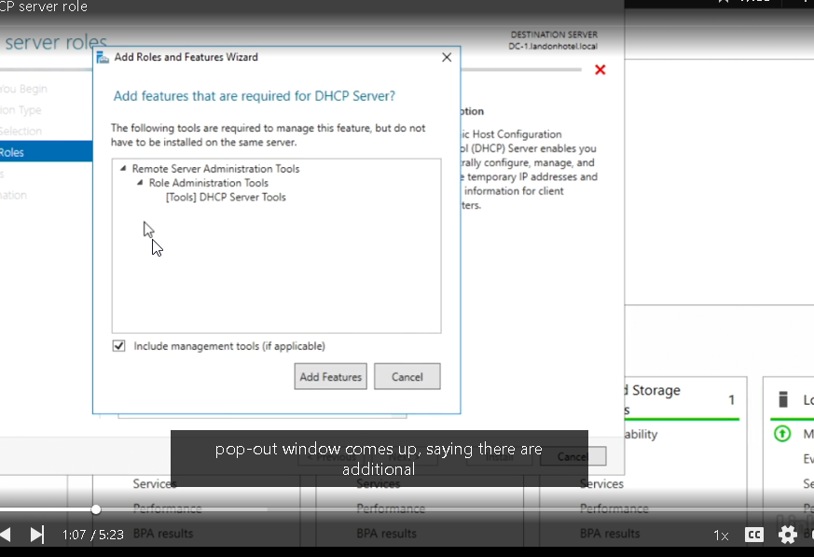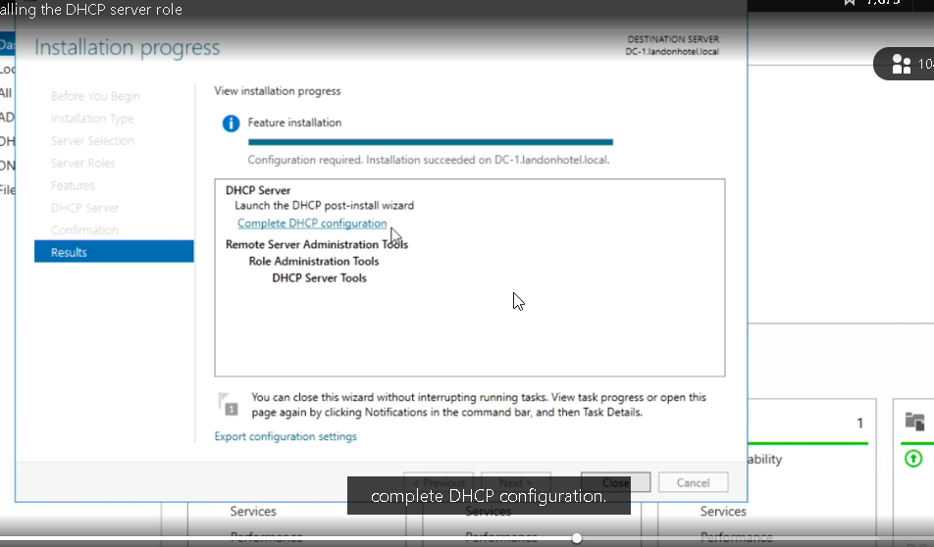
Figure 2.1 and 2.2
Create any name for the scope
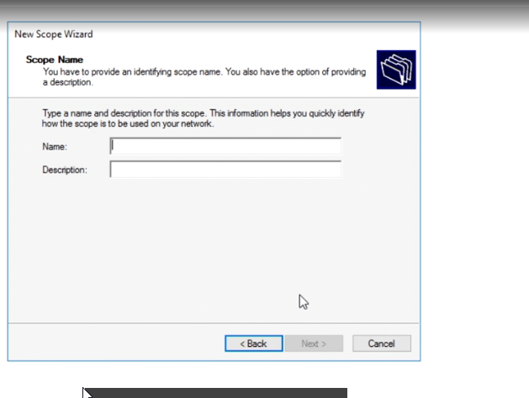

An IP addressing scheme is an organized plan for assigning IP addresses within a network. It ensures that every device has a unique address, enabling smooth communication across the network. So, as For the demonstration purposes on figure 3 Requirement 2 of the case study acme could use group C of ip addressing scheme range Using a Class C range of ip addressing, which provides up to 256 addresses per subnet, is particularly suitable for ACME’s needs. It offers enough IP addresses for devices at each location while allowing for easy expansion if more devices are added in the future.
Figure 3 Setting ip addressing range of ip address for the dhcp server
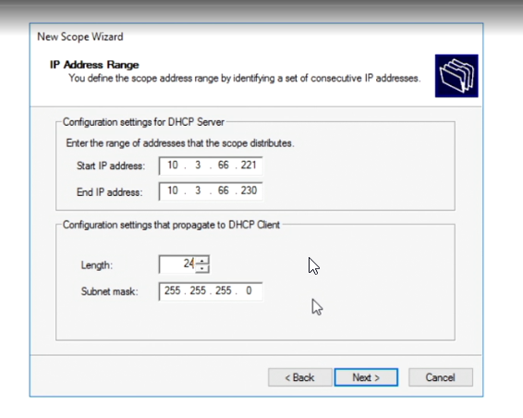

2.2 DNS Server
What, why and how
DNS, which stands for Domain Name System, (Cloudflare, no date) acts like a phonebook for the Internet in a company's network. It translates human-friendly website (Cloudflare, no date) names like for example "acme.com") into machine-readable IP addresses (like 192.168.1.1) that computers use to communicate with each other. Acme requires a DNS server to effectively manage domain names and their corresponding IP addresses within their network. This will enable users to easily access the company's public website for example acme.com internal intranet acme.intranet.com , and shared resources at the head office by using memorable domain names instead of numerical IP addresses. So dns(cloudflare, n.d.) This enables easier access to Acme's websites and resources, improving the overall user experience. (cloudflare, n.d.)

Building the dns server
Acme will require active directory in the Windows Server environment to install and configure DNS on the server effectively. As shown in the image, the initial step involves setting up a static IP address on the server, which is essential before proceeding with the installation of the web server, as illustrated in Figure 4
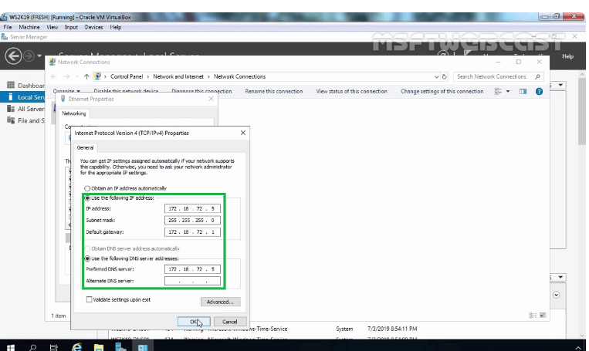

Next, we need to access Server Manager to install the DNS role, as shown in Figure 4.1 below

Figure 4.1 installing the dns server from the Server Manager roles and features
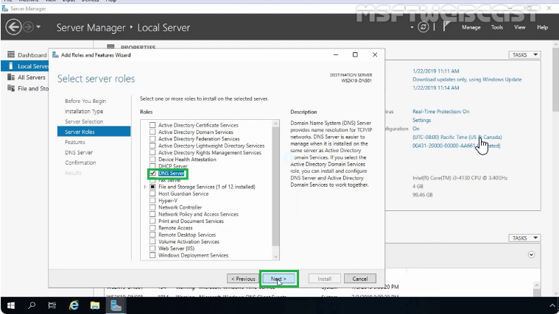

After completing the installation, we can create a new zone, such as acme.com, for Acme, as illustrated in Figure 4.2
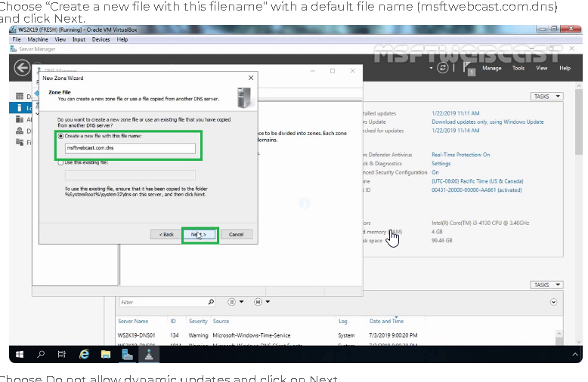

2.2 Web server
Web server is a specialized computer system that stores and serves websites and their content over the Internet. According (Gillis, 2020) states It is responsible for delivering webpages, images, videos, and other resources upon request, allowing users to access and view websites on their devices. (Gillis, 2020) Now that Because Acme requires an efficient network configuration website is important to ensure good connectivity and resource accessibility for its employees. For the case study requirement acme requires to support both public website and private intranet they would need to set up the web server in Bournemouth to manage traffic for both internally and externally for example if you shop online at ecommerce store like amazon you select, add the items in the cart to process when you make a payment the web server securely it sends a confirmatiuon to complete the order for this case acme need a web server to manage the request from both internal and external customers .

Web server process
According to the Research Web servers process HTTP requests by receiving the request, interpreting it, and returning the requested resource or error message. So , When a client, such as a web browser like acme.com , sends an HTTP request to a web server, the server first receives the request. This request is typically sent over the internet using the TCP/IP protocol. The server listens on a specific port (usually port 80 for HTTP and port 443 for HTTPS) for incoming requests. In the case Acme the web server Requirement 4 will be used to host a public website(acme.com) and private (intranet.acme) these web servers need to efficiently handle requests to provide reliable access to resources such for example when customers access acme.com their browsers send http request to the company’s web server responds by delivering the website content such as product details and contact information

Building a web server process

To begin setting up a functional network for ACME, one of the critical steps is to install and configure a web server, either on a Windows Server or a Linux-based system, as illustrated in Figure 3.1 This web server will play a central role in hosting ACME’s public website (acme.com) and its private intranet (intranet.acme), both of which are essential for meeting the company's business and operational needs.

Figure 3.1 shows the process of installing a web server using the Server Manager tool in Windows Server. This step is a crucial part for requirement 4 of ACME's network setup, as it lays the foundation for hosting both the company's public website (acme.com) and its private intranet (intranet.acme).
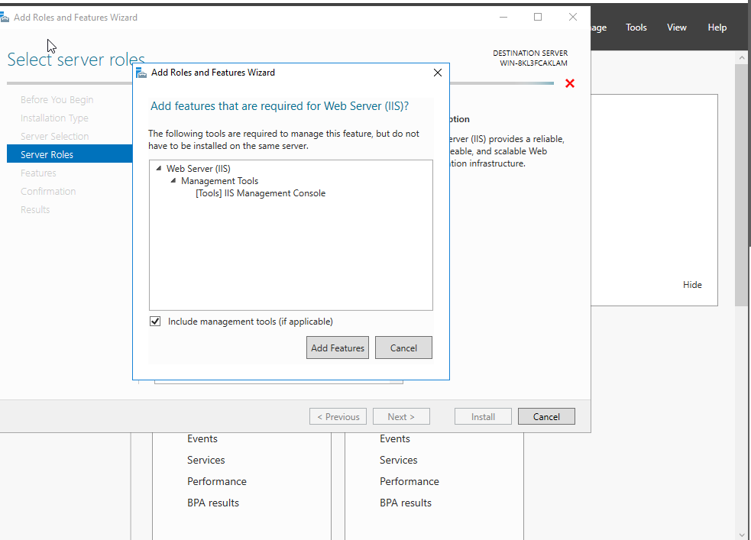

Once the web server installation is complete, a logo for the web server will appear, as shown in Figures 3.2 and 3.3. From there, you can click on the Tools menu to access the IIS Web Server Manager. This interface allows the configuration and management of the web server, ensuring that ACME employees can use the web server efficiently and effectively to support their operations.
Figure 3.2
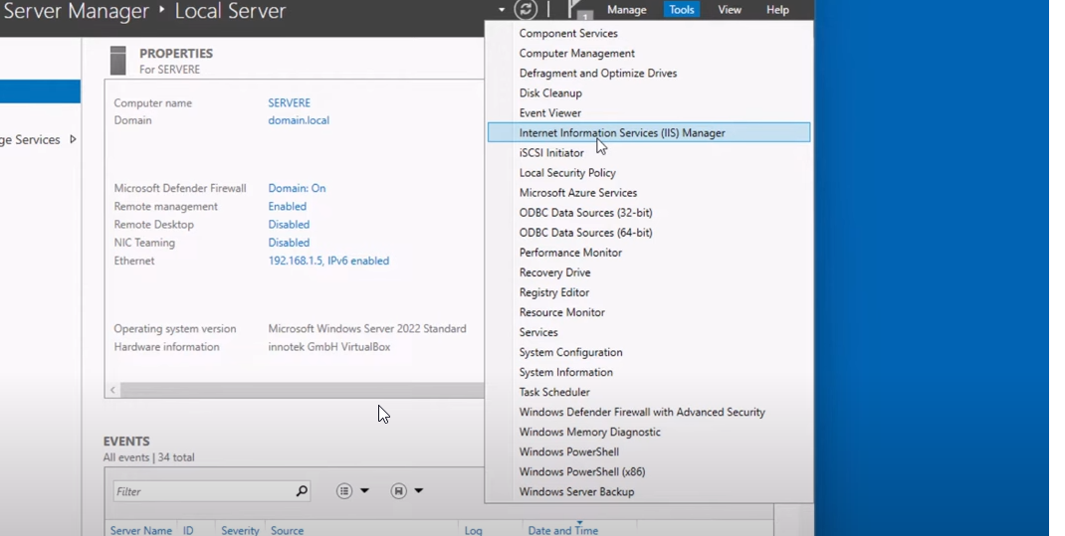
Figure 3.3
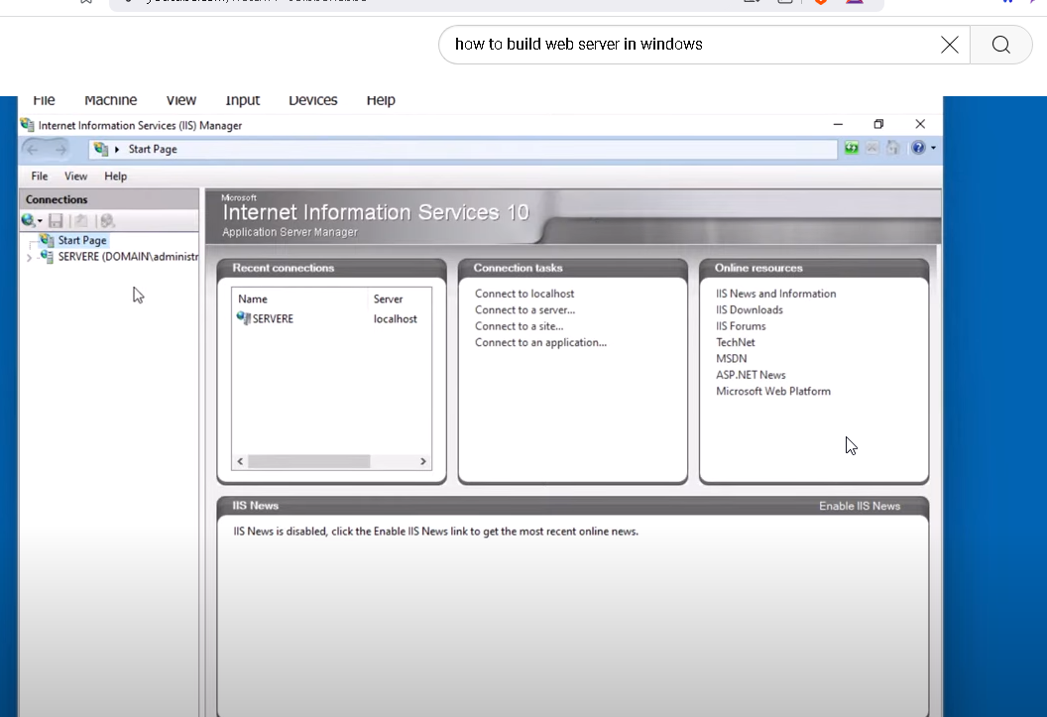

To configure a new site for ACME, such as the public website (acme.com), you would use the IIS Web Server Manager. As shown in Figure 4, the process involves right-clicking on the Sites node in the IIS Manager and selecting the option to Add Website. After specifying the site details (e.g., the site name, physical path, and binding information for acme.com) to meet the requirement of the case 4 and 5 that needs to be created through public website or private website clicking OK completes the setup. This process is shown in Figure 4, 4.1.
Figure 4
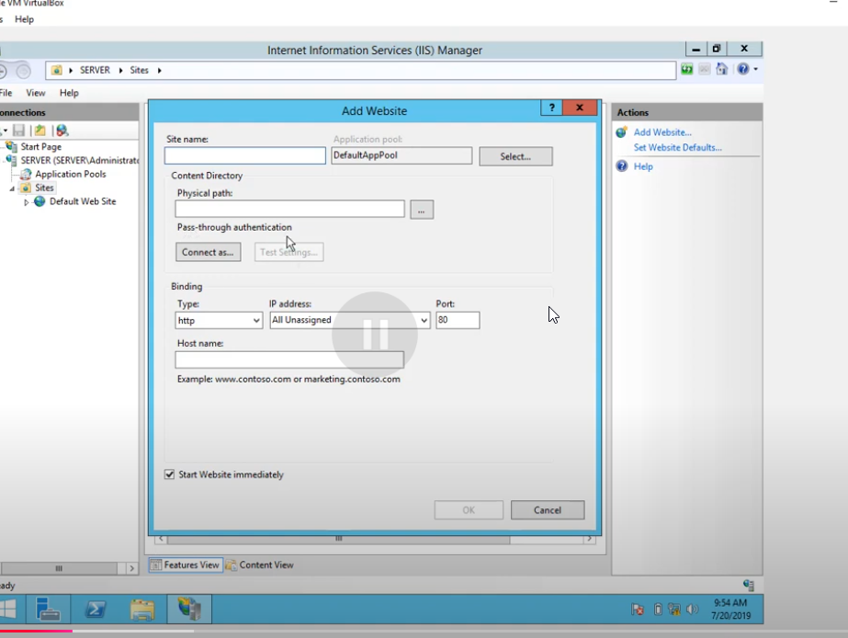

Figure 4.1 and 4.2 provides a demonstration of the testing process to ensure the website is functioning properly. For requirement 4,5 and 7 Testing is a critical step after configuring the web server to verify that both the public website (acme.com) and the private intranet (intranet.acme) are operational and meeting ACME’s requirements. Ensuring smooth performance is essential for delivering a reliable user experience to customers and employees. As shown in figure

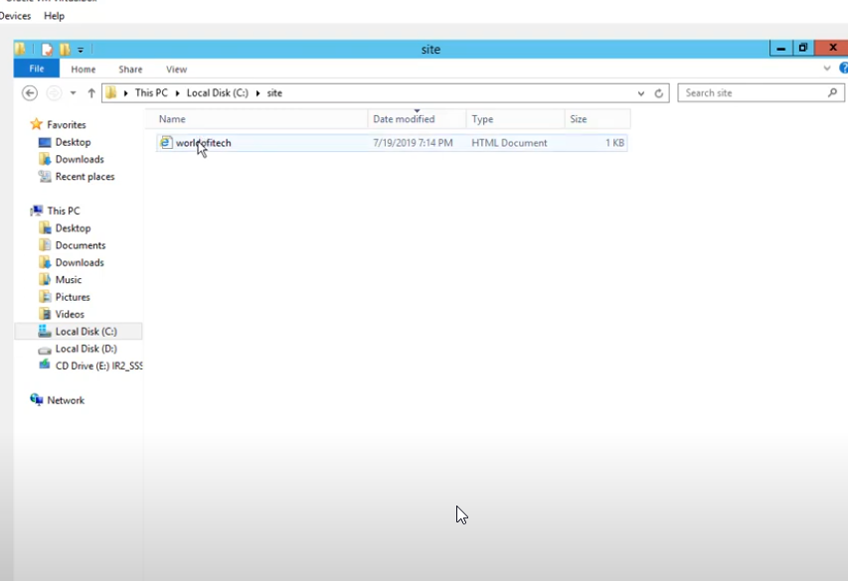
Figure 4.2
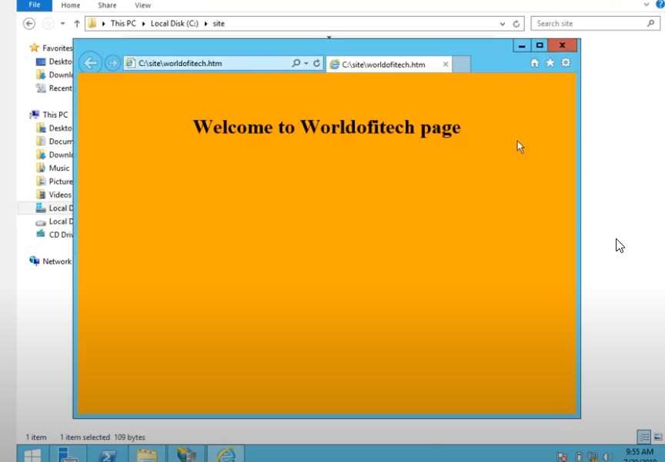

IP Addressing Scheme:
Ip addressing scheme is a system according to (Bhardwaj, 2014) is structured way for assigning Ip addresses to devices within a network (Bhardwaj, 2014) (freeCodeCamp.org, 2021)IPV4 consist of 32 bits example like : 192.168.1.1 and ipv6 128 bits is 2001:0db8:85a3:0000:0000:8a2e:0370:7334 (freeCodeCamp.org, 2021) As For Acme’s case Class B address range would be a suitable as it is medium sized from the figure as shown in in the table of Figure 4 below
(ComputerNetworkingNotes, 2024)
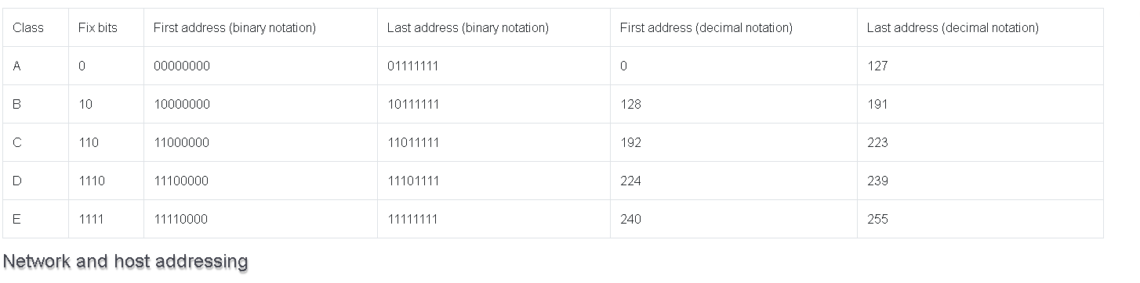

Support material and slides theme summary

Multiple Choice Quiz

DHCP Server

- What does DHCP do for computers in Acme's network?

A) Helps employees browse the Internet.
B) Makes the network safer.
C) Automatically assigns a unique number to each computer so it can communicate on the network.
D) Manages the company’s websites.

- What does DHCP stand for?

A) Dynamic Host Configuration Protocol
B) Don't Have a Clue Probably
C) Domain Hosting Configuration Protocol
D) Dynamic Hypertext Configuration Protocol

- Why is DHCP helpful for managing Acme's network?

A) It creates separate networks for different parts of the company.
B) It automatically gives computers their unique numbers.
C) It connects employees to the company’s websites.
D) It makes the network run faster.

- How did computers get their unique numbers before DHCP?

A) Through a web server.
B) Through a DNS server.
C) Manually by a network manager.
D) Through a VPN.

- What happens if a computer can't find the DHCP service?

A) The computer keeps its old unique number.
B) The computer picks a temporary random number.
C) The computer receives a number from a DNS server.
D) The computer connects to a different network.

DNS Server
1. What does DNS do for Acme's network?
A) It assigns unique numbers to each computer.
B) It manages the company's website.
C) It helps computers find websites by turning their names into numbers.
D) It helps with accessing shared company resources.

2. What does DNS stand for?
A) Dynamic Network Setup
B) Domain Name Server
C) Dynamic Network System
D) Domain Name System

3. How does DNS help Acme's employees when they use the internet for research and communication?
A) It controls who can log in to the network.
B) It changes website names into numbers so computers can visit them.
C) It connects employees to the company's VPN.
D) It assigns unique identifiers to devices.

4. Why is DNS important for Acme's public website?
A) It tells computers the number needed to access Acme’s website.
B) It keeps the website secure from hackers.
C) It makes copies of the website for faster access.
D) It restricts who can visit the website.

5. What happens if DNS isn't working on Acme's network?
A) People can't reach websites by typing their names.
B) Computers need to be given numbers by hand.
C) The network becomes more secure.
D) Access to shared resources is interrupted.

IIS Web Server

- In the Acme case study, what is the primary role of a web server for Acme's public website?
A. Managing user accounts
B. Hosting and displaying the website to visitors*
C. Controlling network access
D. Creating backups of files
- How does a web server contribute to Acme's website, which provides information about their products and services?
A. It serves as a storage and delivery mechanism for the website
B. It assigns unique identifiers to devices
C. It enables Acme's employees to share files
D. It changes the website's name to numbers
- What role does a web server play in Acme's private intranet, used by their employees to access internal resources?
A. Hosting and sharing intranet content with employees*
B. Managing network security
C. Creating Acme's public website
D. Assigning permissions for users
- If a web server encounters issues in Acme's network, how might it affect Acme's customers?
A. Employees might lose access to the intranet
B. Visitors could have trouble accessing Acme's website
C. The network may become more secure
D. Users could experience problems sharing files
- Which of the following best describes the main function of a web server in Acme's network, which includes a public website and a private intranet?*
A. It directs network accessibility
B. It converts website names to numerical addresses
C. It acts as a storage and delivery system for website content*
D. It enables users to establish secure connections

Multiple Choice Quiz Answers

DHCP Server

- C. Automatically assigns a unique number to each computer so it can communicate on the network.
- A. Dynamic Host Configuration Protocol
- B It automatically gives computers their unique number
- C. Manually by network managers
- B. The computer picks a temporary random number

DNS Server
- C. It helps computers find websites by turning their names into numbers
- D. Domain Name System
- B. It changes website names into numbers so computers can visit them
- A. It tells computers the number needed to access Acme’s website
- A. People can’t reach websites by typing their names

IIS Web Server

- B. Hosting and displaying the website to visitors
- A. It serves as a storage and delivery mechanism for the website
- A. Hosting and sharing intranet content with employees
- B. Visitors could have trouble accessing Acme's website
- C. It acts as a storage and delivery system for website content

Further Material and sources

Presentation slides
Chirag, Bhalodia (2024) How to configure DNS Server | Step by step DNS server configuration. [online] YouTube. Available at: https://www.youtube.com/watch?v=CyEacSDD0V4
Network for you (2023) How to Configure DHCP in CISCO router in Packet Tracer | DHCP Server in CCNA | DHCP Configuration. [online] Available at: https://www.youtube.com/watch?v=DsL_JEdMPXg
Danny.Moron (2022) How to setup DHCP failover step by step guide (Windows Server 2022). [online] Available at: https://www.youtube.com/watch?v=S7Eh7ubTVtY

‌Swati ,Tripathi (2021) Http / Web server configuration in cisco packet tracer. [online] YouTube. Available at: https://www.youtube.com/watch?v=vyzvdbnOTXY&list=PL9mwJgoGG8Qf5aratV_TbeZCxBxOckgzN&index=4

‌
DNS and BIND (2024) Google Books. Available at: https://books.google.co.uk/books?hl=en&lr=&id=u0GbAgAAQBAJ&oi=fnd&pg=PT4&dq=build+dns+server+&ots=6-yWBAvZQD&sig=bTz1gBLFKymlhtC_oqxJ9MV6vik&redir_esc=y#v=onepage&q=build%20dns%20server&f=false

Web Server Technology (2024) Google Books. Available at: https://books.google.co.uk/books?hl=en&lr=&id=0jExRH3_-hQC&oi=fnd&pg=PR13&dq=building+web+server&ots=74LQunX48e&sig=1kTRurn5jZWaY2kbEGVJkCxp47o&redir_esc=y#v=onepage&q=building%20web%20server&f=false

Torogi ,Pro (2024) What is DHCP and How does it work? [online] YouTube. Available at: https://www.youtube.com/watch?v=HCXlTOBSlf4

Hoang.H, Duc. D and Nang (2024). VIETNAM -KOREA UNIVERSITY OF INFORMATION AND COMMUNICATION TECHNOLOGY FACULTY OF COMPUTER ENGINEERING AND ELECTRONICS & GRADUATION THESIS TOPIC RESEARCH AND BUILD A THREE-LAYER NETWORK SYSTEM FOR BUSINESSES. [online] Available at: https://elib.vku.udn.vn/bitstream/123456789/4105/1/21IT.T012-19IT6-Duong%20Huu%20Thai-DATN.pdf

‌

‌

‌

Appendices

Appendix A

DHCP Server – Appendix B

Appendix B

DNS Server -Appendix C

Appendix C

IIS Web Server -Appendix D

Multiple Choice Quiz Answers

DHCP Server – Appendix E

DNS Server -Appendix F

IIS Web Server -Appendix G

Reference

(Paessler AG, n.d). Available at: https://www.paessler.com/it-explained/server

(Microsoft ,2021). Dynamic Host Configuration Protocol (DHCP). [online] learn.microsoft.com. Available at: https://learn.microsoft.com/en-us/windows-server/networking/technologies/dhcp/dhcp-top.

‌Cloudflare DNS: Authoritative and secondary DNS (no date) Cloudflare. Available at: https://www.cloudflare.com/application-services/products/dns/ (Accessed: 14 November 2024).

(Networks,2023). DHCP server and client communication diagram found YouTube. Available at: https://www.youtube.com/watch?v=ldtUSSZJCGg

Chirag Bhalodia (2024). How to configure DNS Server | Step by step DNS server configuration. [online] YouTube. Available at: https://www.youtube.com/watch?v=CyEacSDD0V4 [Accessed 15 Nov. 2024]

‌

https://learn.microsoft.com/en-us/troubleshoot/windows-client/networking/tcpip-addressing-and-subnetting

https://www.solarwinds.com/resources/it-glossary/web-server

https://www.zenarmor.com/docs/network-basics/what-is-dns

Gillis, A.S. (2020). What is a web server and how does it work? [online] techtarget.com. Available at: https://www.techtarget.com/whatis/definition/Web-server

Bhardwaj, R. (2014). IP ADDRESSING SCHEME – IPv4 - IP With Ease. [online] ipwithease.com. Available at: https://ipwithease.com/ip-addressing-scheme-ipv4/.

freeCodeCamp.org. (2021). IPV4 vs IPV6 – What is the Difference Between IP Addressing Schemes? [online] Available at: https://www.freecodecamp.org/news/ipv4-vs-ipv6-what-is-the-difference-between-ip-addressing-schemes/

ComputerNetworkingNotes. (n.d.). IP Address Classes Explained with Examples. [online] Available at: https://www.computernetworkingnotes.com/networking-tutorials/ip-address-classes-explained-with-examples.html.

https://www.shutterstock.com/search/dhcp?image_type=vector
https://stock.adobe.com/images/dns-icon-trendy-dns-logo-concept-on-white-background-from-web-hosting-collection/231435649
https://www.pngegg.com/en/png-zsiwz
https://www.parkplacetechnologies.com/blog/what-is-dhcp-how-works-benefits/

Wynn, J. (2021). What is a DHCP Server? | Petri IT Knowledgebase. [online] PETRI. Available at: https://petri.com/what-is-a-dhcp-server/.

InfoBlox (2017). What is a DHCP Server? | Learn What They Are & How They Work | Infoblox. [online] Infoblox. Available at: https://www.infoblox.com/glossary/dhcp-server/

Pramatarov, M. (2021). What is DHCP? How does the DHCP server work? [online] ClouDNS Blog. Available at: https://www.cloudns.net/blog/dhcp-server/.

Techopedia.com. (n.d.). What is a DNS Server? - Definition from Techopedia. [online] Available at: https://www.techopedia.com/definition/28503/dns-server.

cloudflare (n.d.). What is a DNS Server? | Cloudflare UK. Cloudflare. [online] Available at: https://www.cloudflare.com/en-gb/learning/dns/what-is-a-dns-server/.

Anon, (n.d.). Install and configure the dns server role in windows server 2019. [online] Available at: https://msftwebcast.com/2019/10/install-and-setup-dns-service-on-windows-server-2019.html.
ComputerNetworkingNotes. (2024). IP Address Classes Explained with Examples. [online] Available at: https://www.computernetworkingnotes.com/networking-tutorials/ip-address-classes-explained-with-examples.html.

‌

‌

‌

‌

‌

‌

‌

‌

