Problem 1

Computing end­end delay (transmission and propagation delay)

Consider the figure below, with three links, each with the specified transmission rate and link length.
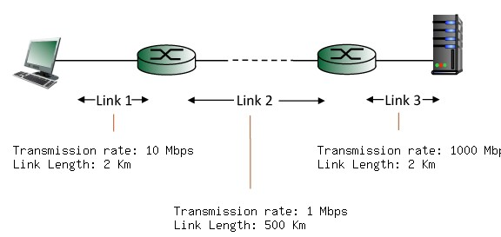
Find the end­to­end delay (including the transmission delays and propagation delays on each of the three links, but ignoring queueing delays and processing delays) from when the left host begins transmitting the first bit of a packet to the time when the last bit of that packet is received at the server at the right. The speed of light propagation delay on each link is 3x10**8 m/sec. Note that the transmission rates are in Mbps and the link distances are in Km. Assume a packet length of 12000 bits. Give your answer in milliseconds.

Problem 2

End to End Throughput and Bottleneck Links

Consider the scenario shown below, with four different servers connected to four different clients over four three­hop paths. The four pairs share a common middle hop with a transmission capacity of R = 400 Mbps. The four links from the servers to the shared link have a transmission capacity of RS = 60 Mbps. Each of the four links from the shared middle link to a client has a transmission capacity of RC = 20 Mbps per second. What is the maximum achievable end­end throughput (in Mbps) for each of four client­to­ server pairs, assuming that the middle link is fair­shared (i.e., divides its transmission rate equally among the four pairs). Which link is the bottleneck link for each session?

