Arduino core for the ESP32

Need help or have a question? Join the chat at

Contents
- Development Status
- Installation Instructions
- Decoding Exceptions
- Issue/Bug report template
- ESP32Dev Board PINMAP

Development Status
Latest Stable Release
Latest Development Release

Installation Instructions
- Using Arduino IDE Boards Manager (preferred)
  - Instructions for Boards Manager
- Using Arduino IDE with the development repository
  - Instructions for Windows
  - Instructions for Mac
  - Instructions for Debian/Ubuntu Linux
  - Instructions for Fedora
  - Instructions for openSUSE
- Using PlatformIO
- Building with make
- Using as ESP-IDF component
- Using OTAWebUpdater

Decoding exceptions
You can use EspExceptionDecoder to get meaningful call trace.

Issue/Bug report template
Before reporting an issue, make sure you've searched for similar one that was already created. Also make sure to go through all the issues labelled as for reference.
Finally, if you are sure no one else had the issue, follow the ISSUE_TEMPLATE while reporting any issue.

ESP32Dev Board PINMAP
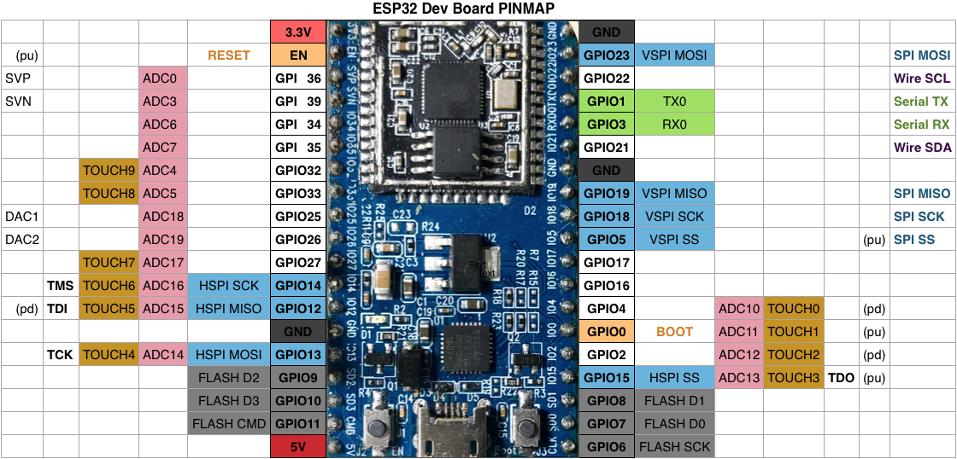

Tip
Sometimes to program ESP32 via serial you must keep GPIO0 LOW during the programming process

