Remap keys for Function key usage in RDM

RDM is Remote Desktop Mobile

# Intermec Keyboard Remapper

There is no need to redefine the Function Keys with the Remapper Utility. The solution uses a keyboard hook that will be only active if the Demote Desktop Mobile Window is in foreground with an active session.

# iHookRemapKeys

This keyboard hook application captures the KEY_DOWN and KEY_UP messages of the hardware keyboard. The Function Keys F1 to F12 will then be consumed and 0xF1 to 0xFC Char messages will be send to the RDM keyboard target window.

It is not possible to send KEYDOWN and KEYUP messages for non-char keys to RDM. RDM only translates char messages for the Terminal Server host.

If RDM is not running in foreground, the hook application will not alter the Function Key presses.

After start a new notification icon is added to the home screen, an "U" inside a yellow box. The frame around will change the color indicating if iHookRemapKeys was able to find the RDM window and if RDM is the foreground Window.

# RDM tscshift.txt

Modify \windows\tscshift.txt to map the 'chars' 0xF1 to 0xFC to index 0x70 to 0x7B:

0x7d 0xdd 1  
0x7e 0xde 1  
0x7F 0x2E 0  
0x80 0x00 0  
0x81 0x00 0  
...  
0xEF 0x00 0  
0xF0 0x00 0  
0xF1 0x70 0  
0xF2 0x71 0  
0xF3 0x72 0  
0xF4 0x73 0  
0xF5 0x74 0  
0xF6 0x75 0  
0xF7 0x76 0  
0xF8 0x77 0  
0xF9 0x78 0  
0xFA 0x79 0  
0xFB 0x7A 0  
0xFC 0x7B 0  
0xFD 0x00 0  
0xFE 0x00 0  
0xFF 0x00 0

The above tscshift.txt was extended with all values above 0x7F. This is not necessary. Just add the new lines as needed maintaining the sort.

Instead of mapping the 'chars' from 0xF1 to 0xFC it is also possible to map to other 'unused' 'chars'. Here 0xF1 to 0xFC make the 'chars' ñ, ò, ó, ô, õ, ö, ÷, ø, ù, ú, û, ü unusable as these are 'interpreted' as Function Key presses by RDM. See also "Upper char map" in appendix.

# RDM tscscan.txt

Modify lines 0x70 (112) to 0x7B (115) in \windows\tscscan.txt. The line count starts at 0 and comment lines (lines beginning with "//") are not counted. The line counted is the index that tscshift.txt is pointing to.

...  
0x00 0x00 // 0x6e - VK_DECIMAL  
0x00 0x00 // 0x6f - VK_DIVIDE  
0x3B 0x70 // 0x70 - VK_F1  
0x3C 0x71 // 0x71 - VK_F2  
0x3D 0x72 // 0x72 - VK_F3  
0x3E 0x73 // 0x73 - VK_F4  
0x3F 0x74 // 0x74 - VK_F5  
0x40 0x75 // 0x75 - VK_F6  
0x41 0x76 // 0x76 - VK_F7  
0x42 0x77 // 0x77 - VK_F8  
0x43 0x78 // 0x78 - VK_F9  
0x44 0x79 // 0x79 - VK_F10  
0x57 0x7A // 0x7a - VK_F11  
0x58 0x7B // 0x7b - VK_F12  
0x00 0x00 // 0x7c - VK_F13  
0x00 0x00 // 0x7d - VK_F14  
...

The first byte is the scancode to be used for this key. The scan codes used here are the ones for the F1 to F12 keys as defined for a PS/2 keyboard.

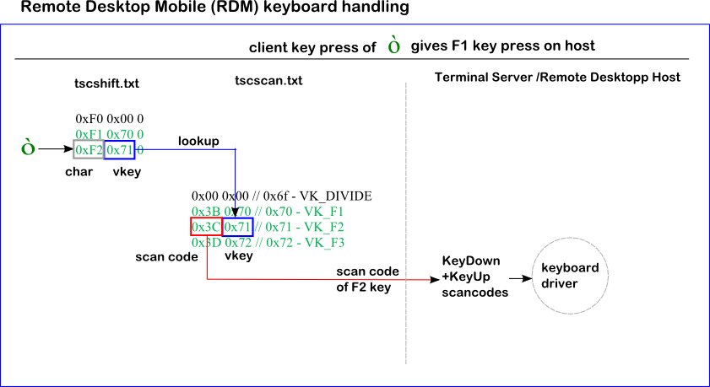

# Test against Terminal Server/Remote Desktop host

The below shows that the hardware Function Keys on the Windows Mobile keypad now are sent to the Terminal Server. The test application shows the keyboard messages received.

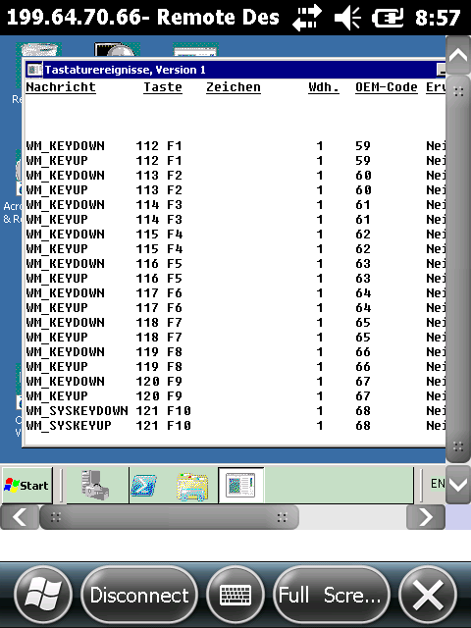

Note: F11 and F12 are not processed by this test application.

# Define a Function Key as Pre- or Postamble

## Virtual Wedge settings

To define a Function Key, for example, as Postamble, open "Start">"Settings">"System">"Intermec Settings" and scroll down to "Virtual Wedge". Ensure "Enable Virtual Wedge" is selected. The "Virtual Wedge Method" should be set to "Character Mode". Inside "Barcode Scanner Wedge" set ".*=>\1\xf1" as "Barcode Scanner Grid". This will add the 0xF1 char code at the end of every scanned barcode. This 0xF1 is routed thru tscshift.txt and the index there points to line 0x70 of tscscan.txt. Via tscscan.txt RDM will send the scan code 0x3B to the host. The host sees that scan code and translates it to the F1 key.

Additionally to "Adapt to application" a custom vwConfig.ini for "TSSHELLWND" can be used.

[VWConfig]  
;dump config to vwCustom.log.txt and vwDefault.log.txt  
DumpConfig="1"  
  
;Only the default application is allowed to have a NULL string for the window name.  
;the text between [ and ] specifies either a window title or class name. If you use   
;DEFAULT_APPLICATION, then the setting is applied, if no other section matches  
[DEFAULT_APPLICATION]  
WindowName="**TSSHELLWND**"  
  
;__GlobalXmitMethod__  
;GlobalXmitMethod is a string and used similarly to the GlobalFlag.   
;Setting this variable to will force all sequences from 0-255 to use this transmit method.  
;The following are the only transmit method strings allowed:  
;EVENT  
;POST  
;SEND  
;CLIP  
;These strings are not case sensitive and must be surrounded by quotes.  
  
GlobalXmitMethod="EVENT"  
  
;__GlobalXmitType__  
;GlobalXmitType is a string and used similarly to the GlobalXmitMethod. Setting this variable will force all sequences from 0-255 to use this transmit type.  
;Characters above this can be modified using the UpperKeySeq variable. Except for one case, the following are the only transmit type strings allowed:  
;PLAIN - character sent with any modifiers such as shift, ctrl, alt, etc.  
;SHIFT - character sent with the "shift" modifier  
;CTRL - character sent with the "control" modifier  
;CTRL_SHIFT - character sent with both the "shift" and "control" modifiers  
;ALT - character sent with the "alternate" modifier  
;CTRL_ALT - character sent with both the "control" and "alternate" modifiers  
;UNSHIFT - sends the "shift" release only  
;SYNTH - character is sent using "synthesize" to generate the character. This is useful mostly for characters above 127.  
;PACKET - this is used by the PostKeybdMessage() API on some platforms. The virtual key is set to VK_PACKET and the number value of the character is included in the API call.  
;Table - uses a table for transmit type  
  
GlobalXmitType="Table"  
  
;;;exceptions to the above for TAB and CR  
;RegSeq="0x09 POST PLAIN 0X09 0X00 0x0000"  
;RegSeq="0x0D POST PLAIN 0X0D 0X00 0x0000"

The default vwConfig settings use the clipboard and that will not be compatible with the above custom tscshift.txt setup.

# Appendix

## Upper Char Map

|  |  |  |  |  |  |  |  |  |  |  |  |  |  |  |
| --- | --- | --- | --- | --- | --- | --- | --- | --- | --- | --- | --- | --- | --- | --- |
| **hex** | **dec** | **char** |  | **hex** | **dec** | **char** |  | **hex** | **dec** | **char** |  | **hex** | **dec** | **char** |
| 0x80 | 128 | € |  | 0xA0 | 160 |  |  | 0xC0 | 192 | À |  | 0xE0 | 224 | à |
| 0x81 | 129 |  |  | 0xA1 | 161 | ¡ |  | 0xC1 | 193 | Á |  | 0xE1 | 225 | á |
| 0x82 | 130 | ‚ |  | 0xA2 | 162 | ¢ |  | 0xC2 | 194 | Â |  | 0xE2 | 226 | â |
| 0x83 | 131 | ƒ |  | 0xA3 | 163 | £ |  | 0xC3 | 195 | Ã |  | 0xE3 | 227 | ã |
| 0x84 | 132 | „ |  | 0xA4 | 164 | ¤ |  | 0xC4 | 196 | Ä |  | 0xE4 | 228 | ä |
| 0x85 | 133 | … |  | 0xA5 | 165 | ¥ |  | 0xC5 | 197 | Å |  | 0xE5 | 229 | å |
| 0x86 | 134 | † |  | 0xA6 | 166 | ¦ |  | 0xC6 | 198 | Æ |  | 0xE6 | 230 | æ |
| 0x87 | 135 | ‡ |  | 0xA7 | 167 | § |  | 0xC7 | 199 | Ç |  | 0xE7 | 231 | ç |
| 0x88 | 136 | ˆ |  | 0xA8 | 168 | ¨ |  | 0xC8 | 200 | È |  | 0xE8 | 232 | è |
| 0x89 | 137 | ‰ |  | 0xA9 | 169 | © |  | 0xC9 | 201 | É |  | 0xE9 | 233 | é |
| 0x8A | 138 | Š |  | 0xAA | 170 | ª |  | 0xCA | 202 | Ê |  | 0xEA | 234 | ê |
| 0x8B | 139 | ‹ |  | 0xAB | 171 | « |  | 0xCB | 203 | Ë |  | 0xEB | 235 | ë |
| 0x8C | 140 | Œ |  | 0xAC | 172 | ¬ |  | 0xCC | 204 | Ì |  | 0xEC | 236 | ì |
| 0x8D | 141 |  |  | 0xAD | 173 | ­ |  | 0xCD | 205 | Í |  | 0xED | 237 | í |
| 0x8E | 142 | Ž |  | 0xAE | 174 | ® |  | 0xCE | 206 | Î |  | 0xEE | 238 | î |
| 0x8F | 143 |  |  | 0xAF | 175 | ¯ |  | 0xCF | 207 | Ï |  | 0xEF | 239 | ï |
| 0x90 | 144 |  |  | 0xB0 | 176 | ° |  | 0xD0 | 208 | Ð |  | 0xF0 | 240 | ð |
| 0x91 | 145 | ‘ |  | 0xB1 | 177 | ± |  | 0xD1 | 209 | Ñ |  | 0xF1 | 241 | ñ |
| 0x92 | 146 | ’ |  | 0xB2 | 178 | ² |  | 0xD2 | 210 | Ò |  | 0xF2 | 242 | ò |
| 0x93 | 147 | “ |  | 0xB3 | 179 | ³ |  | 0xD3 | 211 | Ó |  | 0xF3 | 243 | ó |
| 0x94 | 148 | ” |  | 0xB4 | 180 | ´ |  | 0xD4 | 212 | Ô |  | 0xF4 | 244 | ô |
| 0x95 | 149 | • |  | 0xB5 | 181 | µ |  | 0xD5 | 213 | Õ |  | 0xF5 | 245 | õ |
| 0x96 | 150 | – |  | 0xB6 | 182 | ¶ |  | 0xD6 | 214 | Ö |  | 0xF6 | 246 | ö |
| 0x97 | 151 | — |  | 0xB7 | 183 | · |  | 0xD7 | 215 | × |  | 0xF7 | 247 | ÷ |
| 0x98 | 152 | ˜ |  | 0xB8 | 184 | ¸ |  | 0xD8 | 216 | Ø |  | 0xF8 | 248 | ø |
| 0x99 | 153 | ™ |  | 0xB9 | 185 | ¹ |  | 0xD9 | 217 | Ù |  | 0xF9 | 249 | ù |
| 0x9A | 154 | š |  | 0xBA | 186 | º |  | 0xDA | 218 | Ú |  | 0xFA | 250 | ú |
| 0x9B | 155 | › |  | 0xBB | 187 | » |  | 0xDB | 219 | Û |  | 0xFB | 251 | û |
| 0x9C | 156 | œ |  | 0xBC | 188 | ¼ |  | 0xDC | 220 | Ü |  | 0xFC | 252 | ü |
| 0x9D | 157 |  |  | 0xBD | 189 | ½ |  | 0xDD | 221 | Ý |  | 0xFD | 253 | ý |
| 0x9E | 158 | ž |  | 0xBE | 190 | ¾ |  | 0xDE | 222 | Þ |  | 0xFE | 254 | þ |
| 0x9F | 159 | Ÿ |  | 0xBF | 191 | ¿ |  | 0xDF | 223 | ß |  | 0xFF | 255 | ÿ |

## Scan codes (PS/2)

