Remap keys for Funcion key usage in RDM

# Intermec Keyboard Remapper

(CK71 numeric-funckeys keypad)

<?xml version="1.0" encoding="UTF-8"?>  
<KBDMap Keyboard="C2-Numeric\0001" Date="2003/01/01 12:57:52" Absolute="0">  
 <Normal>  
 <KEY Page="7" Usage="0" Value="0"/>  
 <KEY Page="7" Usage="1" Value="0"/>  
 <KEY Page="7" Usage="2" Value="0"/>  
 <KEY Page="7" Usage="3" Value="0"/>  
 <KEY Page="7" Usage="36" Value="61"/>  
 <KEY Page="7" Usage="37" Value="62"/>  
 <KEY Page="7" Usage="38" Value="70"/>  
 <KEY Page="7" Usage="33" Value="37"/>  
 <KEY Page="7" Usage="34" Value="46"/>  
 <KEY Page="7" Usage="35" Value="54"/>  
 <KEY Page="7" Usage="30" Value="22"/>  
 <KEY Page="7" Usage="31" Value="30"/>  
 <KEY Page="7" Usage="32" Value="38"/>  
 <KEY Page="7" Usage="44" Value="41"/>  
 <KEY Page="7" Usage="55" Value="73"/>  
 <KEY Page="7" Usage="39" Value="69"/>  
 <KEY Page="7" Usage="45" Value="78"/>  
 <KEY Page="7" Usage="40" Value="90"/>  
 <KEY Page="7" Usage="234" Value="241" NoRepeat="1" VKEY="1"/>  
 <KEY Page="7" Usage="235" Value="242" NoRepeat="1" VKEY="1"/>  
 <KEY Page="7" Usage="236" Value="243" NoRepeat="1" VKEY="1"/>  
 <KEY Page="7" Usage="237" Value="244" NoRepeat="1" VKEY="1"/>  
 <KEY Page="7" Usage="238" Value="234" NoRepeat="1" VKEY="1"/>

The F1 to F4 keys will now send VKEY 241 (0xF1) to VKEY 244 (0xF4).

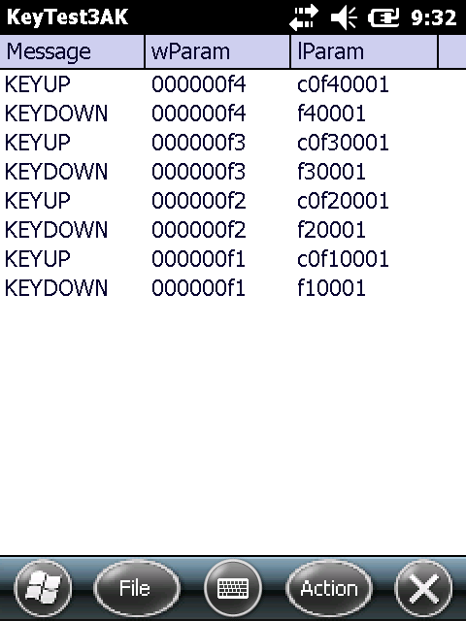

# RDM tscshift.txt

Modify \windows\tscshift.txt to map these 'chars' to index 0x70 to 0x73:

0xF1 0x70 0  
0xF2 0x71 0  
0xF3 0x72 0  
0xF4 0x73 0

# RDM tscscan.txt

Modify lines 0x70 (112) to 0x73 (115) in \windows\tscscan.txt. The line count starts at 0 and comment lines are not counted.

0x3B 0x70 // 0x70 - VK_F1  
0x3C 0x71 // 0x71 - VK_F2  
0x3D 0x72 // 0x72 - VK_F3  
0x3E 0x73 // 0x73 - VK_F4

The first byte is the scancode to be used for this key.

Test against Terminal Server

Does not work. Only sees F1 to F2 key presses if ALT key pressed too.

