# ews_grabber documentation

ews_grabber is a tool to grab emails with attached license files and extracts the licenses into a database. This database can be search for a license, device or other present data. You can export single or multiple license data into a xml file of your choice.

Table of Contents

ews_grabber documentation 1

First start and setup 3

Settings 3

Domain name 3

User name 3

Database file 3

Exchange Web Service 3

Service URL 3

Use Web Proxy 4

Proxy URL 4

Proxy Port 4

Logon/Connect 5

Logon dialog 5

Main Window 5

Color Status Field 6

Text status 6

Browse tab 7

Search 7

No Filter 8

Export License Data 8

Log tab 8

Data refresh 9

Requirements 9

License eMail definition 9

eMail Body 9

Attached xml 10

Changes to processed eMails 10

## First start and setup

When you start ews_grabber the first time with a new database, you will see an empty list.

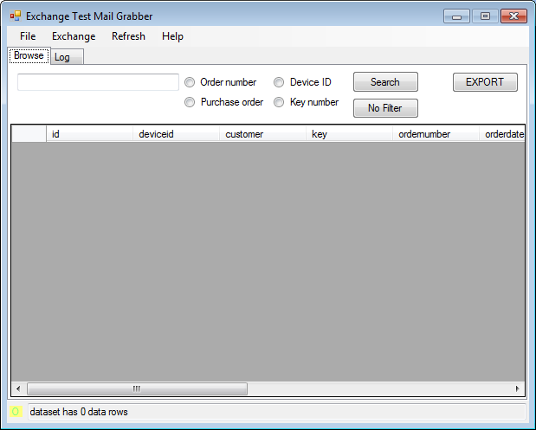

Please change the global settings before you go on. Select the Settings option in the File menu.

# Settings

## Domain name

Enter the domain name for the user account you want to use. This domain name will preset the logon dialog. The normal honeywell domain is "Global".

## User name

Enter the user name that will be used as default in the logon dialog. This will be you E ID name.

## Database file

EWS_Grabber uses a single database file to store and retrieve data. You can use a database file on a shared resources and share the same file with other users on the network. If you omit the directory and enter a file name only, the database file will be created used from the directory where ews_grabber was started.  
Click the [...] button to select a directory and file name.

## Exchange Web Service

### Service URL

The Service URL is preset for the Honeywell exchange network.

### Use Web Proxy

If you are not directly connected to the honeywell network but using remote access you may have to enable this option.

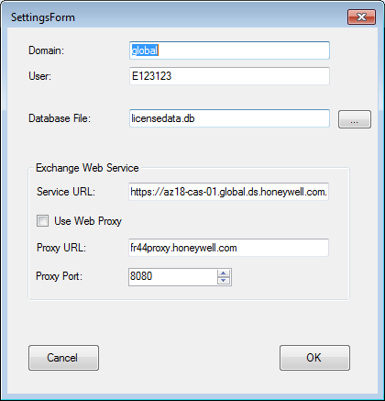

### Proxy URL

Enter the web proxy URL for the network if you are using remote access.

### Proxy Port

Enter the web proxy port for the network if you are using remote access.

Close the dialog using the OK button to save the settings.

# Logon/Connect

After you have set your defaults you can logon to the web service and let ews_grabber start processing eMails. To logon click on Exchange in the menu and then on the Connect item.

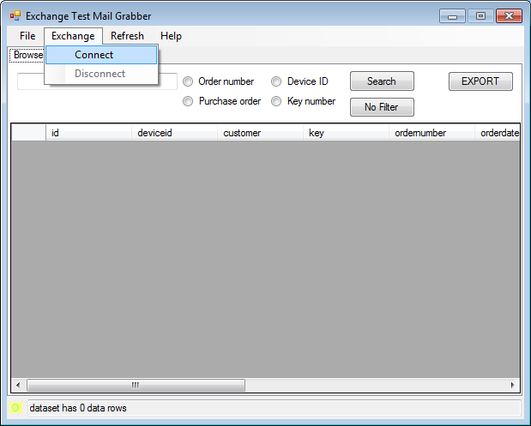

## Logon dialog

To be able to grab emails of the echange server you must specify a valid user logon. Fill in Domain, User and Password and click OK to start the connect.

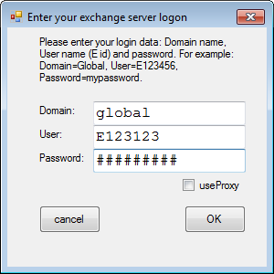

# Main Window

The main window comes with a menu and two tabs, one for data browsing and one with a text log. At the bottom you see a status indicator on the left and a text status line.

## Color Status Field

The indicator at the bottom left corner changes between  
yellow idle/not connected  
green connected  
red disconnected.

## Text status

The text in the status field shows different messages and let you know, waht ews_grabber is doing.

## Browse tab

In this tab you can list all known licenses.

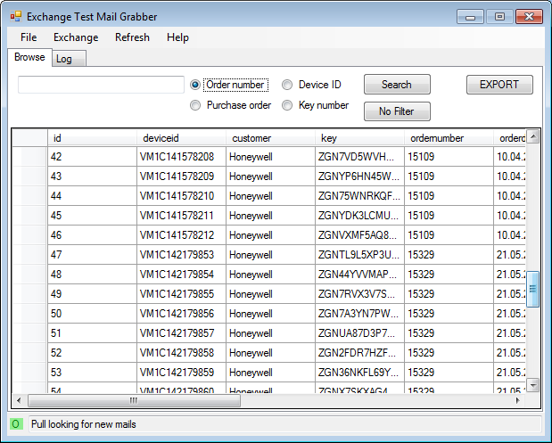

### Search

You can search for a license using either

* Order Number
* Purchase Order number
* Device ID
* License Key number

Enter the search text in the field to the left and select which data field you would like to search. Then press the [Search] button. The data grid will then show the filtered data.

Sample filter using "Order Number" and the criteria "15329":

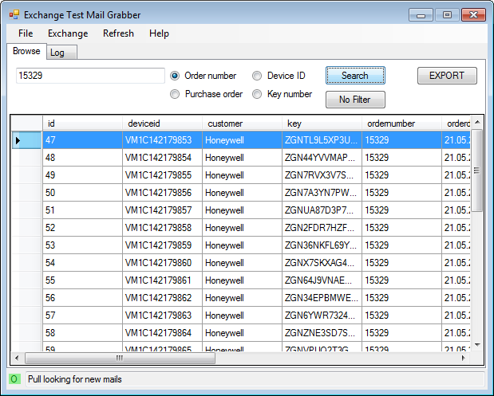

### No Filter

If you finished with filtering the data and want to see all data again then press the [No Filter] button.

## Export License Data

To export one or more license data first select one or more rows in the data grid using Ctrl+click, Shift+click or a single click. Then click the [Export] button or right-click any selected row and select Export from the popup menu.

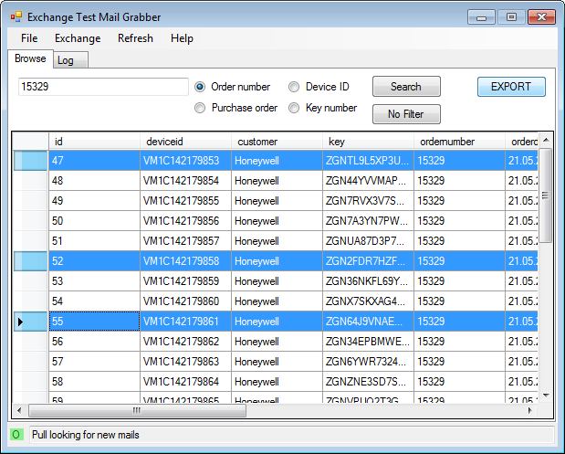

You will then be asked for the destination location and file name for the export license file. Browse to the desired directory and enter a file name and then click [OK].

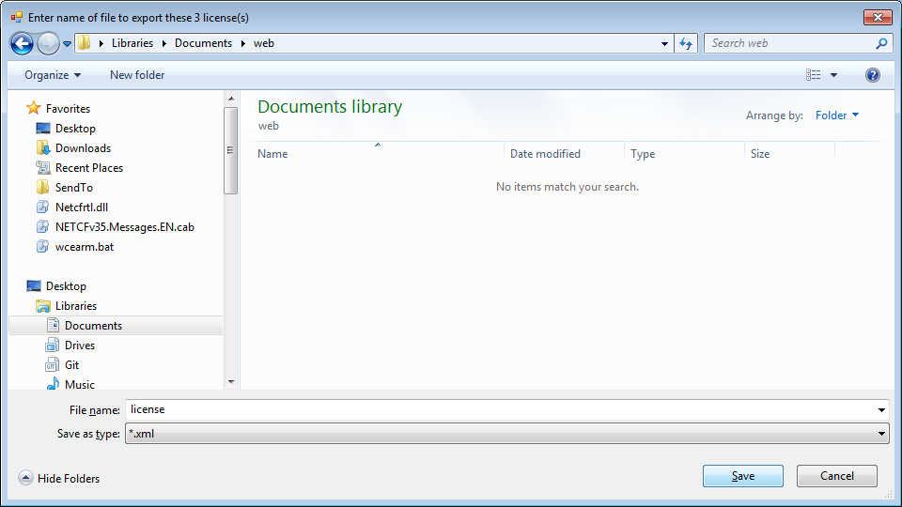

After a successful export you get a message, so you know the liceses have been exported.

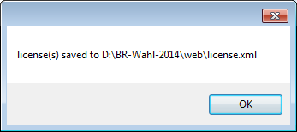

## Log tab

This tab will simply list some of the status message for reference.

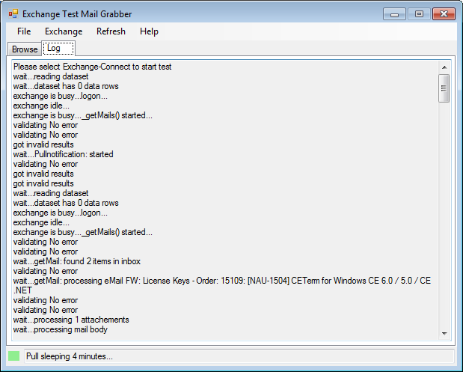

This is just for informational view.

# Data refresh

As the data is hold in an external file and that does not support change notifications you have the Refresh menu item to re-load the actual data from the database file.

When ews_grabber connects to the exchange server it first processes all existing eMails using a "license mail" filter. The same may happen on another PC where ews_grabber is running using the same file. After the initial processing of received eMails in the inbox of the specified user account, ews_grabber starts to pull the exchange server for new "license mails" periodically. If a new eMail has been received and matches a "license mail", then the license data is extracted and added to the database file but not automatically in the data grid view.

You have to click [Refresh] in the menu from time to time to get updated data.

# Requirements

## License eMail definition

ews_grabber does not process all eMails. It searches eMail for subject having "License Keys - Order" and not having "[processed]" and having at least one attachement ending in "xml".

### eMail Body

To be able to capture the order data, the email body has to have the following text lines:

Order Number: 12345  
 Order Date: 5/21/2014  
 Your PO Number: PO1234  
 End Customer: Honeywell  
 Product: [NAU-1504] CETerm for Windows CE 6.0 / 5.0 / CE .NET  
 Quantity: 31

### Attached xml

The attached xml file containing the license data has to conform to the following schema:

<?xml version='1.0'?>  
<CETerm>  
<license>  
<id>VM1C142179853</id>  
<user>Honeywell</user>  
<key>ZGNTL9L5XP3UB9ZA9XZD6QSGU3Y2S4KV</key>  
</license>  
...  
<license>  
<id>VM1C142179854</id>  
<user>Honeywell</user>  
<key>ZGN44YVVMAPNEN2J9XZD6QSGU3Y2SLEJ</key>  
</license></CETerm>

## Changes to processed eMails

ews_grabber adds "[processed]" to the subject of an email after the contents has been processed.