PriceMarkdown

Usage

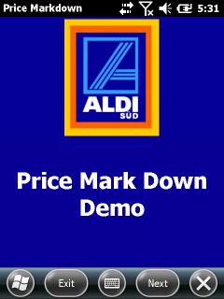

Background image and color can be customized, see appendix.

Press (Next)[Serial]

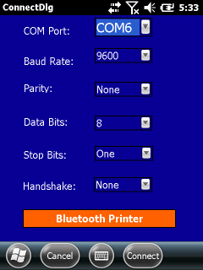

The default BT Printer virtual COM port is COM6. The other options are usable defaults.

If you did already run the Printer Wizard or used [Bluetooth Printer] to assign the BT Printer you can simply press (Next).

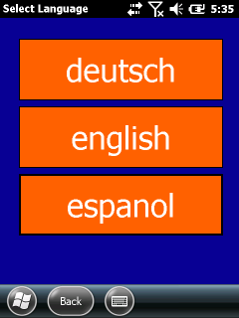

Now press a button to select a language to be used for printing. The text on the buttons can be customized, see appendix.

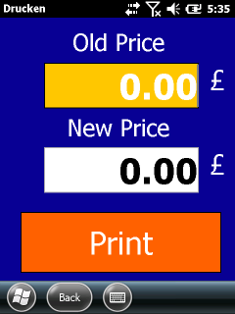

Enter the old and new price and press the button [print]. Again the text on the button and the labels can be customized, see appendix.

If everything is OK, you should get a label üprinted on the connected printer.

Bluetooth

To make a first connection with a BT printer press the [Bluetooth Printer] button in the Connect dialog.

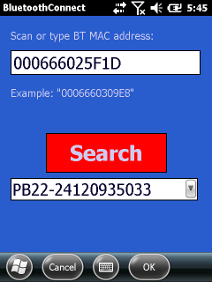

Press the [Search] button to query for BT devices around the device. At the end of a search the list below the [Serach] button is populated with found BT devices. You can then select one of the BT devices of the list.

You can also type or scan the BT Mac address in the upper edit field.

Finally tap on (OK) to create an association between the COM port and the BT device.

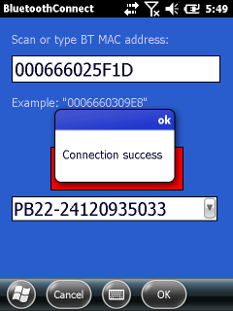

If the connection fails you will be back on the start dialog. If the connection is successfull, you will be back on the connect dialog.

Appendix

The application can be customized using external files placed in the programs directory.

Colors

File: appcolors.xml  
Sample:

<?xml version="1.0" encoding="utf-8" ?>  
<colors>  
 <formback>3149D6</formback>  
 <formtext>FFFFFF</formtext>  
 <pictback>3149D6</pictback>  
 <buttonback>FF0000</buttonback>  
 <buttontext>CECBEF</buttontext>  
 <texthighlight>FF0000</texthighlight>  
</colors>  
This file defines the colors for dialog backgrounds, dialog text elements, the picture background, the button background and text and the highlight color of the numeric input fields.

Each entry represents the RGB color values in hex notation.

National text

File: language.xml  
Sample:

<?xml version="1.0" ?>  
<text>  
 <buttons>  
 <button id="0" text="deutsch" />  
 <button id="1" text="english" />  
 <button id="2" text="espanol" />  
 </buttons>  
 <labels>  
 <labels0>  
 <label id="0" text="Alter Preis" />  
 <label id="1" text="Neuer Preis" />  
 <label id="2" text="Drucken" />  
 </labels0>  
 <labels1>  
 <label id="0" text="Old Price" />  
 <label id="1" text="New Price" />  
 <label id="2" text="Print" />  
 </labels1>  
 <labels2>  
 <label id="0" text="Precio antiguo" />  
 <label id="1" text="Precio nuevo" />  
 <label id="2" text="Imprimir" />  
 </labels2>  
 </labels>  
 <vars>  
 <var id="0" text="reduziert" />  
 <var id="1" text="reduced" />  
 <var id="2" text="muy reducido" />  
 </vars>  
 <currencies>  
 <currency id="0" text="€" />  
 <currency id="1" text="$" />  
 <currency id="2" text="€" />  
 </currencies>

</text>

The button tags define the text on the three buttons in the language dialog.

The labels tags define the text used in the print dialog.

The vars tags define the text to be used as 'reduced' text on the printed label.

The currency tags define the currency symbol to be used on the printed label.

Print layout

File: layout-prn.txt  
Sample:

SYSVAR(18)=0  
INPUT OFF  
NEW   
OPEN "tmp:setup.sys" for output as #2  
PRINT#2, "MEDIA,MEDIA SIZE,LENGTH,400"  
PRINT#2, "MEDIA,MEDIA SIZE,XSTART,0"  
PRINT#2, "MEDIA,MEDIA SIZE,WIDTH,420"  
PRINT#2, "MEDIA,MEDIA TYPE,LABEL (w GAPS)"  
PRINT#2, "FEEDADJ,STARTADJ,-48"  
PRINT#2, "FEEDADJ,STOPADJ,0"  
PRINT#2, "PRINT DEFS,PRINT SPEED,75"  
PRINT#2, "MEDIA,PAPER TYPE,DIRECT THERMAL"  
PRINT#2, "MEDIA,PAPER TYPE,DIRECT THERMAL,LABEL CONSTANT,75"  
PRINT#2, "MEDIA,PAPER TYPE,DIRECT THERMAL,LABEL FACTOR,40"  
PRINT#2, "MEDIA,CONTRAST,+0%"  
PRINT#2, "RFID,OFF"  
CLOSE #2  
Setup "tmp:setup.sys"  
Kill "tmp:setup.sys"  
OPTIMIZE "BATCH" ON  
LTS& OFF  
SETUP KEY ON  
SYSVAR(48)=0  
FORMAT INPUT CHR$(2),CHR$(3),CHR$(13)  
LAYOUT INPUT "tmp:LBLSOFT.LAY"  
CLIP ON  
CLIP BARCODE ON  
XORMODE OFF  
qFnt1$="Swiss 721 BT"  
qFnt2$="Swiss 721 Bold BT"  
NASC 8  
DIR 1  
AN 1  
AN 5  
PP 80,125:FT qFnt2$,13,0,100:NI  
PRBOX 140,180,0,VAR1$,2,2,"",""  
AN 2  
if len(var2$)=4 then PP 220,185:FT qFnt1$,12,0,105:NI:PT VAR2$  
if len(var2$)=5 then PP 220,186:FT qFnt1$,12,0,100:NI:PT VAR2$  
if len(var2$)=6 then PP 222,187:FT qFnt1$,11,0,100:NI:PT VAR2$  
if len(var2$)=7 then PP 224,188:FT qFnt1$,10,0,95:NI:PT VAR2$  
AN 1  
if len(var2$)=4 then PP PRSTAT(3)+PRSTAT(5),PRSTAT(4)+1:FT qFnt1$,10,0,100:NI:PT VAR5$  
if len(var2$)=5 then PP PRSTAT(3)+PRSTAT(5),PRSTAT(4)+1:FT qFnt1$,10,0,100:NI:PT VAR5$  
if len(var2$)=6 then PP PRSTAT(3)+PRSTAT(5),PRSTAT(4)+1:FT qFnt1$,9,0,100:NI:PT VAR5$  
if len(var2$)=7 then PP PRSTAT(3)+PRSTAT(5),PRSTAT(4)+1:FT qFnt1$,8,0,100:NI:PT VAR5$  
AN 2  
if len(var3$)=4 then PP 275,122:FT qFnt2$,18,0,105:NI:PT VAR3$  
if len(var3$)=5 then PP 273,122:FT qFnt2$,18,0,100:NI:PT VAR3$  
if len(var3$)=6 then PP 271,122:FT qFnt2$,18,0,95:NI:PT VAR3$  
if len(var3$)=7 then PP 269,122:FT qFnt2$,17,0,100:NI:PT VAR3$  
AN 1  
if len(var3$)=4 then PP PRSTAT(3)+PRSTAT(5),PRSTAT(4)+1:FT qFnt1$,15,0,100:NI:PT VAR5$  
if len(var3$)=5 then PP PRSTAT(3)+PRSTAT(5),PRSTAT(4)+1:FT qFnt1$,15,0,100:NI:PT VAR5$  
if len(var3$)=6 then PP PRSTAT(3)+PRSTAT(5),PRSTAT(4)+1:FT qFnt1$,14,0,100:NI:PT VAR5$  
if len(var3$)=7 then PP PRSTAT(3)+PRSTAT(5),PRSTAT(4)+1:FT qFnt1$,13,0,95:NI:PT VAR5$  
AN 2  
PP 185,20:BARSET "CODE128",1,1,3,90  
BARFONT OFF  
PB VAR4$  
AN 1  
DIR 4  
PP 375,20:FT qFnt1$,10,0,100:NI:PT VAR4$  
LAYOUT END  
COPY "TMP:LBLSOFT.LAY","C:PRICE_MARKDOWN.LAY"

The above is a fingerprint command file that defines a layout for the label. Printing will be done into that saved label layout data. The layout defines five vars that will be filled by using the [Print] button.

The layout file or resource is sent only once per session to the printer. If you would try another layout file, you have to exit and start the PriceMarkdown application.

Notes

Please use standard xml only (<?xml version="1.0" ?>). Specifying a wrong encoding may the app fail to load the xml.

If the app does not work for you, exit and reboot the device. The PriceMarkdown application also writes a log file to enable basic problem solving.

Possibly one of your added files are incorrect. Just remove them of the programs directory and start over.