1.
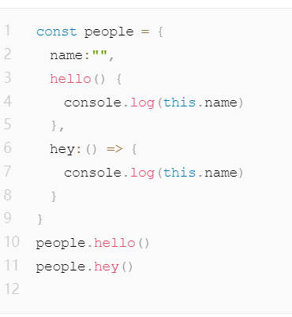
people.hello() => “” hello方法的this指向创建的实例
people.hey() => “” 箭头函数是this是静态的，不会改变

2.
跨域
jsonp 处理跨域
cors 处理跨域
Niginx 代理跨域
一般在项目中（vue：config文件中配置server反向代理，react：setupProxy文件使用使用中间件的createProxyMiddleware实现代理）

3.
class List {
constructor(...elements) {
this.length = elements.length;
this.elements = [...elements];
}

add(...newElements) {
this.elements.push(...newElements);
this.length += newElements.length;
}
}
const myList = new List(1, 2, 3);
console.log(myList.length); // 3
console.log(myList.elements); // [1, 2, 3]

myList.add(4, 5);
console.log(myList.length); // 5
console.log(myList.elements); // [1, 2, 3, 4, 5]

4.
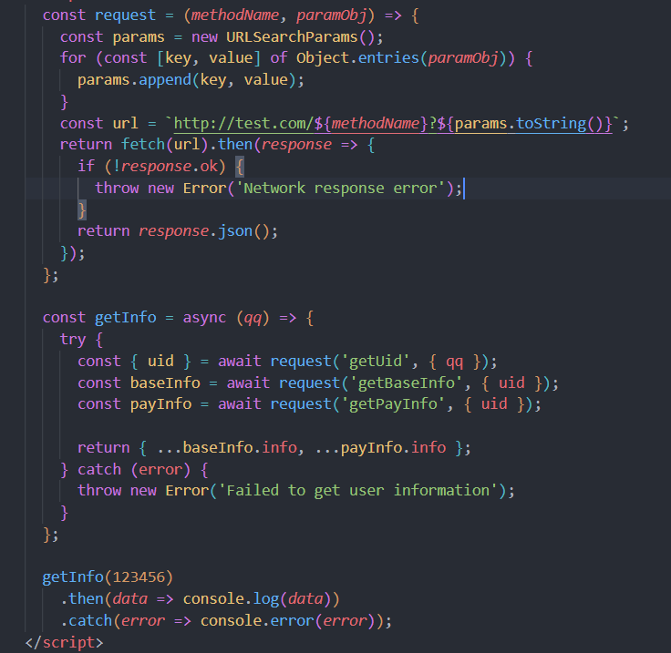

5.
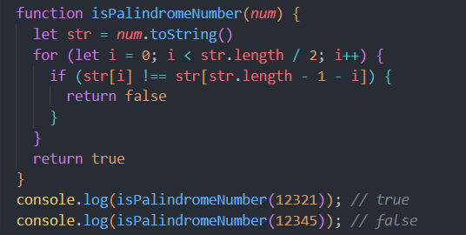

6.
......
7.
https://stackblitz.com/edit/vue3-typescript-vue-cli-starter-g6facm
8.
https://codesandbox.io/s/nest-forked-lmf2hp
9.
(1)
创建表格
CREATE TABLE game_exposure (
id INT AUTO_INCREMENT PRIMARY KEY,
game_code VARCHAR(50),
expose INT,
channel VARCHAR(50),
spend INT
);
插入模拟数据
INSERT INTO game_exposure (game_code, expose, channel, spend) VALUES
('lol', 500, 'A', 5),
('cf', 300, 'A', 10),
('wzry', 1000, 'B', 6),
('pubgm', 800, 'B', 11),
('pubgm', 900, 'A', 1),
('lolm', 700, 'A', 2);

(2)
SELECT game_code, channel, MAX(spend) AS spend
FROM game_exposure
GROUP BY channel;
(3)
SELECT game_code, channel, SUM(spend) AS spend, SUM(expose) AS expose
FROM game_exposure
GROUP BY game_code, channel
ORDER BY spend DESC, expose ASC
LIMIT 0, 2;

(4)
SELECT 'Total' AS game_code, '-' AS channel, SUM(spend) AS spend, SUM(expose) AS expose
FROM game_exposure;
(5)
SELECT CEIL(COUNT(*) / 2) AS total_page_num
FROM game_exposure;

