R report Class 04
Harshita Jha
2026-01-15
x <- 1:50
plot(x, sin(x))
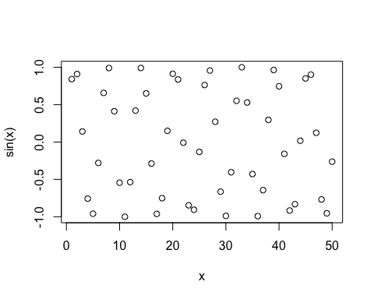
plot(x, sin(x),type="l", col="violet", lwd="2")
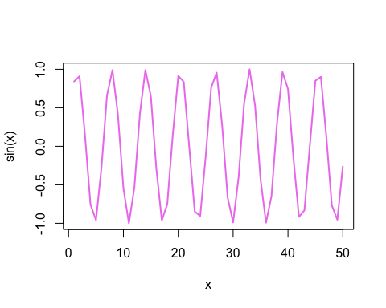
log(10, base = 10)
## [1] 1

