Tidal potential measured on a coastal–inland optical-clock baseline
WORKING DRAFT v71 — physical-unit spectra and measurement sensitivity, 6 November 2026.
Prepared for author evaluation. The formal R7 handoff has been received and its measured-record spectral analysis and the diurnal-band diagnostic are incorporated here. The matched v68 primary sample, direct-potential and resampling chain remains outstanding, so the two reductions retain their identities and no final common estimator is declared.
[Author list and affiliation assignments to be confirmed.]

Abstract
Optical-clock networks can sense changing gravitational potential through changes in relative clock rates. We compare coastal Shanghai and inland Wuhan using interrupted observations spanning a year. The lunar M2 tide repeats every 12.42 h, while solar S2 repeats every 12 h. The measured record shows distinct spectral maxima near both frequencies without filling observational gaps. Sampling their changing relative phase permits joint estimation of lunar M2+N2 and neighbouring S2+K2 responses. The coefficients are $0.97±0.14$ and $0.90±0.29$ in a segment-based reduction, and $0.99±0.12$ and $1.13±0.29$ in a period-based reduction, each with its own uncertainty rule. Both semidiurnal responses are consistent with the combined tidal potential; the diurnal response is less tightly constrained. Ocean loading supplies about one third of the predicted variation, although its separate coefficient remains unresolved.

Main text
An optical-clock network can sense Earth’s gravitational potential by comparing how fast time passes at different sites.^{1,2} Phase-stabilized fibres carry clock signals between laboratories, extending this comparison across a landscape.^{3,4} Static potential differences have been measured with laboratory, transportable and fibre-connected clocks.^{5,6,7,8} Following a changing potential adds a different challenge: the clock-rate variation must be distinguished from changes in the clocks and the connections between them.^{9,10,11} A fractional rate change of ${10}^{−18}$ corresponds to a potential difference of about 0.09 m²/s², providing a common physical scale for the clock signal and its residual background.
Tides provide a natural test with timing set by celestial motion. The Moon and Sun change the potential directly, deform the solid Earth and move ocean water. Two strong rhythms are close together: lunar M2 repeats every 12.42 h and solar S2 every 12 h. Their relative phase drifts with date. Observing across that drift allows their contributions to be estimated separately, even when the clock comparison is interrupted.¹²
Here we compare coastal Shanghai with inland Wuhan. The geographical contrast makes ocean loading a substantial part of the predicted potential difference. We estimate the lunar M2+N2 and neighbouring S2+K2 responses jointly, with their astronomical phase and relative amplitude fixed within each group. K2 contains lunar and solar forcing. The approximately daily K1+O1+P1+Q1 group is included in the same model. This tests two prescribed half-daily patterns without first subtracting an empirical daily waveform.

A coastal–inland clock comparison
A strontium clock in Shanghai and a ytterbium clock in Wuhan are separated by 692 km and connected through Hefei by a 1,350-km phase-stabilized fibre link (Fig. 1a).¹³ The station coordinates are 31.130° N, 121.570° E and 30.529° N, 114.357° E, respectively. Evaluations of the clocks report systematic uncertainties of $9.2×{10}^{−19}$ for Sr and $1.3×{10}^{−18}$ for Yb.^{14,15}
We express the observation as a fractional change in the Wuhan-Yb/Shanghai-Sr frequency ratio. Positive values mean that Wuhan runs faster relative to Shanghai. The corresponding prediction combines the direct tide-generating potential, Earth’s induced potential, the displacement of each clock and the complete ocean-loading potential. In the direct-potential implementation, IERS 2010 solid tides are combined with FES2022 ocean elevations through a loading calculation that includes the attraction of seawater, deformation-induced potential and clock displacement.^{12,16,17,18}
For the differential M2 prediction, the solid and loading contributions have amplitudes of $3.41×{10}^{−18}$ and $1.42×{10}^{−18}$. Their phases differ by about 20°, and their vector sum is $4.77×{10}^{−18}$ (Fig. 1b). Over the segment-centred sampling, the respective root-mean-square variations are 3.0, 1.35 and $4.1×{10}^{−18}$. Thus loading supplies approximately one third of the combined predicted variation. Fitting a separate loading scale gives $0.89±0.55$, which does not resolve that contribution independently. The measured quantity is the response to the combined potential.
The record extends from September 2025 to August 2026. Its segment-based reduction (v68) contains five campaigns and 54 segments, with approximately 544 retained hours. Summer contributes 274 h and samples the lunar pattern across the solar day (Fig. 1c,d). A second, period-based reduction (R7) organizes the observations into eight operating periods and 29 original groups. Its 3,299 accepted ten-minute means contain 545.9 sample-hours. The counts differ because the reductions use different selection and averaging procedures. Each figure identifies the observations it shows.
Interruptions introduce unknown reference levels. We fit those levels jointly with the tidal responses, assigning a constant to each segment or each operating period in the two reductions. This preserves the changing signal within an interval without joining the entire record into an absolutely calibrated frequency level. The summer record is particularly useful because the lunar and solar patterns move past one another while the same physical model is tested.

Two semidiurnal responses
The full-record phase plot makes the tidal variation visible (Fig. 2). Observations and the unit lunar prediction undergo the same removal of nuisance components before averaging in twelve fixed M2 phase intervals. All 3,299 R7 observations remain in the display, and every interval contains data from all eight periods. The error bars propagate the nuisance projection and averaging. The lunar amplitude is estimated from the original rows rather than from the twelve displayed means.
The frequency view reveals two distinct local maxima near the lunar and solar semidiurnal frequencies (Fig. 3c). It uses the measured ten-minute observations at their actual calendar times, with an unknown constant allowed for each of the 54 segments and equal weights. No tide is removed before calculating the blue spectrum, and no values are inserted into gaps. The maxima occur at 22.361 and 23.147 µHz, close to M2 at 22.364 µHz and S2 at 23.148 µHz. Their separation is much larger than the inverse 353-day calendar span. The left axis expresses power per unit frequency as an equivalent gravitational-potential variation; the right axis gives exactly the same signal in fractional clock-rate units. This places the two half-daily features and their surrounding background on one physical scale.
Interruptions also shape the surrounding peaks. Passing the known tidal prediction through the same sampling and segment projection produces a series of neighbouring maxima: strong tides spread power into the sidelobes of the observation window. A unit M2 signal produces about 8% as much scan power at S2 as at M2, with a similar reverse leakage. Thus frequency proximity alone does not identify every smaller peak as another measured constituent. The two local maxima remain when the other frequency is included in the scan (Methods). Subtracting the fixed physical prediction in the time domain reduces both features, leaving the orange residual spectrum. This comparison reuses the observations and is a description of the record, not a second detection test.
For the physical amplitudes, both reductions estimate the lunar, neighbouring semidiurnal and diurnal groups together, including other predicted contributions once at their fixed values. The segment-based analysis uses equal weights and applies the same triangular filter to data and prediction. The period-based analysis uses ten-minute means and noise weights derived within the observed runs. Their template implementations and uncertainty calculations are retained separately in Methods. The single-frequency scan in Fig. 3c is a display on the R7 rows with segment constants, not either reduction’s three-group amplitude estimator.
The segment-based coefficients are $A_{L}=0.97±0.14$ for M2+N2 and $A_{S}=0.90±0.29$ for S2+K2. The period-based coefficients are $A_{L}=0.99±0.12$ and $A_{S}=1.13±0.29$ (Fig. 3a). Each yields positive, separately estimated semidiurnal responses consistent with the unit prediction. The coefficients are moderately anticorrelated: −0.32 and −0.36, respectively. K2 has lunar and solar forcing, so the neighbouring group is a frequency grouping rather than a pure solar component.
The diurnal coefficients are less precise, at $0.35±0.51$ and $0.68±0.36$. The daily group is already present in the joint fit, and its correlations enter the reported semidiurnal uncertainties. The observations therefore constrain the frequency groups with different precision rather than requiring the daily response to be detected before the half-daily responses can be estimated.
A phase-relaxed fit gives a lunar in-phase coefficient of $0.99±0.12$ and a quadrature coefficient of $−0.18±0.14$ on the R7 design (Fig. 3b). The relative M2–N2 phase remains fixed within this common-phase test. The phase fold, quadrature fit and frequency scan provide complementary views of the same observations, with their distinct projections and uncertainty definitions retained.
The daily-band spectrum is less distinctive and does not identify separate daily constituents (Methods and Extended Data Figs. 1 and 2). Frequency-resolved background levels are reported in potential units, with their relation to measurement sensitivity described in Methods.

Support across observations and measured controls
The period-based analysis gives a lunar coefficient of $1.10±0.21$ before summer and $0.80±0.18$ in summer. Removing each period in turn leaves lunar point estimates between 0.88 and 1.05 (Fig. 4a). The segment-based summer and non-summer estimates are $0.87±0.18$ and $1.05±0.31$. These comparisons locate the support for the lunar response across time. The subsets and full record share observations, so their errors are retained with their individual fits rather than combined as independent experiments.
In the segment-based analysis, adding outdoor-temperature covariates for Shanghai and Wuhan gives $A_{L}=0.98±0.13$ (Fig. 4b). These covariates come from ERA5 two-metre air temperatures.¹⁹ A separate, direct Sr-chamber record averages twenty PT100 sensors over 98 h; its residual blackbody-shaped coefficient is $0.92±0.74$. Both clocks apply blackbody corrections during operation. Outdoor weather and chamber thermometry therefore address different parts of the environmental question.
For an effect linked to daytime heating or operating schedules, a 24-h term with a physically motivated phase is the appropriate first diagnostic. The segment-based temperature-phase check gives $A_{L}=0.99±0.14$. Allowing an unrelated 12-h phase to reset in every campaign gives $0.82±0.17$. That supplementary fit explores competition with semidiurnal tides over short campaigns; it does not establish that the laboratory contains a disturbance with that period or a particular amplitude.
The fibre round-trip monitor supplies a directly recorded transmission control. In the segment-based analysis, adding it on identical 474-h support changes both the lunar and whole-template coefficients by less than 0.005 (Fig. 4c). The newly transferred R7 control uses a different matched subset of 246.6 sample-hours and changes the lunar coefficient by $0.0064±0.0061$, with paired day-jackknife uncertainty. These are separately supported comparisons, not two estimates on the same 474-h sample. They constrain the monitored transmission path; clock-specific effects and laboratory branches outside that path require their own measurements.

From clock networks to changing potentials
The coastal–inland geometry and the changing lunar–solar phase address different aspects of the measurement. The geometry makes loading important in the prediction; the phase coverage allows two nearby semidiurnal responses to be estimated together. The present measurement tests their combined tidal potential. Separating the loading contribution itself will require longer coastal records and better characterized transfer branches.
Hou et al. report the absolute Yb/Sr ratio on this link using overlapping summer observations.¹³ Here the question is the separation of tidal responses in the extended interrupted record; the absolute ratio and its earlier correlation significance are not re-estimated. Independent, contemporaneous European observations by Stahl et al. use clock-network baselines of about 800 km with different mixtures of diurnal and semidiurnal tides.²⁰ These complementary baselines show how geography and observing duration shape a clock network’s sensitivity. Expressing signal and residual background in potential units provides a common scale on which to compare them.

References
- Ludlow, A. D., Boyd, M. M., Ye, J., Peik, E. & Schmidt, P. O. Optical atomic clocks. Rev. Mod. Phys. 87, 637–701 (2015). https://doi.org/10.1103/revmodphys.87.637
- Mehlstäubler, T. E., Grosche, G., Lisdat, C., Schmidt, P. O. & Denker, H. Atomic clocks for geodesy. Rep. Prog. Phys. 81, 064401 (2018). https://doi.org/10.1088/1361-6633/aab409
- Lisdat, C. et al. A clock network for geodesy and fundamental science. Nat. Commun. 7, 12443 (2016). https://doi.org/10.1038/ncomms12443
- Riehle, F. Optical clock networks. Nat. Photon. 11, 25–31 (2017). https://doi.org/10.1038/nphoton.2016.235
- Chou, C. W., Hume, D. B., Rosenband, T. & Wineland, D. J. Optical Clocks and Relativity. Science 329, 1630–1633 (2010). https://doi.org/10.1126/science.1192720
- McGrew, W. F. et al. Atomic clock performance enabling geodesy below the centimetre level. Nature 564, 87–90 (2018). https://doi.org/10.1038/s41586-018-0738-2
- Bothwell, T. et al. Resolving the gravitational redshift across a millimetre-scale atomic sample. Nature 602, 420–424 (2022). https://doi.org/10.1038/s41586-021-04349-7
- Grotti, J. et al. Geodesy and metrology with a transportable optical clock. Nat. Phys. 14, 437–441 (2018). https://doi.org/10.1038/s41567-017-0042-3
- Voigt, C., Denker, H. & Timmen, L. Time-variable gravity potential components for optical clock comparisons and the definition of international time scales. Metrologia 53, 1365–1383 (2016). https://doi.org/10.1088/0026-1394/53/6/1365
- Denker, H. et al. Geodetic methods to determine the relativistic redshift at the level of ${10}^{−18}$ in the context of international timescales: a review and practical results. J. Geod. 92, 487–516 (2018). https://doi.org/10.1007/s00190-017-1075-1
- Schröder, S., Stellmer, S. & Kusche, J. Potential and scientific requirements of optical clock networks for validating satellite-derived time-variable gravity data. Geophys. J. Int. 226, 764–779 (2021). https://academic.oup.com/gji/article/226/2/764/6212226
- Petit, G. & Luzum, B. (eds) IERS Conventions (2010). IERS Technical Note 36 (2010). https://iers-conventions.obspm.fr/content/tn36.pdf
- Hou, L. et al. Yb/Sr optical clock comparison at $2.2×{10}^{−18}$ uncertainty over a 1350-km fiber link. arXiv, 2610.34250v1 (2026). https://arxiv.org/abs/2610.34250v1
- Jia, Z.-P. et al. Improved systematic evaluation of a strontium optical clock with uncertainty below $1×{10}^{−18}$. Metrologia 63, 025002 (2026). https://doi.org/10.1088/1681-7575/ae449e
- Zhu, Q. et al. Ytterbium lattice clock with systematic uncertainty of $1.3×{10}^{−18}$ and instability at the ${10}^{−19}$ level. arXiv, 2606.10514v2 (2026). https://arxiv.org/abs/2606.10514v2
- CNES. FES2022 (Finite Element Solution) Tidal model (Version 2024). CNES https://doi.org/10.24400/527896/A01-2024.004 (2024).
- Farrell, W. E. Deformation of the Earth by surface loads. Rev. Geophys. 10, 761–797 (1972). https://doi.org/10.1029/RG010i003p00761
- Han, D. & Wahr, J. The viscoelastic relaxation of a realistically stratified earth, and a further analysis of postglacial rebound. Geophys. J. Int. 120, 287–311 (1995). https://doi.org/10.1111/j.1365-246x.1995.tb01819.x
- Hersbach, H. et al. The ERA5 global reanalysis. Q. J. R. Meteorol. Soc. 146, 1999–2049 (2020). https://doi.org/10.1002/qj.3803
- Stahl, K. et al. Optical clock network tracks tidal variations of the gravity potential. arXiv, 2610.39635v1 (2026). https://arxiv.org/abs/2610.39635v1

Figure legends
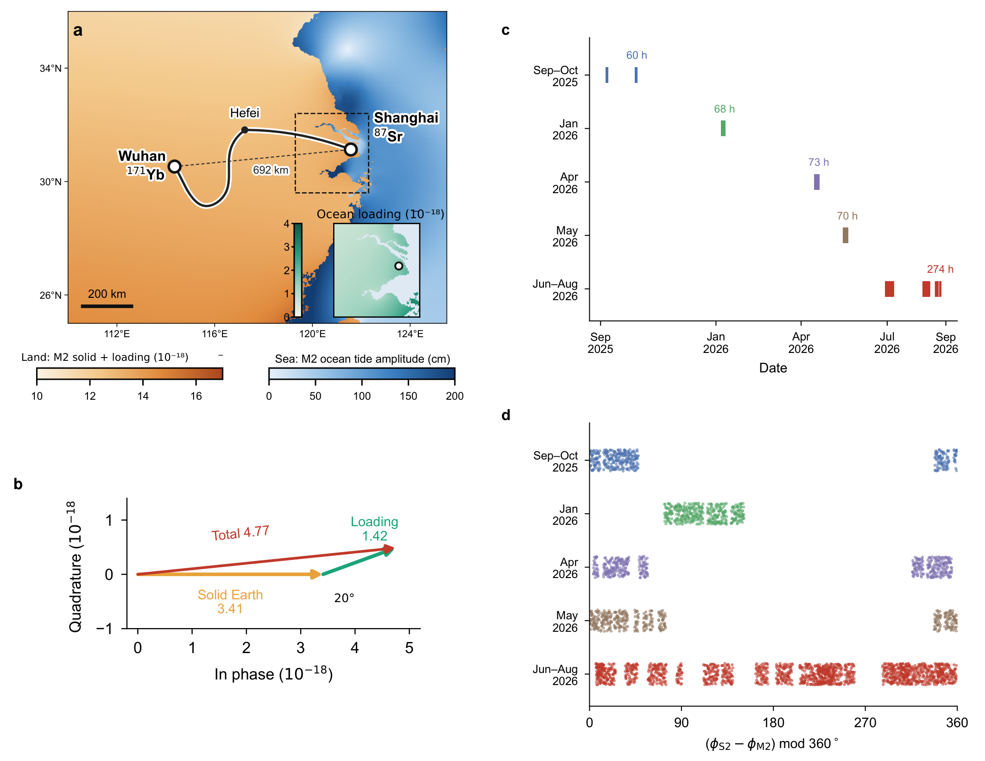
Fig. 1 | Coastal–inland geometry and lunar–solar phase coverage. Prediction and sampling panels retained from v68. a, Shanghai Sr and Wuhan Yb, their 692-km separation and schematic 1,350-km fibre route through Hefei. Land colour represents predicted M2 clock potential; sea colour represents FES2022 M2 elevation. The inset shows Shanghai loading. b, Differential solid and loading phasors of 3.41 and 1.42, separated by approximately 20° and summing to 4.77, in ${10}^{−18}$ fractional-frequency units. c, Five v68 campaigns and their reported integer-hour durations, with an approximately 544-h retained total. d, Relative S2–M2 astronomical phase at the v68 filtered samples. These panels describe the specified prediction and sampling, not a hypothesis test. The period-based R7 row support used in Figs. 2–4 is separately identified; phase coverage does not imply calibrated zero-point continuity.

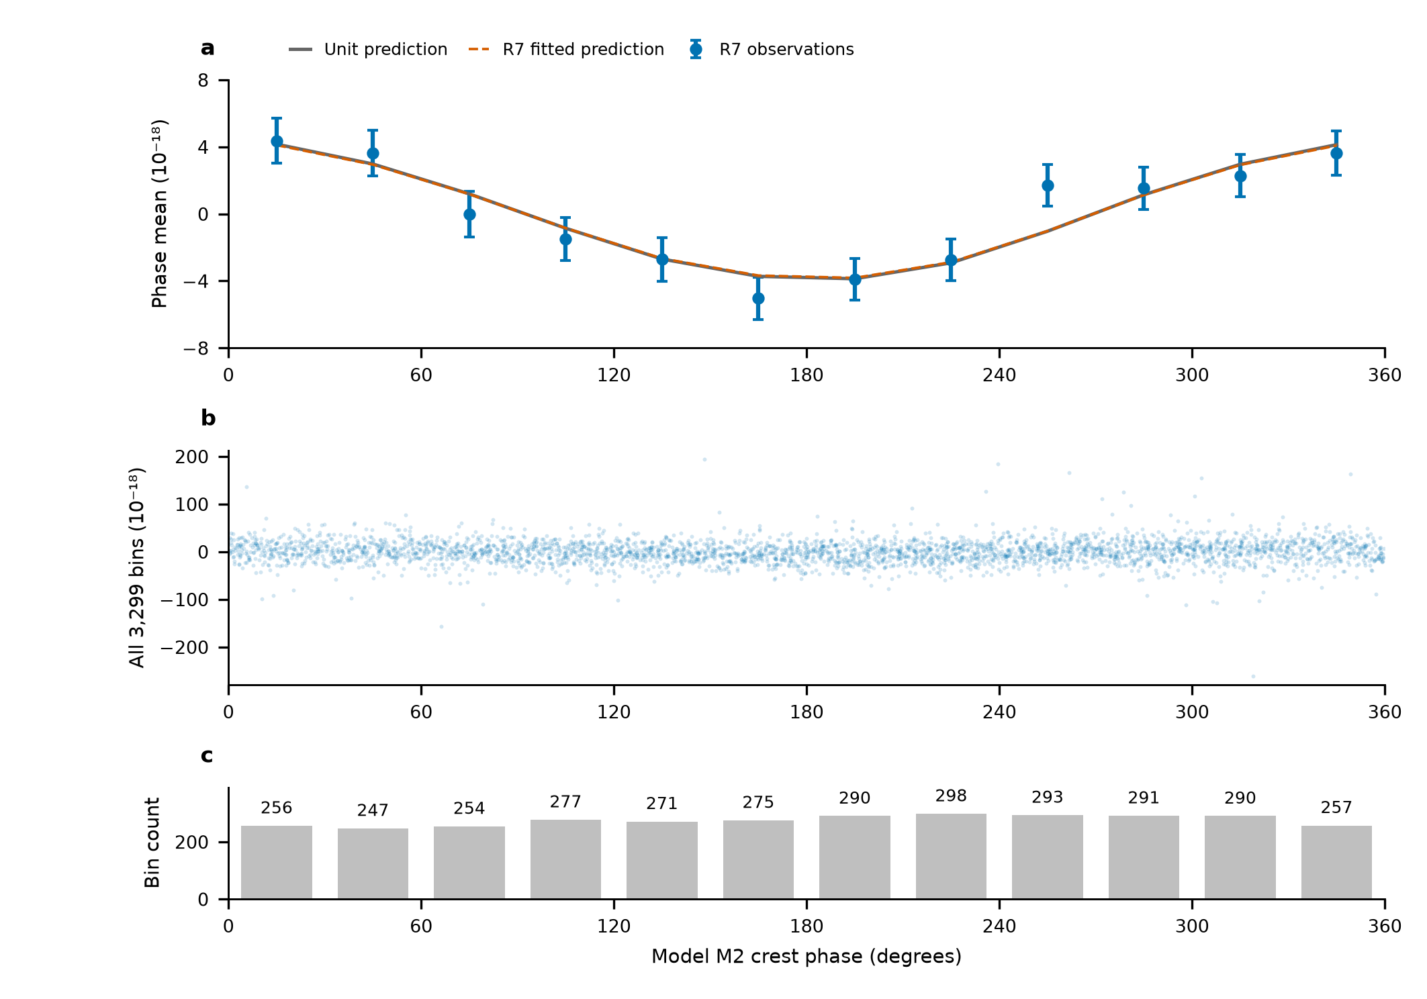
Fig. 2 | The full-record lunar phase display on the R7 design. a, Twelve fixed 30° phase-bin means after subtracting the fixed remainder and projecting both observations and unit lunar prediction against the same period, near-12-h and diurnal columns. Solid and dashed curves show the identically transformed unit and fitted predictions. Error bars are marginal standard errors from the complete propagated scaled-working covariance, including the nuisance projection; the twelve means are correlated and their covariance has rank eleven. b, All 3,299 projected R7 observations, retaining their full ordinate range. c, Row counts per phase interval; each interval contains all eight periods and 31–36 UTC days. R7 noise weights, template and sampling are used throughout. The amplitude is fitted to the original rows, not to the phase means. No new rejection, phase adjustment or independent significance test is introduced.

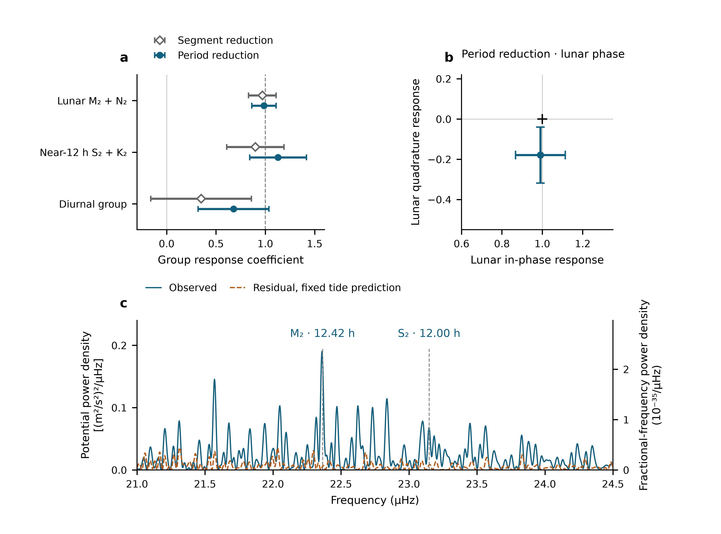
Fig. 3 | Semidiurnal amplitudes, phase and the measured frequency spectrum. a, Three-group coefficients from two named reductions of overlapping observations. Open diamonds retain v68 values: the lunar error is its reported residual-resampling standard deviation, while near-12-h and diurnal errors use its scaled-LS/day-jackknife maximum. Filled circles show recomputed R7 coefficients with that reduction’s own scaled-LS/day-jackknife maximum. Estimates and errors are not combined. b, The R7 common M2+N2 in-phase/quadrature fit with marginal errors; the cross marks unit in-phase and zero quadrature response. These bars are not a separately calibrated joint confidence region. c, Spectrum of the 3,299 measured R7 bins at actual UTC times, with equal weights and 54 segment constants. Blue is calculated before tide subtraction; orange follows time-domain subtraction of the fixed unit R7 physical prediction without refitting its amplitude or phase. No gap is filled. The left axis gives nominal equivalent-potential PSD in (m²/s²)²/µHz and the right gives fractional-frequency PSD in 10⁻³⁵/µHz, related by $S_{W}=c^{4}S_{y}$. Dashed lines mark M2 and S2. All spectral values in the displayed 21–24.5 µHz band are retained, including sidelobes. This panel uses a single-frequency scan, not the three-group estimator in a. The same-record phase and spectral views do not add independent detection significance.

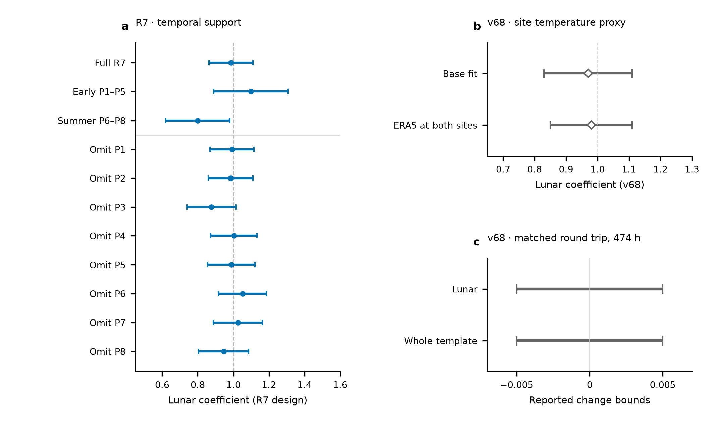
Fig. 4 | Temporal support and observed-channel controls. a, R7 full-record, early and summer lunar estimates, followed by eight leave-period estimates. Every fit uses its own retained rows and scaled-LS/day-jackknife maximum; these overlapping fits are not independent replications. b, Reported v68 base and two-site ERA5-temperature-regression estimates, retaining their respective 0.14 and 0.13 marginal errors. ERA5 is an outdoor-temperature proxy, not direct laboratory thermometry. c, Reported v68 bounds on the change induced by adding the round-trip monitor on identical 474-h support. The horizontal intervals indicate $\left|ΔA\right|<0.005$ for each named coefficient; they are neither error bars nor estimates located at zero. Panels b and c have not been recalculated with R7 weights. The monitor constrains its measured transmission channel, with unmonitored branches and clock-specific effects outside its coverage.

Methods

Frequency ratio, sign and corrections
The clock apparatus and absolute-ratio experiment are described by Hou et al., with separate Sr and Yb uncertainty evaluations.^{13,14,15} The Sr-referenced optical carrier is transferred from Shanghai and compared with the Yb-referenced comb in Wuhan. The ratio orientation is $R=ν_{Yb,Wuhan}/ν_{Sr,Shanghai}$. For positive geodetic potential, the differential fractional signal is
$$y\left(t\right)=−\frac{δW_{eff,Wuhan}\left(t\right)−δW_{eff,Shanghai}\left(t\right)}{c^{2}}.$$
A positive $y$ therefore means that Wuhan runs faster relative to Shanghai. The R7 period-relative beat conversion is $y_{rel}=−d_{p}\left(f_{beat}−f_{ref,p}\right)/F_{1550}$, with $F_{1550}=1.933992×{10}^{14}$ Hz, $d_{p}=2$ in 2025 and $d_{p}=1$ in 2026. This corresponds to a 2026 conversion magnitude of approximately $5.17×{10}^{−15}$ per hertz; the 2025 divided counter requires restoration of the factor of two. The reference beat is a period-specific level, not the optical frequency.
R7 applies the recorded summer group-resolved Sr and Yb corrections through the frequency-chain equations in 80-digit Decimal arithmetic, before taking a fractional ratio. Early periods retain period-relative scales because their absolute-chain calibration is incomplete. The early 37.2-mHz feedback term can be absorbed by a period intercept only if its sign, magnitude and conversion remain constant within that period. Group-dependent or time-dependent errors are not absorbed by a common intercept. Missing early AC Stark entries and the provisional May Yb entry are recorded as missing or assumed, rather than measured zero. Correction covariances have not been supplied. They are not invented or combined with the statistical errors.

Selection, support and temporal processing
The v68 specification retains 54 segments in five campaign groupings. It rejects large counter departures and applies a six-robust-standard-deviation transient screen based on local medians, independently of tidal residuals. The reported transient removal is 0.4%, approximately 2.2 h; adding the theoretical tide with factors −1, 1 and 3 leaves the reported mask unchanged. Its data and theoretical samples receive the same 1200-s triangular filter at 600-s steps. Its reported retained duration is approximately 544 h. The final per-row mask, filter membership and matched directly calculated potential series remain required inputs for the common-support replay.
R7 reads the updated 54-segment mask, excludes original group 22 and retains segment 48. Period files are joined before applying intervals, preserving intervals that cross midnight. Beijing-time labels are converted to UTC. Printed-second endpoints retain subsecond timestamp jitter; shared-boundary seconds belong to the preceding segment. Its raw selection has 1,966,908 loaded rows versus 1,966,905 tabulated rows, with the three-row net difference individually reconciled at interval boundaries. Ten-minute means are formed separately by segment on a fixed grid, requiring at least 180 nominal one-second rows. The 3,299 accepted rows contain 545.9242 sample-hours and 43 observed UTC days. Distinct segments may contribute separate partial bins at the same centre without sharing underlying samples. The formal R7 handoff reconstructs these means and weights from 42 counter files; its 1,965,327 retained bin members reproduce the saved observation rows. The spectral analysis consumes that verified table, preserving separate row identities at repeated bin centres. The numerical display and raw-member replay are retained as distinct steps in the provenance record.

Physical template and band definitions
The direct-potential formulation used by v68 is
δWsolid=m​1+k2mV2m+1+k3V3−gur,
with $k_{20}=0.29525$, $k_{22}=0.29801$, $k_{3}=0.093$, and the IERS resonance prescription for $k_{21}$.¹² The displacement term follows the associated frequency- and latitude-dependent response. Ocean loading is computed from ocean elevation $ζ$ and the full effective-potential kernel,
δWload=∫ρwζr′,tGWψ dA, GWψ=gaMEn​1+k′n−h′nPncosψ.
The kernel contains seawater attraction, induced potential and the clock displacement.^{16,17,18} The reported implementation uses water density 1025 kg m$​^{−3}$, PREM load Love numbers through degree 696, high-degree continuation and summation to degree 40,000. The $1/{30}^{∘}$ ocean grid is retained near the stations. Ocean means are removed for mass conservation. The complete model configuration and its software versions must accompany the final analysis archive.
R7 instead consumes an IERS-based displacement series converted with $−\left(1+k_{2}−h_{2}\right)g/\left(h_{2}c^{2}\right)$, using $h_{2}=0.6078$, $k_{2}=0.3010$ and $g=9.794$ m s$​^{−2}$. This is a specified approximation, not the same mode-dependent direct-potential implementation. The R7 source documents a K1 amplitude about 18% below its quoted potential-weighted reference; that model discrepancy remains part of the common-template audit. Its loading uses the supplied full-potential phasors. Temporal synthesis uses pyTMD 3.0.9 FES astronomical arguments and nodal corrections.²¹ In the convention $f_{k}ℜ\left[C_{k}exp\left(−iϕ_{k}\right)\right]$, consistently conjugating the coefficient and reversing the exponential leaves the real series unchanged. The bridge reported here holds this R7 series fixed; it does not certify equivalence to the direct-potential series.
Both reductions group M2+N2, S2+K2 and K1+O1+P1+Q1. Relative amplitudes and phases are fixed within each group. A remaining theoretical contribution enters once at its predicted value. Thus
$$y_{i}=A_{L}b_{L}\left(t_{i}\right)+A_{S}b_{S}\left(t_{i}\right)+A_{D}b_{D}\left(t_{i}\right)+r_{0}\left(t_{i}\right)+c_{j\left(i\right)}+ϵ_{i}.$$
The intercept index $j$ is a segment in v68 and a period in R7. The controlled bridge also evaluates original-group intercepts on the same R7 rows. No fitted offsets are used to construct a long-term stability series.

Statistical errors and controlled bridge
The v68 lunar error is a reported residual-circular-shift standard deviation. Residuals are shifted within continuous filtered runs and added to the unit-response model. The reported lunar values from two sets of 200 realizations are 0.13 and 0.14, with 0.14 retained. Its reported four-scenario study gives 67–68% coverage for ${\hat{A}}_{L}±0.14$ and 94.5–95.2% for ${\hat{A}}_{L}±1.96\left(0.14\right)$. These results remain source-reported until the associated code, seeds and inputs are transferred. They are not calibration of the R7 estimator.
R7 estimates period noise factors from within-segment overlapping Allan deviations after subtracting the fixed unit template and segment constants.²² It fits a fixed $τ^{−1/2}$ slope on 256–4096 nominal one-second samples and uses $σ_{i}=α_{p\left(i\right)}/\sqrt{n_{i}}$. No fitted inter-segment stitching enters this weighting. Scaled least-squares errors use the reduced chi-square; UTC-day jackknife deletes each of 43 observed days and removes empty intercept columns. The reported marginal error is the larger of these two quantities, with period deletion retained separately. For its lunar estimate the three errors are 0.1231, 0.1116 and 0.1314, respectively. The weights are held fixed during deletion (Extended Data Table 1).
The independent bridge uses QR least squares and checks the saved R7 coefficient, covariance and deletion results. It crosses three intercept levels (8 periods, 29 groups, 54 segments), two weight choices (saved noise weights or equal weights) and two saved response representations (summer-corrected or period-relative), giving twelve cases. All use the same 3,299 rows, timestamps, band templates and fixed remainder. This separates those choices from sampling/filtering/template differences that remain untested. A small change on removing saved corrections does not validate missing corrections or establish their constancy in time.
The R7 conditional study holds rows, weights and design fixed. Its independent Gaussian reference and twelve correlation scenarios use $Σ=D\left[\left(1−ρ\right)I+ρK\right]D$, with exponential correlation times of 1, 6 or 24 h, segment or period clusters, and $ρ=0.1$ or 0.5. These are specified stress scenarios, not estimates of actual laboratory noise. Recounting the saved 10,000 draws per scenario reproduces 95.94% coverage for the reference and 94.16–97.79% across all scenarios for intervals ${\hat{A}}_{L}±1.959964u$. The rule is not uniformly conservative (Extended Data Table 3). Estimation of the weights, selection, non-Gaussian excursions and instrumental covariance lie outside that conditional study. The scenario results do not replace the reported standard error. These coverage checks target the lunar coefficient; they do not calibrate a detection probability for the neighbouring group or a joint two-response confidence region.

Baseline choice and comparison between reductions
The matched-R7 bridge gives lunar coefficients 0.9866 for eight period intercepts with recorded noise weights, 1.0004 for 54 segment intercepts with those weights, 0.9364 for eight intercepts with equal weights and 0.9461 for 54 intercepts with equal weights. These variants share rows and physical templates. They isolate baseline and weight choices, not the differences in raw masks, triangular filtering and direct-potential implementation between the two source reductions.
The projected lunar-template squared norm allocated to summer is 61% in the reported segment/equal-weight design and 50.2% in the period/noise-weighted design. These are conditional design quantities, not universal information fractions. The original period-analysis continuity flag was generated by comparing fitted summer amplitudes under two intercept choices. Passing that comparison establishes only the stated amplitude-sensitivity check; it does not calibrate zero-point continuity across interruptions. The present synthesis retains separate statuses for those two questions. No fitted offsets are used to construct long-term stability.
A final common estimator requires the matched raw-member and directly calculated potential package, the relevant operating/correction records, and noise calibration for that design. The currently available period-table replay and the source-reported segment estimates are identified separately. Neither reduction is selected because it has the smaller error, and their shared-observation uncertainties are not combined.

Phase display and temporal diagnostics
Let $W=diag\left(σ_{i}^{−2}\right)$ and let $N$ contain intercepts and the near-12-h and diurnal columns. The nuisance projector is $M_{N}=I−N{\left(N^{T}WN\right)}^{−1}N^{T}W$. The display uses $z=M_{N}\left(y−r_{0}\right)$ and $x=M_{N}b_{L}$, with the crest coordinate $\left[ϕ_{M2}−argC_{M2}\right] mod 2π$. Twelve fixed 30° intervals define inverse-variance averaging operator $B$. The means are $Bz$, $Bx$ and ${\hat{A}}_{L}Bx$, using the original unaggregated amplitude fit.
The displayed working covariance is $BM_{N}C_{y}M_{N}^{T}B^{T}$, with $C_{y}=χ_{red}^{2}diag\left(σ_{i}^{2}\right)$. This propagates the fitted nuisance projection rather than holding nuisance coefficients fixed. It has rank eleven because of the weighted-mean constraint. All points, counts, day/period support and the full covariance are exported. The present independent projection agrees with the saved R7 phase means and marginal errors to numerical precision.
The I/Q diagnostic adds a quadrature obtained by $C_{k}→iC_{k}$ for both lunar constituents and fits it jointly with the original nuisance columns. The figure shows marginal errors from that fit, not a calibrated joint contour. Early/summer and leave-period fits each recompute their own coefficients and errors on their retained rows. Neither phase averaging, spectra nor deletion of overlapping observations provides independent experimental replication.

Observed spectrum, sampling window and potential units
The spectrum uses all 3,299 accepted R7 observation rows, retaining their original UTC bin centres, duplicate-centre row identities and calendar gaps. At each frequency, a sine and cosine are fitted together with 54 segment indicators using equal weights. The nuisance projection is applied to both the observations and the scanned trigonometric columns. The scan does not use the phase-folded data, fitted-tide reconstruction or interpolation across missing intervals. Least-squares periodograms permit scanning the irregular timestamps; physical interpretation additionally requires the sampling-window response.²³
The calculation covers 5–40 µHz, with the physically relevant 21–24.5 µHz region shown in Fig. 3c. The complete scan remains in the figure-source archive. The grid step is $1/\left(12T\right)$ for $T=353.3889$ days; oversampling draws the peaks more finely without improving the independent frequency scale $1/T=0.03275$ µHz. M2 and S2 are separated by 0.78387 µHz. Segment/period intercepts, equal/saved weights and actual member-mean timestamps all retain local maxima near both frequencies. Conditional scans that include the other frequency’s sine and cosine retain maxima at 22.3611 µHz for M2 and 23.1390 µHz near S2. These are sensitivity diagnostics rather than independently calibrated significance tests.
Let $ΔRSS\left(f\right)$ be the decrease in residual sum of squares from adding the sine and cosine to the segment-constant model, with $y$ expressed as a dimensionless fractional frequency. The nominal one-sided density is $S_{y}\left(f\right)=600 s ΔRSS\left(f\right)$. For complete uniformly sampled data it agrees with a one-sided Fourier periodogram. For this interrupted, projected record, its integral is not identified with continuous-year variance. Potential density follows $S_{W}=c^{4}S_{y}$ because $ΔW=−c^{2}y$. The numerical density per microhertz is ${10}^{−6}$ times the density per hertz. An independent direct-SI least-squares calculation at 21 frequencies and an analytic sinusoid/Fourier normalization check verify this conversion.
The observation window has power 0.12099 at the M2–S2 separation under its normalized exponential-sum definition. More directly, scanning unit M2 and S2 templates on the measured rows gives cross-frequency powers of 8.03% and 8.15% of their respective on-frequency powers. The fixed full prediction also produces several neighbouring maxima at the locations seen in the observed scan. These window responses explain why sidelobes need not indicate additional constituents; they do not establish that every residual peak has a tidal origin. In particular, a peak near 12 h alone cannot distinguish solar gravitational forcing from an unmeasured solar-time disturbance. That interpretation also uses astronomical phase and the recorded environmental and transmission controls.
The residual curve is calculated from $y−s_{R7}$ in the time domain, with the R7 unit prediction held fixed, and then passed through the identical spectral operator. It is not obtained by subtracting two power spectra. No observed tidal amplitude or phase is fitted for this subtraction. The residual contains measurement noise together with any template error or unmodelled signal; it is not a separately calibrated instrumental noise floor. The archived R7 spectrum uses a different diagnostic: weighted floating-mean, separately variance-normalized curves before and after a fitted two-band response. Those curves and their white-noise reference are not converted into the physical densities shown here.

Spectral background and measurement sensitivity
For a physical-unit view of sensitivity, Extended Data Fig. 1 shows the amplitude density $D_{W}\left(f\right)=\sqrt{S_{W}\left(f\right)}$, in (m²/s²)/√µHz. Its right axis is $D_{y}=D_{W}/c^{2}$. These are square roots of the same measured power densities, not another estimator or a new selection of observations. A density per √µHz has a numerical value ${10}^{−3}$ times that per √Hz; power densities differ by ${10}^{−6}$. All conversions are performed before plotting. At the exact M2 and S2 frequencies, the fixed-prediction residual amplitude densities are 0.0774 and 0.0909 (m²/s²)/√µHz, respectively (Extended Data Table 4). The table reports prescribed frequencies, rather than choosing local minima as a sensitivity floor.
This frequency-resolved residual level is an empirical background against which a further signal would have to be distinguished. It includes measurement noise, any unmodelled signal and any error in the fixed prediction. It is not an independently calibrated minimum detectable potential. For stationary noise with a calibrated one-sided PSD and complete uniform observing time $T_{obs}$, the standard error of a known-frequency sinusoidal quadrature is approximately $\sqrt{S_{W}^{\left(Hz\right)}\left(f\right)/T_{obs}}$. Applying that approximation to the 353-day calendar span would count unobserved time as exposure.
For the actual sampling, let $H_{f}$ contain the scanned sine and cosine, $M_{Z}$ project out the segment constants and $C_{y}$ describe the noise covariance on the observed rows. The physical-unit coefficient covariance is instead
$$Cov\left({\hat{β}}_{W}\right)=c^{4}K_{f}C_{y}K_{f}^{T}, K_{f}={\left(H_{f}^{T}M_{Z}H_{f}\right)}^{−1}H_{f}^{T}M_{Z}.$$
This expression retains the sampling gaps, nuisance projection and correlation structure. A detectable-amplitude threshold also needs its phase, false-alarm and frequency-search conventions. We therefore report the residual density and the separately defined group-amplitude errors, without deriving a new detection limit from the plotted density. The inverse calendar span describes a frequency scale; the number, timing and covariance of accepted measurements determine amplitude precision.

Diurnal-band and strong-signal leakage checks
The daily scan uses the same measured rows, segment projection, weights and normalization over 9.5–12.5 µHz. Exact Q1, O1, P1, K1 and 24-h frequencies are included in the grid. The local K1 maximum remains between 11.60765 and 11.61311 µHz under the specified intercept, weight and timestamp checks. The normalized P1/24-h/K1 sine–cosine design has condition number 3.26, so this diagnostic does not show severe rank deficiency.
At the exact K1 frequency, subtraction of only the fixed M2+N2+S2+K2 prediction reduces scan power by 64%; subtraction of the full prediction reduces it by 69% (Extended Data Fig. 2). At P1, full-prediction subtraction increases power by a factor of 2.005. These changes retain coherent cross terms and are not additive fractions of constituent power. They show why a residual peak or a reduction after subtraction cannot by itself identify a daily constituent. No individual-diurnal detection probability or upper limit is assigned. The fixed physical template in these checks remains the R7 implementation specified above.

Environmental evidence and limits
The site-temperature regressors in v68 use ERA5 hourly two-metre air temperatures and departures from a 24-h running mean.¹⁹ The Sr-chamber thermometers provide a separate 98-h direct record. The round-trip counter is normalized by the optical carrier without an additional factor of two, screened and filtered like the ratio; comparisons with and without the regressor use identical 474-h support. These reported controls retain their v68 definitions. The formal R7 handoff additionally supplies 1,482 bins with 887,882 matched clock/monitor members, or 246.6339 sample-hours. On that subset, adding the monitor changes the lunar coefficient from 0.834837 to 0.841245; the paired UTC-day-jackknife error of the change is 0.006086. The supports and estimators differ, so this result is not substituted for the v68 474-h bound.
A physically motivated 24-h term can test temperature or operating-cycle coupling. An independently phased 12-h term in each campaign is retained only as a supplementary sensitivity variant. A coefficient change under such a model is not an observed disturbance amplitude. Residual diagnostics must propagate the physical fit’s projection to both residual data and diagnostic bases. No diurnal upper limit or semidiurnal-to-diurnal extrapolation is reported: each would require an estimator-specific interval or an explicit common-response hypothesis.

Data availability
The authors will provide the retained counter-row membership, correction ledger, matched physical templates, figure source tables and versioned manifests through [repository and DOI or editor-accessible link to be confirmed]. The current author working package contains the source-bound v68 material, the received R7 raw-member and control handoff, and source tables for the observed spectrum and its window diagnostics. The matching v68 primary sample/template/resampling package remains to be supplied. Third-party products are identified by their originating citations and access terms.

Code availability
Versioned selection, frequency conversion, potential generation, fitting, uncertainty and figure code will be deposited at [repository and DOI or review link to be confirmed]. The present bridge and display code is retained with its inputs, hashes, environment and execution logs. The final source archive must also include the direct-potential chain and the accepted estimator decision.

Methods references
- Sutterley, T. C., Howard, S. L., Padman, L. & Siegfried, M. R. pyTMD: Python-based tidal prediction software. J. Open Source Softw. 10, 8566 (2025). https://doi.org/10.21105/joss.08566
- Riley, W. J. & Howe, D. A. Handbook of Frequency Stability Analysis. NIST Special Publication 1065 (2008). https://doi.org/10.6028/NIST.SP.1065
- VanderPlas, J. T. Understanding the Lomb–Scargle Periodogram. arXiv, 1703.09824 (2017). https://arxiv.org/abs/1703.09824

Author statements
Authors: [Author list, order and affiliation assignments to be confirmed.]
Affiliation texts retained from the companion frequency-ratio manuscript, pending author assignments:
¹ Hefei National Laboratory, University of Science and Technology of China, Hefei, China
² Shanghai Research Center for Quantum Sciences and CAS Center for Excellence in Quantum Information and Quantum Physics, University of Science and Technology of China, Shanghai, China
³ Hefei National Research Center for Physical Sciences at the Microscale and School of Physical Sciences, University of Science and Technology of China, Hefei, China
⁴ Innovation Academy for Precision Measurement Science and Technology, Chinese Academy of Sciences, Wuhan, China
⁵ Jinan Institute of Quantum Technology and CAS Center for Excellence in Quantum Information and Quantum Physics, University of Science and Technology of China, Jinan, China
⁶ Time and Frequency Geodesy Center (TFGC), School of Geodesy and Geomatics, Wuhan University, Wuhan, China
Contributions: [To be confirmed for this Article.]
Acknowledgements and funding: [To be confirmed by the authors.]
Competing interests: [Declaration to be provided by all authors.]
Correspondence: [Names and contact details to be confirmed.]
AI-assisted preparation: OpenAI Codex assisted source comparison, manuscript drafting, numerical replay and figure preparation. [Authors to specify the scope of their verification and responsibility before submission.]

Extended Data
Extended Data Table 1 | Estimator-specific uncertainty sources. R7 numbers are independently recomputed on saved input rows. All entries are standard errors of the named coefficient. The reported R7 rule is the marginal maximum of scaled LS and UTC-day jackknife; period deletion is retained as a separate sensitivity. No errors are pooled.
Reduction and coefficient | Estimate | Scaled LS | Day jackknife | Period jackknife | Reported error
R7 lunar | 0.9866 | 0.1231 | 0.1116 | 0.1314 | 0.1231
R7 near-12 h | 1.1291 | 0.2825 | 0.2878 | 0.3256 | 0.2878
R7 diurnal | 0.6779 | 0.2860 | 0.3586 | 0.4118 | 0.3586
R7 lunar in phase | 0.9910 | 0.1231 | 0.1145 | 0.1416 | 0.1231
R7 lunar quadrature | -0.1792 | 0.1143 | 0.1394 | 0.1681 | 0.1394
R7 early lunar | 1.0986 | 0.1914 | 0.2084 | 0.5183 | 0.2084
R7 summer lunar | 0.7991 | 0.1798 | 0.1674 | 0.0942 | 0.1798
v68 lunar (source reported) | 0.97 | — | — | — | 0.14, residual shift
R7 full and I/Q fits use 3,299 rows, 43 UTC-day groups and 8 period groups. Early uses 1,651 rows, 20 observed UTC days and 5 periods; summer uses 1,648 rows, 23 observed UTC days and 3 periods. The v68 source reports the maximum of its LS/day-jackknife errors as 0.13 but does not supply those two separate values here. A dash is unavailable, not zero.

Extended Data Table 2 | Controlled choices on the same R7 rows and physical template. Saved corrected response, 3,299 observations. P8, G29 and S54 denote 8 period, 29 group and 54 segment intercepts. Quoted errors use each variant’s own scaled-LS/day-jackknife maximum. These are bridge calculations, not additional primary results.
Intercepts | Weights | Lunar | Near-12 h | Diurnal | Lunar–near-12 h correlation
P8 | Allan | 0.9866 ± 0.1231 | 1.1291 ± 0.2878 | 0.6779 ± 0.3586 | -0.3572
P8 | equal | 0.9364 ± 0.1323 | 1.1627 ± 0.3071 | 0.5588 ± 0.3626 | -0.3669
G29 | Allan | 0.9841 ± 0.1243 | 1.0930 ± 0.2981 | 0.7587 ± 0.4203 | -0.3496
G29 | equal | 0.9320 ± 0.1337 | 1.1284 ± 0.3241 | 0.5691 ± 0.4482 | -0.3622
S54 | Allan | 1.0004 ± 0.1320 | 0.9251 ± 0.3649 | 0.5792 ± 0.5381 | -0.3003
S54 | equal | 0.9461 ± 0.1407 | 0.9735 ± 0.3753 | 0.4151 ± 0.5711 | -0.3245
All twelve corrected/period-relative cases are in the source CSV. The table does not compare the v68 triangular filter, final mask or direct-potential series; those remain missing from the matched replay.

Extended Data Table 3 | Recount of saved R7 conditional simulations. Each scenario contains 10,000 saved draws. Coverage refers to nominal 95% intervals ${\hat{A}}_{L}±1.959964max\left(u_{LS},u_{day}\right)$. Rows, design and weights are held fixed. The correlations are specified scenarios, not measured laboratory noise.
Correlation cluster | Time scale (h) | Correlated fraction | Lunar bias | 95% coverage (%)
Independent Gaussian | — | 0 | +0.0025 | 95.94
segment | 1 | 0.1 | -0.0001 | 94.24
segment | 1 | 0.5 | +0.0025 | 94.16
segment | 6 | 0.1 | +0.0004 | 95.22
segment | 6 | 0.5 | +0.0004 | 95.59
segment | 24 | 0.1 | +0.0008 | 96.00
segment | 24 | 0.5 | +0.0017 | 97.04
period | 1 | 0.1 | -0.0019 | 94.65
period | 1 | 0.5 | +0.0000 | 94.22
period | 6 | 0.1 | -0.0029 | 95.72
period | 6 | 0.5 | +0.0051 | 96.49
period | 24 | 0.1 | +0.0006 | 95.94
period | 24 | 0.5 | -0.0020 | 97.79
This recount checks the archived simulations; it does not regenerate the draws or calibrate the v68 estimator. Weight estimation, raw selection and unknown instrumental covariance remain outside this conditional experiment.

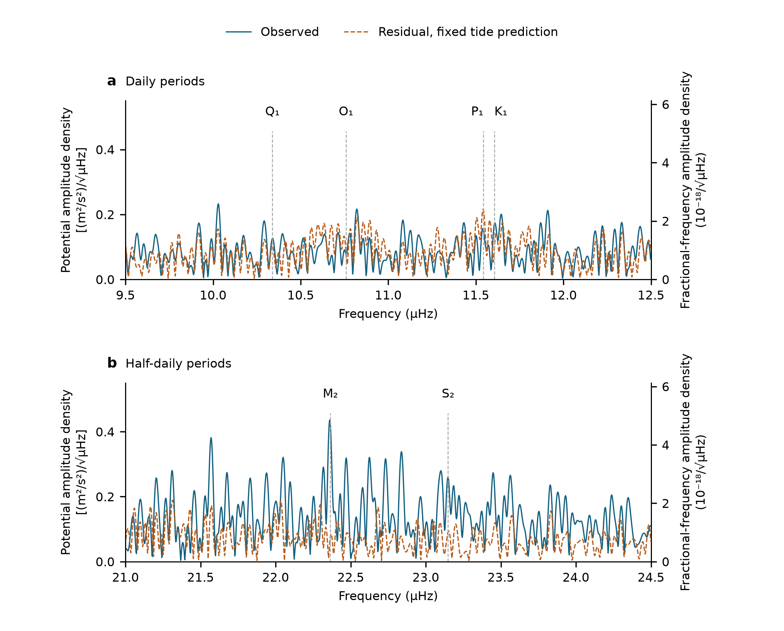
Extended Data Fig. 1 | Potential-equivalent spectral background. a, Daily and b, half-daily frequency bands from the same 3,299 R7 observations used in the main spectrum. Blue shows the measured record and dashed orange the residual after subtraction of the fixed unit physical prediction. The vertical coordinate is the square root of the nominal power density, expressed as potential amplitude per square-root microhertz; the right axis is its exact fractional-frequency equivalent. Both panels use equal weights, 54 segment constants and recorded calendar times. All accepted observations are retained, and missing times are not filled. The shared vertical scale makes the two bands comparable. Dashed lines mark nominal astronomical frequencies. Curves have no confidence envelope: the residual level includes noise and possible prediction error, and is not a calibrated detection threshold. The same observations underlie both curves and panels.

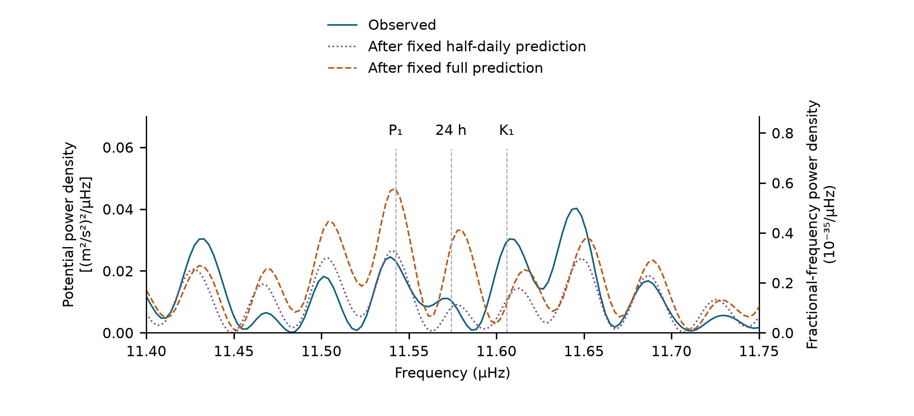
Extended Data Fig. 2 | How the strong half-daily prediction affects the daily spectrum. Blue shows the measured record near P1, exact 24 h and K1. Dotted purple follows subtraction of only the fixed M2+N2+S2+K2 prediction; dashed orange follows subtraction of the fixed full prediction. All curves use the same observed times and spectral operator as Fig. 3c. Subtraction is in the time domain, without refitting amplitudes or phases. At the exact K1 frequency, power decreases by 64% after half-daily subtraction and 69% after full subtraction; at P1 it increases after full subtraction. These are coherent scan-power changes, not additive power fractions or independent detection tests. Axes show potential and fractional-frequency power densities linked by c⁴. Individual daily-constituent assignments require the sampling response and phase information as well as peak position.

Extended Data Table 4 | Spectral levels at prescribed astronomical frequencies. All entries use the same measured rows and equal-weight segment-constant scan. Potential amplitude density is in (m²/s²)/√µHz; the fractional-frequency residual column is in 10⁻¹⁸/√µHz. Residuals follow subtraction of the fixed full physical prediction. Entries are descriptive amplitudes, not uncertainties, detection thresholds or independent estimates. Exact 24 h is a frequency reference, not a measured laboratory disturbance.
Frequency label | Frequency / µHz | Observed potential amplitude density | Residual potential amplitude density | Residual fractional-frequency amplitude density
M2 | 22.364278 | 0.4237 | 0.0774 | 0.8616
S2 | 23.148148 | 0.2608 | 0.0909 | 1.0114
Q1 | 10.338473 | 0.1262 | 0.1043 | 1.1606
O1 | 10.758515 | 0.0774 | 0.0822 | 0.9150
P1 | 11.542385 | 0.1523 | 0.2157 | 2.3996
24 h | 11.574074 | 0.1020 | 0.1680 | 1.8687
K1 | 11.605763 | 0.1712 | 0.0954 | 1.0614
The nominal scan-density normalization is documented in Methods; it is not integrated as a continuous-year variance. This table does not supply a separate laboratory or clock noise budget.

