Tidal potential measured on a coastal–inland optical-clock baseline
[Author list, order and affiliation assignments to be confirmed by the authors]
¹ Hefei National Laboratory, University of Science and Technology of China, Hefei, China
² Shanghai Research Center for Quantum Sciences and CAS Center for Excellence in Quantum Information and Quantum Physics, University of Science and Technology of China, Shanghai, China
³ Hefei National Research Center for Physical Sciences at the Microscale and School of Physical Sciences, University of Science and Technology of China, Hefei, China
⁴ Innovation Academy for Precision Measurement Science and Technology, Chinese Academy of Sciences, Wuhan, China
⁵ Jinan Institute of Quantum Technology and CAS Center for Excellence in Quantum Information and Quantum Physics, University of Science and Technology of China, Jinan, China
⁶ Time and Frequency Geodesy Center (TFGC), School of Geodesy and Geomatics, Wuhan University, Wuhan, China
Tides change the gravitational potential difference between distant sites and thereby the relative rates of clocks.^{1,2} Here we detect tidal variations in the gravitational potential difference between coastal Shanghai and inland Wuhan by comparing a strontium clock and a ytterbium clock 692 km apart. This extends static clock-based potential measurements to changes over hours. We accumulated 545.9 hours of observations across 353 days. The response to the complete solid-Earth and ocean-loading prediction is $0.96±0.11$ (one statistical standard error), where unity denotes the predicted amplitude. A joint fit of physical tidal groups gives a lunar M₂+N₂ response of $1.00±0.13$, with group-internal amplitude ratios and phases fixed. Its measured phase and spectral structure agree with the lunar prediction. Separate frequency levels accommodate interrupted operation, while recorded times fix the astronomical phase. The neighbouring S₂+K₂ group is less precisely constrained and more sensitive to disturbances at 12 hours. Together, these measurements resolve tidal potential variation on this coastal–inland optical-clock baseline.

Earth’s gravitational potential changes as the Moon and Sun move, the solid Earth deforms and ocean water is redistributed. Optical clocks sense a potential difference through the gravitational shift of their relative rates.^{1,2} Laboratory redshift tests and remote clock comparisons have measured static potential differences, while chronometric-levelling experiments have calculated the tidal perturbation during a comparison.^{3,4,5,6} The experimental question is whether two clocks at fixed, distant sites can detect changes in their potential difference over hours through their relative ticking rates.
Fibre networks allow repeated comparisons between clocks hundreds of kilometres apart.^{7,8} Measuring time-dependent potential differences would provide direct constraints on mass redistribution and deformation, while accounting for changing redshifts is also necessary for consistent clock comparisons and time references.^{9,10,11,12,13} We address this question with the Shanghai strontium and Wuhan ytterbium clocks, taking the tidal variation itself as the measured signal.
The same record can also show which tidal components contribute to that variation. The principal lunar semidiurnal tide M₂ repeats every 12.42 h, close to the 12-h solar tide S₂. A corresponding lunar maximum arrives about 50 minutes later on successive solar days, so their relative phase changes with date. Observations on different dates sample different combinations of the two waveforms. Even when the frequency offset between runs is unknown, the variation within each run can be compared with the astronomical phase at its actual observation times. The extended record tests a common tidal response across interrupted operation and constrains neighbouring semidiurnal groups that a single waveform scale does not distinguish.

A coastal–inland baseline and its predicted signal
The two clocks are 692 km apart and connected through Hefei by a 1,350-km phase-stabilized fibre path (Fig. 1a). The apparatus and frequency-comparison chain are described by Hou and colleagues.¹⁴ The reported clock-comparison instability follows the characteristic white-frequency-noise scale $5.4×{10}^{−16}/\sqrt{τ/\left(1 s\right)}$, where $τ$ is averaging time. Clock evaluations and field-fibre experiments provide the metrological basis.^{15,16,17} Hou et al. used 16 overlapping summer segments for an absolute frequency-ratio measurement and reported a combined-template tidal response of $0.87±0.15$. Here the 353-day record supports full-template and grouped estimates. The overlapping observations make these related analyses, rather than independent repetitions.
Shanghai’s proximity to the East China Sea and Wuhan’s inland location give the two sites different responses to ocean mass redistribution. The differential prediction combines direct astronomical forcing, the potential induced by Earth’s deformation and clock displacement, together with the attraction and deformation caused by ocean loading. We use the IERS-based solid prediction and FES2022 ocean elevations with an effective-potential loading kernel (Methods).^{18,19,20,21}
The model predicts M₂ fractional-rate amplitudes of $3.43×{10}^{−18}$ from the solid response and $1.42×{10}^{−18}$ from loading. Their 19.8° phase difference gives a vector sum of $4.78×{10}^{−18}$, equivalent to a potential-difference amplitude of about $0.43 m^{2}/s^{2}$ (Fig. 1b). Loading is about 30% of this combined M₂ phasor amplitude. On the actual weighted, segment-centred sampling, its root-mean-square variation is 33.1% of the combined prediction. These model ratios describe the combined prediction tested by the observations.
The September 2025–August 2026 record contains 3,299 accepted ten-minute means in 54 segments and eight observing periods, representing 545.9 nominal member-hours (Fig. 1c). Observations fall on 43 UTC dates in eight calendar months within the 353-day span. Summer contributes 273.9 h, and the earlier periods add different lunar–solar phases (Fig. 1d). A positive fractional-rate variation denotes Wuhan Yb running faster relative to Shanghai Sr. With the geodetic potential convention used here, $y=−\left[δW_{Wuhan}−δW_{Shanghai}\right]/c^{2}$.

Detection in the full clock record
The response to the complete tidal prediction is $A_{T}=0.96±0.11$ (Fig. 3a). One scale multiplies the full solid-Earth and ocean-loading waveform, including the minor-constituent remainder. The fit uses all 3,299 ten-minute means with the statistical-error rule in Methods. Unity represents the adopted combined prediction; the uncertainty is statistical and conditional on that template.
Each segment retains its own frequency level. We subtract the weighted mean separately from the measurements and from each prediction column, then estimate common physical coefficients from the remaining variations. This reduction is equivalent to fitting a separate constant for every segment. It preserves the comparison of observation and astronomical phase without joining frequency levels across interruptions or filling missing intervals.
The full record reveals recurring modulation when arranged by M₂ phase (Fig. 2a). For this display, the observations and unit lunar template undergo the same projection against segment constants and the non-lunar groups before averaging in twelve phase bins. The error bars propagate uncertainty from that projection.
Figure 2b,c shows the observations on a real UTC axis. The displayed 42.5-hour segment has the largest accepted member count, an objective selection independent of its agreement with the tide. Fixed three-hour means make the variation easier to see, with identical averaging applied to measurements and prediction. All 255 ten-minute means in that interval remain visible below. Parameter estimates use the ten-minute means from the full record, rather than the display averages or this one interval.

Amplitude, phase and semidiurnal structure
We jointly estimate the lunar group M₂+N₂, the neighbouring group S₂+K₂ and an auxiliary diurnal group, keeping relative amplitudes and phases fixed within each group. M₂ and N₂ arise from lunar forcing. S₂ is the principal solar semidiurnal tide, whereas K₂ includes both lunar and solar forcing. The fitted responses are $A_{L}=1.00±0.13$ and $A_{S}=0.93±0.36$ (Fig. 3a), with a scaled least-squares correlation of −0.30. The lunar group gives the stronger component constraint. The separate diurnal coefficient carries its covariance with the semidiurnal responses through the joint model.
Allowing a lunar component in quadrature with the prediction gives in-phase and quadrature coefficients of $1.00±0.13$ and $−0.10±0.20$ (Fig. 3b). This supports agreement with the predicted lunar phase. These coordinates differ from the joint $\left(A_{L},A_{S}\right)$ uncertainty regions in Extended Data Fig. 4, which describe the two groups’ amplitude estimates.
The measured semidiurnal spectrum has local maxima at 22.361 and 23.147 µHz, near the principal M₂ and S₂ frequencies (Fig. 3c). The known astronomical frequency spacing is approximately 0.78 µHz; the reported scan maxima are 0.786 µHz apart. Single-line injections through the actual observation window give about 8% cross-power at the other principal frequency. Conditional scans account for the competing principal sinusoid (Extended Data Fig. 1). These window tests help distinguish the observed frequency structure from sampling sidelobes. Frequency structure and joint physical coefficients describe the same record; they are not independent detection tests.

Consistency across observing periods
Figure 4 shows the two semidiurnal groups fitted separately in each of the eight observing periods, retaining the original segment reference levels. The periods differ in duration and phase coverage, giving broad intervals in the shorter records. The full-record result comes from fitting common physical coefficients to all observations, rather than averaging these eight points. Same-data comparisons of reference-level choices are retained in Extended Data Fig. 2.
To test sensitivity to daily operation or environmental variation, a shared 24-h sine–cosine pair gives a lunar coefficient of $1.04±0.13$ and a full-template coefficient of $1.03±0.10$. Allowing a separate freely phased 12-h pair in every period gives $A_{T}=0.72±0.22$ in the full-template fit, and $A_{L}=0.75±0.24$ and $A_{S}=−5.10±15.01$ in the grouped fit. These are two distinct parameterizations on the same observations. The neighbouring interval broadens because the free term competes for variation at the same frequency. Such terms are sensitivity tests, not independently measured laboratory disturbances. The grouped and full-template results are listed separately in Extended Data Tables 4 and 5.
The simultaneous fibre round-trip monitor covers 246.6 member-hours during summer. Adding it on identical clock/monitor support changes the lunar coefficient by $0.0061±0.0063$ and the neighbouring coefficient by $0.00594±0.01453$ (Extended Data Fig. 3). This control constrains the monitored transmission route during those observations. It does not constrain same-frequency environmental effects in the two clocks.

Discussion
The clock-rate record detects tidal variation of the Shanghai–Wuhan potential difference, with the lunar component providing the clearest constraint. Attribution within the neighbouring group remains more sensitive to 12-h disturbances.
Astronomical phase makes interrupted observations useful without a calibrated frequency-level transfer between runs. A segment’s unknown constant leaves its time-dependent tidal variation available for estimation, and later observations sample new lunar–solar phase combinations. This links variation within runs to the known forcing phase across dates, allowing interrupted clock comparisons to constrain time-dependent components of the potential. The accumulation relies on a predicted phase; an unanticipated transient would require sufficient precision during the event itself.
The loading contribution changes the amplitude and phase of the combined prediction on this baseline, but is not separately measured here. Separating it from the solid response requires observations that distinguish their patterns more strongly. More continuous operation and independent records of instrumental variation near 12 h would strengthen attribution of the neighbouring response. Related results have been reported independently by a European optical-clock network in a contemporaneous arXiv preprint.²²

References
- Ludlow, A. D., Boyd, M. M., Ye, J., Peik, E. & Schmidt, P. O. Optical atomic clocks. Rev. Mod. Phys. 87, 637–701 (2015). https://doi.org/10.1103/revmodphys.87.637
- Mehlstäubler, T. E., Grosche, G., Lisdat, C., Schmidt, P. O. & Denker, H. Atomic clocks for geodesy. Rep. Prog. Phys. 81, 064401 (2018). https://doi.org/10.1088/1361-6633/aab409
- Chou, C. W., Hume, D. B., Rosenband, T. & Wineland, D. J. Optical Clocks and Relativity. Science 329, 1630–1633 (2010). https://doi.org/10.1126/science.1192720
- McGrew, W. F. et al. Atomic clock performance enabling geodesy below the centimetre level. Nature 564, 87–90 (2018). https://doi.org/10.1038/s41586-018-0738-2
- Grotti, J. et al. Geodesy and metrology with a transportable optical clock. Nat. Phys. 14, 437–441 (2018). https://doi.org/10.1038/s41567-017-0042-3
- Takano, T. et al. Geopotential measurements with synchronously linked optical lattice clocks. Nat. Photon. 10, 662–666 (2016). https://doi.org/10.1038/nphoton.2016.159
- Lisdat, C. et al. A clock network for geodesy and fundamental science. Nat. Commun. 7, 12443 (2016). https://doi.org/10.1038/ncomms12443
- Riehle, F. Optical clock networks. Nat. Photon. 11, 25–31 (2017). https://doi.org/10.1038/nphoton.2016.235
- Voigt, C., Denker, H. & Timmen, L. Time-variable gravity potential components for optical clock comparisons and the definition of international time scales. Metrologia 53, 1365–1383 (2016). https://doi.org/10.1088/0026-1394/53/6/1365
- Denker, H. et al. Geodetic methods to determine the relativistic redshift at the level of ${10}^{−18}$ in the context of international timescales: a review and practical results. J. Geod. 92, 487–516 (2018). https://doi.org/10.1007/s00190-017-1075-1
- Schröder, S., Stellmer, S. & Kusche, J. Potential and scientific requirements of optical clock networks for validating satellite-derived time-variable gravity data. Geophys. J. Int. 226, 764–779 (2021). https://academic.oup.com/gji/article/226/2/764/6212226
- Dimarcq, N. et al. Roadmap towards the redefinition of the second. Metrologia 61, 012001 (2024). https://doi.org/10.1088/1681-7575/ad17d2
- Lindvall, T. et al. Coordinated international comparisons between optical clocks connected via fiber and satellite links. Optica 12, 843–852 (2025). https://doi.org/10.1364/OPTICA.561754
- Hou, L. et al. Yb/Sr optical clock comparison at $2.2×{10}^{−18}$ uncertainty over a 1350-km fiber link. arXiv, 2610.34250v1 (2026). https://arxiv.org/abs/2610.34250v1
- Jia, Z.-P. et al. Improved systematic evaluation of a strontium optical clock with uncertainty below $1×{10}^{−18}$. Metrologia 63, 025002 (2026). https://doi.org/10.1088/1681-7575/ae449e
- Zhu, Q. et al. Ytterbium lattice clock with systematic uncertainty of $1.3×{10}^{−18}$ and instability at the ${10}^{−19}$ level. arXiv, 2606.10514v2 (2026). https://arxiv.org/abs/2606.10514v2
- Chen, F.-X. et al. 10⁻²¹-level optical frequency dissemination over 2067 km of noise-loaded field-deployed fiber network. Light Sci. Appl. 15, 276 (2026). https://doi.org/10.1038/s41377-026-02299-1
- Petit, G. & Luzum, B. (eds) IERS Conventions (2010). IERS Technical Note 36 (2010). https://iers-conventions.obspm.fr/content/tn36.pdf
- CNES. FES2022 (Finite Element Solution) Tidal model (Version 2024). CNES https://doi.org/10.24400/527896/A01-2024.004 (2024).
- Farrell, W. E. Deformation of the Earth by surface loads. Rev. Geophys. 10, 761–797 (1972). https://doi.org/10.1029/RG010i003p00761
- Han, D. & Wahr, J. The viscoelastic relaxation of a realistically stratified earth, and a further analysis of postglacial rebound. Geophys. J. Int. 120, 287–311 (1995). https://doi.org/10.1111/j.1365-246x.1995.tb01819.x
- Stahl, K. et al. Optical clock network tracks tidal variations of the gravity potential. arXiv, 2610.39635v1 (2026). https://arxiv.org/abs/2610.39635v1

Figure legends
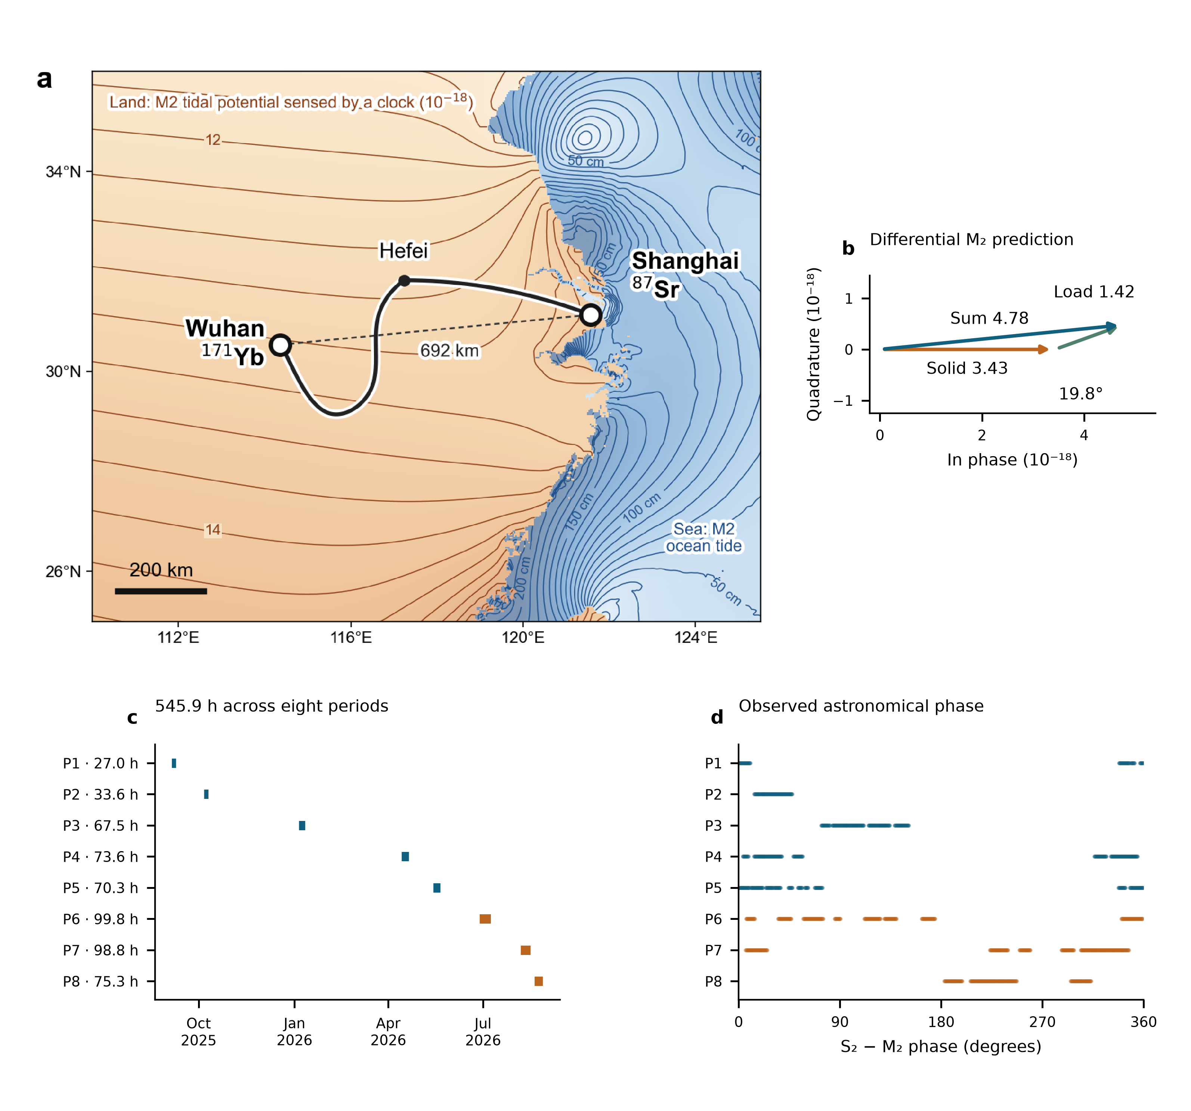
Fig. 1 | A coastal–inland baseline and its tidal prediction. a, Shanghai Sr and Wuhan Yb connected by the fibre route through Hefei. The dashed line marks the 692-km baseline. The supplied map illustrates an M₂ fractional clock-rate field over land in ${10}^{−18}$ and ocean-tide height contours at sea in centimetres. These are different physical quantities. b, Differential solid, loading and combined M₂ phasors from the frozen numerical prediction, with equal data-axis scales; the combined $4.78×{10}^{−18}$ corresponds to about $0.43 m^{2}/s^{2}$. c, Actual UTC sampling and accepted member-hours in eight periods. d, S₂−M₂ phase at those same observations, including nodal corrections. P6–P8 are summer. The map fields and phasors are predictions; the lower panels describe the measured observation window.

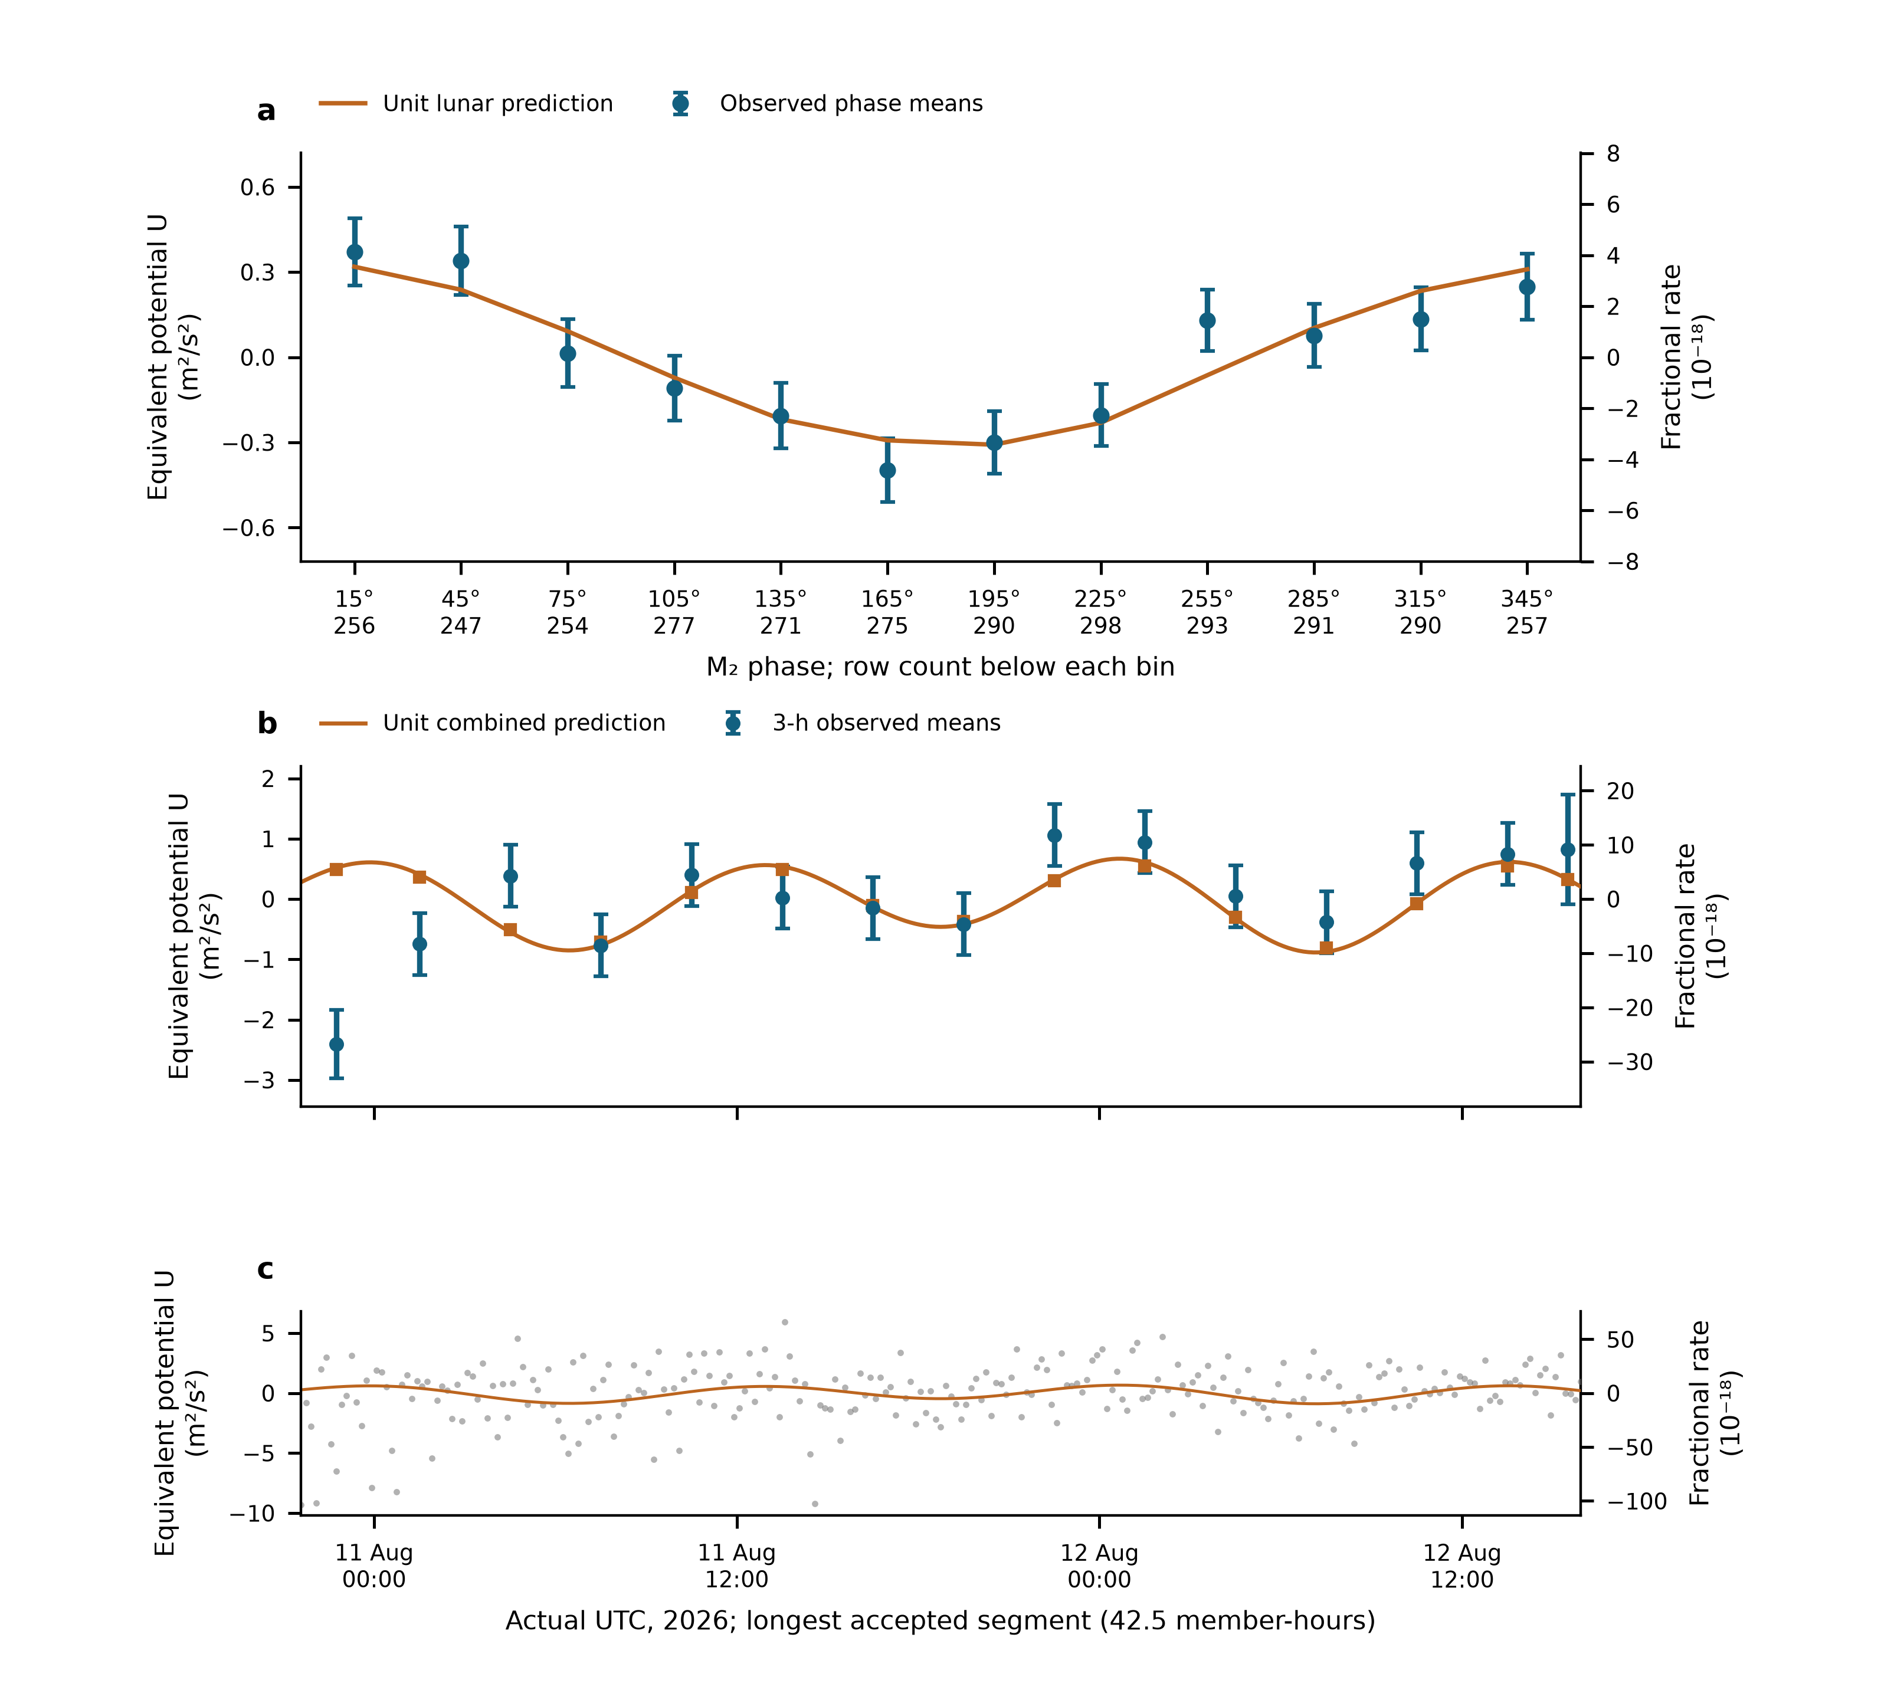
Fig. 2 | Tidal variation in the measured clock rates. a, Twelve M₂-phase means of all 3,299 ten-minute observations. The fixed minor remainder is removed, and data and unit lunar prediction undergo identical weighted projection against segment levels and the other physical groups. Error bars are one working standard error with nuisance propagation; means are correlated. Row counts appear beneath the phase labels. b, The segment with the largest accepted member count, shown at real UTC. Points are fixed-UTC three-hour means after independent weighted centring of data and prediction. Squares apply the same averaging to the unit combined prediction; the line evaluates it at the observed ten-minute times. Error bars propagate centring. c, Every original ten-minute mean in that segment, with its complete vertical range. No empirical daily sinusoid or fit-dependent offset is removed. Left axes use $U=c^{2}y=−ΔW$; right axes give fractional rate. Panels are views of the same measurements, and display averaging does not change the primary sample or inference.

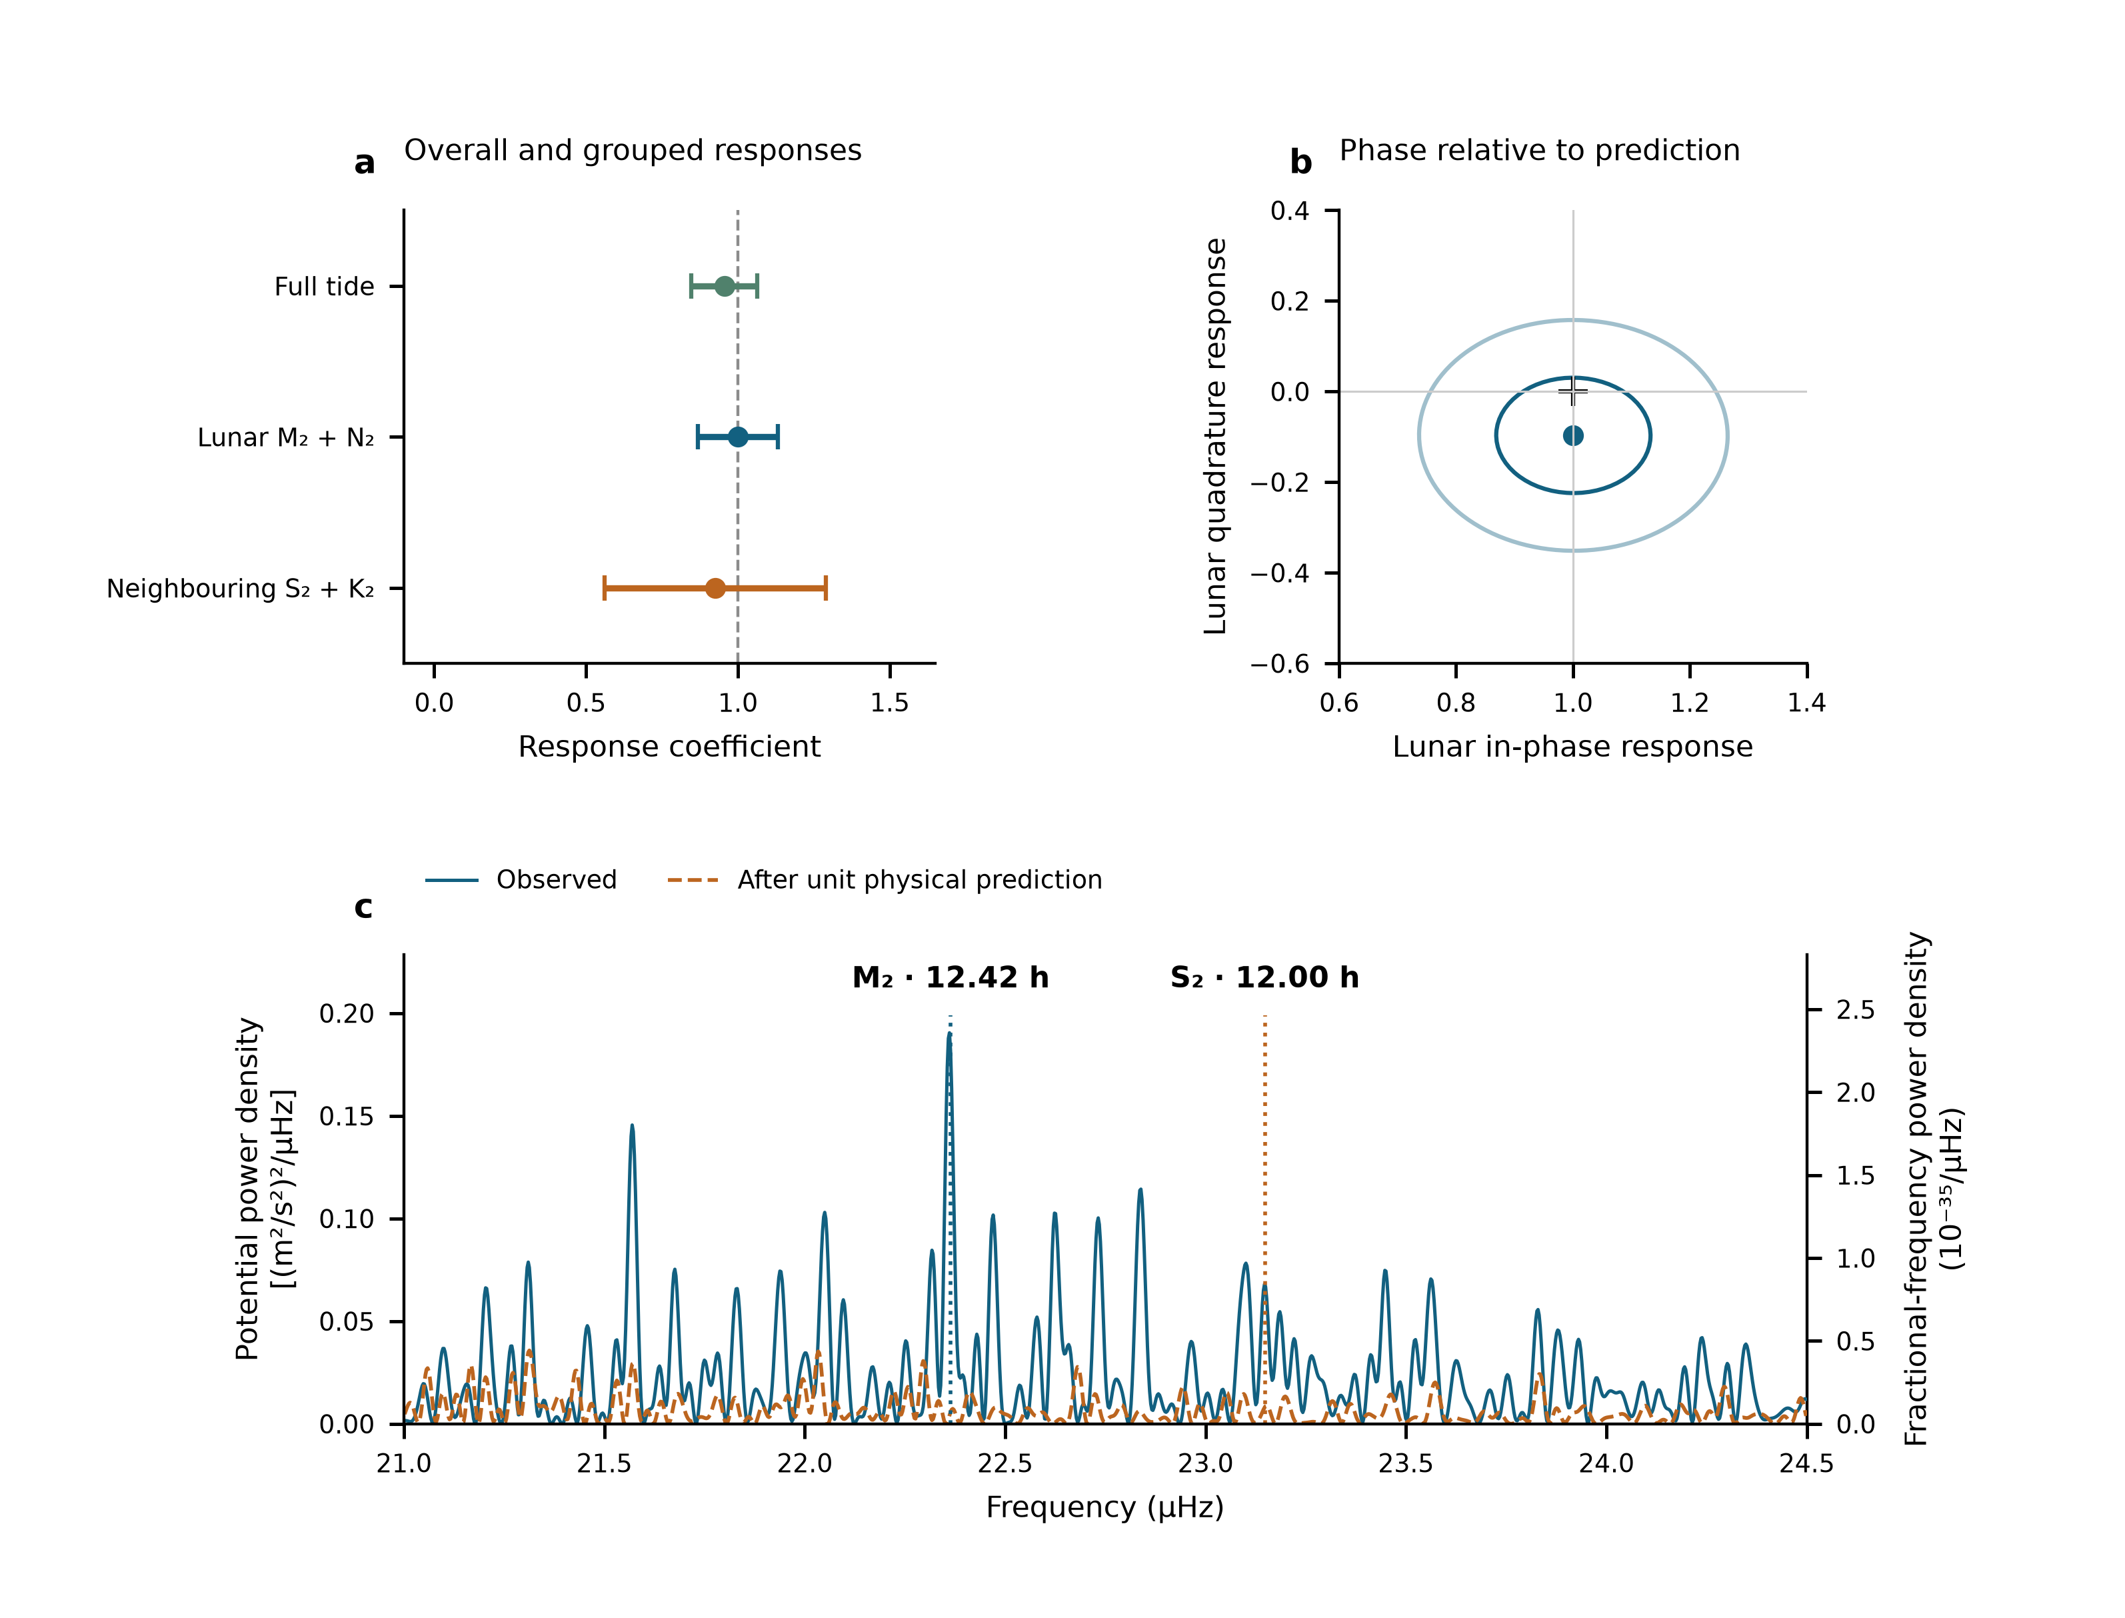
Fig. 3 | Amplitude, phase and frequency of the tidal response. a, The single complete-template response, followed by the jointly fitted lunar and neighbouring semidiurnal coefficients. Error bars are one statistical standard error, the larger of scaled LS and UTC-day-deletion jackknife errors. The estimates share the same observations and weights. b, Lunar in-phase and quadrature fit; the cross marks $\left(1,0\right)$. Contours use scaled-LS covariance radii one and two. The marginal working errors reported in the text are 0.13 and 0.20; the scaled-LS quadrature error is 0.127. These are not independently calibrated joint confidence levels. c, The measured 21–24.5 µHz spectrum and the spectrum after subtracting the fixed unit physical prediction. The scan retains all 3,299 original UTC rows and gaps, with equal weights and 54 segment constants. Vertical markers are the prescribed M₂ and S₂ frequencies. Left and right density axes obey $S_{W}=c^{4}S_{y}$. Peaks, phase and amplitudes use the same record and do not add independent detection significance. Sampling cross-power and conditional scans are given in Extended Data Fig. 1; joint group regions appear in Extended Data Fig. 4. The full-template and three-group coefficients come from two fits to the same observations; they are not averaged.

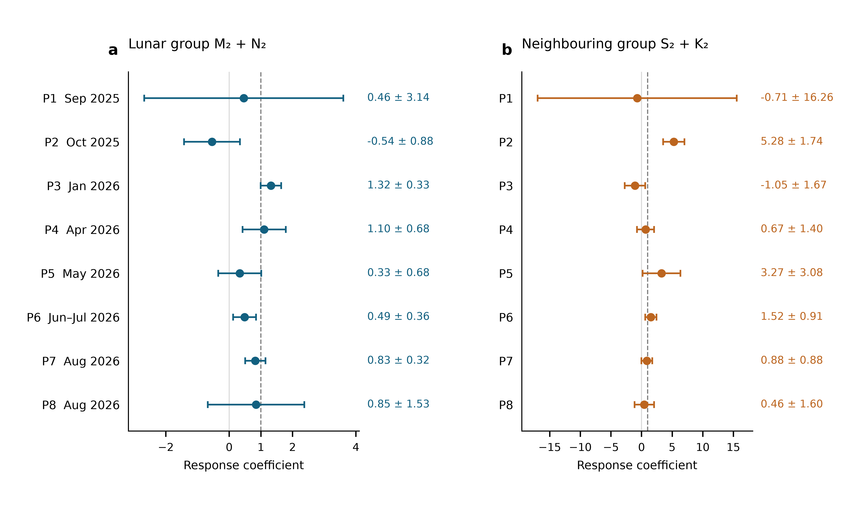
Fig. 4 | Semidiurnal responses in eight individual observing periods. a, Lunar M₂+N₂ coefficients. b, Neighbouring S₂+K₂ coefficients. Each point uses only the indicated period, jointly estimates all three physical groups, and retains independent reference levels for its original segments. All eight periods are shown in calendar order, with 163, 203, 409, 447, 429, 601, 595 and 452 ten-minute means, respectively. Error bars show one statistical standard error, the larger of scaled least squares and a UTC-day-deletion jackknife computed within that period. The periods contain 3, 3, 4, 5, 5, 9, 8 and 6 observed UTC dates. Both axes are linear and show the full error ranges; their scales differ. Dashed lines mark the unit prediction. The plotted periods use disjoint observations and are fitted separately; the full-record estimate is obtained by the common physical fit.

Methods

Observations, frequency sign and averaging
The Shanghai and Wuhan coordinates used by the frozen prediction are 31.130° N, 121.570° E and 30.529° N, 114.357° E. The measured ratio is Wuhan Yb/Shanghai Sr. With positive geodetic potential $W$, its tidal fractional variation is $−\left[δW_{Wuhan}−δW_{Shanghai}\right]/c^{2}$. The period-relative beat conversion is $−d_{p}\left(f_{beat}−f_{ref,p}\right)/F_{1550}$, where $F_{1550}=1.933992×{10}^{14}$ Hz and $d_{p}=2$ in 2025 and 1 in 2026. Thus a 2026 beat deviation of 1 Hz has fractional magnitude $5.17×{10}^{−15}$. The 2025 division factor is applied before forming the small clock-rate variation.
The supplied valid-interval table defines 54 segments in 29 operating groups and eight periods. Counter members are read across midnight before binning. Beijing-time labels are converted to UTC. Summer group corrections follow the decimal-arithmetic frequency-chain calculation; early absolute correction entries remain incomplete. Their constant part is represented by segment intercepts, while any time variation within a segment remains a possible systematic contribution. Fitted intercepts are not used to join the runs for long-term stability estimation.
The membership record contains 1,966,908 nominal one-second rows before the minimum-bin-support cut. Three boundary rows reconcile its difference from the printed interval total. Means are formed in nominal 600-s bins separately within each segment and require at least 180 retained members. The 3,299 accepted means contain 1,965,327 members, or 545.924 h. There are 3,291 unique bin centres: eight centres contain separate partial means from different segments, with disjoint members. The 353.39-day span contains observations on 43 UTC dates. The inherited valid mask is retained; this work neither applies an additional triangular filter nor selects points using tidal residuals. Exact raw-file memberships and hashes are retained in the controlled archive.

What the constituent names mean
Semidiurnal tides produce approximately two cycles per day. M₂ is the principal lunar constituent; N₂ describes an additional lunar variation associated with orbital ellipticity. S₂ is the principal solar semidiurnal constituent, whereas K₂ contains lunar and solar forcing. The names identify astronomical frequencies, not separate instruments or independent experiments. The diurnal group contains K₁ (lunisolar), O₁ (principal lunar), P₁ (principal solar) and Q₁ (lunar elliptic). Their periods are listed in Extended Data Table 1.²³ Internal relative amplitudes, phases and nodal modulation are fixed within each physical group. A group response therefore tests that complete specified pattern.

Combined solid and loading potential
The physical target includes the direct astronomical potential, the Earth’s induced potential and the effect of clock displacement. The selected frozen solid sequence implements these through the IERS radial displacement $u$ and a fixed effective-potential conversion,
$$y_{solid}=−\frac{1+k_{2}−h_{2}}{h_{2}}\frac{g\left(u_{Wuhan}−u_{Shanghai}\right)}{c^{2}},$$
with $h_{2}=0.6078$, $k_{2}=0.3010$ and $g=9.794 m/s^{2}$. This is a displacement-based approximation to the combined solid potential. The same conversion also acts on degree-three and frequency-dependent displacement contributions in the supplied sequence. A previous implementation comparison found an approximately 18% K₁ amplitude deficit relative to a potential-weighted reference. The daily response is accordingly not used to infer a Love number. The quoted statistical errors are conditional on this solid template. A same-sampling potential-weighted comparison has not been completed for these estimates, so the K₁ discrepancy is not assigned as an error on the semidiurnal response.
For loading, FES2022 sea-surface elevations $ζ$ are convolved with the effective-potential kernel
δWload=∫ρwζr′,tGWψ dA, GWψ=gaMEn​1+k′n−h′nPncosψ.
The three terms represent direct water attraction, induced potential and clock displacement. PREM load Love numbers are retained through degree 696 with the archived high-degree continuation. Eighteen loading constituents are synthesized with their astronomical nodal corrections. The complex convention is $f Re\left[Cexp\left(−iϕ\right)\right]$; reversing the exponential sign requires conjugating $C$. The present analysis reads the frozen constituent and time-series tables rather than substituting an older loading sequence.
The eight named constituents form the three physical groups. Minor terms remain once as a fixed remainder $r_{0}$. On the actual weighted segment-centred sampling, solid, loading and total root-mean-square variations are respectively 2.928, 1.328 and $4.011×{10}^{−18}$. Their ratio 0.331 is an amplitude-norm ratio, not an additive fraction of total power. A separate loading coefficient is not estimated here; the measured group responses test the combined prediction.

Segment reduction and the two estimands
Let $W_{s}$ be the original diagonal weight matrix in segment $s$, and define $⟨v⟩_{s}=\left(1^{T}W_{s}v\right)/\left(1^{T}W_{s}1\right)$. For each observation vector and each prediction column we form ${\tilde{v}}_{s}=v_{s}−1⟨v⟩_{s}$. This operation uses sample times and weights but no fitted tidal amplitude. For a physical design matrix $T_{s}$, the common coefficients solve
A=s​TsTWsTs−1s​TsTWsys.
The segment matrices and vectors contain the information needed for this estimate. All 54 segments enter the same fit; separately fitted segment amplitudes are not averaged. An independent full-design QR fit with 54 intercepts reproduces the three coefficients to within $3×{10}^{−15}$. Recomputing the segment means after every deletion also reproduces the original standard errors. No segment level is transferred to create a continuous, calibrated long-term record.
For the full-response estimate, $y$ is the observed fractional rate before removal of the minor remainder. We fit
$$y_{i}=c_{s\left(i\right)}+A_{T}T_{i}+ϵ_{i}, T_{i}=s_{L,i}+s_{S,i}+s_{D,i}+r_{0,i}.$$
The single coefficient multiplies the complete prediction. The restricted comparison retains only the 54 segment constants. For component estimation, we subtract the fixed minor remainder once and fit
$$y_{i}−r_{0,i}=c_{s\left(i\right)}+A_{L}s_{L,i}+A_{S}s_{S,i}+A_{D}s_{D,i}+ϵ_{i}.$$
The full-response model tests the combined waveform, whereas the grouped model allows the three astronomical bands to respond differently. Both use $W_{ii}=1/σ_{i}^{2}$ with the period-dependent Allan-based uncertainties defined below.
For Fig. 4, we repeat the same three-group estimation separately on each of P1–P8. The data, fixed theoretical remainder and Allan-based weights are inherited from the frozen primary design; each period retains its original segment constants. The UTC-day jackknife is recomputed using only the dates present in that period. All period fits and day-deletion replicates retain full column rank and were independently checked against an explicit segment-intercept QR calculation. The individual-period errors use the same working standard-error rule as the full record.
The daily group is an auxiliary physical component; its coefficient remains $0.58±0.54$ (Extended Data Table 2). The interval and correction records do not establish calibrated zero transfer at the 46 boundaries where an eight-period intercept would be shared. They document valid observing times but not signed boundary transfers with uncertainties. The segment convention follows that experimental information.

Construction of bin uncertainties
For ten-minute bin $i$, the assigned uncertainty is
$$σ_{i}=\frac{α_{p\left(i\right)}}{\sqrt{n_{i}}},$$
where $n_{i}$ counts retained nominal one-second members and $α_{p}$ is the one-second fractional-frequency noise level of period $p$. In this convention the corresponding white-frequency instability is $α_{p}/\sqrt{τ/\left(1 s\right)}$. The machine-readable source data provide all eight period coefficients, bin member counts and reconstructed uncertainties.
The noise calculation uses original segments containing at least 8,192 retained members. The fixed unit tidal prediction is evaluated at member timestamps and subtracted after centring within each segment. Overlapping Allan deviations are calculated at 256, 512, 1,024, 2,048 and 4,096 nominal seconds, using the acquisition’s one-second member convention. At each averaging time the deviations are averaged across eligible segments, weighted by their member counts. The geometric mean of these averaged deviations multiplied by $\sqrt{τ/\left(1 s\right)}$ gives $α_{p}$. No Allan window crosses a segment boundary. These coefficients determine relative fitting weights; residual scaling and day deletion determine the reported statistical errors.
The instability benchmark quoted with Fig. 1a was reported for the spliced summer comparison.¹⁴ It is not used to assign the present weights, which are reconstructed from the period coefficients and retained member counts. No stability estimate from joined, fit-adjusted levels is used in this analysis.

Statistical errors and conditional coverage
For each group the reported standard error is the larger of residual-scaled least squares and leave-one-UTC-day-out jackknife errors. Deletions remove a calendar day, refit all remaining coefficients and drop empty intercept columns. The jackknife variance is G−1G−1g​A−g−A2. Period-deletion errors are recorded separately. Extended Data Table 2 gives all components and the same-data intercept comparisons. Observations are repeated measurements of one clock pair, not thousands of independent experiments.
Conditional simulations apply both designs to the same 3,299-row sampling and heteroscedastic uncertainties. Each of four scenarios has 1,000 realizations: independent Gaussian noise; equal variance contributions from Gaussian white noise and a 6-h Ornstein–Uhlenbeck process within segments; the corresponding 24-h process within periods; and standardized Student-$t_{5}$ noise. The overall scale is the observed segment-model residual scale; all true physical response coefficients are one. Each realization recomputes both components of the standard-error rule. Seed 2026110617 fixes the simulation. Coverage of $\hat{A}±1.96u$ is 95.1–97.4% for the segment-model lunar coefficient and 95.4–96.8% for its neighbouring coefficient; Monte Carlo standard errors are about 0.4–0.7 percentage points (Extended Data Table 3). These are tests under declared noise laws, not a calibration against every possible disturbance.
The full-template coefficient uses the same standard-error rule. Its scaled-LS, day-deletion, day-cluster CR1 and period-deletion standard errors are respectively 0.0973, 0.1082, 0.1033 and 0.1216. The CR1 sandwich uses 43 UTC-day clusters and the finite-sample factor $\left[G/\left(G−1\right)\right]\left[\left(n−1\right)/\left(n−K\right)\right]$, with $K=55$. The working interval ${\hat{A}}_{T}±1.96u$ is 0.743–1.167. This is an explicitly labelled working interval, rather than a confidence statement valid for every possible noise process.
For targeted zero-response tests, we compare the weighted RSS of nested models on the unchanged rows. The full-template test adds one entire prediction to segment constants. The neighbouring-group test adds one S₂+K₂ coefficient while retaining the lunar and daily groups and the constants. Noise is generated on the true window with the original heteroscedastic uncertainties and the observed full-model residual scale. Each of the four declared noise scenarios has 20,000 realizations; seeds 2026110711 and 2026110709 fix the full-template and neighbouring-group simulations. The exact residualized-template projection computes the RSS improvement, and direct restricted/full refits check that calculation. The full-template statistic is 110.353; none of the 20,000 draws in any scenario reaches it. The plus-one tail estimate is $1/20,001$ in each scenario, not zero. For the neighbouring statistic 10.943, the corresponding tail estimates are 0.00185, 0.12559, 0.01435 and 0.00205 in the listed noise-scenario order.
Restricted period-wise residual sign flips enumerate all $2^{8}=256$ patterns, preserving each period’s internal structure. The diagnostic tail fractions are 2/256 for the full response and 16/256 for the added neighbouring group. They rely on period independence and symmetry and are not exact experimental randomization tests. The two-sided resolution is 2/256; neither enumeration is converted to a Gaussian sigma value.
The noise scenarios are conditional stress tests, not measured noise laws. In separate 2,000-draw diagnostics per law, the observed within-segment lag-one residual correlation is −0.148. The simulated 95% ranges are −0.054–0.015 for Gaussian noise, 0.216–0.347 for the 6-h mixture, 0.072–0.202 for the 24-h mixture and −0.051–0.017 for $t_{5}$. Thus the positively correlated mixtures do not describe the observed short-lag structure; neither do the other two laws fully reproduce it. No scenario is selected because of its tidal tail probability. No simulated record is added to the observations.
Extended Data Fig. 4 gives conditional two-group regions: the first 10,000 draws estimate error covariance and the empirical 95% Mahalanobis threshold; the other 10,000 assess coverage. Held-out joint coverage is 94.3–94.8%, with binomial Monte Carlo standard errors of about 0.22 percentage points and additional calibration uncertainty. These nominal regions describe the specified laws and do not replace the reported marginal working errors with a universally calibrated joint confidence region.
The phase-relaxed model adds a lunar component shifted by a quarter-cycle while retaining the prescribed M₂/N₂ relationship. Covariance contours use scaled least squares. Subset and deletion fits refit the same model on their retained rows. Shared-data estimates are not averaged. The simulation coverage refers to two-sided intervals; the reported $±$ values are standard errors.

Phase means, spectral density and sampling sidelobes
For the phase plot, $N$ contains segment constants and the two non-lunar groups. We project both $y−r_{0}$ and the unit lunar prediction with $M_{N}=I−N{\left(N^{T}WN\right)}^{−1}N^{T}W$, and average in twelve fixed M₂ phase bins. If $B$ is weighted bin averaging, the mean covariance is $BM_{N}C_{y}M_{N}^{T}B^{T}$, where $C_{y}$ is the scaled working observation covariance. It retains correlations between means and propagates nuisance estimation. The response is estimated from the original ten-minute means, before phase binning.
For the actual-time display, the representative segment maximizes accepted nominal member count, with segment ID breaking ties. Segment 51 contains 255 ten-minute means and 153,000 members. Its 42.5 member-hours extend from 10 August 2026 21:35 UTC to 12 August 15:55 UTC. Three-hour display bins follow fixed UTC boundaries and remain inside the segment. All 255 means are assigned; none is removed to improve the display. Weighted averaging is identical for observed and unit-predicted centred values. If a display bin has total weight $w_{b}$ and its segment has total weight $w_{s}$, the centred-observation variance is ${\hat{σ}}^{2}\left(1/w_{b}−1/w_{s}\right)$. This propagates the segment-mean operation and creates correlations between display means. The curve at ten-minute timestamps is a sampled physical prediction, not gap filling. The potential display uses $U=c^{2}y$ and the right axis retains the fractional rate.
Figure 3c preserves the independently specified equal-weight, 54-intercept scan of the unchanged observed means, rather than replacing it with the amplitude fit’s weights. Every trial sine–cosine pair and the data are projected against the same constants. For a reduction in squared residuals $ΔRSS\left(f\right)$ with dimensionless $y$, the nominal one-sided projection density is $S_{y}\left(f\right)=600 s ΔRSS\left(f\right)$ per Hz, or ${10}^{−6}$ times that value per µHz. Potential density is $S_{W}=c^{4}S_{y}$; amplitude density is $c^{2}\sqrt{S_{y}}$. Uniform-grid checks reproduce the conventional one-sided Fourier density. For interrupted data this normalization is a stated projection density, not a Parseval-calibrated variance over a filled year.²⁴
The frequency step is 0.002729 µHz; the inverse calendar span is 0.032752 µHz. Fine plotting steps do not improve physical resolution. The listed peak positions are scan maxima; no constituent-frequency fit or frequency-confidence interval is reported. M₂-only and S₂-only astronomical injections use the same actual times, nodal factors and equal-weight segment projection. Power at the opposite principal frequency, divided by power at the injected frequency, gives 0.08027 and 0.08149. Conditional scans project out a freely phased sinusoid at the other frequency before scanning the target neighbourhood. Amplitude interference means that such corrections act on sampled waveforms or complex coefficients, not by subtracting scalar power spectra. Gaps alone do not predict the realization of measurement noise. Residual density can describe remaining measurement fluctuations, but includes possible model mismatch and cannot be called a pure instrumental noise floor.

Instrument and daily-response checks
The matched monitor calculation uses 1,482 rows with 887,882 nominal members, or 246.634 h, in P6–P8. Both baseline and augmented fits have identical members, segment labels and weights. Paired day-deletion replicates propagate uncertainty in their difference. Extended Data Fig. 3 reports the response changes and dates. This comparison concerns the monitored transmission route during the measured overlap.
On the selected data and model, a common 24-h sine–cosine pair gives $A_{L}=1.036±0.133$; separate 24-h pairs in each period give $1.003±0.136$. These daily sensitivity designs address a periodicity motivated by temperature and operating schedules, without assigning an independently measured thermal amplitude. A shared 12-h pair gives lunar $0.994±0.132$ and neighbouring $2.931±1.011$. Separate pairs in each period give $0.751±0.242$ and $−5.100±15.008$. The normalized design condition number grows from 2.37 to 6.90 and 122.54, respectively; all designs retain full numerical rank. These terms test same-frequency identifiability and are not independently measured disturbances. Extended Data Table 4 reports both groups and their 1.96-SE working intervals.
The full-template sensitivity fits add either one shared 24-h sine–cosine pair or a separate 12-h pair in each of the eight periods. The basis functions are evaluated at the recorded UTC bin centres. All 3,299 observations, 54 segment constants, original weights and the full minor remainder are retained. Each model recomputes scaled least-squares and 43-day-deletion errors; Extended Data Table 5 lists both components. These scalar-response fits are distinct from the grouped models in Extended Data Table 4.

AI-assisted preparation
OpenAI Codex assisted English drafting, code preparation and checking, numerical replay, and plotting from derived experimental tables using Python. The geographical map in Fig. 1a was supplied by the authors and retained unchanged. No observations were generated to replace or fill the experimental record. [Authors to confirm the tool and version details, their verification of the code, source data, statistics, figures and citations, and responsibility for the final work.]

Data availability
The author review package contains the 3,299 derived means, fixed templates, noise weights, figure source tables and immutable input hashes. The original counters and membership ledger are held in the controlled experimental archive. [Authors to supply an editor-accessible location and confirm the permanent data-access statement and repository identifier before submission.]

Code availability
The package contains the independent QR replay, same-data design comparison, conditional simulations, spectral calculations, covariance propagation and figure scripts, with software versions and a reproducible entry point. [Authors to confirm the code licence and permanent repository identifier before submission.]

Methods references
- NOAA. Harmonic constituents. NOAA Tides and Currents. https://tidesandcurrents.noaa.gov/harcon.html?id=8577330 (accessed 6 November 2026).
- VanderPlas, J. T. Understanding the Lomb–Scargle periodogram. Astrophys. J. Suppl. Ser. 236, 16 (2018). https://doi.org/10.3847/1538-4365/aab766

Acknowledgements
[To be completed by the authors.]

Funding statement
[Funding sources and grant identifiers to be completed by the authors.]

Author contributions
[To be completed and approved by all authors.]

Competing interests
[Declaration to be supplied by the authors.]

Additional information
Correspondence: [Corresponding author names and email addresses to be supplied; mark them with an asterisk in the author list.]

Extended Data
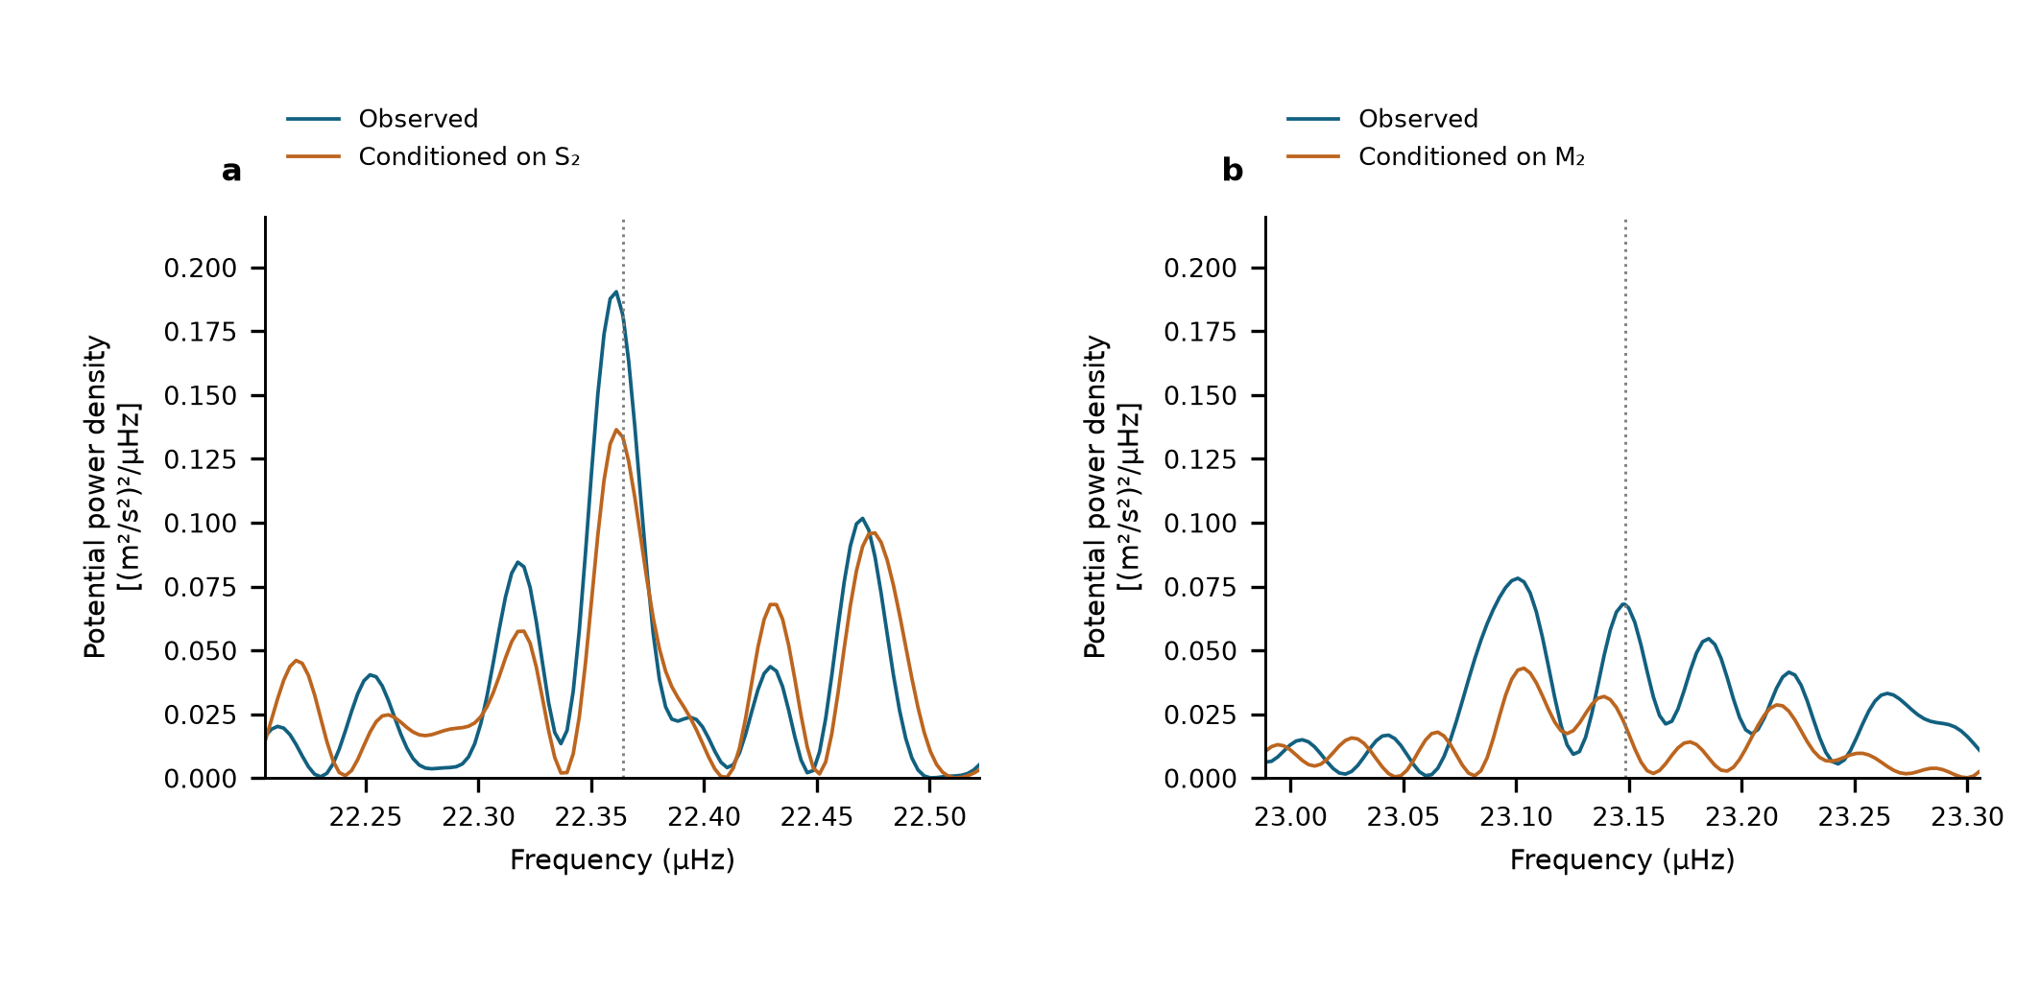
Extended Data Fig. 1 | Conditional semidiurnal scans. Equal-weight scans of the same 3,299 observations with 54 segment intercepts. a, M₂ neighbourhood before and after projection of a sine–cosine pair at S₂. b, S₂ neighbourhood before and after projection at M₂. Dotted lines show the astronomical target frequencies. These are descriptive projections on shared observations, not additional detection probabilities.

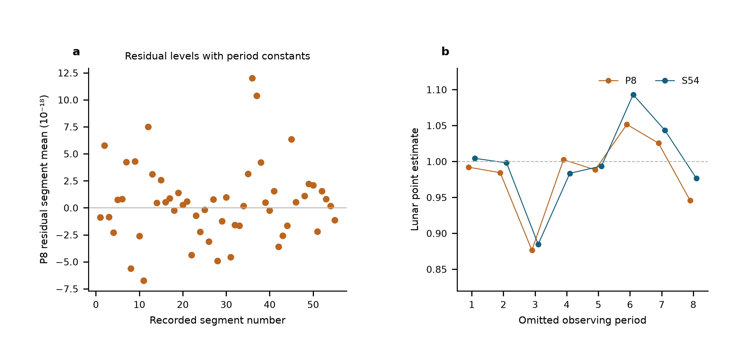
Extended Data Fig. 2 | Same-data comparison of reference-level designs. a, Weighted segment-mean residuals after the eight-period joint fit, ranging from $−6.75$ to $12.00×{10}^{−18}$. Segment constants make these means zero by construction. b, Lunar point estimates after period deletion, spanning 0.877–1.052 with eight period constants and 0.885–1.093 with 54 segment constants. The weighted residual sums of squares are 3,781.58 and 3,713.64; the latter has 46 additional intercept parameters. Unweighted residual root-mean-square values are 24.114 and $23.934×{10}^{−18}$, and reduced residual sums of squares are 1.1501 and 1.1455. Adjacent standardized residual correlations are −0.127 and −0.148, using pairs within the same segment and separated by at most 900 s. All comparisons retain identical observations, templates, corrections and noise weights. These are residual diagnostics, not measurements of physical jumps or zero-transfer calibration.

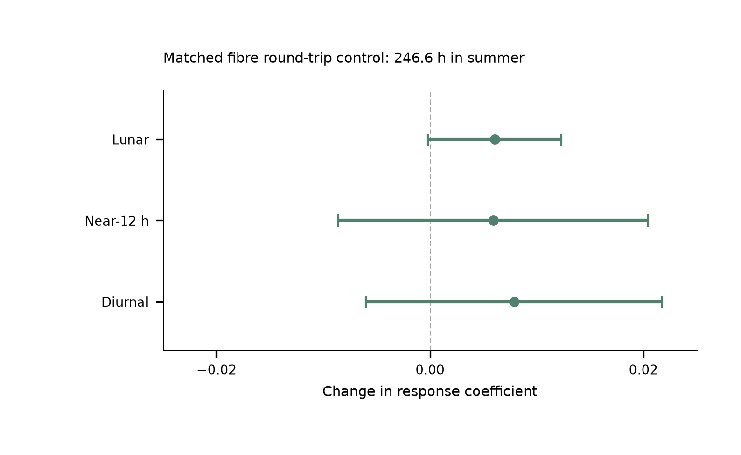
Extended Data Fig. 3 | Simultaneous summer transmission control. Changes caused by adding the fibre round-trip monitor to the joint model, with paired UTC-day-jackknife standard errors. Baseline and augmented fits use identical clock/monitor members, labels and weights: 1,482 means containing 887,882 nominal one-second members, or 246.634 h in P6–P8, from 29 June to 25 August 2026. The lunar, neighbouring and daily shifts are respectively $0.00606±0.00627$, $0.00594±0.01453$ and $0.00791±0.01388$. The paired monitor constrains the measured transmission route on this summer overlap. The main tidal estimate uses the entire 545.9-h clock record. The prior transmission-architecture demonstration over 2,067 km is a separate experiment.¹⁷

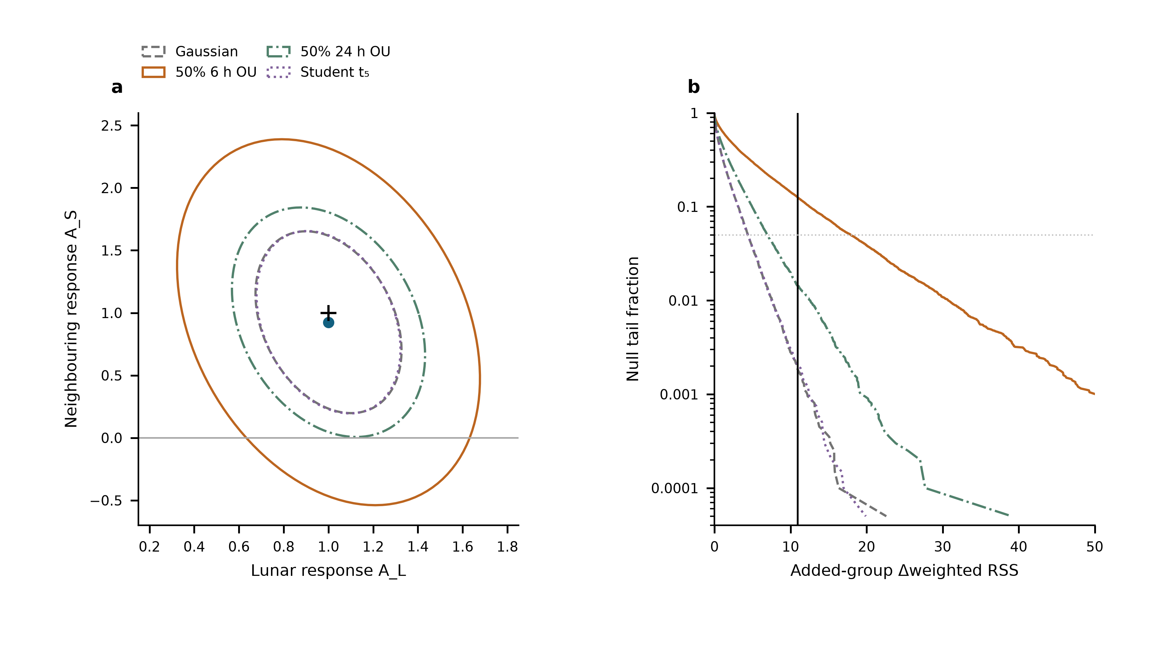
Extended Data Fig. 4 | Conditional uncertainty of the neighbouring response. a, Nominal 95% joint regions for $\left(A_{L},A_{S}\right)$ under four declared noise laws on the original 3,299-row design. The point is the observed estimate and the cross is $\left(1,1\right)$. Each region uses 10,000 calibration and 10,000 validation simulations; held-out coverage is 94.3–94.8%. The regions are conditional on the specified laws, none of which fully matches the measured short-lag residual structure. b, Null tail curves for the added S₂+K₂ coefficient from 20,000 simulations per law. The vertical line marks the observed weighted-RSS improvement; the dotted horizontal line is 0.05. Simulations are separate from the measured data. The declared scenarios provide sensitivity information, not four additional experiments or an independently validated laboratory-noise model.

Extended Data Table 1 | Astronomical constituent guide. Names specify forcing and frequency; one response coefficient multiplies each complete group with its internal ratios and phases fixed.
Symbol | Period_h | Meaning | Group
M2 | 12.421 | Principal lunar semidiurnal | Lunar
N2 | 12.658 | Lunar elliptic semidiurnal | Lunar
S2 | 12 | Principal solar semidiurnal | Near-12 h
K2 | 11.967 | Lunisolar semidiurnal | Near-12 h
K1 | 23.934 | Lunisolar diurnal | Diurnal
O1 | 25.819 | Principal lunar diurnal | Diurnal
P1 | 24.066 | Principal solar diurnal | Diurnal
Q1 | 26.868 | Lunar elliptic diurnal | Diurnal

Extended Data Table 2 | Estimator and uncertainty comparison. All directly replayed designs use the same 3,299 means, physical templates and Allan-based weights. Errors are standard errors.
Design | Lunar | Near_12h | Diurnal | Status
S54 | 1.000 ± 0.132 | 0.925 ± 0.365 | 0.579 ± 0.538 | Replayed
G29 | 0.984 ± 0.124 | 1.093 ± 0.298 | 0.759 ± 0.420 | Replayed
P8 | 0.987 ± 0.123 | 1.129 ± 0.288 | 0.678 ± 0.359 | Replayed

Group | Estimate | Scaled_LS | Day_JK | Period_JK | Reported_SE
Lunar | 1.0004 | 0.132 | 0.1218 | 0.147 | 0.132
Near-12 h | 0.9251 | 0.2993 | 0.3649 | 0.3531 | 0.3649
Diurnal | 0.5792 | 0.3887 | 0.5381 | 0.7735 | 0.5381

Extended Data Table 3 | Conditional 95% interval coverage. Each scenario has 1,000 simulated realizations per design, with fixed observed sampling and weights. Values are percentages for the larger-of-LS-and-day-jackknife rule, using multiplier 1.96. They assess the specified scenarios, not unknown systematic effects.
scenario | design | Diurnal | Lunar | Near12h
50% OU 24 h, period | P8 | 97.9 | 98 | 97.3
50% OU 24 h, period | S54 | 96.4 | 95.1 | 95.4
50% OU 6 h, segment | P8 | 94.7 | 95.7 | 96
50% OU 6 h, segment | S54 | 95.8 | 95.6 | 96.3
Student t (df 5) | P8 | 96.8 | 96.3 | 96.2
Student t (df 5) | S54 | 96.2 | 96.1 | 96.8
Gaussian | P8 | 95.7 | 96.2 | 95.9
Gaussian | S54 | 95.5 | 97.4 | 96.7

Extended Data Table 4 | Same-data 12-h sensitivity. Each row retains the original 3,299 means, 54 segment levels, astronomical group templates and Allan weights. Errors are the larger of scaled LS and day-deletion jackknife standard errors. Working intervals are estimate ±1.96 standard errors; they are not calibrated for all correlated-noise or deterministic-disturbance models. A common 12-h sine–cosine pair has one phase across the record; the period-wise design gives each of eight periods its own pair. These fits assess degeneracy, not the independently established magnitude of an instrumental effect.
Model | Lunar coefficient | Lunar working interval | Neighbouring coefficient | Neighbouring working interval
Primary | 1.000 ± 0.132 | [0.742, 1.259] | 0.925 ± 0.365 | [0.210, 1.640]
Shared 12 h | 0.994 ± 0.132 | [0.735, 1.252] | 2.931 ± 1.011 | [0.950, 4.913]
12 h per period | 0.751 ± 0.242 | [0.277, 1.224] | -5.100 ± 15.008 | [-34.515, 24.316]

Extended Data Table 5 | Full-template response and sensitivity. Each fit uses the same 3,299 ten-minute means, 54 segment constants and Allan-based weights. The scalar response multiplies the complete solid-Earth and ocean-loading waveform, including the minor-constituent remainder. Standard errors are statistical; the reported value is the larger of scaled least squares and UTC-day-deletion jackknife. The grouped-model sensitivities remain in Extended Data Table 4.
Model | Response | Scaled LS | Day jackknife | Reported SE
Whole template | 0.9551 | 0.0973 | 0.1082 | 0.1082
With shared 24-h pair | 1.0316 | 0.1028 | 0.098 | 0.1028
With period-specific 12-h pairs | 0.7222 | 0.1791 | 0.2212 | 0.2212

