Tidal potential measured on a coastal–inland optical-clock baseline
WORKING DRAFT v69 — v68/R7 synthesis, 6 November 2026, revised after one Nature-style review.
Prepared for author evaluation. This is not the unique merged submission manuscript: the round-specific R7 handoff and the matched v68 primary input chain remain outstanding. Both reductions are named wherever their observations or coefficients appear; no combined estimate or final primary estimator is asserted.
[Author list and affiliation assignments to be confirmed.]

Abstract
Networks of optical clocks can sense changes in gravitational potential through changes in their relative rates. We compare clocks in coastal Shanghai and inland Wuhan over interrupted observations spanning a year. The lunar semidiurnal tide repeats every 12.42 h, whereas the solar S2 tide repeats every 12 h. Sampling their changing relative phase allows lunar M2+N2 and neighbouring S2+K2 responses to be estimated together. The lunar and neighbouring coefficients are $0.97±0.14$ and $0.90±0.29$ in a segment-based reduction, and $0.99±0.12$ and $1.13±0.29$ in a period-based reduction. Each uses its own uncertainty rule. Both reductions yield positive responses in the two semidiurnal groups; the diurnal response is less tightly constrained. Ocean loading contributes about one third of the predicted variation on this baseline. The measurement tests the combined tidal potential, with loading not separately resolved.

Main text
Optical clocks can compare the passage of time precisely enough to sense differences in gravitational potential between their sites.^{1,2} Phase-stabilized optical fibres extend these comparisons beyond a single laboratory, connecting distant clocks into networks.^{3,4} A clock network can therefore act as a spatially distributed sensor of gravitational potential. Experiments have measured static potential differences using laboratory, transportable and fibre-connected clocks.^{5,6,7,8} A changing potential presents a further challenge. Its signature must be distinguished from changes in the clocks and in the systems carrying their signals.^{9,10,11}
Tides provide a natural test because their timing is set by celestial motion. The Moon and Sun change the potential directly, deform the solid Earth and redistribute ocean water. These effects alter clock rates in predictable combinations. Two of the strongest rhythms are close together: the lunar semidiurnal constituent M2 repeats approximately every 12.42 h, while the solar constituent S2 repeats every 12 h. Their relative phase changes over the observing calendar. A few hours can make the two patterns look alike; observations spread across their relative phase provide a way to estimate them separately.¹²
Here we use a coastal–inland comparison between Shanghai and Wuhan to examine these semidiurnal responses. The geographical contrast matters as well as the timing. Shanghai is near the East China Sea, whereas Wuhan is inland, so ocean loading is a substantial part of the predicted difference rather than a small correction. We jointly estimate the lunar group M2+N2 and the neighbouring S2+K2 group, retaining the astronomical phase and relative amplitude within each. K2 has both lunar and solar forcing. The separate, approximately daily group K1+O1+P1+Q1 is estimated in the same model. This approach asks whether the observations distinguish two prescribed semidiurnal patterns, without first subtracting an empirical laboratory-day waveform.

A coastal–inland clock comparison
A strontium clock in Shanghai and a ytterbium clock in Wuhan are separated by 692 km and connected through Hefei by a 1,350-km phase-stabilized fibre link (Fig. 1a).¹³ The station coordinates are 31.130° N, 121.570° E and 30.529° N, 114.357° E, respectively. Evaluations of the clocks report systematic uncertainties of $9.2×{10}^{−19}$ for Sr and $1.3×{10}^{−18}$ for Yb.^{14,15}
We express the observation as a fractional change in the Wuhan-Yb/Shanghai-Sr frequency ratio. Positive values mean that Wuhan runs faster relative to Shanghai. The corresponding prediction combines the direct tide-generating potential, Earth’s induced potential, the displacement of each clock and the complete ocean-loading potential. In the direct-potential implementation, IERS 2010 solid tides are combined with FES2022 ocean elevations through a loading calculation that includes the attraction of seawater, deformation-induced potential and clock displacement.^{12,16,17,18}
For the differential M2 prediction, the solid and loading contributions have amplitudes of $3.41×{10}^{−18}$ and $1.42×{10}^{−18}$. Their phases differ by about 20°, and their vector sum is $4.77×{10}^{−18}$ (Fig. 1b). Over the segment-centred sampling, the respective root-mean-square variations are 3.0, 1.35 and $4.1×{10}^{−18}$. Thus loading supplies approximately one third of the combined predicted variation. Fitting a separate loading scale gives $0.89±0.55$, which does not resolve that contribution independently. The measured quantity is the response to the combined potential.
The record extends from September 2025 to August 2026. Its segment-based reduction (v68) contains five campaigns and 54 segments, with approximately 544 retained hours. Summer contributes 274 h and samples the lunar pattern across the solar day (Fig. 1c,d). A second, period-based reduction (R7) organizes the observations into eight operating periods and 29 original groups. Its 3,299 accepted ten-minute means contain 545.9 sample-hours. The counts differ because the reductions use different selection and averaging procedures. Each figure identifies the observations it shows.
Interruptions introduce unknown reference levels. We fit those levels jointly with the tidal responses, assigning a constant to each segment or each operating period in the two reductions. This preserves the changing signal within an interval without joining the entire record into an absolutely calibrated frequency level. The summer record is particularly useful because the lunar and solar patterns move past one another while the same physical model is tested.

Two semidiurnal responses
Both reductions estimate the three tidal groups together, with other predicted contributions included once at their fixed values. The segment-based analysis uses equal weights and applies the same triangular filter to data and prediction. The period-based analysis uses ten-minute means and noise weights derived within the observed runs. Their physical-template implementations and uncertainty calculations are retained separately in Methods.
The segment-based coefficients are $A_{L}=0.97±0.14$ for M2+N2 and $A_{S}=0.90±0.29$ for S2+K2. The period-based coefficients are $A_{L}=0.99±0.12$ and $A_{S}=1.13±0.29$ (Fig. 3a). Each reduction therefore yields positive, separately estimated semidiurnal responses consistent with the prescribed unit prediction. The coefficients are moderately anticorrelated: −0.32 and −0.36, respectively.
The diurnal coefficients are less precise, at $0.35±0.51$ and $0.68±0.36$. Their uncertainty does not invalidate the semidiurnal estimates: the daily group is already present in the joint fit, and its correlations with the semidiurnal groups enter that fit’s covariance. The observations constrain the different frequency groups with different precision. We report their own errors rather than requiring equal sensitivity across bands.
The full-record phase plot makes the semidiurnal variation visible (Fig. 2). Observations and the unit lunar prediction undergo the same removal of nuisance components before being averaged in twelve fixed M2 phase intervals. All 3,299 period-based observations remain in the display, including the largest excursions. Every phase interval contains data from all eight periods. The uncertainty bars propagate the nuisance projection and averaging; the amplitude itself is estimated from the unbinned rows, not from the twelve displayed means.
A phase-relaxed fit provides a further view of the same observations (Fig. 3b). It gives a lunar in-phase coefficient of $0.99±0.12$ and a quadrature coefficient of $−0.18±0.14$, with the relative M2–N2 phase still fixed. This tests a common phase displacement of the lunar pattern. The phase plot and the spectral display in Extended Data Fig. 1 visualize observations already used in the fits. The spectral peaks cannot separate M2 from S2 in this interrupted record; that separation comes from their prescribed phases across the observing calendar and their simultaneous estimation.

Support across observations and measured controls
The period-based analysis gives a lunar coefficient of $1.10±0.21$ before summer and $0.80±0.18$ in summer. Removing each period in turn leaves lunar point estimates between 0.88 and 1.05 (Fig. 4a). The segment-based summer and non-summer estimates are $0.87±0.18$ and $1.05±0.31$. These comparisons locate the support for the lunar response across time. The subsets and full record share observations, so their errors are retained with their individual fits rather than combined as independent experiments.
In the segment-based analysis, adding outdoor-temperature covariates for Shanghai and Wuhan gives $A_{L}=0.98±0.13$ (Fig. 4b). These covariates come from ERA5 two-metre air temperatures.¹⁹ A separate, direct Sr-chamber record averages twenty PT100 sensors over 98 h; its residual blackbody-shaped coefficient is $0.92±0.74$. Both clocks apply blackbody corrections during operation. Outdoor weather and chamber thermometry therefore address different parts of the environmental question.
For an effect linked to daytime heating or operating schedules, a 24-h term with a physically motivated phase is the appropriate first diagnostic. The segment-based temperature-phase check gives $A_{L}=0.99±0.14$. Allowing an unrelated 12-h phase to reset in every campaign gives $0.82±0.17$. That supplementary fit explores competition with semidiurnal tides over short campaigns; it does not establish that the laboratory contains a disturbance with that period or a particular amplitude.
The fibre round-trip monitor supplies a directly recorded transmission control. In the segment-based analysis, adding it on identical 474-h support changes both the lunar and whole-template coefficients by less than 0.005 (Fig. 4c). This comparison constrains the transfer path sampled by the monitor. Clock-specific effects and laboratory branches outside that path require their own measurements.

From clock networks to changing potentials
The coastal–inland geometry and the changing lunar–solar phase address different aspects of the measurement. The geometry makes loading important in the prediction; the phase coverage allows two nearby semidiurnal responses to be estimated together. The present measurement tests their combined tidal potential. Separating the loading contribution itself will require longer coastal records and better characterized transfer branches.
Hou et al. report the absolute Yb/Sr ratio on this link using overlapping summer observations.¹³ Here the question is the separation of tidal responses in the extended interrupted record; the absolute ratio and its earlier correlation significance are not re-estimated. Independent, contemporaneous European observations by Stahl et al. use clock-network baselines of about 800 km with different mixtures of diurnal and semidiurnal tides.²⁰ These complementary baselines show how geography and observing duration shape a clock network’s sensitivity.

References
- Ludlow, A. D., Boyd, M. M., Ye, J., Peik, E. & Schmidt, P. O. Optical atomic clocks. Rev. Mod. Phys. 87, 637–701 (2015). https://doi.org/10.1103/revmodphys.87.637
- Mehlstäubler, T. E., Grosche, G., Lisdat, C., Schmidt, P. O. & Denker, H. Atomic clocks for geodesy. Rep. Prog. Phys. 81, 064401 (2018). https://doi.org/10.1088/1361-6633/aab409
- Lisdat, C. et al. A clock network for geodesy and fundamental science. Nat. Commun. 7, 12443 (2016). https://doi.org/10.1038/ncomms12443
- Riehle, F. Optical clock networks. Nat. Photon. 11, 25–31 (2017). https://doi.org/10.1038/nphoton.2016.235
- Chou, C. W., Hume, D. B., Rosenband, T. & Wineland, D. J. Optical Clocks and Relativity. Science 329, 1630–1633 (2010). https://doi.org/10.1126/science.1192720
- McGrew, W. F. et al. Atomic clock performance enabling geodesy below the centimetre level. Nature 564, 87–90 (2018). https://doi.org/10.1038/s41586-018-0738-2
- Bothwell, T. et al. Resolving the gravitational redshift across a millimetre-scale atomic sample. Nature 602, 420–424 (2022). https://doi.org/10.1038/s41586-021-04349-7
- Grotti, J. et al. Geodesy and metrology with a transportable optical clock. Nat. Phys. 14, 437–441 (2018). https://doi.org/10.1038/s41567-017-0042-3
- Voigt, C., Denker, H. & Timmen, L. Time-variable gravity potential components for optical clock comparisons and the definition of international time scales. Metrologia 53, 1365–1383 (2016). https://doi.org/10.1088/0026-1394/53/6/1365
- Denker, H. et al. Geodetic methods to determine the relativistic redshift at the level of ${10}^{−18}$ in the context of international timescales: a review and practical results. J. Geod. 92, 487–516 (2018). https://doi.org/10.1007/s00190-017-1075-1
- Schröder, S., Stellmer, S. & Kusche, J. Potential and scientific requirements of optical clock networks for validating satellite-derived time-variable gravity data. Geophys. J. Int. 226, 764–779 (2021). https://academic.oup.com/gji/article/226/2/764/6212226
- Petit, G. & Luzum, B. (eds) IERS Conventions (2010). IERS Technical Note 36 (2010). https://iers-conventions.obspm.fr/content/tn36.pdf
- Hou, L. et al. Yb/Sr optical clock comparison at $2.2×{10}^{−18}$ uncertainty over a 1350-km fiber link. arXiv, 2610.34250v1 (2026). https://arxiv.org/abs/2610.34250v1
- Jia, Z.-P. et al. Improved systematic evaluation of a strontium optical clock with uncertainty below $1×{10}^{−18}$. Metrologia 63, 025002 (2026). https://doi.org/10.1088/1681-7575/ae449e
- Zhu, Q. et al. Ytterbium lattice clock with systematic uncertainty of $1.3×{10}^{−18}$ and instability at the ${10}^{−19}$ level. arXiv, 2606.10514v2 (2026). https://arxiv.org/abs/2606.10514v2
- CNES. FES2022 (Finite Element Solution) Tidal model (Version 2024). CNES https://doi.org/10.24400/527896/A01-2024.004 (2024).
- Farrell, W. E. Deformation of the Earth by surface loads. Rev. Geophys. 10, 761–797 (1972). https://doi.org/10.1029/RG010i003p00761
- Han, D. & Wahr, J. The viscoelastic relaxation of a realistically stratified earth, and a further analysis of postglacial rebound. Geophys. J. Int. 120, 287–311 (1995). https://doi.org/10.1111/j.1365-246x.1995.tb01819.x
- Hersbach, H. et al. The ERA5 global reanalysis. Q. J. R. Meteorol. Soc. 146, 1999–2049 (2020). https://doi.org/10.1002/qj.3803
- Stahl, K. et al. Optical clock network tracks tidal variations of the gravity potential. arXiv, 2610.39635v1 (2026). https://arxiv.org/abs/2610.39635v1

Figure legends
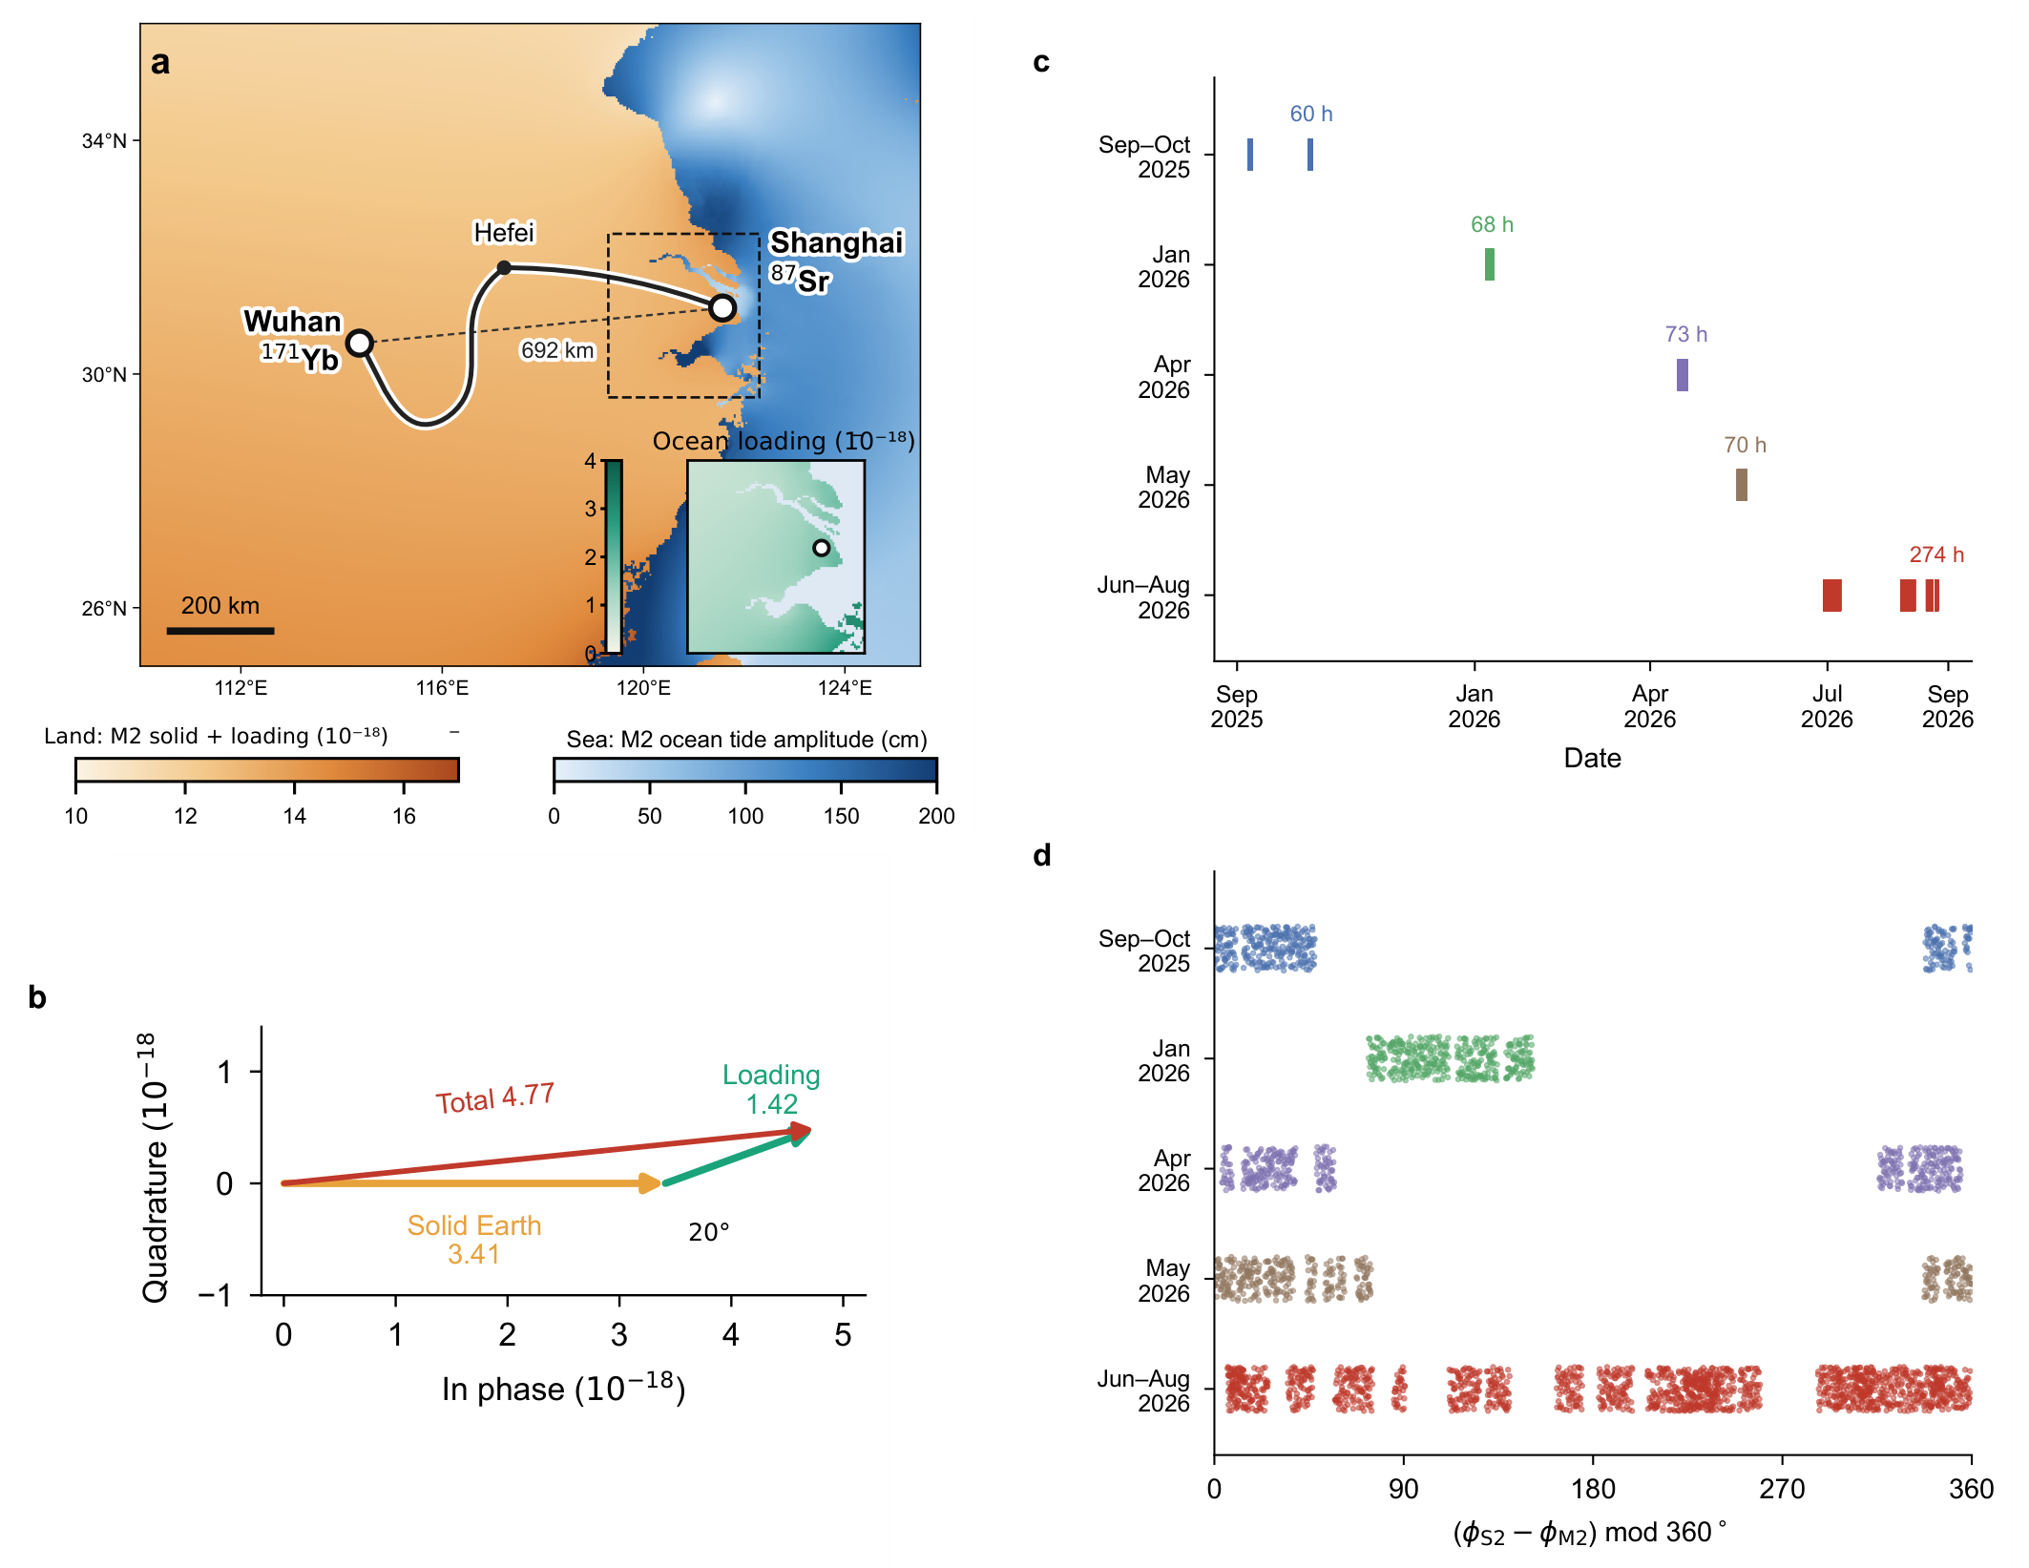
Fig. 1 | Coastal–inland geometry and lunar–solar phase coverage. Prediction and sampling panels retained from v68. a, Shanghai Sr and Wuhan Yb, their 692-km separation and schematic 1,350-km fibre route through Hefei. Land colour represents predicted M2 clock potential; sea colour represents FES2022 M2 elevation. The inset shows Shanghai loading. b, Differential solid and loading phasors of 3.41 and 1.42, separated by approximately 20° and summing to 4.77, in ${10}^{−18}$ fractional-frequency units. c, Five v68 campaigns and their reported integer-hour durations, with an approximately 544-h retained total. d, Relative S2–M2 astronomical phase at the v68 filtered samples. These panels describe the specified prediction and sampling, not a hypothesis test. The period-based R7 row support used in Figs. 2–4 is separately identified; phase coverage does not imply calibrated zero-point continuity.

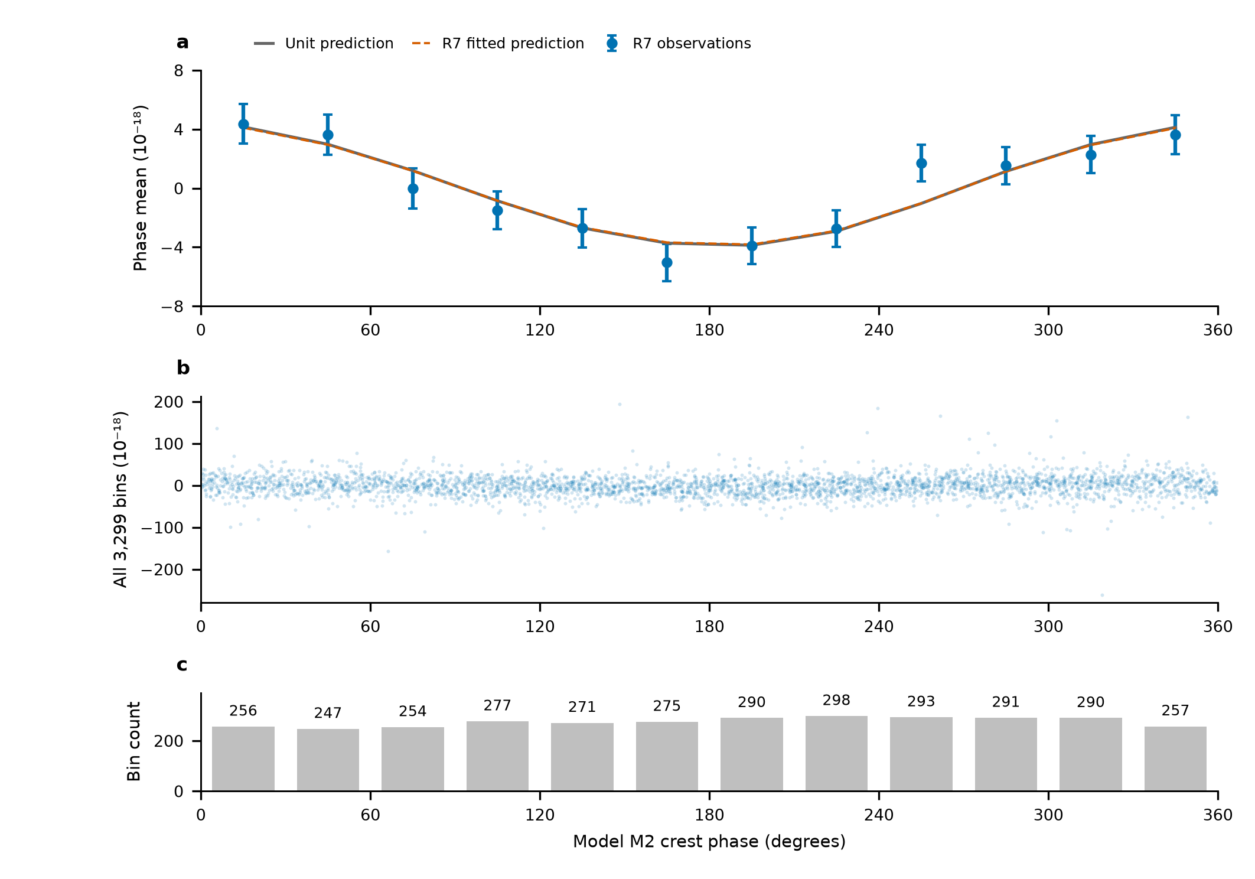
Fig. 2 | The full-record lunar phase display on the R7 design. a, Twelve fixed 30° phase-bin means after subtracting the fixed remainder and projecting both observations and unit lunar prediction against the same period, near-12-h and diurnal columns. Solid and dashed curves show the identically transformed unit and fitted predictions. Error bars are marginal standard errors from the complete propagated scaled-working covariance, including the nuisance projection; the twelve means are correlated and their covariance has rank eleven. b, All 3,299 projected R7 observations, retaining their full ordinate range. c, Row counts per phase interval; each interval contains all eight periods and 31–36 UTC days. R7 noise weights, template and sampling are used throughout. The amplitude is fitted to the original rows, not to the phase means. No new rejection, phase adjustment or independent significance test is introduced.

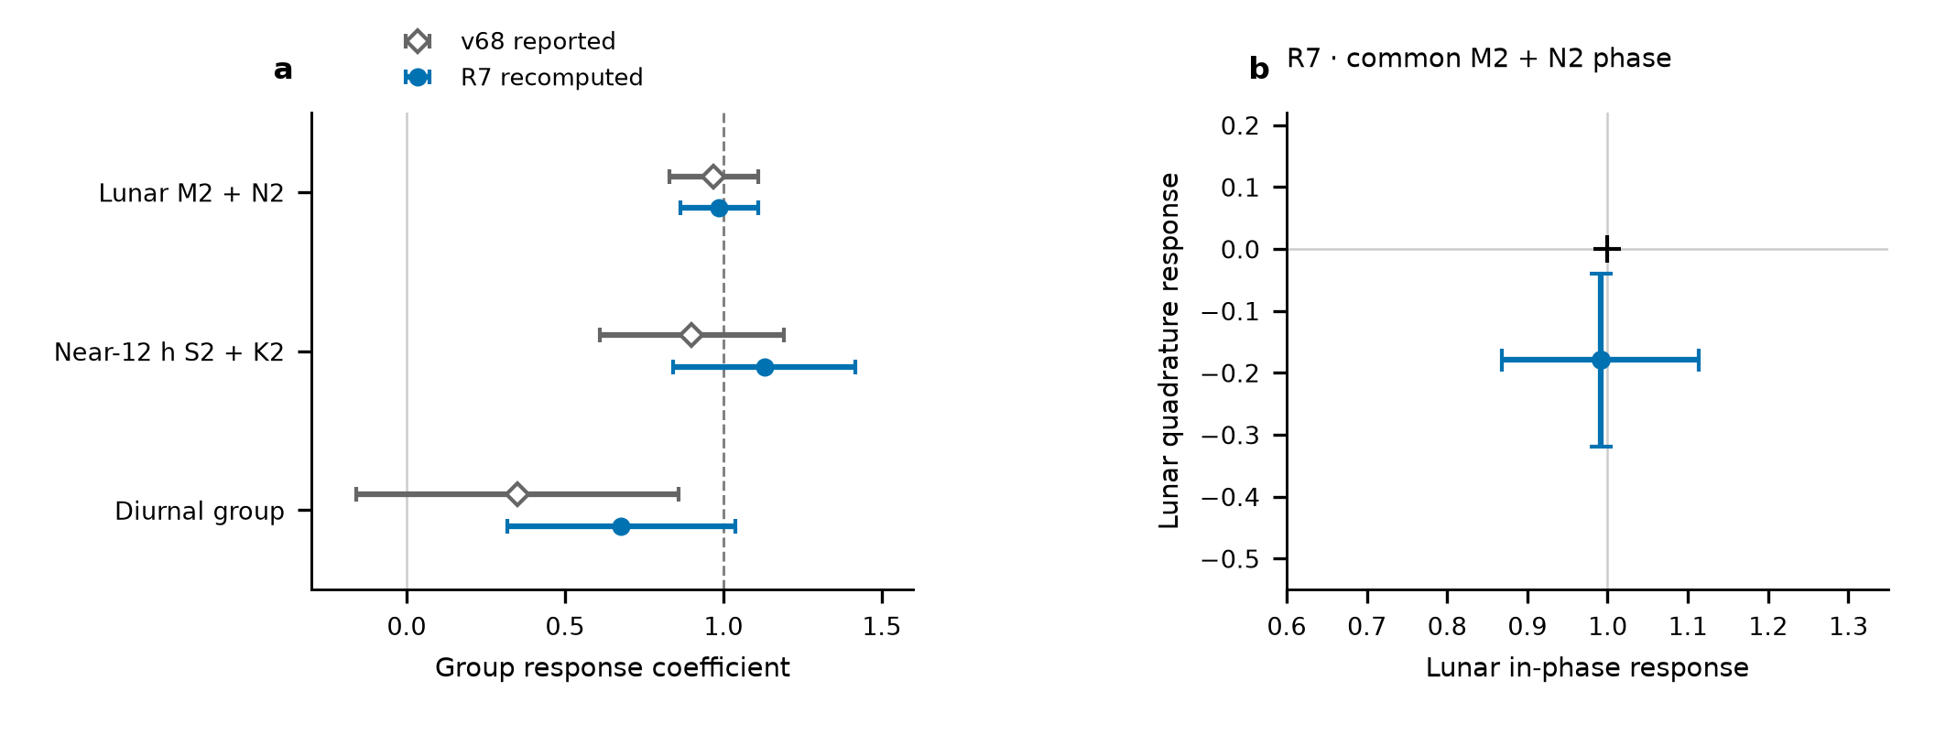
Fig. 3 | Separate semidiurnal responses and a common lunar phase test. a, Three-group coefficients from the two named reductions of overlapping observations. Open diamonds retain v68 values: the lunar error is its reported residual-resampling standard deviation, while near-12-h and diurnal errors use its scaled-LS/day-jackknife maximum. Filled circles show independently recomputed R7 values, each with its own scaled-LS/day-jackknife maximum. Neither coefficients nor errors are combined. K2 is lunisolar; the neighbouring group is defined by frequency. b, The R7 common M2+N2 in-phase/quadrature fit, with marginal errors from that same fit; the cross marks unit in-phase and zero quadrature response. Constituent phases and relative amplitudes remain linked within the lunar group. The bars are not a separately calibrated joint confidence contour. Both panels reuse observations underlying their named fits.

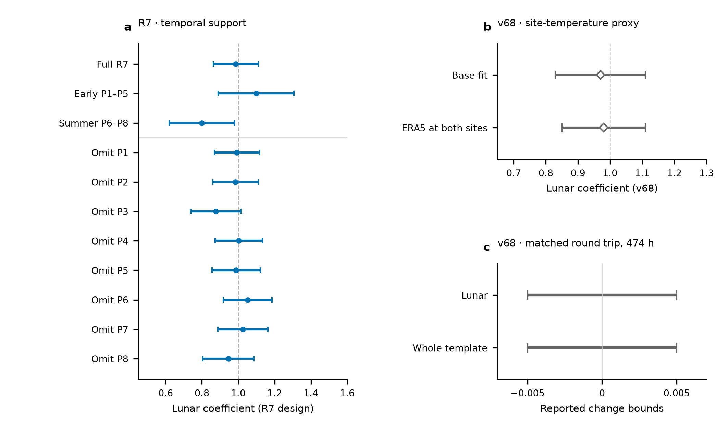
Fig. 4 | Temporal support and observed-channel controls. a, R7 full-record, early and summer lunar estimates, followed by eight leave-period estimates. Every fit uses its own retained rows and scaled-LS/day-jackknife maximum; these overlapping fits are not independent replications. b, Reported v68 base and two-site ERA5-temperature-regression estimates, retaining their respective 0.14 and 0.13 marginal errors. ERA5 is an outdoor-temperature proxy, not direct laboratory thermometry. c, Reported v68 bounds on the change induced by adding the round-trip monitor on identical 474-h support. The horizontal intervals indicate $\left|ΔA\right|<0.005$ for each named coefficient; they are neither error bars nor estimates located at zero. Panels b and c have not been recalculated with R7 weights. The monitor constrains its measured transmission channel, with unmonitored branches and clock-specific effects outside its coverage.

Methods

Frequency ratio, sign and corrections
The clock apparatus and absolute-ratio experiment are described by Hou et al., with separate Sr and Yb uncertainty evaluations.^{13,14,15} The Sr-referenced optical carrier is transferred from Shanghai and compared with the Yb-referenced comb in Wuhan. The ratio orientation is $R=ν_{Yb,Wuhan}/ν_{Sr,Shanghai}$. For positive geodetic potential, the differential fractional signal is
$$y\left(t\right)=−\frac{δW_{eff,Wuhan}\left(t\right)−δW_{eff,Shanghai}\left(t\right)}{c^{2}}.$$
A positive $y$ therefore means that Wuhan runs faster relative to Shanghai. The R7 period-relative beat conversion is $y_{rel}=−d_{p}\left(f_{beat}−f_{ref,p}\right)/F_{1550}$, with $F_{1550}=1.933992×{10}^{14}$ Hz, $d_{p}=2$ in 2025 and $d_{p}=1$ in 2026. This corresponds to a 2026 conversion magnitude of approximately $5.17×{10}^{−15}$ per hertz; the 2025 divided counter requires restoration of the factor of two. The reference beat is a period-specific level, not the optical frequency.
R7 applies the recorded summer group-resolved Sr and Yb corrections through the frequency-chain equations in 80-digit Decimal arithmetic, before taking a fractional ratio. Early periods retain period-relative scales because their absolute-chain calibration is incomplete. The early 37.2-mHz feedback term can be absorbed by a period intercept only if its sign, magnitude and conversion remain constant within that period. Group-dependent or time-dependent errors are not absorbed by a common intercept. Missing early AC Stark entries and the provisional May Yb entry are recorded as missing or assumed, rather than measured zero. Correction covariances have not been supplied. They are not invented or combined with the statistical errors.

Selection, support and temporal processing
The v68 specification retains 54 segments in five campaign groupings. It rejects large counter departures and applies a six-robust-standard-deviation transient screen based on local medians, independently of tidal residuals. The reported transient removal is 0.4%, approximately 2.2 h; adding the theoretical tide with factors −1, 1 and 3 leaves the reported mask unchanged. Its data and theoretical samples receive the same 1200-s triangular filter at 600-s steps. Its reported retained duration is approximately 544 h. The final per-row mask, filter membership and matched directly calculated potential series remain required inputs for the common-support replay.
R7 reads the updated 54-segment mask, excludes original group 22 and retains segment 48. Period files are joined before applying intervals, preserving intervals that cross midnight. Beijing-time labels are converted to UTC. Printed-second endpoints retain subsecond timestamp jitter; shared-boundary seconds belong to the preceding segment. Its raw selection has 1,966,908 loaded rows versus 1,966,905 tabulated rows, with the three-row net difference individually reconciled at interval boundaries. Ten-minute means are formed separately by segment on a fixed grid, requiring at least 180 nominal one-second rows. The 3,299 accepted rows contain 545.9242 sample-hours and 43 observed UTC days. Distinct segments may contribute separate partial bins at the same centre without sharing underlying samples. The present R7 replay consumes these saved tables; it does not newly reconstruct their raw selection.

Physical template and band definitions
The direct-potential formulation used by v68 is
δWsolid=m​1+k2mV2m+1+k3V3−gur,
with $k_{20}=0.29525$, $k_{22}=0.29801$, $k_{3}=0.093$, and the IERS resonance prescription for $k_{21}$.¹² The displacement term follows the associated frequency- and latitude-dependent response. Ocean loading is computed from ocean elevation $ζ$ and the full effective-potential kernel,
δWload=∫ρwζr′,tGWψ dA, GWψ=gaMEn​1+k′n−h′nPncosψ.
The kernel contains seawater attraction, induced potential and the clock displacement.^{16,17,18} The reported implementation uses water density 1025 kg m$​^{−3}$, PREM load Love numbers through degree 696, high-degree continuation and summation to degree 40,000. The $1/{30}^{∘}$ ocean grid is retained near the stations. Ocean means are removed for mass conservation. The complete model configuration and its software versions must accompany the final analysis archive.
R7 instead consumes an IERS-based displacement series converted with $−\left(1+k_{2}−h_{2}\right)g/\left(h_{2}c^{2}\right)$, using $h_{2}=0.6078$, $k_{2}=0.3010$ and $g=9.794$ m s$​^{−2}$. This is a specified approximation, not the same mode-dependent direct-potential implementation. The R7 source documents a K1 amplitude about 18% below its quoted potential-weighted reference; that model discrepancy remains part of the common-template audit. Its loading uses the supplied full-potential phasors. Temporal synthesis uses pyTMD 3.0.9 FES astronomical arguments and nodal corrections.²¹ In the convention $f_{k}ℜ\left[C_{k}exp\left(−iϕ_{k}\right)\right]$, consistently conjugating the coefficient and reversing the exponential leaves the real series unchanged. The bridge reported here holds this R7 series fixed; it does not certify equivalence to the direct-potential series.
Both reductions group M2+N2, S2+K2 and K1+O1+P1+Q1. Relative amplitudes and phases are fixed within each group. A remaining theoretical contribution enters once at its predicted value. Thus
$$y_{i}=A_{L}b_{L}\left(t_{i}\right)+A_{S}b_{S}\left(t_{i}\right)+A_{D}b_{D}\left(t_{i}\right)+r_{0}\left(t_{i}\right)+c_{j\left(i\right)}+ϵ_{i}.$$
The intercept index $j$ is a segment in v68 and a period in R7. The controlled bridge also evaluates original-group intercepts on the same R7 rows. No fitted offsets are used to construct a long-term stability series.

Statistical errors and controlled bridge
The v68 lunar error is a reported residual-circular-shift standard deviation. Residuals are shifted within continuous filtered runs and added to the unit-response model. The reported lunar values from two sets of 200 realizations are 0.13 and 0.14, with 0.14 retained. Its reported four-scenario study gives 67–68% coverage for ${\hat{A}}_{L}±0.14$ and 94.5–95.2% for ${\hat{A}}_{L}±1.96\left(0.14\right)$. These results remain source-reported until the associated code, seeds and inputs are transferred. They are not calibration of the R7 estimator.
R7 estimates period noise factors from within-segment overlapping Allan deviations after subtracting the fixed unit template and segment constants.²² It fits a fixed $τ^{−1/2}$ slope on 256–4096 nominal one-second samples and uses $σ_{i}=α_{p\left(i\right)}/\sqrt{n_{i}}$. No fitted inter-segment stitching enters this weighting. Scaled least-squares errors use the reduced chi-square; UTC-day jackknife deletes each of 43 observed days and removes empty intercept columns. The reported marginal error is the larger of these two quantities, with period deletion retained separately. For its lunar estimate the three errors are 0.1231, 0.1116 and 0.1314, respectively. The weights are held fixed during deletion (Extended Data Table 1).
The independent bridge uses QR least squares and checks the saved R7 coefficient, covariance and deletion results. It crosses three intercept levels (8 periods, 29 groups, 54 segments), two weight choices (saved noise weights or equal weights) and two saved response representations (summer-corrected or period-relative), giving twelve cases. All use the same 3,299 rows, timestamps, band templates and fixed remainder. This separates those choices from sampling/filtering/template differences that remain untested. A small change on removing saved corrections does not validate missing corrections or establish their constancy in time.
The R7 conditional study holds rows, weights and design fixed. Its independent Gaussian reference and twelve correlation scenarios use $Σ=D\left[\left(1−ρ\right)I+ρK\right]D$, with exponential correlation times of 1, 6 or 24 h, segment or period clusters, and $ρ=0.1$ or 0.5. These are specified stress scenarios, not estimates of actual laboratory noise. Recounting the saved 10,000 draws per scenario reproduces 95.94% coverage for the reference and 94.16–97.79% across all scenarios for intervals ${\hat{A}}_{L}±1.959964u$. The rule is not uniformly conservative (Extended Data Table 3). Estimation of the weights, selection, non-Gaussian excursions and instrumental covariance lie outside that conditional study. The scenario results do not replace the reported standard error. These coverage checks target the lunar coefficient; they do not calibrate a detection probability for the neighbouring group or a joint two-response confidence region.

Baseline choice and comparison between reductions
The matched-R7 bridge gives lunar coefficients 0.9866 for eight period intercepts with recorded noise weights, 1.0004 for 54 segment intercepts with those weights, 0.9364 for eight intercepts with equal weights and 0.9461 for 54 intercepts with equal weights. These variants share rows and physical templates. They isolate baseline and weight choices, not the differences in raw masks, triangular filtering and direct-potential implementation between the two source reductions.
The projected lunar-template squared norm allocated to summer is 61% in the reported segment/equal-weight design and 50.2% in the period/noise-weighted design. These are conditional design quantities, not universal information fractions. The original period-analysis continuity flag was generated by comparing fitted summer amplitudes under two intercept choices. Passing that comparison establishes only the stated amplitude-sensitivity check; it does not calibrate zero-point continuity across interruptions. The present synthesis retains separate statuses for those two questions. No fitted offsets are used to construct long-term stability.
A final common estimator requires the matched raw-member and directly calculated potential package, the relevant operating/correction records, and noise calibration for that design. The currently available period-table replay and the source-reported segment estimates are identified separately. Neither reduction is selected because it has the smaller error, and their shared-observation uncertainties are not combined.

Phase display and temporal diagnostics
Let $W=diag\left(σ_{i}^{−2}\right)$ and let $N$ contain intercepts and the near-12-h and diurnal columns. The nuisance projector is $M_{N}=I−N{\left(N^{T}WN\right)}^{−1}N^{T}W$. The display uses $z=M_{N}\left(y−r_{0}\right)$ and $x=M_{N}b_{L}$, with the crest coordinate $\left[ϕ_{M2}−argC_{M2}\right] mod 2π$. Twelve fixed 30° intervals define inverse-variance averaging operator $B$. The means are $Bz$, $Bx$ and ${\hat{A}}_{L}Bx$, using the original unaggregated amplitude fit.
The displayed working covariance is $BM_{N}C_{y}M_{N}^{T}B^{T}$, with $C_{y}=χ_{red}^{2}diag\left(σ_{i}^{2}\right)$. This propagates the fitted nuisance projection rather than holding nuisance coefficients fixed. It has rank eleven because of the weighted-mean constraint. All points, counts, day/period support and the full covariance are exported. The present independent projection agrees with the saved R7 phase means and marginal errors to numerical precision.
The I/Q diagnostic adds a quadrature obtained by $C_{k}→iC_{k}$ for both lunar constituents and fits it jointly with the original nuisance columns. The figure shows marginal errors from that fit, not a calibrated joint contour. Early/summer and leave-period fits each recompute their own coefficients and errors on their retained rows. Neither phase averaging, spectra nor deletion of overlapping observations provides independent experimental replication.

Environmental evidence and limits
The site-temperature regressors in v68 use ERA5 hourly two-metre air temperatures and departures from a 24-h running mean.¹⁹ The Sr-chamber thermometers provide a separate 98-h direct record. The round-trip counter is normalized by the optical carrier without an additional factor of two, screened and filtered like the ratio; comparisons with and without the regressor use identical 474-h support. These reported controls are retained with their v68 definitions until the final primary design is available for matched recalculation.
A physically motivated 24-h term can test temperature or operating-cycle coupling. An independently phased 12-h term in each campaign is retained only as a supplementary sensitivity variant. A coefficient change under such a model is not an observed disturbance amplitude. Residual diagnostics must propagate the physical fit’s projection to both residual data and diagnostic bases. No diurnal upper limit or semidiurnal-to-diurnal extrapolation is reported: each would require an estimator-specific interval or an explicit common-response hypothesis.

Data availability
The authors will provide the retained counter-row membership, correction ledger, matched physical templates, figure source tables and versioned manifests through [repository and DOI or editor-accessible link to be confirmed]. The current author working package contains the source-bound v68 material and replayable R7 saved-table diagnostics. The matching v68 primary sample/template/resampling package remains to be supplied. Third-party products are identified by their originating citations and access terms.

Code availability
Versioned selection, frequency conversion, potential generation, fitting, uncertainty and figure code will be deposited at [repository and DOI or review link to be confirmed]. The present bridge and display code is retained with its inputs, hashes, environment and execution logs. The final source archive must also include the direct-potential chain and the accepted estimator decision.

Author statements
Authors: [Author list, order and affiliation assignments to be confirmed.]
Affiliation texts retained from the companion frequency-ratio manuscript, pending author assignments:
¹ Hefei National Laboratory, University of Science and Technology of China, Hefei, China
² Shanghai Research Center for Quantum Sciences and CAS Center for Excellence in Quantum Information and Quantum Physics, University of Science and Technology of China, Shanghai, China
³ Hefei National Research Center for Physical Sciences at the Microscale and School of Physical Sciences, University of Science and Technology of China, Hefei, China
⁴ Innovation Academy for Precision Measurement Science and Technology, Chinese Academy of Sciences, Wuhan, China
⁵ Jinan Institute of Quantum Technology and CAS Center for Excellence in Quantum Information and Quantum Physics, University of Science and Technology of China, Jinan, China
⁶ Time and Frequency Geodesy Center (TFGC), School of Geodesy and Geomatics, Wuhan University, Wuhan, China
Contributions: [To be confirmed for this Article.]
Acknowledgements and funding: [To be confirmed by the authors.]
Competing interests: [Declaration to be provided by all authors.]
Correspondence: [Names and contact details to be confirmed.]
AI-assisted preparation: OpenAI Codex assisted source comparison, manuscript drafting, numerical replay and figure preparation. [Authors to specify the scope of their verification and responsibility before submission.]

Methods references
- Sutterley, T. C., Howard, S. L., Padman, L. & Siegfried, M. R. pyTMD: Python-based tidal prediction software. J. Open Source Softw. 10, 8566 (2025). https://doi.org/10.21105/joss.08566
- Riley, W. J. & Howe, D. A. Handbook of Frequency Stability Analysis. NIST Special Publication 1065 (2008). https://doi.org/10.6028/NIST.SP.1065

Extended Data
Extended Data Table 1 | Estimator-specific uncertainty sources. R7 numbers are independently recomputed on saved input rows. All entries are standard errors of the named coefficient. The reported R7 rule is the marginal maximum of scaled LS and UTC-day jackknife; period deletion is retained as a separate sensitivity. No errors are pooled.
Reduction and coefficient | Estimate | Scaled LS | Day jackknife | Period jackknife | Reported error
R7 lunar | 0.9866 | 0.1231 | 0.1116 | 0.1314 | 0.1231
R7 near-12 h | 1.1291 | 0.2825 | 0.2878 | 0.3256 | 0.2878
R7 diurnal | 0.6779 | 0.2860 | 0.3586 | 0.4118 | 0.3586
R7 lunar in phase | 0.9910 | 0.1231 | 0.1145 | 0.1416 | 0.1231
R7 lunar quadrature | -0.1792 | 0.1143 | 0.1394 | 0.1681 | 0.1394
R7 early lunar | 1.0986 | 0.1914 | 0.2084 | 0.5183 | 0.2084
R7 summer lunar | 0.7991 | 0.1798 | 0.1674 | 0.0942 | 0.1798
v68 lunar (source reported) | 0.97 | — | — | — | 0.14, residual shift
R7 full and I/Q fits use 3,299 rows, 43 UTC-day groups and 8 period groups. Early uses 1,651 rows, 20 observed UTC days and 5 periods; summer uses 1,648 rows, 23 observed UTC days and 3 periods. The v68 source reports the maximum of its LS/day-jackknife errors as 0.13 but does not supply those two separate values here. A dash is unavailable, not zero.

Extended Data Table 2 | Controlled choices on the same R7 rows and physical template. Saved corrected response, 3,299 observations. P8, G29 and S54 denote 8 period, 29 group and 54 segment intercepts. Quoted errors use each variant’s own scaled-LS/day-jackknife maximum. These are bridge calculations, not additional primary results.
Intercepts | Weights | Lunar | Near-12 h | Diurnal | Lunar–near-12 h correlation
P8 | Allan | 0.9866 ± 0.1231 | 1.1291 ± 0.2878 | 0.6779 ± 0.3586 | -0.3572
P8 | equal | 0.9364 ± 0.1323 | 1.1627 ± 0.3071 | 0.5588 ± 0.3626 | -0.3669
G29 | Allan | 0.9841 ± 0.1243 | 1.0930 ± 0.2981 | 0.7587 ± 0.4203 | -0.3496
G29 | equal | 0.9320 ± 0.1337 | 1.1284 ± 0.3241 | 0.5691 ± 0.4482 | -0.3622
S54 | Allan | 1.0004 ± 0.1320 | 0.9251 ± 0.3649 | 0.5792 ± 0.5381 | -0.3003
S54 | equal | 0.9461 ± 0.1407 | 0.9735 ± 0.3753 | 0.4151 ± 0.5711 | -0.3245
All twelve corrected/period-relative cases are in the source CSV. The table does not compare the v68 triangular filter, final mask or direct-potential series; those remain missing from the matched replay.

Extended Data Table 3 | Recount of saved R7 conditional simulations. Each scenario contains 10,000 saved draws. Coverage refers to nominal 95% intervals ${\hat{A}}_{L}±1.959964max\left(u_{LS},u_{day}\right)$. Rows, design and weights are held fixed. The correlations are specified scenarios, not measured laboratory noise.
Correlation cluster | Time scale (h) | Correlated fraction | Lunar bias | 95% coverage (%)
Independent Gaussian | — | 0 | +0.0025 | 95.94
segment | 1 | 0.1 | -0.0001 | 94.24
segment | 1 | 0.5 | +0.0025 | 94.16
segment | 6 | 0.1 | +0.0004 | 95.22
segment | 6 | 0.5 | +0.0004 | 95.59
segment | 24 | 0.1 | +0.0008 | 96.00
segment | 24 | 0.5 | +0.0017 | 97.04
period | 1 | 0.1 | -0.0019 | 94.65
period | 1 | 0.5 | +0.0000 | 94.22
period | 6 | 0.1 | -0.0029 | 95.72
period | 6 | 0.5 | +0.0051 | 96.49
period | 24 | 0.1 | +0.0006 | 95.94
period | 24 | 0.5 | -0.0020 | 97.79
This recount checks the archived simulations; it does not regenerate the draws or calibrate the v68 estimator. Weight estimation, raw selection and unknown instrumental covariance remain outside this conditional experiment.

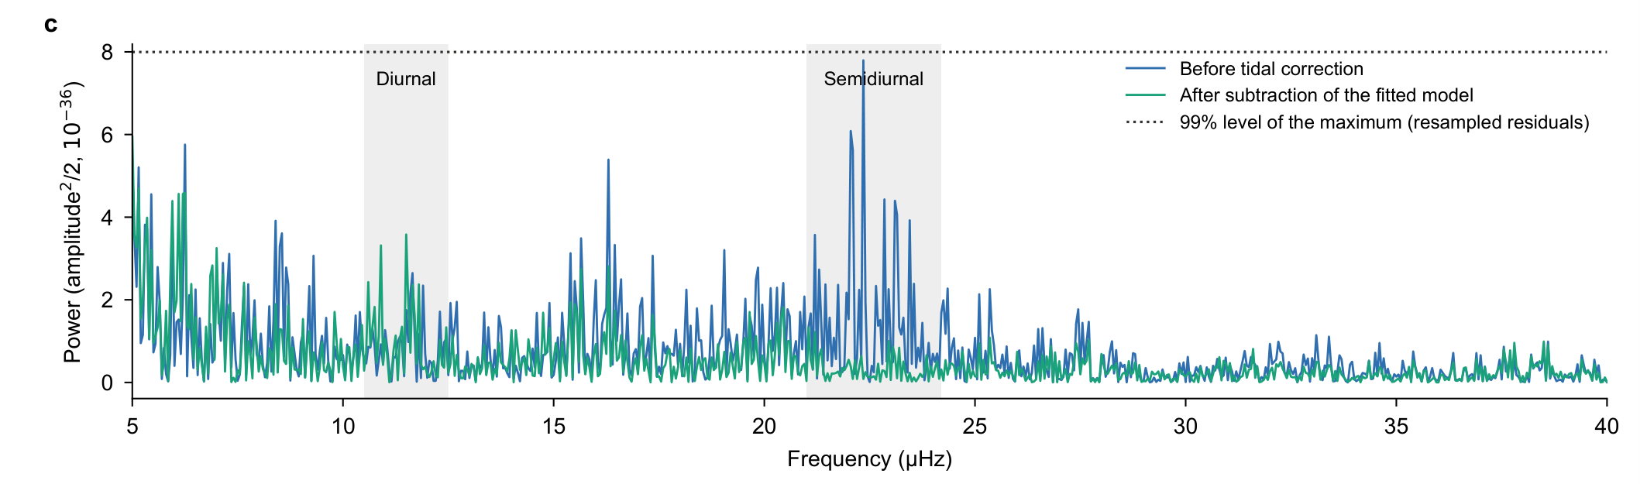
Extended Data Fig. 1 | Same-record spectral display retained from v68/v29. Segment-constant-projected sinusoidal power of the v68 record before and after subtraction of the whole template fitted to those observations. The source threshold is the 99% level of the maximum over 5–40 μHz from 200 residual resamples. Markers indicate one and two cycles per solar day. Interrupted sampling does not resolve M2 and S2 as distinct lines here, and fitted-template removal is not independent evidence. This display has not been recomputed on R7 rows; its source and observation identity remain explicit.

