CS120B Final Project Report

Basic DC Multimeter

Spring 2017

Hector Jimenez

SID: 861195497

Table of Contents

**Introduction** **2**

**Hardware** **3**

Parts List 3

Pinout 3

**Software** **4**

**Complexities** **5**

Completed Complexities: 5

Incomplete complexities: 5

**Youtube Link** **5**

**Known Bugs and Shortcomings** **5**

**Future work** **5**

**References** **6**

**Appendix** **6, 7, 8, 9**

# 

# Introduction

This device is capable of measuring DC voltage and current, along with resistance/continuity. Operating mode is selected by the user with one of three buttons. When in a mode and measurements are being displayed, the user can save a currently displayed value to the EEPROM with the press of a button. Output is displayed on a Nokia 5110 LCD with an SPI interface.

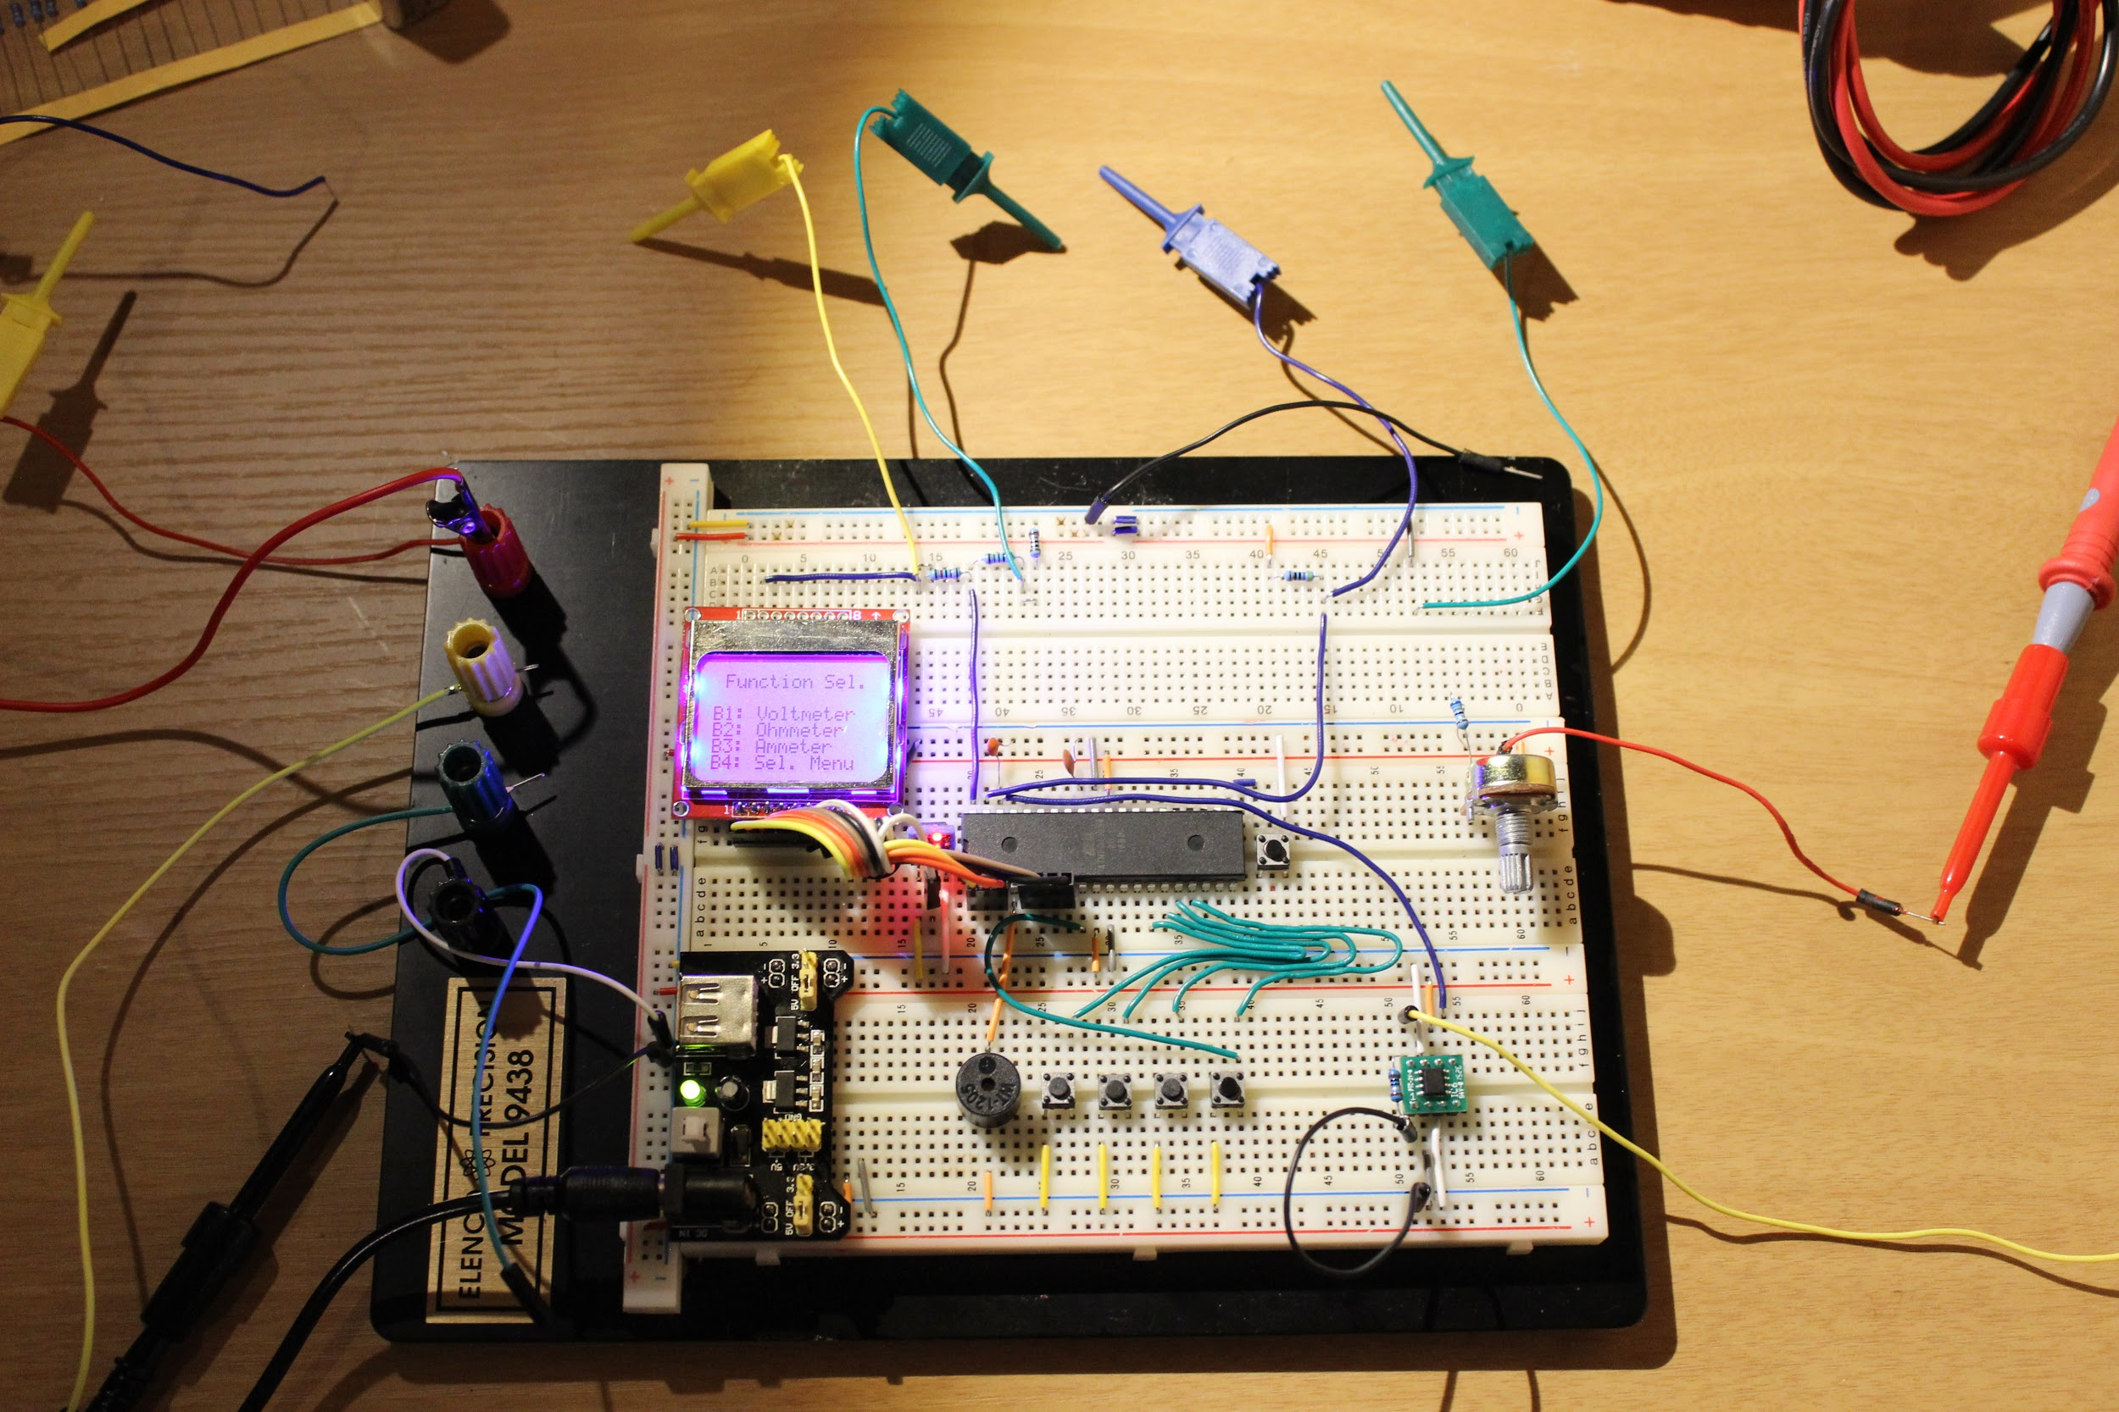

# 

# Hardware

## Parts List

The hardware that was used in this design is listed below. The equipment that was not taught in this course has been bolded.

* ATMega1284p microcontroller
* **Nokia 5110 LCD through SPI interface**
* **Voltage Divider Circuit #1 (12kΩ & 3kΩ resistors)**
* **Voltage Divider Circuit #2 (470Ω resistor)**
* **Analog Devices AD8210 current shunt monitor (with 1Ω resistor)**
* Buttons
* Speaker

## Pinout



# Software

The software designed for this project was implemented using the PES standard. The overall design as a task diagram is included below.

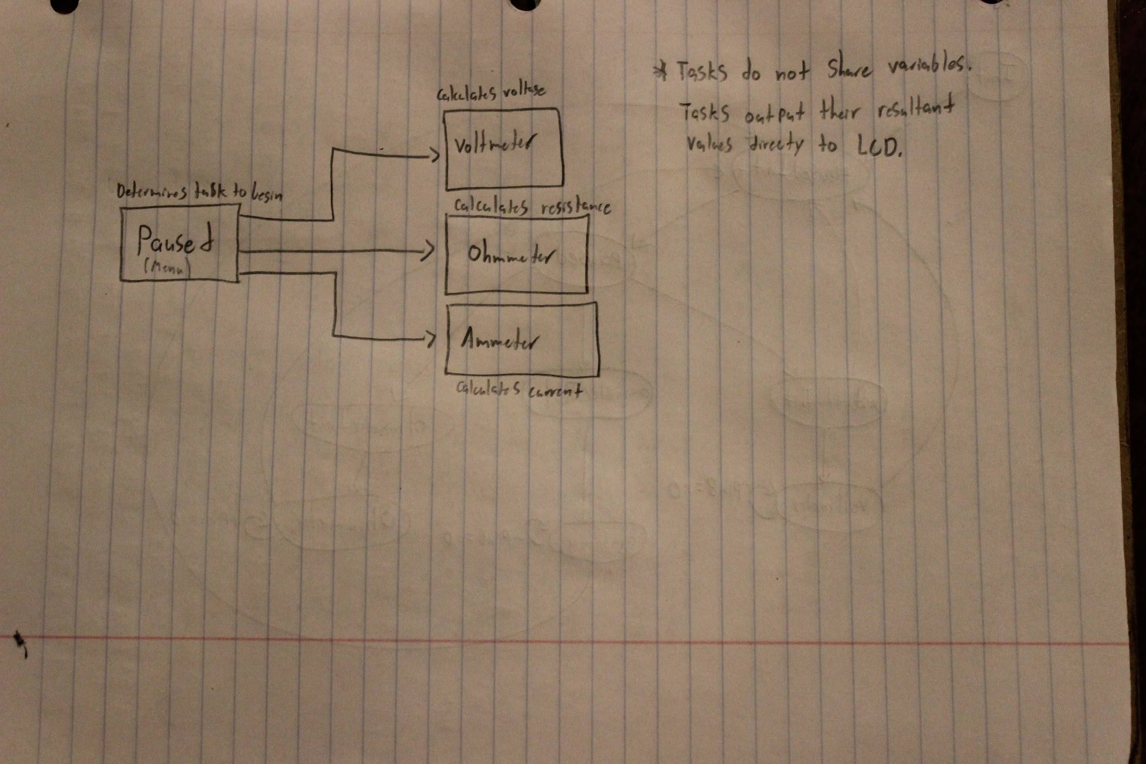

The Paused task outputs a list of the available modes and the buttons to enable them. The task waits for an input and uses this input to determine which task to switch to.

The Voltmeter task captures a value on ADC channel 0, on pin A0. Using an equation I derived from the equation for a voltage divider circuit, the ATmega converts this value into a voltage value, This value is then displayed on the LCD. Further details of operation are shown in the Appendix.

The Ohmmeter task captures a value on ADC channel 1, on pin A1. Using an equation I derived from the equation for a voltage divider circuit, the ATmega converts this value into a resistance value, This value is then displayed on the LCD. Further details of operation are shown in the Appendix.

The Ammeter task captures a value on ADC channel 2, on pin A2. Using an equation I derived from the gain characteristics of the AD8210 current shunt monitor, the ATmega converts this value into a current value in milliAmps, This value is then displayed on the LCD. Further details of operation are shown in the Appendix.

# Complexities

## Completed Complexities:

* Full output of all information on Nokia 5110 LCD
* Voltage Measurement
* Resistance Measurement
* Current Measurement
* Using EEPROM to save a currently displayed measurement

## Incomplete complexities:

* Frequency Counter: Incomplete due to limited time
* Signal generator: Incomplete due to poor performance of I2C module
* ACS712 current sensor was dropped in favor of an Analog Devices AD8210 current shunt monitor, due to the high noise and low sensitivity of the ACS712.

# Youtube Link

* <https://youtu.be/MHRPTyi9A4E>
* (Video is properly subtitled in English.)

# Known Bugs and Shortcomings

* Direct switching from one mode to another mode without returning to the menu is not enabled, as the rapid switching of the ADC channels produces cross-talk and noise in the channels that renders the received values unusable for calculation.

# Future work

Integration of frequency counter is planned, along with a capacitance meter and diode forward voltage measurement mode.

# References

Code for the Nokia 5110 LCD display was obtained from the following website.

<http://www.pocketmagic.net/atmega8-and-nokia-5110-lcd/>

The code used is included in an “includes” folder in the C++ directory of this project folder.

Code for the PWM output used with the speaker was obtained from the UC Riverside’s Bourns College of Engineering.

# Appendix

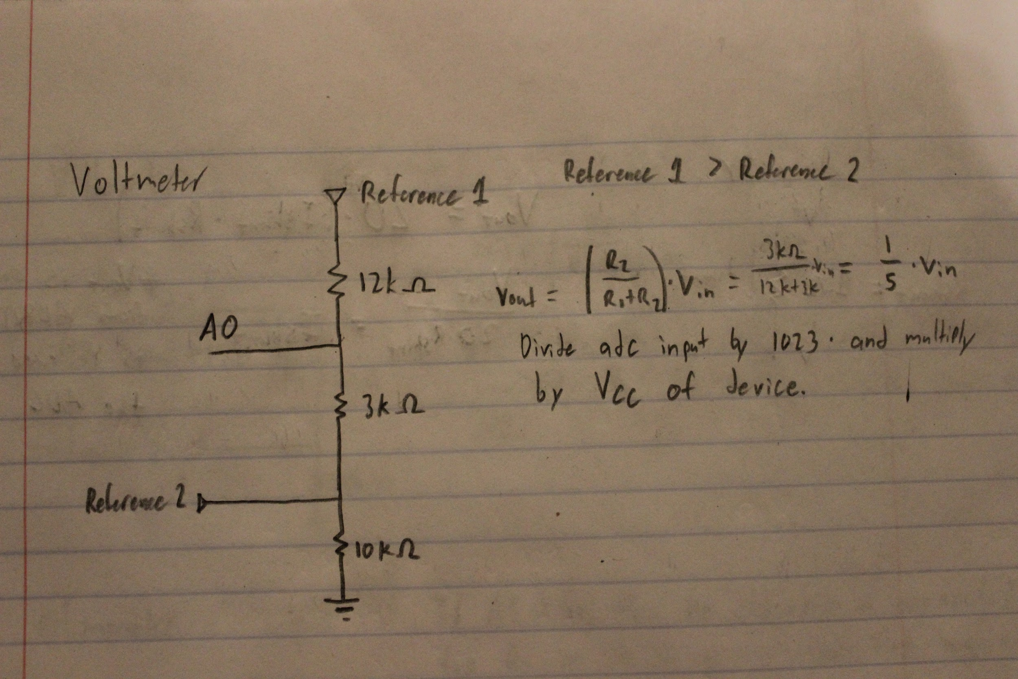

(Design of circuit used for voltage measurement.)

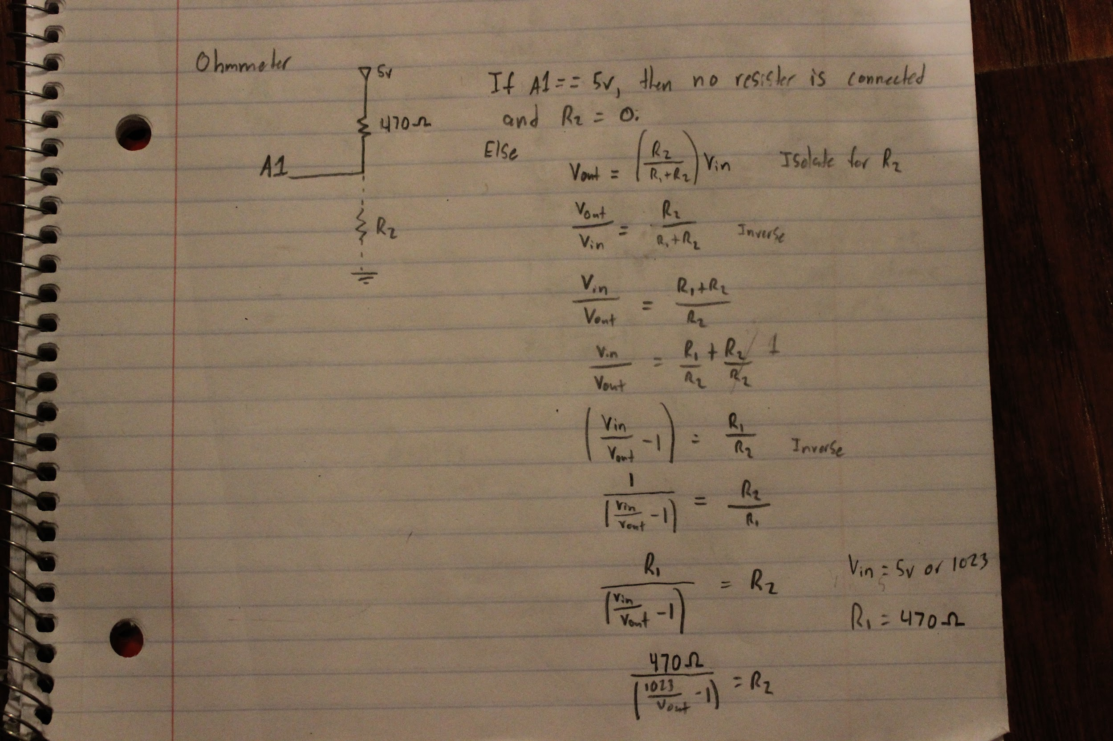

(Design of circuit used for resistance measurement.)

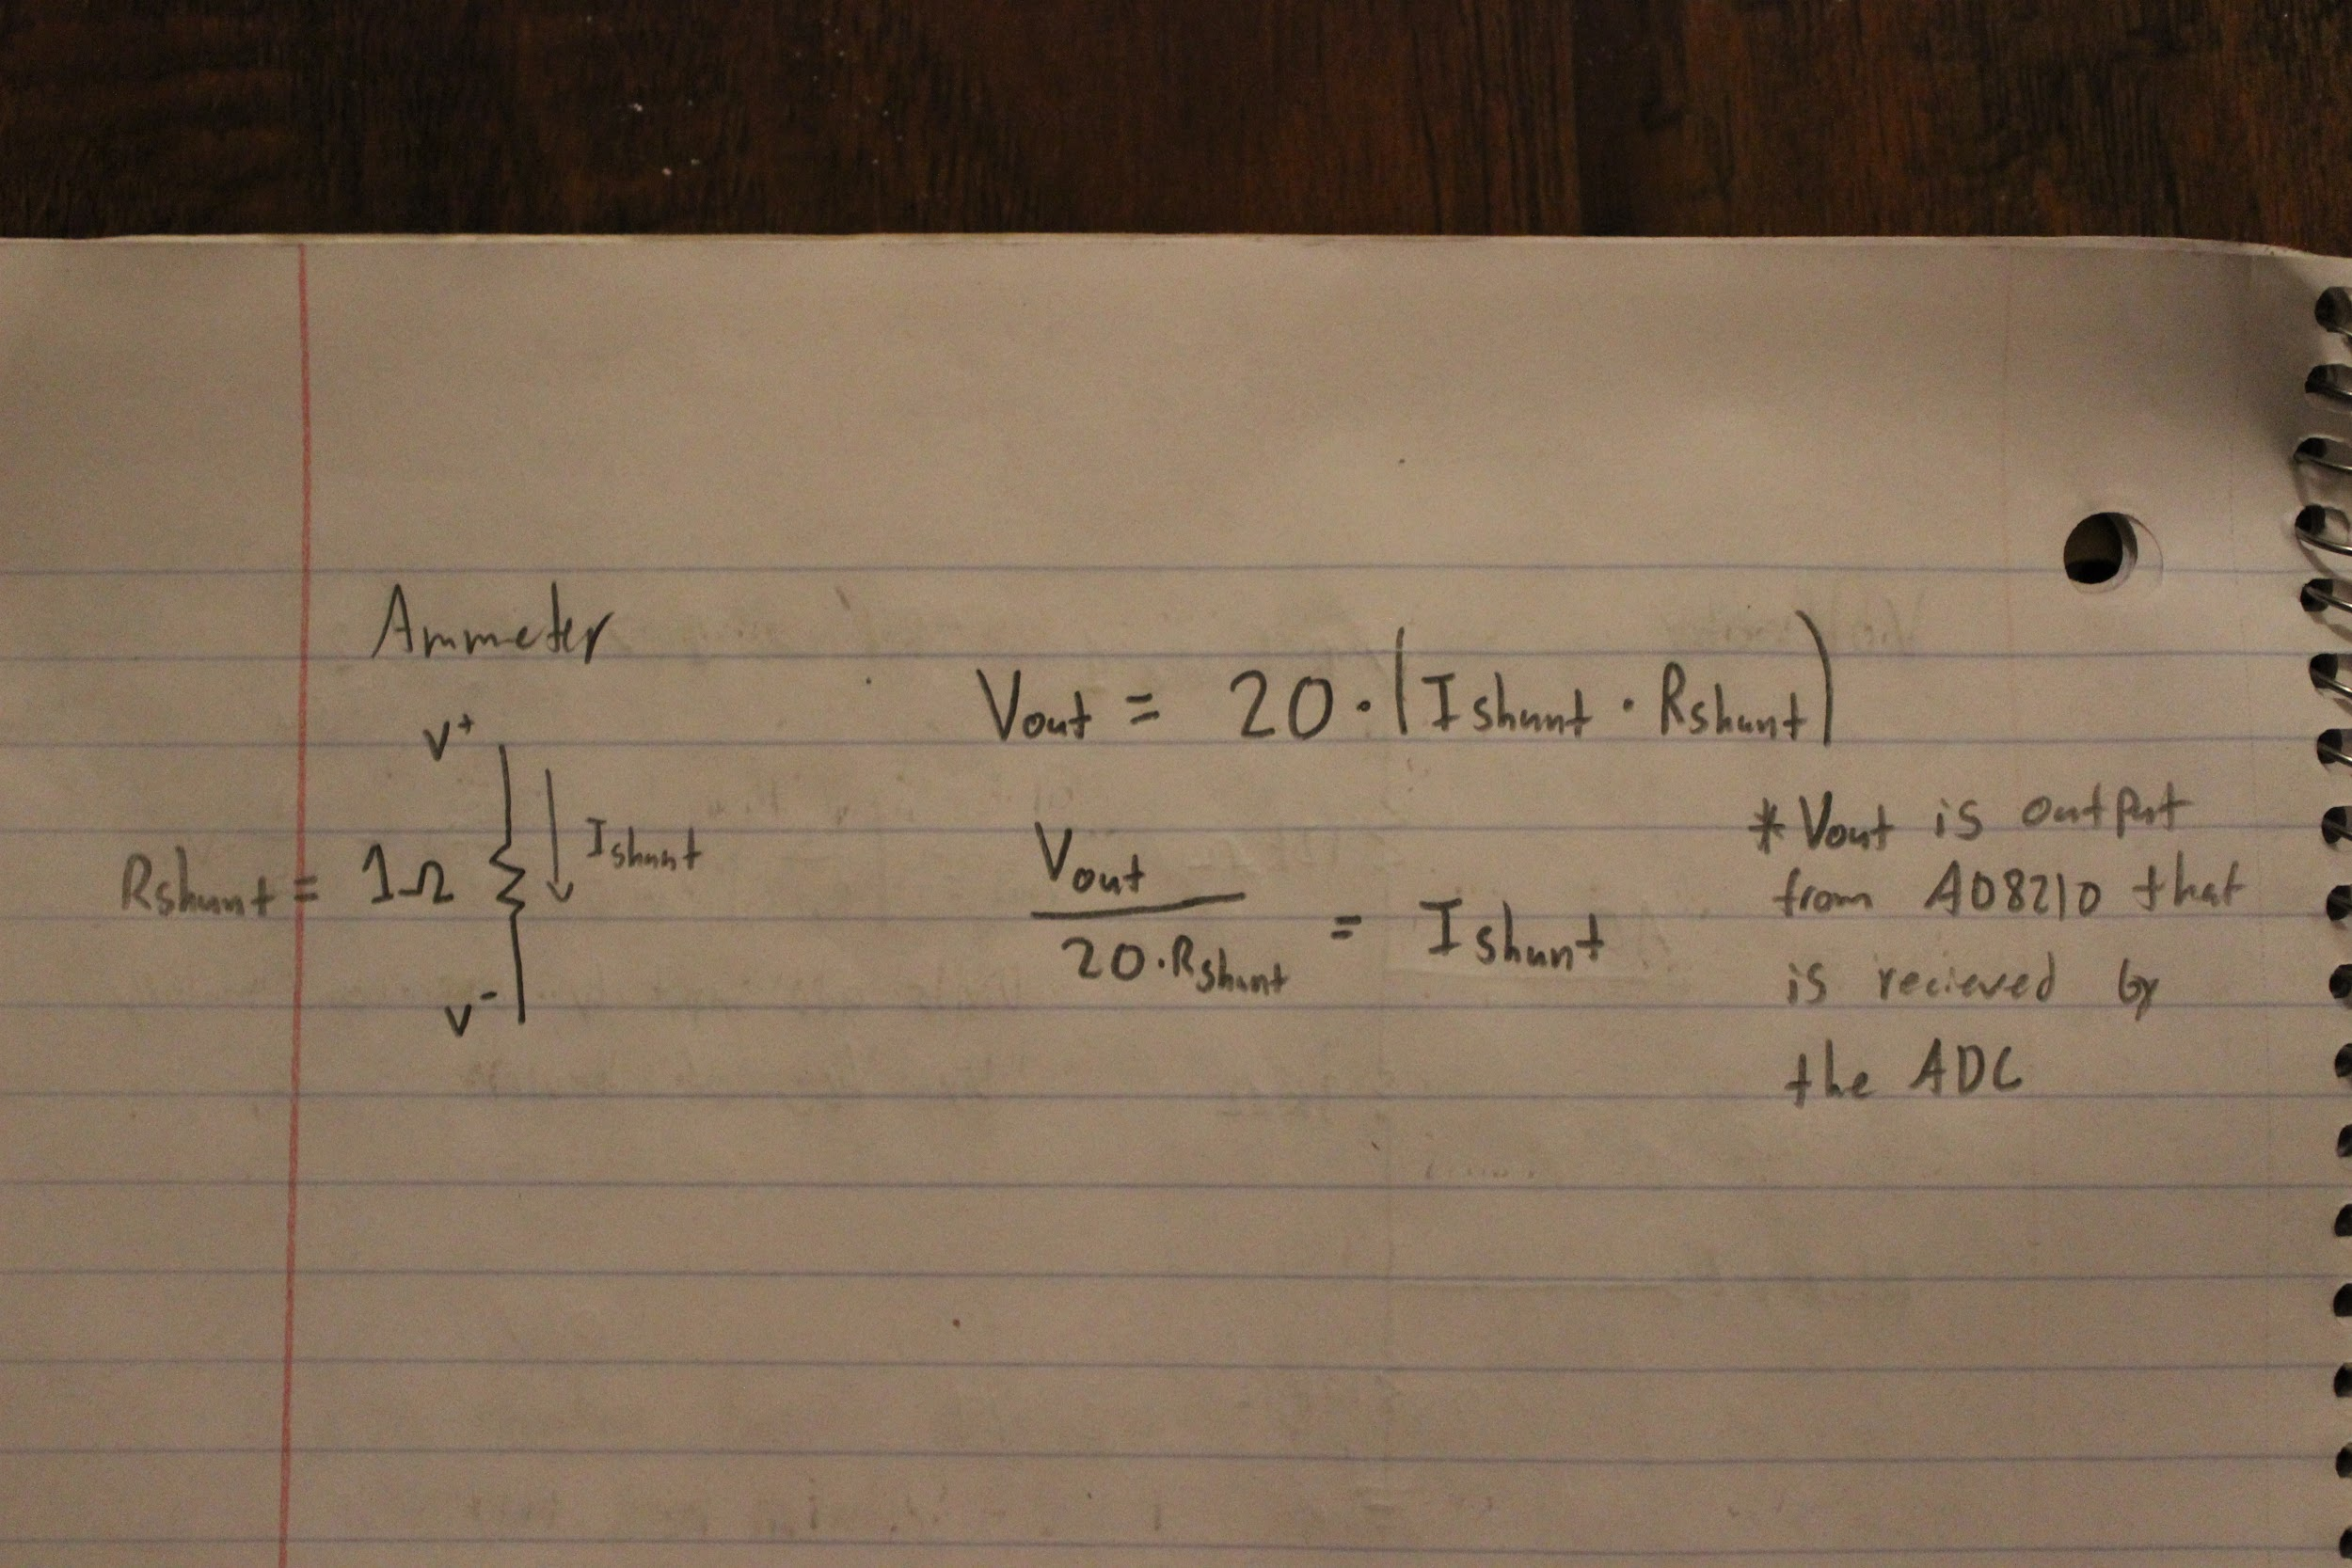

(Theory of operation for AD8210 current shunt monitor.)

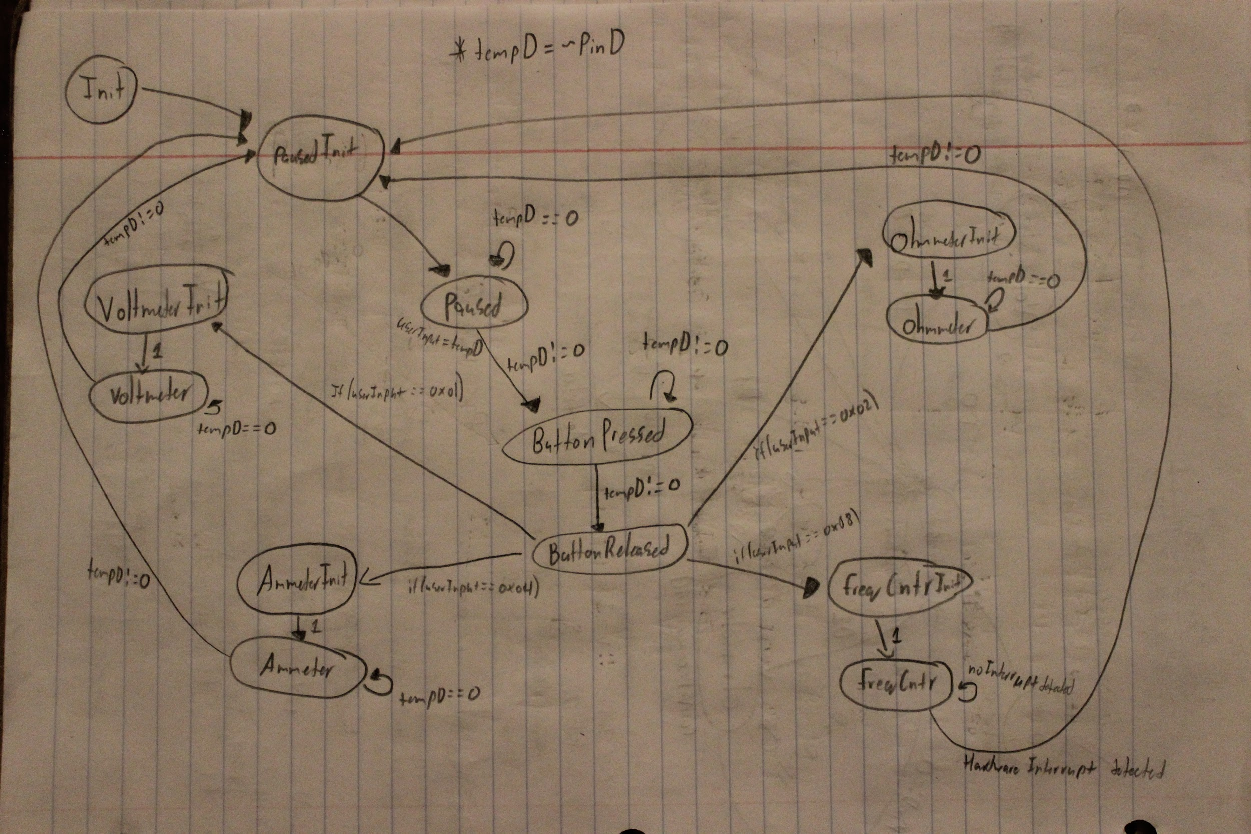

(Overall system state machine)