Lab 2 – Analog to Digital Conversion (ADC)

For this lab exercise, you will develop an application for our STM32F401RE lab board that reads the voltage level of a GPIO pin using the Analog to Digital Converter (ADC). The objective is to get familiar with the ADC driver functions adc_init() and adc_read() and understand how to read analogue voltage, read the converted digital value (as an unsigned integer) and convert it to discrete value.

Important note:
- This lab contributes to 2.5% of your final grade.
- All Exercises are of equal marks.
- If you have obtained any assistance from someone or AI services to complete this lab, please complete the declaration form in the end of this lab sheet.
- Any source code(s) that you submit are subject to be checked against Internet sources and other students’ submissions for potential plagiarism.
- This lab is an individual work. When you submit, you also confirm that the submission is entirely your own work and agree to have your work checked again plagiarism.

Useful references / sources for this lab practice
- Lab 2 Keil uVision project (QMPlus)
- Lecture 8-9 TW2 QMPlus
Group ID: | 4
Board Number: | MB1136-F401RE-C04A224908491
IOT/IST: | IOT
Name: | Ziyan Wei
QMUL Student ID: | 231225340
BUPT Student ID: | 2023213347

Exercise 1

Download and extract the given project to a folder that contains NO Chinese characters.

Open the project in Keil uVision software

Navigate to design sources on the left pane and open “main.c”.

Study the given function main_sample().

Build the project.

Connect the lab board to your laptop using the USB cable.

Download the image to the lab board. Reset the board.

Press the UP button on the LCD shield and describe what do you see in the LCD display.
EBU5477 Lab 2

Now, start debugging and set a breakpoint at the C statement that calls the driver function adc_read().

Keep pressing the UP button and run until the program pauses at the breakpoint, record the value of the variable res for the first time.
Run the program again until it pauses, record the value of the variable res again.
Write down both values. Are they the same?

res1=0x000002A3
res2=0x0000029F
The two values are not identical, but they are extremely close with only a 4-count decimal difference. This minor fluctuation is completely normal for physical ADC hardware, caused by tiny voltage noise, button contact resistance, and electrical interference. Both values fall well within the UP button's valid detection range (300 < res < 1000), confirming the ADC reading is stable and reliable.

Copy the contents of main_sample() to main1(), and then modify the statements in main1() such that
- it contains an infinite loop;
- it recognises which of the five buttons on the LCD shield is pressed, namely UP, DOWN, LEFT, RIGHT, and SELECT.
- print the name of button being pressed; or “NONE” otherwise.

The breakpoint technique that you practised previously is useful for you to work out different values from the ADC pin.

Update main() to run main1() instead of main_sample().

What is the largest value that you get from the function adc_read()? How many bits are needed to encode this largest value?

What is the largest value that you get from the function adc_read()
4095
How many bits are needed to encode this largest value
12 bits

Exercise 2

Get two (Dupont) jumper wires and connect to the leftmost S (+) and GND (-), just above A1. This pin will correspond to PA_1 in your C program. Connect the other ends of the wires across a AA battery (please connect + only when you measure its voltage). Check your connection carefully against the picture below.

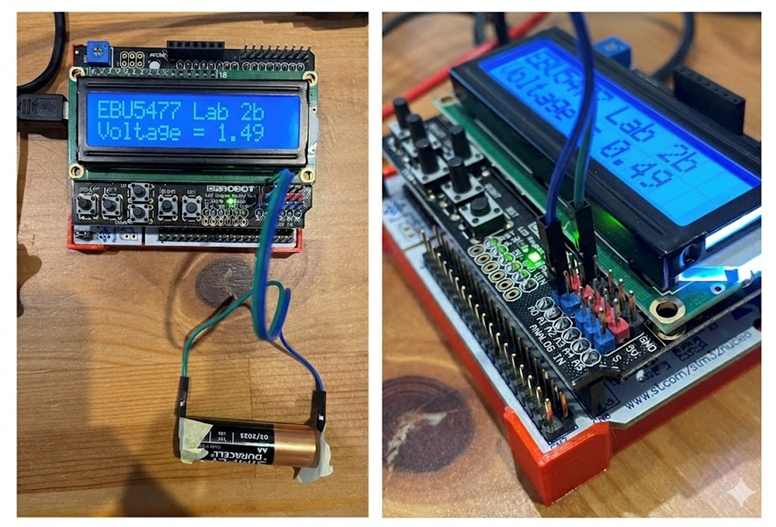

Now, inside main2(), write a program to measure on the voltage of the battery and show the voltage of the LCD display.

Change main() to run main2() instead.

Build the project and download the image to the lab board.

Verify your program on the lab board and debug if needed.

In this box, write down THREE records (at least 5 seconds apart) of the voltages reported by your program.

V1=1.58v，v2=1.57v，v3=1.58v

You have now completed this lab practice. Well done!

Don’t forget to get ready your files and submit them to QMPlus.

Declaration

Please declare any form of assistances from persons or AI services that you used to complete this lab practice. If none, please it empty.

Submission

- Word document of this lab sheet with your answers
Type your answers (no handwriting please) in boxes provided. Do not attach pictures, which will be ignored in the marking.
- main.c (only) with all functions completed. If you add or modify any other C source files, submit them too.

Please submit the above documents to the corresponding QMPlus assignment pages. The deadline is usually a week after the lab session and will be stated clearly on QMPlus.

- End of Lab Practice -

