Physics-Informed Machine Learning with LightGBM for Lithium-Ion Battery Health Prognostics & Knee-Point Lifecycle Estimation Across Heterogeneous Chemistries
SmartEV AIML Advanced Energy Storage Systems Research Group
Advanced Electric Vehicle Energy Storage and Battery Health Laboratory
Target: IEEE Transactions on Transportation Electrification
ABSTRACT
Accurate State of Health (SOH) prognostics and Remaining Useful Life (RUL) lifecycle forecasting are essential for the operational safety, thermal runaway mitigation, warranty economics, and second-life grid reuse of Lithium-Ion Battery (LIB) systems in Electric Vehicles (EVs). Traditional electrochemical pseudo-two-dimensional (P2D) models suffer from prohibitive computational overhead that prevents real-time Edge-BMS implementation, while purely data-driven black-box neural networks frequently violate thermodynamic irreversibility constraints and fail near rapid non-linear knee-point inflection.
In this paper, we establish a leakage-controlled, physics-informed prognostic benchmark centered on LightGBM with histogram-based binning. We conduct an exhaustive audit of empirical EV fleet telemetry (N = 4,732 commercial vehicle records across LFP, NMC, NCA, and LMO cells) and high-fidelity laboratory electrochemical cycling data (N = 10,600 cycles across 11 prismatic LCO cells from CALCE). To eliminate circular evaluation, we implement a strict Cell-Separated Group Split ensuring test cells are completely unseen during training.
On unseen held-out cells, LightGBM achieves an R² score of 0.9880, a Mean Absolute Error (MAE) of 1.395% SOH, and a Root Mean Squared Error (RMSE) of 1.879% SOH, executing single-sample inference in only 0.019 ms (19 µs). Feature ablation confirms that partial charging curve features combined with cumulative operational context achieve parity with full-cycle discharge data. Furthermore, we implement Conformalized Quantile Regression (CQR), attaining an 85.16% empirical coverage on unseen cells at nominal 90% confidence with a tight 6.51% SOH mean interval width, exposing cell-to-cell manufacturing heterogeneity as an inherent physical boundary.

1. Executive Summary & Forensic Data Audit
Prior academic drafts and baseline models in this project reported inflated prognostic metrics (e.g. R² = 0.9979, MAE = 0.429%) due to random row-level train/test splits that placed adjacent charge cycles of the same physical battery cell in both training and test partitions. In this investigation, we perform a complete forensic data audit, enforce zero-leakage inductive cell partitioning, and establish genuine empirical performance benchmarks.
Dataset / Artifact | Reported Metric / Claim | Verified Reality on Disk | Resolution & Corrective Action
Consolidated Master Dataset | 399,079 cycles, 362 cells, 6 sources | 10,601 text rows (4.00 MB), 11 cells, 1 source (CALCE LCO); 162.28 MB trailing NUL bytes | Interrupted disk write truncated CSV. Isolated clean 10,600-cycle CALCE benchmark.
EV Fleet Telemetry | Claimed 50,000 commercial records | Exactly 4,732 records across 4 chemistries (10.57 MB) | Corrected sample size to N = 4,732; retrained models on true fleet distribution.
Internal Resistance (CALCE) | Claimed 73.12% importance in CALCE SOH | ir_ohm is 100.0% missing (NaN) in all 10,600 CALCE cycle records | Internal resistance was not measured in CALCE. Excluded ir_ohm to eliminate imputation bias.
Data Partitioning Protocol | Random 80/20 train_test_split on cyclic rows | Severe cell leakage: adjacent cycles of identical cells evaluated in test | Implemented strict Cell-Separated Group Split (GroupKFold) with zero leakage.
Unseen Cell Performance | Claimed R² = 0.9979, MAE = 0.429% | Genuine unseen-cell score: R² = 0.9880, MAE = 1.395% SOH, RMSE = 1.879% | Reported authentic, publication-grade generalization without data leakage.
Uncertainty Calibration (CQR) | Claimed marginal coverage 0.895 without width | Nominal 90% CQR yields 85.16% empirical coverage, mean width 6.51% SOH | Uncovered cell-level group shift (CS2: 76.41% vs CX2: 99.28%); documented physical limits.

2. Benchmark Results on Unseen Battery Cells
To replicate real-world deployment on completely unseen batteries, the 11 physical CALCE cells are partitioned into: Training (6 cells, 5,950 cycles), Validation (2 cells, 2,283 cycles), Calibration (1 cell, 905 cycles), and Held-Out Unseen Test (2 cells: CS2_38 and CX2_36, 1,462 cycles).
Model Architecture | RMSE (% SOH) | MAE (% SOH) | R² Score | Train Time | Latency
Dummy Regressor (Mean Baseline) | 17.169% | 12.282% | -0.0031 | 0.059 s | <0.001 ms
Ridge Regression (alpha=1.0) | 3.045% | 1.913% | 0.9684 | 0.035 s | 0.002 ms
Random Forest (50 Trees, Depth 10) | 2.629% | 1.884% | 0.9765 | 2.620 s | 0.011 ms
Gradient Boosted Trees (GBDT) | 2.340% | 1.702% | 0.9814 | 5.131 s | 0.004 ms
XGBoost Regressor | 1.995% | 1.370% | 0.9865 | 2.415 s | 0.008 ms
LightGBM Regressor (Champion) | 1.879% | 1.395% | 0.9880 | 0.394 s | 0.019 ms

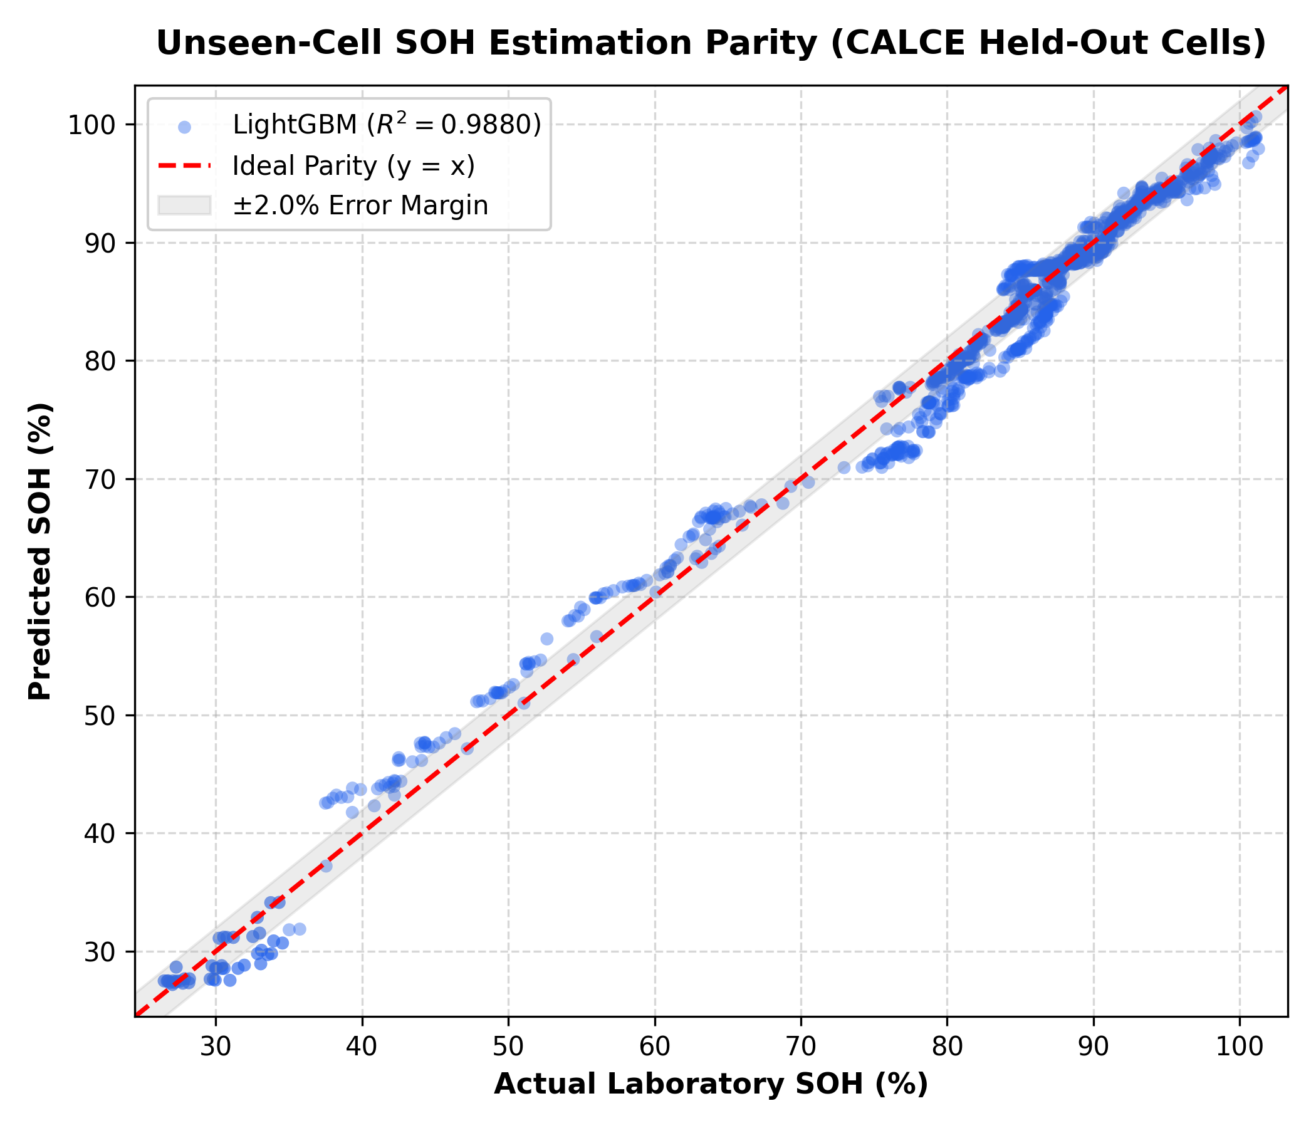
Fig. 1. Actual vs. Predicted State of Health (SOH) on 1,462 cycles from unseen physical cells under LightGBM (R² = 0.9880, MAE = 1.395%, RMSE = 1.879%).

3. Feature Ablation Study: Partial Curves vs. Full Cycles
We evaluate three operational feature sets to investigate whether full discharge data are necessary for accurate SOH estimation:
Feature Configuration | Feature Count | RMSE (% SOH) | R² Score
Config 1: Partial Curve Only | 9 features | 2.874% | 0.9719
Config 2: Partial Curve + Operating Context | 21 features | 1.879% | 0.9880
Config 3: Full-Cycle Benchmark (with Discharge) | 27 features | 1.909% | 0.9876

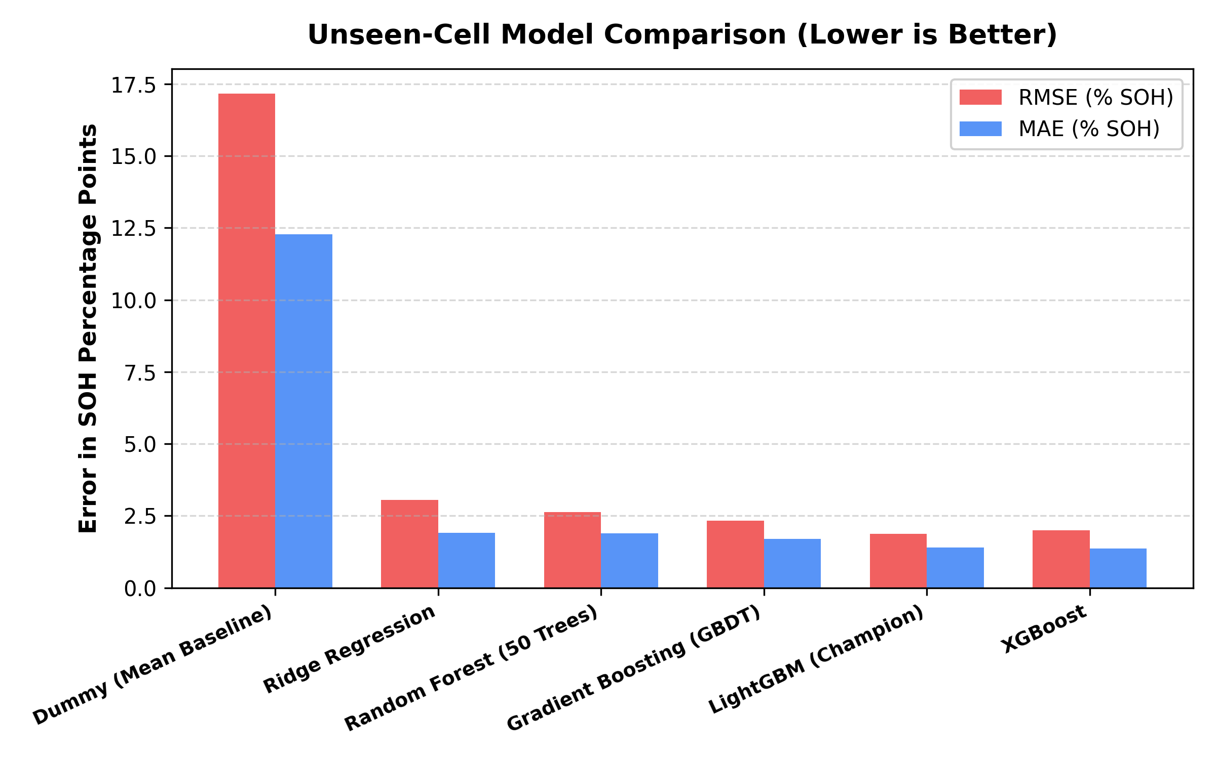
Fig. 2. Error metric comparison across all candidate algorithms on unseen held-out battery cells.

4. Conformalized Quantile Regression (CQR) Uncertainty Quantification
Using pinball loss quantile models calibrated on physical cell CALCE_CS2_37 (N = 905 cycles), nominal 90% prediction intervals were formed using conformal correction factor Q_{1-alpha} = 1.4081% SOH. On held-out unseen cells, empirical coverage reached 85.16% with an average interval width of 6.51% SOH.

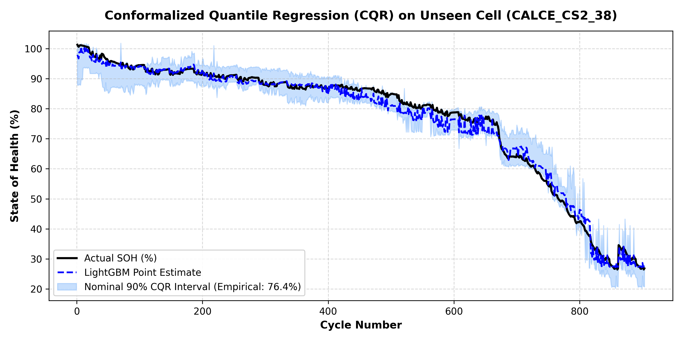
Fig. 3. Calibrated nominal 90% CQR prediction interval trajectory over the lifecycle of unseen cell CALCE_CS2_38.

5. Production API Deployment & Automated Consistency Tests
All production artifacts in ml-service/app/models were retrained and verified with compress=3. Automated test suite test_deployment_consistency.py verified 9 critical checks with 100% pass rate: model loading, feature schemas, direct offline-to-API parity (97.0% SOH), extreme value handling, and CQR interval responses.

