Supplementary Material

## Model structure

For each of the 17 plankton types below, all of which were present in >50% of samples collected, we tested four related models. All four models employed a hurdle structure (zero and non-zero outcomes modeled separately) and had a fixed effect for location and depth:location, but varied in error and random effect structure.

**Model 0**: Truncated poisson distribution

**Model 1**: Truncated negative binomial family 1

**Model 2**: Truncated negative binomial family 2

**Model 3**: Best performing error structure with added random effect for survey date

## Model selection

We used the Aikaike Information Criterion (AIC) to select the highest performing model (model estimates are reported in the main text). In each of the sections below we show histograms of plankton concentration to demonstrate the degree of zero-inflation and over-dispersion in each group, and we present AIC tables comparing the four model types. NAs indicate failed model convergence.

### *Balanus crenatus* cyprids

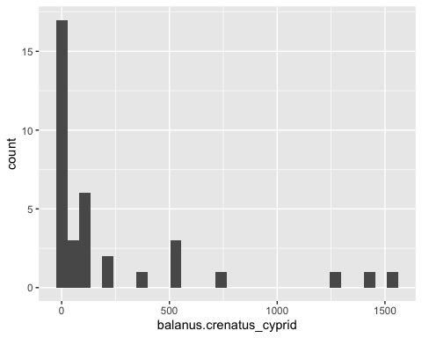

## df AIC  
## m0 7 10414.4257  
## m1 8 NA  
## m2 8 381.0971  
## m3 9 376.9875

### *Balanus crenatus* nauplius

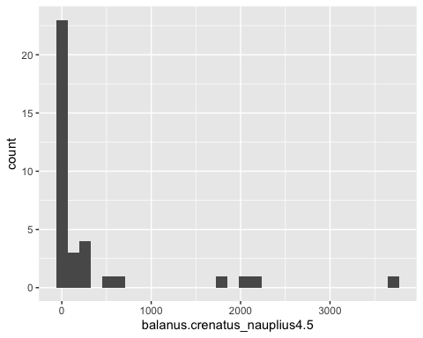

## df AIC  
## m0 7 20546.3687  
## m1 8 NA  
## m2 8 373.0885  
## m3 9 364.4234

### Bivalve umbo

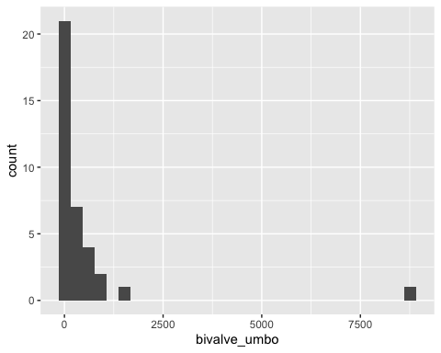

## df AIC  
## m0 7 28028.2084  
## m1 8 NA  
## m2 8 388.1278  
## m3 9 390.1278

### *Chthamalus* spp. cyprid

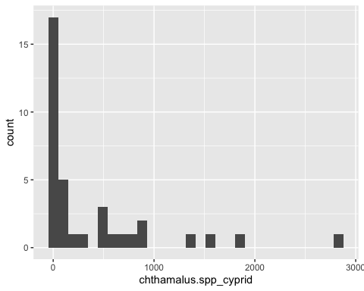

## df AIC  
## m0 7 10927.8153  
## m1 8 NA  
## m2 8 373.8031  
## m3 9 370.3721

### Gastropod veliger

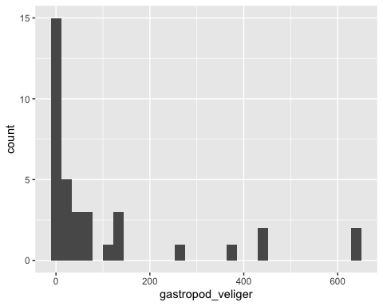

## df AIC  
## m0 7 4665.4165  
## m1 8 360.9392  
## m2 8 355.1992  
## m3 9 348.2313

### Pinnotherid zoea

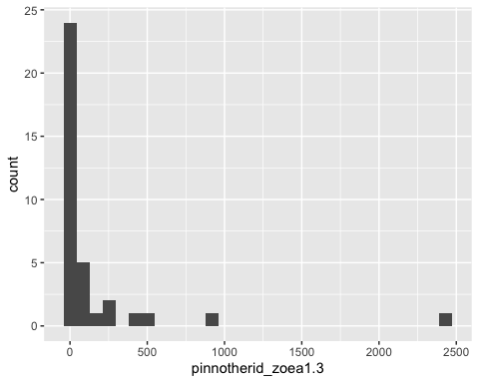

## df AIC  
## m0 7 11727.7516  
## m1 8 NA  
## m2 8 354.2808  
## m3 9 344.0585

### Polychaete setiger

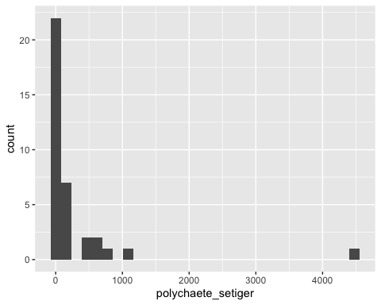

## df AIC  
## m0 7 14740.9162  
## m1 8 NA  
## m2 8 410.5229  
## m3 9 405.7348

### Calanoid adult

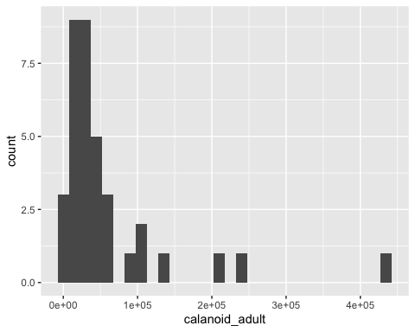

## df AIC  
## m0 7 1338544.0505  
## m1 8 NA  
## m2 8 858.9115  
## m3 9 853.3617

### Copepod metanauplius

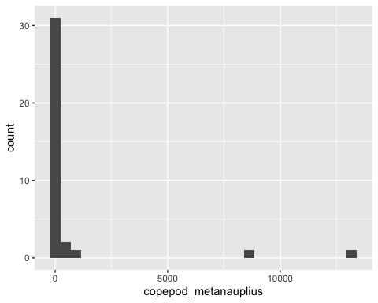

## df AIC  
## m0 7 17126.8521  
## m1 8 NA  
## m2 8 290.2589  
## m3 9 291.9234

### Copepod nauplius

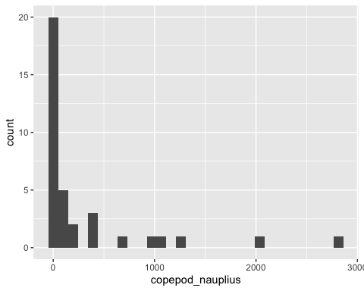

## df AIC  
## m0 7 8757.3061  
## m1 8 NA  
## m2 8 347.6864  
## m3 9 349.7145

### Cyclopoid adult

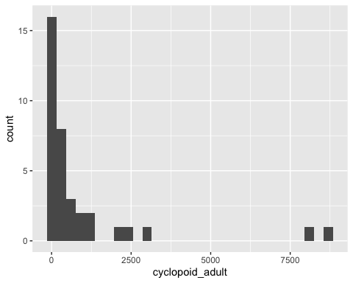

## df AIC  
## m0 7 54984.1877  
## m1 8 NA  
## m2 8 514.8219  
## m3 9 495.8090

### Evadne

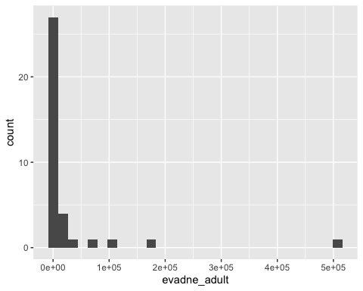

## df AIC  
## m0 7 1688523.7608  
## m1 8 NA  
## m2 8 629.9913  
## m3 9 616.0474

### Larvacea

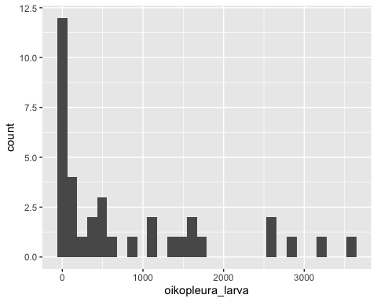

## df AIC  
## m0 7 30569.9806  
## m1 8 NA  
## m2 8 526.4882  
## m3 9 495.9507

### Podon

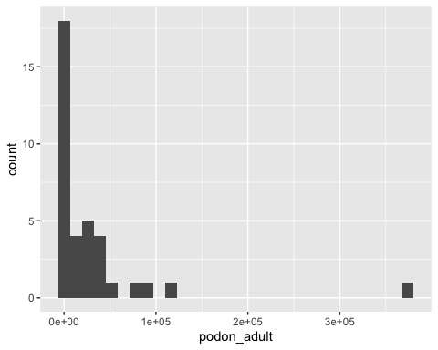

## df AIC  
## m0 7 1371881.1346  
## m1 8 NA  
## m2 8 750.3483  
## m3 9 708.1862

### Diatom

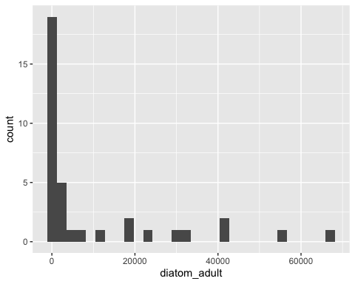

## df AIC  
## m0 7 824879.1691  
## m1 8 NA  
## m2 8 634.6155  
## m3 9 571.7285

### Large eggs

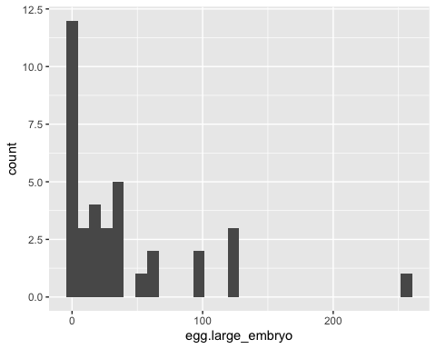

## df AIC  
## m0 7 1891.0292  
## m1 8 323.1575  
## m2 8 323.1748  
## m3 9 313.1321

### Small eggs

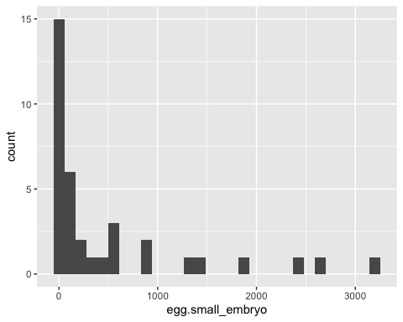

## df AIC  
## m0 7 17917.9700  
## m1 8 NA  
## m2 8 428.5293  
## m3 9 431.0516