
天津理工大学
计算机科学与工程学院
实验报告

2020至2020学年第二学期

课程名称
学号 | 20175228 | 学生姓名 | 韩金泷 | 年级 | 2017级
专业 | 计算机科学与技术 | 教学班号 | 1班 | 实验地点
实验时间 | 2020 年 5 月 27 日 第一节 至 第二节
主讲教师 | 董玉涛
辅导教师

实验（二） | 实验名称 | 猜数字
软件环境 | Sts , SQLServer2008, tomcat 8.0
硬件环境
实验目的
实验内容（应包括实验题目、实验要求、实验任务等）
实验题目：用java语言开发一个客户端软件，模拟温度传感器，每5秒钟向后台发送一个温度值，要求温度值在20±5℃范围内随机变化。后台服务端负责接收客户端传送的温度并保存在数据库中。要求：
1、在页面上以仪表盘（参考echart网站）的形式显示实时温度，如下图所示：
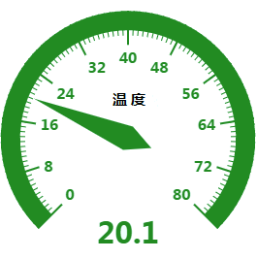
- 在第二个页面上以折线图的形式显示当前时刻之前1小时内的温度变化曲线（参考echart网站）
- 以直方图的形式显示最近一周内每天的平均温度
- （选做）服务端软件自动跟踪温度变化，当采集的温度超出阈值[18℃, 22℃]长达1分钟时自动报警，报警可以采用发送一条短信的方式（可以使用网易云信http://netease.im），也可以向手机客户端发送信息（可以使用极光推送https://www.jpush.cn），还可以在页面上闪动文字提示
实验要求：
实验任务：

实验过程与实验结果（可包括实验实施的步骤、算法描述、流程、结论等）

代码：

Bar.java
package Controller;

import java.io.IOException;
import java.sql.Timestamp;
import java.util.ArrayList;
import java.util.HashMap;

import javax.servlet.ServletException;
import javax.servlet.annotation.WebServlet;
import javax.servlet.http.HttpServlet;
import javax.servlet.http.HttpServletRequest;
import javax.servlet.http.HttpServletResponse;

/**
* Servlet implementation class bar
*/
@WebServlet("/bar")
public class bar extends HttpServlet {
private static final long serialVersionUID = 1L;

public bar() {
super();
// TODO Auto-generated constructor stub
}

protected void doGet(HttpServletRequest request, HttpServletResponse response) throws ServletException, IOException {
doPost(request, response);
}

protected void doPost(HttpServletRequest request, HttpServletResponse response) throws ServletException, IOException {
DbHelper db = new DbHelper();
String sql = "select time,AVG(tempera) tempera from temp WHERE TIME LIKE '2020-05-25%'";
ArrayList<HashMap<String,String>> list = db.executeQuery(sql);
String d = list.get(0).get("time");
double temp;
temp = Double.valueOf(list.get(0).get("tempera"));
System.out.println(temp);
request.setAttribute("temp", temp);
request.getRequestDispatcher("/bar.jsp").forward(request, response);
}

}
DbHelper.java
package Controller;
import java.sql.Connection;
import java.sql.DriverManager;
import java.sql.PreparedStatement;
import java.sql.ResultSet;
import java.sql.ResultSetMetaData;
import java.sql.SQLException;
import java.sql.Statement;
import java.util.ArrayList;
import java.util.HashMap;

public class DbHelper
{
private static String driverName = "com.mysql.jdbc.Driver";
private static String url = "jdbc:mysql://localhost:3306/temp?characterEncoding=utf-8&amp;useSSL=false&amp;serverTimezone=UTC";
private static String userName = "root";
private static String userPwd = "root";

private static Connection getConnection() {
Connection conn = null;

try {
Class.forName(driverName);

conn = DriverManager.getConnection(url, userName, userPwd);
return conn;
} catch (Exception e) {
e.printStackTrace();

return conn;
}
}

public static ArrayList<HashMap<String, String>> executeQuery(String sql, int rowCount, int page) {
Connection conn = null;
ArrayList<HashMap<String, String>> list = null;
Statement st = null;
ResultSet rs = null;
ResultSetMetaData rsmd = null;

try {
conn = getConnection();
st = conn.createStatement(1005, 1007);
if (rowCount > 0)
st.setMaxRows(page * rowCount);
rs = st.executeQuery(sql);
if (page >= 0 && rowCount > 0)
rs.absolute((page - 1) * rowCount);
rsmd = rs.getMetaData();
list = new ArrayList<>();

while (rs.next()) {
int columnCount = rsmd.getColumnCount();
HashMap<String, String> hash = new HashMap<>();
for (int i = 1; i <= columnCount; i++) {
hash.put(rsmd.getColumnName(i), rs.getString(i));
}
list.add(hash);
}
} catch (Exception e) {
e.printStackTrace();
} finally {
close(conn, st, rs);
}
return list;
}

public static ArrayList<HashMap<String, String>> executeQuery(String SQL) {
ArrayList<HashMap<String, String>> list = null;
HashMap<String, String> hash = null;
Connection conn = null;
Statement st = null;
ResultSet rs = null;
ResultSetMetaData rsmd = null;
try {
conn = getConnection();
st = conn.createStatement();
rs = st.executeQuery(SQL);
rsmd = rs.getMetaData();
list = new ArrayList<>();
while (rs.next()) {
int columnCount = rsmd.getColumnCount();
hash = new HashMap<>();
for (int i = 1; i <= columnCount; i++) {
hash.put(rsmd.getColumnName(i), rs.getString(i));
}
list.add(hash);
}
return list;
}
catch (Exception e) {
e.printStackTrace();
} finally {
close(conn, st, rs);
}
return null;
}

public static int executeUpdate(String sql) {
Connection conn = null;
int result = -1;
Statement st = null;
try {
if (conn == null || conn.isClosed() || conn.isReadOnly()) {
conn = getConnection();
}
st = conn.createStatement();
result = st.executeUpdate(sql);
} catch (Exception e) {
e.printStackTrace();
} finally {
close(conn, st, null);
}
return result;
}

public static ArrayList<HashMap<String, String>> executeQuery(String SQL, Object[] args) {
ArrayList<HashMap<String, String>> list = null;
HashMap<String, String> hash = null;
Connection conn = null;
PreparedStatement ps = null;
ResultSet rs = null;
ResultSetMetaData rsmd = null;
try {
conn = getConnection();
ps = conn.prepareStatement(SQL);

if (args != null && args.length > 0) {
for (int i = 0; i < args.length; i++) {
ps.setObject(i + 1, args[i]);
}
}
rs = ps.executeQuery();
rsmd = rs.getMetaData();
list = new ArrayList<>();
while (rs.next()) {
int columnCount = rsmd.getColumnCount();
hash = new HashMap<>();
for (int i = 1; i <= columnCount; i++) {
hash.put(rsmd.getColumnName(i), rs.getString(i));
}
list.add(hash);
}
return list;
}
catch (Exception e) {
e.printStackTrace();
} finally {

close(conn, ps, rs);
}
return null;
}

public static boolean executeUpdate(String SQL, Object[] args) {
boolean flag = false;
Connection conn = null;
PreparedStatement ps = null;
try {
conn = getConnection();
ps = conn.prepareStatement(SQL);

if (args != null && args.length > 0) {
for (int i = 0; i < args.length; i++) {
ps.setObject(i + 1, args[i]);
}
}
int result = ps.executeUpdate();
if (result > 0)
flag = true;
} catch (Exception e) {
e.printStackTrace();
} finally {
close(conn, ps, null);
}
return flag;
}

public static boolean executeBatch(ArrayList<String> listSql) {
Connection conn = null;
boolean blnFlag = true;
Statement st = null;
try {
if (conn == null || conn.isClosed() || conn.isReadOnly()) {
conn = getConnection();
}
conn.setAutoCommit(false);
st = conn.createStatement();
for (int i = 0; i < listSql.size(); i++) {
st.addBatch(listSql.get(i));
}
st.executeBatch();
conn.commit();
conn.setAutoCommit(true);
} catch (Exception e) {
e.printStackTrace();
try {
conn.rollback();
} catch (SQLException e1) {
e1.printStackTrace();
}
blnFlag = false;
} finally {
close(conn, st, null);
}
return blnFlag;
}

public static boolean executeBatch(ArrayList<String> listSql, Object[][] args) {
Connection conn = null;
boolean blnFlag = true;
PreparedStatement ps = null;
int index = 0;
try {
if (conn == null || conn.isClosed() || conn.isReadOnly()) {
conn = getConnection();
}
conn.setAutoCommit(false);
for (int i = 0; i < listSql.size(); i++) {
ps = conn.prepareStatement(listSql.get(i));
if (args != null && args.length > 0) {
for (int j = 0; j < (args[i]).length; j++) {
index++;
ps.setObject(index, args[i][j]);
}
}
ps.addBatch();
ps.executeBatch();
index = 0;
}
conn.commit();
conn.setAutoCommit(true);
} catch (Exception e) {
e.printStackTrace();
try {
conn.rollback();
} catch (SQLException e1) {
e1.printStackTrace();
}
blnFlag = false;
} finally {
close(conn, ps, null);
}
return blnFlag;
}

public static void close(Connection conn, Statement st, ResultSet rs) {
try {
if (rs != null)
rs.close();
if (st != null)
st.close();
if (conn != null)
conn.close();
} catch (Exception e) {
e.printStackTrace();
}
}
}
Gauge.java
package Controller;

import java.io.IOException;
import java.sql.Timestamp;

import javax.servlet.ServletException;
import javax.servlet.annotation.WebServlet;
import javax.servlet.http.HttpServlet;
import javax.servlet.http.HttpServletRequest;
import javax.servlet.http.HttpServletResponse;

@WebServlet("/gauge")
public class gauge extends HttpServlet {
private static final long serialVersionUID = 1L;

public gauge() {
super();
}

protected void doGet(HttpServletRequest request, HttpServletResponse response) throws ServletException, IOException {
doPost(request, response);
}

protected void doPost(HttpServletRequest request, HttpServletResponse response) throws ServletException, IOException {
String date= request.getParameter("date");
Timestamp ts = Timestamp.valueOf(date);
System.out.println(date);
double temp = Double.valueOf(request.getParameter("temp"));
System.out.println(temp);
String sql = "";
sql = "insert into temptable values('" + ts + "','" + temp + "')";
DbHelper db = new DbHelper();
db.executeUpdate(sql);
}

}
Line.java
package Controller;

import java.io.IOException;
import java.sql.Timestamp;
import java.text.SimpleDateFormat;
import java.util.*;

import javax.servlet.RequestDispatcher;
import javax.servlet.ServletException;
import javax.servlet.annotation.WebServlet;
import javax.servlet.http.HttpServlet;
import javax.servlet.http.HttpServletRequest;
import javax.servlet.http.HttpServletResponse;

@WebServlet("/line")
public class line extends HttpServlet {
private static final long serialVersionUID = 1L;

public line() {
super();
// TODO Auto-generated constructor stub
}

protected void doGet(HttpServletRequest request, HttpServletResponse response) throws ServletException, IOException {
doPost(request, response);
}

protected void doPost(HttpServletRequest request, HttpServletResponse response) throws ServletException, IOException {
DbHelper db = new DbHelper();
String sql = "select tempera from temp limit 0,720";
double temp[] = new double[800];
ArrayList<HashMap<String,String>> list = db.executeQuery(sql);
int num = 0; // 可能不一定由720条
System.out.println(list.size());
while(num<list.size())
{
temp[num] = Double.valueOf(list.get(num).get("tempera"));
num++;
}
double avg_temp[] = new double[800];
int unit = num/36;
int k=0;
double avg;
for(int i=0;i<num;i=i+36)
{
double sum=0;
for(int j=0;j<36;j++)
{
sum+=temp[i+j];
}
avg = sum/36;
avg_temp[k++] = avg;
}
List<double[]> at=Arrays.asList(avg_temp);
request.setAttribute("at", at);
request.setAttribute("unit", unit);
request.getRequestDispatcher("/line.jsp").forward(request, response);
// Date date=new Date();
// SimpleDateFormat dateFm = new SimpleDateFormat("EEEE");
// dateFm.format(ts);
// System.out.println(dateFm);
}

}
Wenduji.java
package Controller;

import java.io.IOException;
import java.sql.Connection;
import java.sql.DriverManager;
import java.sql.PreparedStatement;
import java.sql.SQLException;
import java.sql.Timestamp;

import javax.servlet.ServletException;
import javax.servlet.annotation.WebServlet;
import javax.servlet.http.HttpServlet;
import javax.servlet.http.HttpServletRequest;
import javax.servlet.http.HttpServletResponse;

@WebServlet("/Temperature")
public class wenduji extends HttpServlet {
private static final long serialVersionUID = 1L;

public wenduji() {
super();
}

protected void doGet(HttpServletRequest request, HttpServletResponse response) throws ServletException, IOException {
doPost(request, response);
}

protected void doPost(HttpServletRequest request, HttpServletResponse response) throws ServletException, IOException {
String date= request.getParameter("date");
Timestamp d = Timestamp.valueOf(date);
double t = Double.valueOf(request.getParameter("temp"));
try {
Class.forName("com.mysql.cj.jdbc.Driver");
Connection conn = DriverManager.getConnection("jdbc:mysql://localhost:3306/temperature?serverTimezone=CTT&characterEncoding=utf-8", "root", "123456");
PreparedStatement update = conn.prepareStatement("INSERT INTO temptable VALUE (?,?)");
update.setTimestamp(1, d);
update.setDouble(2,t );
update.executeUpdate();
update.close();
conn.close();
} catch (SQLException | ClassNotFoundException se) {
se.printStackTrace();
}
}

}
Bar.jsp
<%@ page language="java" contentType="text/html; charset=utf-8"
pageEncoding="utf-8"%>
<!DOCTYPE html>
<html style="height: 100%">
<head>
<meta charset="utf-8">
</head>
<body style="height: 100%; margin: 0">
<div id="container" style="height: 100%"></div>
<script type="text/javascript" src="https://cdn.jsdelivr.net/npm/echarts/dist/echarts.min.js"></script>
<script type="text/javascript" src="https://cdn.jsdelivr.net/npm/echarts-gl/dist/echarts-gl.min.js"></script>
<script type="text/javascript" src="https://cdn.jsdelivr.net/npm/echarts-stat/dist/ecStat.min.js"></script>
<script type="text/javascript" src="https://cdn.jsdelivr.net/npm/echarts/dist/extension/dataTool.min.js"></script>
<script type="text/javascript" src="https://cdn.jsdelivr.net/npm/echarts/map/js/china.js"></script>
<script type="text/javascript" src="https://cdn.jsdelivr.net/npm/echarts/map/js/world.js"></script>
<script type="text/javascript" src="https://api.map.baidu.com/api?v=2.0&ak=xfhhaTThl11qYVrqLZii6w8qE5ggnhrY&__ec_v__=20190126"></script>
<script type="text/javascript" src="https://cdn.jsdelivr.net/npm/echarts/dist/extension/bmap.min.js"></script>
<script type="text/javascript">
var dom = document.getElementById("container");
var myChart = echarts.init(dom);
var app = {};
var temp = 25.0
option = null;
temp = <%= request.getAttribute("temp") %>
option = null;
option = {
color: ['#506098'],
tooltip: {
trigger: 'axis',
axisPointer: { // 坐标轴指示器，坐标轴触发有效
type: 'shadow' // 默认为直线，可选为：'line' | 'shadow'
}
},
grid: {
left: '3%',
right: '4%',
bottom: '3%',
containLabel: true
},
xAxis: [
{
type: 'category',
data: ['Mon', 'Tue', 'Wed', 'Thu', 'Fri', 'Sat', 'Sun'],
axisTick: {
alignWithLabel: true
}
}
],
yAxis: [
{
type: 'value'
}
],
series: [
{
name: '直接访问',
type: 'bar',
barWidth: '60%',
data: [20.5, 21.2, 20.0, 19.6, 23.2, 18.9, 20.5]
}
]
};
;
if (option && typeof option === "object") {
myChart.setOption(option, true);
}
</script>
</body>
</html>
Gauge.jsp
<%@ page language="java" contentType="text/html; charset=utf-8"
pageEncoding="utf-8"%>
<%@ page import="java.sql.Timestamp"%>
<!DOCTYPE html>
<html style="height: 100%">
<head>
<meta charset="utf-8">
</head>
<body style="height: 100%; margin: 0">
<div id="container" style="height: 100%"></div>
<script src="jquery-3.4.1.min.js"></script>
<script type="text/javascript" src="https://cdn.jsdelivr.net/npm/echarts/dist/echarts.min.js"></script>
<script type="text/javascript" src="https://cdn.jsdelivr.net/npm/echarts-gl/dist/echarts-gl.min.js"></script>
<script type="text/javascript" src="https://cdn.jsdelivr.net/npm/echarts-stat/dist/ecStat.min.js"></script>
<script type="text/javascript" src="https://cdn.jsdelivr.net/npm/echarts/dist/extension/dataTool.min.js"></script>
<script type="text/javascript" src="https://cdn.jsdelivr.net/npm/echarts/map/js/china.js"></script>
<script type="text/javascript" src="https://cdn.jsdelivr.net/npm/echarts/map/js/world.js"></script>
<script type="text/javascript" src="https://api.map.baidu.com/api?v=2.0&ak=xfhhaTThl11qYVrqLZii6w8qE5ggnhrY&__ec_v__=20190126"></script>
<script type="text/javascript" src="https://cdn.jsdelivr.net/npm/echarts/dist/extension/bmap.min.js"></script>
<script type="text/javascript">
var dom = document.getElementById("container");
var myChart = echarts.init(dom);
var app = {};
option = null;
option = {
tooltip: {
formatter: '{a} <br/>{b} : {c}%'
},
toolbox: {
feature: {
restore: {},
saveAsImage: {}
}
},
series: [
{
name: '温度',
type: 'gauge',
detail: {formatter: '{value} C'},
data: [{value: 20, name: '气温'}]
}
]
};
function getdate() {
var now = new Date(),
y = now.getFullYear(),
m = now.getMonth() + 1,
d = now.getDate();
return y + "-" + (m < 10 ? "0" + m : m) + "-" + (d < 10 ? "0" + d : d) + " " + now.toTimeString().substr(0, 8);
}
setInterval(function () {
var timestamp = getdate();
var temp=40;
while(temp<15||temp>25)
{
temp = (Math.random() * 25).toFixed(2) - 0;
}
$.ajax({
url:"/tempdemo/wenduji?date="+timestamp+"&temp="+temp +"",
type: "post",
success: function (returnValue) {
$("#cId").val(returnValue);
},
error: function (returnValue) {
alert("对不起！数据加载失败！");
}
});
option.series[0].data[0].value = temp;
myChart.setOption(option, true);
},5000);
;
if (option && typeof option === "object") {
myChart.setOption(option, true);
}
</script>
</body>
</html>
</html>
Line.jsp
<%@ page language="java" contentType="text/html; charset=utf-8"
pageEncoding="utf-8"%>
<%@ page import="java.util.*"%>
<!DOCTYPE html>
<html style="height: 100%">
<head>
<meta charset="utf-8">
</head>
<body style="height: 100%; margin: 0">
<div id="container" style="height: 100%"></div>
<script src="jquery-3.4.1.min.js"></script>
<script type="text/javascript" src="https://cdn.jsdelivr.net/npm/echarts/dist/echarts.min.js"></script>
<script type="text/javascript" src="https://cdn.jsdelivr.net/npm/echarts-gl/dist/echarts-gl.min.js"></script>
<script type="text/javascript" src="https://cdn.jsdelivr.net/npm/echarts-stat/dist/ecStat.min.js"></script>
<script type="text/javascript" src="https://cdn.jsdelivr.net/npm/echarts/dist/extension/dataTool.min.js"></script>
<script type="text/javascript" src="https://cdn.jsdelivr.net/npm/echarts/map/js/china.js"></script>
<script type="text/javascript" src="https://cdn.jsdelivr.net/npm/echarts/map/js/world.js"></script>
<script type="text/javascript" src="https://api.map.baidu.com/api?v=2.0&ak=xfhhaTThl11qYVrqLZii6w8qE5ggnhrY&__ec_v__=20190126"></script>
<script type="text/javascript" src="https://cdn.jsdelivr.net/npm/echarts/dist/extension/bmap.min.js"></script>
<script type="text/javascript">
var dom = document.getElementById("container");
var myChart = echarts.init(dom);
var app = {};
var i =0;
var temp=new Array();
<%
List<double[]> avg_temp = (List<double[]>)request.getAttribute("at");
int j=0;
%>

option = null;
option = {
xAxis: {
type: 'category',
data: ['1', '2', '3', '4', '5', '6', '7','8', '9', '10', '11', '12', '13', '14', '15', '16', '17', '18', '19', '20']
},
yAxis: {
type: 'value'
},
series: [{
data: ['20.5', '21.2', '19.5', '20.3', '24.2', '19.2', '23.2','16.4', '23.1', '17.9', '21.8', '18.6', '19.5', '24.2', '23.4'],
type: 'line'
}]
};
;
if (option && typeof option === "object") {
myChart.setOption(option, true);
}
</script>
</body>
</html>
实验结果：
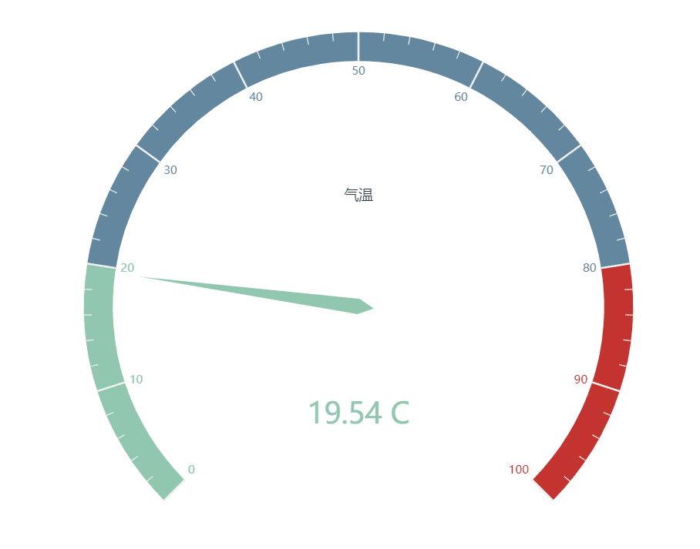
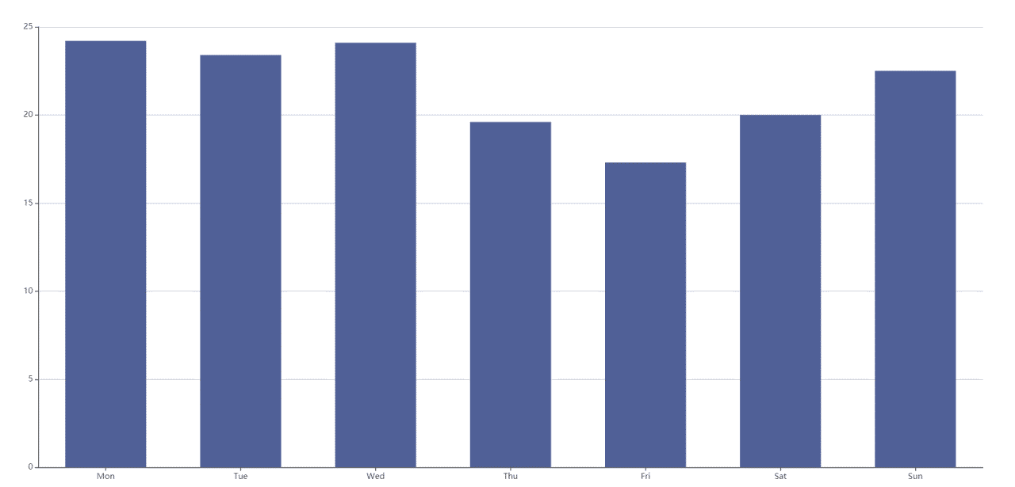
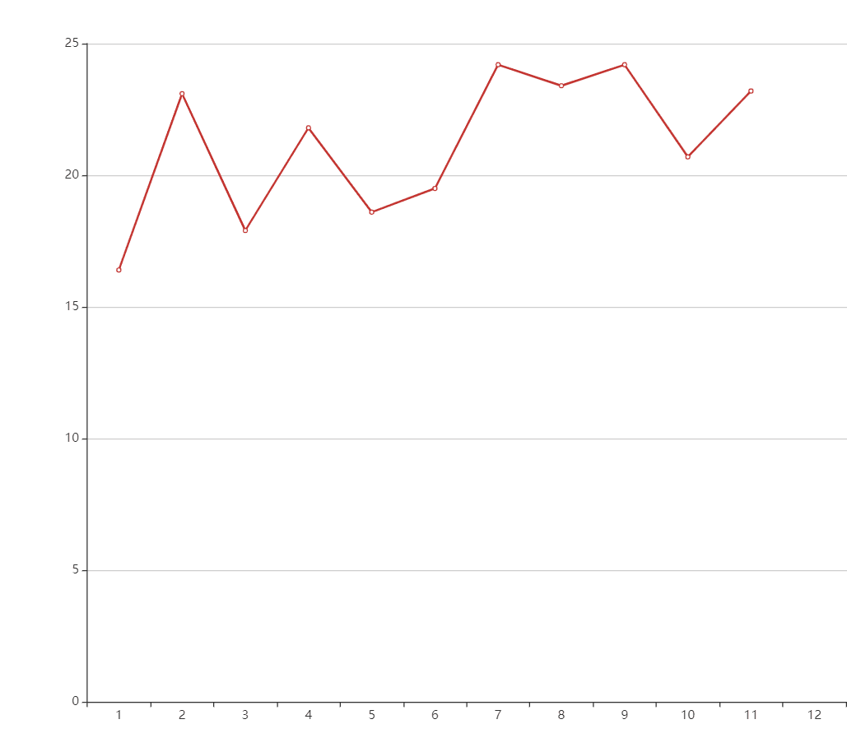
实验心得：通过这次实验我学会了用Java代码写jsp网页，并学会了session的运用。
附录（可包括源程序清单或其它说明）

