Module 2 Assignment: Spark SQL and DataFrames
Holly Morehouse
November 21, 2024
Table of contents

1 GitHub Repo
https://github.com/hjmorehouse89/A03-sp26-hjmorehouse89
import pandas as pd
import plotly.express as px
import plotly.io as pio
from pyspark.sql import SparkSession
import re
import numpy as np
import plotly.graph_objects as go
from pyspark.sql.functions import col, split, explode, regexp_replace, transform, when, trim, replace
from pyspark.sql import functions as F
from pyspark.sql.functions import col, monotonically_increasing_id
np.random.seed(42)
pio.renderers.default = "notebook+svg+png"
# Initialize Spark Session
spark = SparkSession.builder.appName("LightcastData").getOrCreate()
# Load Data
df = spark.read.option("header", "true").option("inferSchema", "true").option("multiLine","true").option("escape", "\"").csv("./data/lightcast_job_postings.csv")
df.createOrReplaceTempView("job_postings")
# Show Schema and Sample Data
#print("---This is Diagnostic check, No need to print it in the final doc---")
#df.printSchema() # comment this line when rendering the submission
#df.show(5)
WARNING: Using incubator modules: jdk.incubator.vector
Using Spark's default log4j profile: org/apache/spark/log4j2-defaults.properties
Setting default log level to "WARN".
To adjust logging level use sc.setLogLevel(newLevel). For SparkR, use setLogLevel(newLevel).
26/04/09 04:37:12 WARN NativeCodeLoader: Unable to load native-hadoop library for your platform... using builtin-java classes where applicable
[Stage 1:> (0 + 1) / 1] 26/04/09 04:37:30 WARN SparkStringUtils: Truncated the string representation of a plan since it was too large. This behavior can be adjusted by setting 'spark.sql.debug.maxToStringFields'.
Plotly Template
import plotly.graph_objects as go
import plotly.io as pio
pio.templates["nike"] = go.layout.Template(
# LAYOUT
layout = {
# Fonts
# Note - 'family' must be a single string, NOT a list or dict!
'title':
{'font': {'family': 'HelveticaNeue-CondensedBold, Helvetica, Sans-serif',
'size':30,
'color': '#333'}
},
'font': {'family': 'Helvetica Neue, Helvetica, Sans-serif',
'size':16,
'color': '#333'},
# Colorways
'colorway': ['#e56414', '#a15b5b'],
# Keep adding others as needed below
'hovermode': 'x unified'
},
# DATA
data = {
# Each graph object must be in a tuple or list for each trace
'bar': [go.Bar(texttemplate = '%{value:$.2s}',
textposition='outside',
textfont={'family': 'Helvetica Neue, Helvetica, Sans-serif',
'size': 20,
'color': '#FFFFFF'
})]
}
)

2 Casting Salary and Experience Columns
df = df.withColumn("SALARY_FROM", col("SALARY_FROM").cast("float")) \
.withColumn("SALARY_TO",col("SALARY_TO").cast("float")) \
.withColumn("SALARY",col("SALARY").cast("float")) \
.withColumn("MAX_YEARS_EXPERIENCE", col("MAX_YEARS_EXPERIENCE").cast("float"))
def compute_median(sdf, col_name):
q = sdf.approxQuantile(col_name, [0.5], 0.01)
return q[0] if q else None
median_from = compute_median(df, "SALARY_FROM")
median_to = compute_median(df, "SALARY_TO")
median_salary = compute_median(df, "SALARY")
print("Medians: ", median_from, median_to, median_salary)
df = df.fillna({
"SALARY_FROM":median_from,
"SALARY_TO": median_to
})
df = df.withColumn("AVERAGE_SALARY", (col("SALARY_FROM") + col("SALARY_TO"))/2)
df = df.replace("EDUCATION_LEVELS_NAME", "[\\n")
export_cols = [
"EDUCATION_LEVELS_NAME",
"REMOTE_TYPE_NAME",
"MAX_YEARS_EXPERIENCE",
"AVERAGE_SALARY",
"LOT_V6_SPECIALIZED_OCCUPATION_NAME"
]
df_selected = df.select(*export_cols)
pdf = df_selected.toPandas()
pdf.to_csv("./data/lightcast_cleaned.csv",index = False)
print("Cleaned up the Data. Number of Rows: ", len(pdf))
df_selected.show(10)
[Stage 2:> (0 + 1) / 1] [Stage 3:> (0 + 1) / 1][Stage 3:===========================================================(1 + 0) / 1] [Stage 4:> (0 + 1) / 1]
Medians: 87295.0 130042.0 115024.0
[Stage 5:> (0 + 1) / 1]
Cleaned up the Data. Number of Rows: 72498
+---------------------+----------------+--------------------+--------------+----------------------------------+
|EDUCATION_LEVELS_NAME|REMOTE_TYPE_NAME|MAX_YEARS_EXPERIENCE|AVERAGE_SALARY|LOT_V6_SPECIALIZED_OCCUPATION_NAME|
+---------------------+----------------+--------------------+--------------+----------------------------------+
| [\n "Bachelor's ...| [None]| 2.0| 108668.5| General ERP Analy...|
| [\n "No Educatio...| Remote| 3.0| 108668.5| Oracle Consultant...|
| [\n "Bachelor's ...| [None]| NULL| 108668.5| Data Analyst|
| [\n "No Educatio...| [None]| NULL| 108668.5| Data Analyst|
| [\n "No Educatio...| [None]| NULL| 92500.0| Oracle Consultant...|
| [\n "Bachelor's ...| Remote| NULL| 110155.0| Data Analyst|
| [\n "Bachelor's ...| [None]| NULL| 108668.5| Data Analyst|
| [\n "Bachelor's ...| [None]| NULL| 108668.5| Data Analyst|
| [\n "No Educatio...| [None]| 7.0| 108668.5| General ERP Analy...|
| [\n "Bachelor's ...| [None]| 2.0| 92962.0| Data Analyst|
+---------------------+----------------+--------------------+--------------+----------------------------------+
only showing top 10 rows

3 Salary Distribution by Industry and Employment Type
pdf = df.select("NAICS2_NAME", "SALARY","EMPLOYMENT_TYPE_NAME").toPandas()
fig = px.box(pdf, x="NAICS2_NAME", y="SALARY", color="EMPLOYMENT_TYPE_NAME", title ="Salary Distribution by Industry", color_discrete_sequence=["#AA00FF","#00AA77","#AA7700"])
fig.update_layout(template="nike", height = 750, width = 1500)
fig.update_xaxes(tickangle=45)
fig.update_layout(boxmode='group')
fig.write_image("figures/Q2.svg")
fig.write_image("figures/Q2.png")
fig.show()
[Stage 7:> (0 + 1) / 1]
Unable to display output for mime type(s): text/html
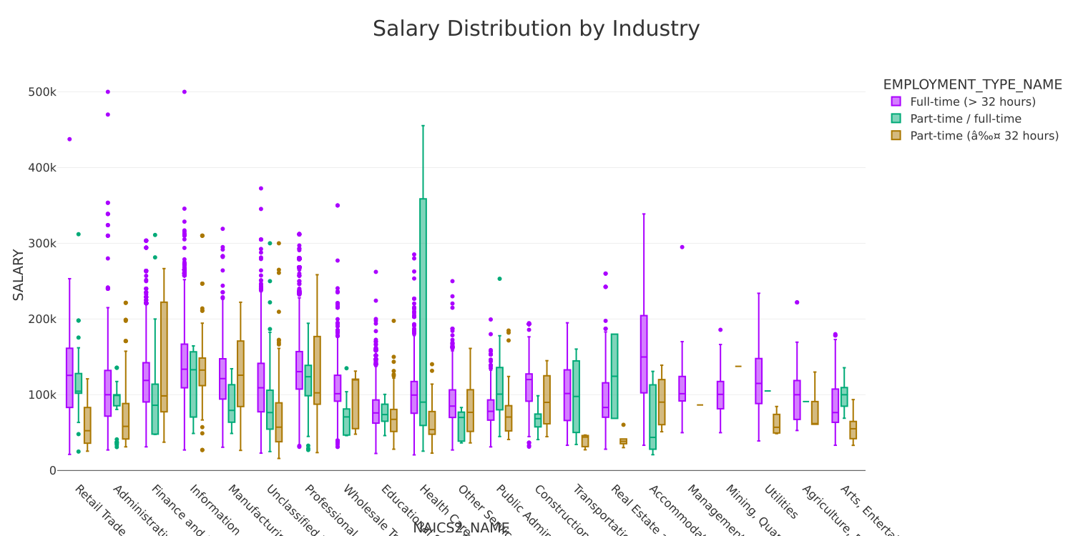

4 Key Insights
The generated graph with detailed box plots shows how the highest amount of salary variations are coming from human services fields, such as health care, which includes the widest margin in salary level, as well as information. However, the strongest salary outliers can be found in the administrative support and remediation & waste management fields. Both show the potential for salary, indicative of positions that require advanced skill , education, and risk.

5 Salary Analysis by ONET Occupation Type
salary_analysis_df = spark.sql("""
SELECT
LOT_OCCUPATION_NAME AS Occupation_Name,
PERCENTILE(SALARY,0.5) AS Median_Salary,
COUNT(*) AS Job_Postings
FROM job_postings
GROUP BY LOT_OCCUPATION_NAME
ORDER BY Job_Postings DESC
LIMIT(5)
""")
salary_pd = salary_analysis_df.toPandas()
salary_pd.head
fig = px.scatter(
salary_pd,
x="Occupation_Name",
y="Median_Salary",
size="Job_Postings"
)
fig.write_image("figures/Q3.svg")
fig.write_image("figures/Q3.png")
fig.show()
[Stage 8:> (0 + 1) / 1]
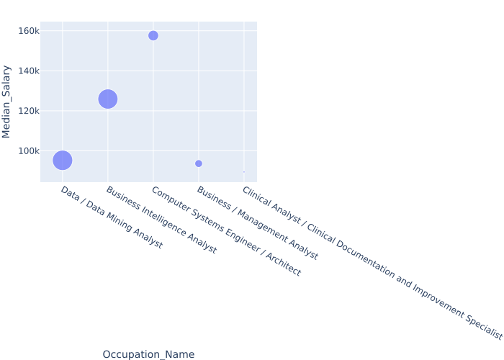

6 Key Insights
The median salary graph show an interesting relationship of occupation median salary to job availability, which can be understood based on position demands and experience. For example, while there are a higher number of postings for a data analyst, the business intelligence analyst has almost as many positions open, yet a significantly higher pay median. This can also be supported in the demonstration of the computer science positions having fewer position postings, yet a higher salary median. The graph infers and represents the competitive and technical nature of the computer systems field.

7 Salary by Education Level
from pyspark.sql.functions import randn
#define education level groups
bachelor_lower = ["GED","No Education Listed", "High school", "Bachelor's"]
masters_higher = ["Master's degree", "PhD or professional degree"]
df_edu = df.withColumn(
"EDU_GROUP",
when(col("EDUCATION_LEVELS_NAME").rlike("|".join([f"(?i){deg}" for deg in bachelor_lower])), "Bachelor's or Lower")
.when(col("EDUCATION_LEVELS_NAME").rlike("|".join([f"(?i){deg}" for deg in masters_higher])), "Master's or Higher")
.otherwise("Other")
)
df_edu = df_edu.withColumn("MAX_YEARS_EXPERIENCE", col("MAX_YEARS_EXPERIENCE").cast("float"))
df_edu = df_edu.withColumn("AVERAGE_SALARY", col("AVERAGE_SALARY").cast("float"))
df_edu = df_edu.filter(
col("MAX_YEARS_EXPERIENCE").isNotNull() &
col("AVERAGE_SALARY").isNotNull() &
(col("MAX_YEARS_EXPERIENCE") > 0) &
(col("AVERAGE_SALARY") > 0)
)
df_filtered = df_edu.filter(col("EDU_GROUP").isin("Bachelor's or Lower", "Master's or Higher"))
df_filtered = df_filtered.withColumn("MAX_YEARS_EXPERIENCE_JITTER", col("MAX_YEARS_EXPERIENCE") + randn() * 0.1)
df_pd = df_filtered.toPandas()
[Stage 11:> (0 + 1) / 1]
fig_edusalary = px.scatter(
df_pd,
x="MAX_YEARS_EXPERIENCE_JITTER",
y="AVERAGE_SALARY",
color="EDU_GROUP",
hover_data=["LOT_V6_SPECIALIZED_OCCUPATION_NAME"],
title = "Experience vs Salary by Education Level",
color_discrete_sequence=["#0088FF","#8800EE"]
)
fig_edusalary.update_traces(marker=dict(size=7,line=dict(width=1, color="black")))
fig_edusalary.write_image("figures/Q4.svg")
fig_edusalary.write_image("figures/Q4.png")
fig_edusalary.show()
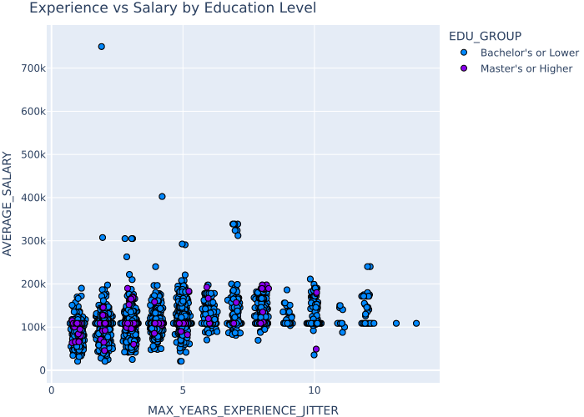

8 Key Insights
A significant insight is showing how there’s more averages within certain business roles and positions for those with masters degrees or higher, whereas the variation is more profound for those with a bachelors degree or lower. One could infer that a master’s degree or higher, would increase changes of having your salary be closest to the average salary of the role, and in contrast, giving it more stablity and reliability in salary, compared with those who only have a bachelor’s degree or lower.

9 Salary By Remote Work Type
from pyspark.sql.functions import when, col, trim
df_remote = df.withColumn("REMOTE_GROUP",
when(trim(col("REMOTE_TYPE_NAME")) == "Remote", "Remote")
.when(trim(col("REMOTE_TYPE_NAME")) == "Hybrid Remote", "Hybrid")
.when(trim(col("REMOTE_TYPE_NAME")) == "Not Remote", "Onsite")
.when(col("REMOTE_TYPE_NAME").isNull(), "Onsite")
.otherwise("Onsite")
)
df_remote = df_remote.filter(
col("MAX_YEARS_EXPERIENCE").isNotNull() &
col("AVERAGE_SALARY").isNotNull() &
(col("MAX_YEARS_EXPERIENCE")>0) &
(col("AVERAGE_SALARY") > 0)
)
df_remote = df_remote.withColumn("MAX_YEARS_EXPERIENCE_JITTER", col("MAX_YEARS_EXPERIENCE") + randn() * 0.1)
df_pd = df_remote.select("MAX_YEARS_EXPERIENCE_JITTER", "AVERAGE_SALARY", "LOT_V6_SPECIALIZED_OCCUPATION_NAME", "REMOTE_GROUP").toPandas()
[Stage 12:> (0 + 1) / 1]
fig_remotesalary = px.scatter(
df_pd,
x="MAX_YEARS_EXPERIENCE_JITTER",
y="AVERAGE_SALARY",
color="REMOTE_GROUP",
hover_data=["LOT_V6_SPECIALIZED_OCCUPATION_NAME"],
title = "Experience vs Salary by Education Level",
color_discrete_sequence=["#0088FF","#8800EE","#009955","#FF5500"]
)
fig_remotesalary.update_traces(marker=dict(size=7,line=dict(width=1, color="black")))
fig_remotesalary.write_image("figures/Q5.svg")
fig_remotesalary.write_image("figures/Q5.png")
fig_remotesalary.show()
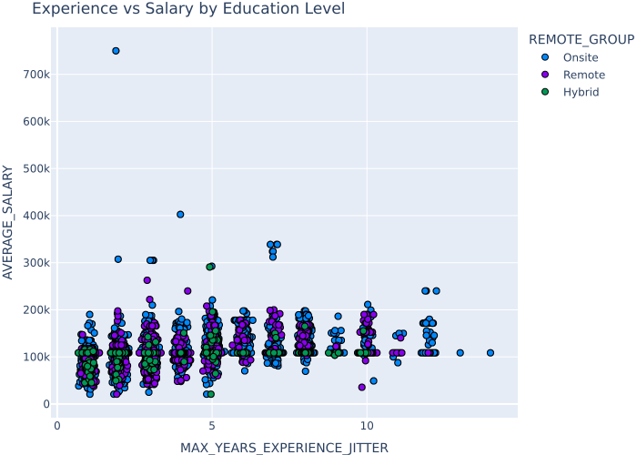

10 Key Insights
The salary medians begin to increase for hybrid positions over the years. While experience does matter in increasing the median salaries for certain roles such as Enterprise Architechs, especially onsite, there is reason to believe that experience is not the only key factor in salary range. Education and accessibility to physical office space for onsite and hybrid employees can play a factor into someone’s salary level.

