## Buildings.Controls.OBC.ASHRAE.G36_PR1.AHUs.MultiZone.VAV.Economizers.Subsequences.Limits

Multi zone VAV AHU minimum outdoor air control - damper position limits

### Info

This block models the multi zone VAV AHU minimum outdoor air control with a single common damper for minimum outdoor air and economizer functions based on outdoor airflow measurement, designed in line with ASHRAE Guidline 36 (G36), PART5.N.6.c.

The controller is enabled when the supply fan is proven on (uSupFan=true), the AHU operation mode Buildings.Controls.OBC.ASHRAE.G36_PR1.Types.OperationModes equals occupied, and the freeze protection stage Buildings.Controls.OBC.ASHRAE.G36_PR1.Types.FreezeProtectionStages is stage1 or lower. Otherwise the damper position limits are set to their corresponding maximum and minimum physical or at commissioning fixed limits. The state machine chart below illustrates listed conditions:

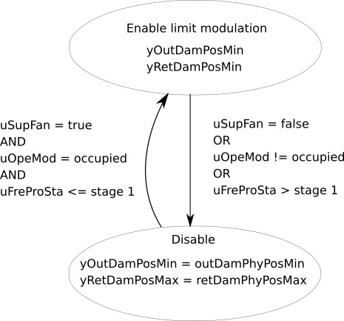

The controller sets the outdoor and return damper position limits so that the outdoor airflow rate VOut_flow stays equal or above the minimum outdoor air setpoint VOutMinSet_flow. The fraction of the controller output signal between yMin and uRetDamMin is linearly mapped to the outdoor air damper minimal position yOutDamPosMin while the fraction of the controller output between uRetDamMin and yMax is linearly mapped to the return air damper maximum position yRetDamPosMax. Thus the dampers are not interlocked.

The following control charts show the input/output structure and an expected damper position limits for a well configured controller.

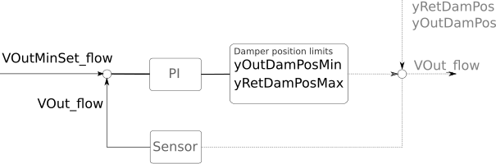

The expected damper position limits vs. the control loop signal are as follows:

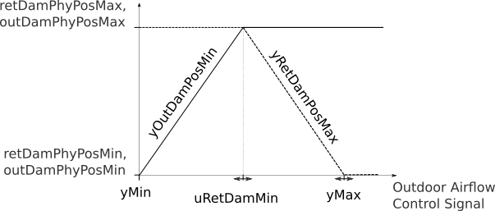

### Parameters

It has the following parameters:

|  |  |  |  |  |  |  |  |  |
| --- | --- | --- | --- | --- | --- | --- | --- | --- |
| **Type** | **Quantity** | **Name** | **Default** | **Unit** | **Display unit** | **min** | **max** | **Description** |
| Commissioning | | | | | | | | |
| Controller | | | | | | | | |
| Real |  | uRetDamMin | 0.5 | 1 | 1 | yMin (adjustable) | yMax (adjustable) | Minimum control signal for the return air damper position limit |
| Physical damper position limits | | | | | | | | |
| Real |  | retDamPhyPosMax | 1 | 1 | 1 | 0 (adjustable) | 1 (adjustable) | Physically fixed maximum position of the return air damper |
| Real |  | retDamPhyPosMin | 0 | 1 | 1 | 0 (adjustable) | 1 (adjustable) | Physically fixed minimum position of the return air damper |
| Real |  | outDamPhyPosMax | 1 | 1 | 1 | 0 (adjustable) | 1 (adjustable) | Physically fixed maximum position of the outdoor air damper |
| Real |  | outDamPhyPosMin | 0 | 1 | 1 | 0 (adjustable) | 1 (adjustable) | Physically fixed minimum position of the outdoor air damper |
| General | | | | | | | | |
| Controller | | | | | | | | |
| Buildings.Controls.OBC.CDL.Types.SimpleController |  | controllerType | Buildings.Controls.OBC.CDL.Types.SimpleController.PI | 1 | 1 |  |  | Type of controller |
| Real |  | k | 0.05 | 1 | 1 |  |  | Gain of damper limit controller |
| Real | Time | Ti | 1200 | s | s |  |  | Time constant of damper limit controller integrator block |
| Real | Time | Td | 0.1 | s | s |  |  | Time constant of damper limit controller derivative block |

### Inputs

It has the following inputs:

|  |  |  |  |  |  |  |  |
| --- | --- | --- | --- | --- | --- | --- | --- |
| **Type** | **Quantity** | **Name** | **Description** | **min** | **max** | **Unit** | **Display unit** |
| Real |  | VOut_flow_normalized | Measured outdoor volumetric airflow rate, normalized by design minimum outdoor airflow rate |  |  | 1 | 1 |
| Real |  | VOutMinSet_flow_normalized | Effective minimum outdoor airflow setpoint, normalized by design minimum outdoor airflow rate |  |  | 1 | 1 |
| Integer |  | uOpeMod | AHU operation mode status signal |  |  |  |  |
| Integer |  | uFreProSta | Freeze protection status signal |  |  |  |  |
| Boolean |  | uSupFan | Supply fan status signal |  |  |  |  |

### Outputs

It has the following outputs:

|  |  |  |  |  |  |  |  |
| --- | --- | --- | --- | --- | --- | --- | --- |
| **Type** | **Quantity** | **Name** | **Description** | **min** | **max** | **Unit** | **Display unit** |
| Real |  | yOutDamPosMin | Minimum outdoor air damper position limit | outDamPhyPosMin (adjustable) | outDamPhyPosMax (adjustable) | 1 | 1 |
| Real |  | yOutDamPosMax | Maximum outdoor air damper position limit | outDamPhyPosMin (adjustable) | outDamPhyPosMax (adjustable) | 1 | 1 |
| Real |  | yRetDamPosMin | Minimum return air damper position limit | retDamPhyPosMin (adjustable) | retDamPhyPosMax (adjustable) | 1 | 1 |
| Real |  | yRetDamPosMax | Maximum return air damper position limit | retDamPhyPosMin (adjustable) | retDamPhyPosMax (adjustable) | 1 | 1 |
| Real |  | yRetDamPhyPosMax | Physical maximum return air damper position limit. Required as an input for the economizer enable disable sequence | 0 (adjustable) | 1 (adjustable) | 1 | 1 |

### Blocks

It has the following blocks:

|  |  |  |  |
| --- | --- | --- | --- |
| **Type** | **Name** | **Description** | **Parameter Assignments** |
| Real | yMin | Lower limit of control loop signal |  |
| Real | yMax | Upper limit of control loop signal |  |
| [Buildings.Controls.OBC.CDL.Continuous.LimPID](http://simulationresearch.lbl.gov/modelica/releases/v5.0.1/help/Buildings_Controls_OBC_CDL_Continuous.html#Buildings.Controls.OBC.CDL.Continuous.LimPID) | damLimCon | Damper position limit controller | * final controllerType = controllerType * final k = k * final Ti = Ti * final Td = Td * final yMax = yMax * final yMin = yMin * reset = Buildings.Controls.OBC.CDL.Types.Reset.Parameter |

### Protected Blocks

It has the following protected blocks:

|  |  |  |  |
| --- | --- | --- | --- |
| **Type** | **Name** | **Description** | **Parameter Assignments** |
| [Buildings.Controls.OBC.CDL.Continuous.Sources.Constant](http://simulationresearch.lbl.gov/modelica/releases/v5.0.1/help/Buildings_Controls_OBC_CDL_Continuous_Sources.html#Buildings.Controls.OBC.CDL.Continuous.Sources.Constant) | outDamPhyPosMinSig | Physically fixed minimum position of the outdoor air damper. This is the initial position of the economizer damper | * final k = outDamPhyPosMin |
| [Buildings.Controls.OBC.CDL.Continuous.Sources.Constant](http://simulationresearch.lbl.gov/modelica/releases/v5.0.1/help/Buildings_Controls_OBC_CDL_Continuous_Sources.html#Buildings.Controls.OBC.CDL.Continuous.Sources.Constant) | outDamPhyPosMaxSig | Physically fixed maximum position of the outdoor air damper. | * final k = outDamPhyPosMax |
| [Buildings.Controls.OBC.CDL.Continuous.Sources.Constant](http://simulationresearch.lbl.gov/modelica/releases/v5.0.1/help/Buildings_Controls_OBC_CDL_Continuous_Sources.html#Buildings.Controls.OBC.CDL.Continuous.Sources.Constant) | retDamPhyPosMinSig | Physically fixed minimum position of the return air damper | * final k = retDamPhyPosMin |
| [Buildings.Controls.OBC.CDL.Continuous.Sources.Constant](http://simulationresearch.lbl.gov/modelica/releases/v5.0.1/help/Buildings_Controls_OBC_CDL_Continuous_Sources.html#Buildings.Controls.OBC.CDL.Continuous.Sources.Constant) | retDamPhyPosMaxSig | Physically fixed maximum position of the return air damper. This is the initial condition of the return air damper | * final k = retDamPhyPosMax |
| [Buildings.Controls.OBC.CDL.Continuous.Sources.Constant](http://simulationresearch.lbl.gov/modelica/releases/v5.0.1/help/Buildings_Controls_OBC_CDL_Continuous_Sources.html#Buildings.Controls.OBC.CDL.Continuous.Sources.Constant) | minSigLim | Equals minimum controller output signal | * final k = yMin |
| [Buildings.Controls.OBC.CDL.Continuous.Sources.Constant](http://simulationresearch.lbl.gov/modelica/releases/v5.0.1/help/Buildings_Controls_OBC_CDL_Continuous_Sources.html#Buildings.Controls.OBC.CDL.Continuous.Sources.Constant) | maxSigLim | Equals maximum controller output signal | * final k = yMax |
| [Buildings.Controls.OBC.CDL.Continuous.Sources.Constant](http://simulationresearch.lbl.gov/modelica/releases/v5.0.1/help/Buildings_Controls_OBC_CDL_Continuous_Sources.html#Buildings.Controls.OBC.CDL.Continuous.Sources.Constant) | sigFraForOutDam | Equals the fraction of the control loop signal below which the outdoor air damper limit gets modulated and above which the return air damper limit gets modulated | * final k = uRetDamMin |
| [Buildings.Controls.OBC.CDL.Continuous.Line](http://simulationresearch.lbl.gov/modelica/releases/v5.0.1/help/Buildings_Controls_OBC_CDL_Continuous.html#Buildings.Controls.OBC.CDL.Continuous.Line) | minOutDam | Linear mapping of the outdoor air damper position to the control signal | * final limitBelow = true * final limitAbove = true |
| [Buildings.Controls.OBC.CDL.Continuous.Line](http://simulationresearch.lbl.gov/modelica/releases/v5.0.1/help/Buildings_Controls_OBC_CDL_Continuous.html#Buildings.Controls.OBC.CDL.Continuous.Line) | minRetDam | Linear mapping of the return air damper position to the control signal | * final limitBelow = true * final limitAbove = true |
| [Buildings.Controls.OBC.CDL.Logical.Switch](http://simulationresearch.lbl.gov/modelica/releases/v5.0.1/help/Buildings_Controls_OBC_CDL_Logical.html#Buildings.Controls.OBC.CDL.Logical.Switch) | retDamPosMinSwitch | A switch to deactivate the return air damper minimal outdoor airflow control |  |
| [Buildings.Controls.OBC.CDL.Logical.Switch](http://simulationresearch.lbl.gov/modelica/releases/v5.0.1/help/Buildings_Controls_OBC_CDL_Logical.html#Buildings.Controls.OBC.CDL.Logical.Switch) | outDamPosMaxSwitch | A switch to deactivate the outdoor air damper minimal outdoor airflow control |  |
| [Buildings.Controls.OBC.CDL.Logical.MultiAnd](http://simulationresearch.lbl.gov/modelica/releases/v5.0.1/help/Buildings_Controls_OBC_CDL_Logical.html#Buildings.Controls.OBC.CDL.Logical.MultiAnd) | and1 | Locigal and block | * final nu = 3 |
| [Buildings.Controls.OBC.CDL.Logical.Not](http://simulationresearch.lbl.gov/modelica/releases/v5.0.1/help/Buildings_Controls_OBC_CDL_Logical.html#Buildings.Controls.OBC.CDL.Logical.Not) | not1 | Logical not block |  |
| [Buildings.Controls.OBC.CDL.Integers.Sources.Constant](http://simulationresearch.lbl.gov/modelica/releases/v5.0.1/help/Buildings_Controls_OBC_CDL_Integers_Sources.html#Buildings.Controls.OBC.CDL.Integers.Sources.Constant) | conInt | Freeze protection stage 1 | * final k = Buildings.Controls.OBC.ASHRAE.G36_PR1.Types.FreezeProtectionStages.stage1 |
| [Buildings.Controls.OBC.CDL.Integers.Sources.Constant](http://simulationresearch.lbl.gov/modelica/releases/v5.0.1/help/Buildings_Controls_OBC_CDL_Integers_Sources.html#Buildings.Controls.OBC.CDL.Integers.Sources.Constant) | conInt1 | Occupied mode index | * final k = Buildings.Controls.OBC.ASHRAE.G36_PR1.Types.OperationModes.occupied |
| [Buildings.Controls.OBC.CDL.Integers.LessEqual](http://simulationresearch.lbl.gov/modelica/releases/v5.0.1/help/Buildings_Controls_OBC_CDL_Integers.html#Buildings.Controls.OBC.CDL.Integers.LessEqual) | intLesEqu | Check if freeze protection stage is stage 0 |  |
| [Buildings.Controls.OBC.CDL.Integers.Equal](http://simulationresearch.lbl.gov/modelica/releases/v5.0.1/help/Buildings_Controls_OBC_CDL_Integers.html#Buildings.Controls.OBC.CDL.Integers.Equal) | intEqu | Check if operation mode is occupied |  |

### Connections

The inputs of the internal blocks are connected to the following outputs:

1. minRetDam.y → yRetDamPosMax
2. retDamPosMinSwitch.y → minRetDam.f2
3. sigFraForOutDam.y → minRetDam.x1
4. maxSigLim.y → minRetDam.x2
5. VOut_flow_normalized → damLimCon.u_m
6. VOutMinSet_flow_normalized → damLimCon.u_s
7. damLimCon.y → minRetDam.u
8. outDamPosMaxSwitch.y → minOutDam.f2
9. minSigLim.y → minOutDam.x1
10. sigFraForOutDam.y → minOutDam.x2
11. damLimCon.y → minOutDam.u
12. outDamPosMaxSwitch.y → yOutDamPosMax
13. minOutDam.y → yOutDamPosMin
14. retDamPhyPosMaxSig.y → retDamPosMinSwitch.u1
15. retDamPhyPosMaxSig.y → minRetDam.f1
16. retDamPhyPosMinSig.y → retDamPosMinSwitch.u3
17. outDamPhyPosMaxSig.y → outDamPosMaxSwitch.u3
18. outDamPhyPosMinSig.y → outDamPosMaxSwitch.u1
19. outDamPhyPosMinSig.y → minOutDam.f1
20. and1.y → not1.u
21. not1.y → retDamPosMinSwitch.u2
22. not1.y → outDamPosMaxSwitch.u2
23. retDamPosMinSwitch.y → yRetDamPosMin
24. retDamPhyPosMaxSig.y → yRetDamPhyPosMax
25. and1.u[1] → uSupFan
26. uOpeMod → intEqu.u1
27. conInt1.y → intEqu.u2
28. intLesEqu.y → and1.u[2]
29. intEqu.y → and1.u[3]
30. conInt.y → intLesEqu.u2
31. uFreProSta → intLesEqu.u1
32. damLimCon.trigger → uSupFan

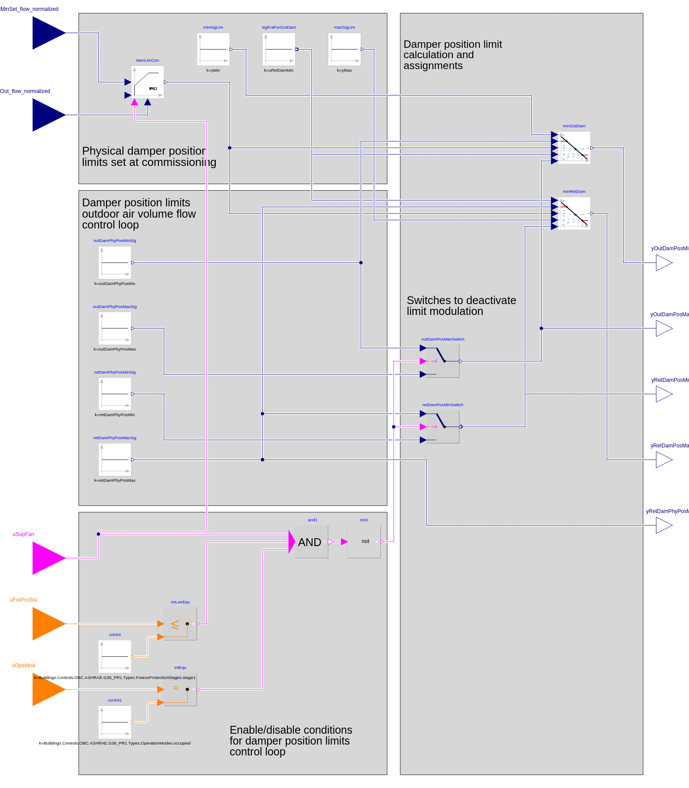

Generated through CDL export of [OpenBuildingControl](http://obc.lbl.gov), [Berkeley Lab](https://www.lbl.gov).