## Buildings.Controls.OBC.ASHRAE.G36_PR1.TerminalUnits.Reheat.DamperValves

Output signals for controlling VAV reheat box damper and valve position

### Info

This sequence sets the damper and valve position for VAV reheat terminal unit. The implementation is according to ASHRAE Guideline 36 (G36), PART5.E.6. The calculation is done following the steps below.

1. When the zone state is cooling (uCoo>0), then the cooling loop output uCoo shall be mapped to the airflow setpoint from the cooling minimum VActCooMin_flow to the cooling maximum VActCooMax_flow airflow setpoints. The hot water valve is closed (yHeaVal=0) unless the discharge air temperature TDis is below the minimum setpoint (10 °C).
2. If supply air temperature TSup from the AHU is greater than room temperature TZon, cooling supply airflow setpoint shall be no higher than the minimum.
3. When the zone state is Deadband (uCoo=0 and uHea=0), then the active airflow setpoint shall be the minimum airflow setpoint VActMin_flow. Hot water valve is closed unless the discharge air temperature is below the minimum setpoint (10 °C).
4. When the zone state is Heating (uHea>0), then the heating loop shall maintain space temperature at the heating setpoint as follows:
   * From 0-50%, the heating loop output uHea shall reset the discharge temperature setpoint from current AHU SAT setpoint TSup to a maximum of dTDisZonSetMax above space temperature setpoint. The airflow setpoint shall be the heating minimum VActHeaMin_flow.
   * From 50-100%, if the discharge air temperature TDis is greater than room temperature plus 2.8 Kelvin, the heating loop output uHea shall reset the airflow setpoint from the heating minimum airflow setpoint VActHeaMin_flow to the heating maximum airflow setpoint VActHeaMax_flow.
5. The hot water valve (or modulating electric heating coil) shall be modulated to maintain the discharge temperature at setpoint.
6. The VAV damper shall be modulated by a control loop to maintain the measured airflow at the active setpoint.

The sequences of controlling damper and valve position for VAV reheat terminal unit are described in the following figure below.

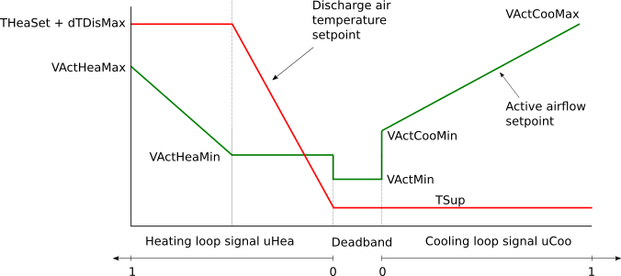

### Parameters

It has the following parameters:

|  |  |  |  |  |  |  |  |  |
| --- | --- | --- | --- | --- | --- | --- | --- | --- |
| **Type** | **Quantity** | **Name** | **Default** | **Unit** | **Display unit** | **min** | **max** | **Description** |
| General | | | | | | | | |
| Parameters | | | | | | | | |
| Real | TemperatureDifference | dTDisZonSetMax | 11 | K | F |  |  | Zone maximum discharge air temperature above heating setpoint |
| Real | Temperature | TDisMin | 283.15 | K | F |  |  | Lowest discharge air temperature |
| Valve | | | | | | | | |
| Buildings.Controls.OBC.CDL.Types.SimpleController |  | controllerTypeVal | Buildings.Controls.OBC.CDL.Types.SimpleController.PI | 1 | 1 |  |  | Type of controller |
| Real |  | kVal | 0.5 | 1 | 1 |  |  | Gain of controller for valve control |
| Real | Time | TiVal | 300 | s | s |  |  | Time constant of integrator block for valve control |
| Real | Time | TdVal | 0.1 | s | s |  |  | Time constant of derivative block for valve control |
| Damper | | | | | | | | |
| Buildings.Controls.OBC.CDL.Types.SimpleController |  | controllerTypeDam | Buildings.Controls.OBC.CDL.Types.SimpleController.PI | 1 | 1 |  |  | Type of controller |
| Real |  | kDam | 0.5 | 1 | 1 |  |  | Gain of controller for damper control |
| Real | Time | TiDam | 300 | s | s |  |  | Time constant of integrator block for damper control |
| Real | Time | TdDam | 0.1 | s | s |  |  | Time constant of derivative block for damper control |
| Real | VolumeFlowRate | V_flow_nominal |  | m3/s | cfm | 1E-10 |  | Nominal volume flow rate, used to normalize control error |

### Inputs

It has the following inputs:

|  |  |  |  |  |  |  |  |
| --- | --- | --- | --- | --- | --- | --- | --- |
| **Type** | **Quantity** | **Name** | **Description** | **min** | **max** | **Unit** | **Display unit** |
| Real |  | uHea | Heating control signal | 0 | 1 | 1 | 1 |
| Real |  | uCoo | Cooling control signal | 0 | 1 | 1 | 1 |
| Real | VolumeFlowRate | VActCooMax_flow | Active cooling maximum airflow rate | 0 |  | m3/s | cfm |
| Real | VolumeFlowRate | VActCooMin_flow | Active cooling minimum airflow rate | 0 |  | m3/s | cfm |
| Real | VolumeFlowRate | VActMin_flow | Active minimum airflow rate | 0 |  | m3/s | cfm |
| Real | VolumeFlowRate | VActHeaMin_flow | Active heating minimum airflow rate | 0 |  | m3/s | cfm |
| Real | VolumeFlowRate | VActHeaMax_flow | Active heating maximum airflow rate | 0 |  | m3/s | cfm |
| Real | VolumeFlowRate | VDis_flow | Measured discharge airflow rate airflow rate | 0 |  | m3/s | cfm |
| Real | ThermodynamicTemperature | TSup | Supply air temperature from central air handler |  |  | K | F |
| Real | ThermodynamicTemperature | THeaSet | Zone heating setpoint temperature |  |  | K | F |
| Real | ThermodynamicTemperature | TZon | Measured zone temperature |  |  | K | F |
| Real | ThermodynamicTemperature | TDis | Measured discharge air temperature |  |  | K | F |
| Integer |  | uOpeMod | Zone operation mode |  |  |  |  |

### Outputs

It has the following outputs:

|  |  |  |  |  |  |  |  |
| --- | --- | --- | --- | --- | --- | --- | --- |
| **Type** | **Quantity** | **Name** | **Description** | **min** | **max** | **Unit** | **Display unit** |
| Real |  | yDam | Damper position | 0 | 1 | 1 | 1 |
| Real |  | yHeaVal | Reheater valve position | 0 | 1 | 1 | 1 |
| Real | VolumeFlowRate | VDisSet_flow | Discharge airflow setpoint | 0 |  | m3/s | cfm |
| Real | ThermodynamicTemperature | TDisHeaSet | Discharge airflow setpoint temperature for heating |  |  | K | F |

### Blocks

It has the following blocks:

|  |  |  |  |
| --- | --- | --- | --- |
| **Type** | **Name** | **Description** | **Parameter Assignments** |
| [Buildings.Controls.OBC.CDL.Logical.Not](http://simulationresearch.lbl.gov/modelica/releases/v5.0.1/help/Buildings_Controls_OBC_CDL_Logical.html#Buildings.Controls.OBC.CDL.Logical.Not) | not1 | Logical not |  |
| [Buildings.Controls.OBC.CDL.Logical.Not](http://simulationresearch.lbl.gov/modelica/releases/v5.0.1/help/Buildings_Controls_OBC_CDL_Logical.html#Buildings.Controls.OBC.CDL.Logical.Not) | not2 | Logical not |  |
| [Buildings.Controls.OBC.CDL.Logical.Not](http://simulationresearch.lbl.gov/modelica/releases/v5.0.1/help/Buildings_Controls_OBC_CDL_Logical.html#Buildings.Controls.OBC.CDL.Logical.Not) | not4 | Logical not |  |
| [Buildings.Controls.OBC.CDL.Logical.And](http://simulationresearch.lbl.gov/modelica/releases/v5.0.1/help/Buildings_Controls_OBC_CDL_Logical.html#Buildings.Controls.OBC.CDL.Logical.And) | and2 | Check if current zone state is deadband |  |
| [Buildings.Controls.OBC.CDL.Logical.And](http://simulationresearch.lbl.gov/modelica/releases/v5.0.1/help/Buildings_Controls_OBC_CDL_Logical.html#Buildings.Controls.OBC.CDL.Logical.And) | and4 | Logical and |  |
| [Buildings.Controls.OBC.CDL.Continuous.Line](http://simulationresearch.lbl.gov/modelica/releases/v5.0.1/help/Buildings_Controls_OBC_CDL_Continuous.html#Buildings.Controls.OBC.CDL.Continuous.Line) | lin | Active airflow setpoint for cooling |  |
| [Buildings.Controls.OBC.CDL.Continuous.Line](http://simulationresearch.lbl.gov/modelica/releases/v5.0.1/help/Buildings_Controls_OBC_CDL_Continuous.html#Buildings.Controls.OBC.CDL.Continuous.Line) | conTDisHeaSet | Discharge air temperature for heating |  |
| [Buildings.Controls.OBC.CDL.Continuous.Line](http://simulationresearch.lbl.gov/modelica/releases/v5.0.1/help/Buildings_Controls_OBC_CDL_Continuous.html#Buildings.Controls.OBC.CDL.Continuous.Line) | lin3 | Active airflow setpoint for heating |  |
| [Buildings.Controls.OBC.CDL.Continuous.LimPID](http://simulationresearch.lbl.gov/modelica/releases/v5.0.1/help/Buildings_Controls_OBC_CDL_Continuous.html#Buildings.Controls.OBC.CDL.Continuous.LimPID) | conVal | Hot water valve controller | * final controllerType = controllerTypeVal * final k = kVal * final Ti = TiVal * final Td = TdVal * final yMax = 1 * final yMin = 0 * u_s = * u_m = * reset = Buildings.Controls.OBC.CDL.Types.Reset.Parameter |
| [Buildings.Controls.OBC.CDL.Continuous.LimPID](http://simulationresearch.lbl.gov/modelica/releases/v5.0.1/help/Buildings_Controls_OBC_CDL_Continuous.html#Buildings.Controls.OBC.CDL.Continuous.LimPID) | conDam | Damper position controller | * final controllerType = controllerTypeDam * final k = kDam * final Ti = TiDam * final Td = TdDam * final yMax = 1 * final yMin = 0 * final reset = Buildings.Controls.OBC.CDL.Types.Reset.Parameter * final y_reset = 0 |
| [Buildings.Controls.OBC.CDL.Logical.Switch](http://simulationresearch.lbl.gov/modelica/releases/v5.0.1/help/Buildings_Controls_OBC_CDL_Logical.html#Buildings.Controls.OBC.CDL.Logical.Switch) | swi | Output active cooling airflow according to cooling control signal |  |
| [Buildings.Controls.OBC.CDL.Logical.Switch](http://simulationresearch.lbl.gov/modelica/releases/v5.0.1/help/Buildings_Controls_OBC_CDL_Logical.html#Buildings.Controls.OBC.CDL.Logical.Switch) | swi1 | Output active airflow when it is in deadband state |  |
| [Buildings.Controls.OBC.CDL.Logical.Switch](http://simulationresearch.lbl.gov/modelica/releases/v5.0.1/help/Buildings_Controls_OBC_CDL_Logical.html#Buildings.Controls.OBC.CDL.Logical.Switch) | swi2 | Acitive heating airflow rate |  |
| [Buildings.Controls.OBC.CDL.Logical.Switch](http://simulationresearch.lbl.gov/modelica/releases/v5.0.1/help/Buildings_Controls_OBC_CDL_Logical.html#Buildings.Controls.OBC.CDL.Logical.Switch) | swi4 | Output active heating airflow according to heating control signal |  |
| [Buildings.Controls.OBC.CDL.Logical.Switch](http://simulationresearch.lbl.gov/modelica/releases/v5.0.1/help/Buildings_Controls_OBC_CDL_Logical.html#Buildings.Controls.OBC.CDL.Logical.Switch) | swi5 | Output active cooling airflow |  |
| [Buildings.Controls.OBC.CDL.Continuous.MultiSum](http://simulationresearch.lbl.gov/modelica/releases/v5.0.1/help/Buildings_Controls_OBC_CDL_Continuous.html#Buildings.Controls.OBC.CDL.Continuous.MultiSum) | mulSum | Active airflow setpoint | * nin = 3 |

### Protected Blocks

It has the following protected blocks:

|  |  |  |  |
| --- | --- | --- | --- |
| **Type** | **Name** | **Description** | **Parameter Assignments** |
| [Buildings.Controls.OBC.CDL.Continuous.Sources.Constant](http://simulationresearch.lbl.gov/modelica/releases/v5.0.1/help/Buildings_Controls_OBC_CDL_Continuous_Sources.html#Buildings.Controls.OBC.CDL.Continuous.Sources.Constant) | conZer | Constant zero | * final k = 0 |
| [Buildings.Controls.OBC.CDL.Continuous.Sources.Constant](http://simulationresearch.lbl.gov/modelica/releases/v5.0.1/help/Buildings_Controls_OBC_CDL_Continuous_Sources.html#Buildings.Controls.OBC.CDL.Continuous.Sources.Constant) | conZer1 | Constant zero | * final k = 0 |
| [Buildings.Controls.OBC.CDL.Continuous.Sources.Constant](http://simulationresearch.lbl.gov/modelica/releases/v5.0.1/help/Buildings_Controls_OBC_CDL_Continuous_Sources.html#Buildings.Controls.OBC.CDL.Continuous.Sources.Constant) | conZer2 | Constant zero | * final k = 0 |
| [Buildings.Controls.OBC.CDL.Continuous.Sources.Constant](http://simulationresearch.lbl.gov/modelica/releases/v5.0.1/help/Buildings_Controls_OBC_CDL_Continuous_Sources.html#Buildings.Controls.OBC.CDL.Continuous.Sources.Constant) | conZer3 | Constant zero | * final k = 0 |
| [Buildings.Controls.OBC.CDL.Continuous.Sources.Constant](http://simulationresearch.lbl.gov/modelica/releases/v5.0.1/help/Buildings_Controls_OBC_CDL_Continuous_Sources.html#Buildings.Controls.OBC.CDL.Continuous.Sources.Constant) | conZer6 | Constant zero | * final k = 0 |
| [Buildings.Controls.OBC.CDL.Continuous.Sources.Constant](http://simulationresearch.lbl.gov/modelica/releases/v5.0.1/help/Buildings_Controls_OBC_CDL_Continuous_Sources.html#Buildings.Controls.OBC.CDL.Continuous.Sources.Constant) | conOne | Constant one | * final k = 1 |
| [Buildings.Controls.OBC.CDL.Continuous.Sources.Constant](http://simulationresearch.lbl.gov/modelica/releases/v5.0.1/help/Buildings_Controls_OBC_CDL_Continuous_Sources.html#Buildings.Controls.OBC.CDL.Continuous.Sources.Constant) | conOne2 | Constant real value | * final k = 1 |
| [Buildings.Controls.OBC.CDL.Continuous.Sources.Constant](http://simulationresearch.lbl.gov/modelica/releases/v5.0.1/help/Buildings_Controls_OBC_CDL_Continuous_Sources.html#Buildings.Controls.OBC.CDL.Continuous.Sources.Constant) | conHal | Constant real value | * final k = 0.5 |
| [Buildings.Controls.OBC.CDL.Continuous.Sources.Constant](http://simulationresearch.lbl.gov/modelica/releases/v5.0.1/help/Buildings_Controls_OBC_CDL_Continuous_Sources.html#Buildings.Controls.OBC.CDL.Continuous.Sources.Constant) | conHal1 | Constant real value | * final k = 0.5 |
| [Buildings.Controls.OBC.CDL.Continuous.AddParameter](http://simulationresearch.lbl.gov/modelica/releases/v5.0.1/help/Buildings_Controls_OBC_CDL_Continuous.html#Buildings.Controls.OBC.CDL.Continuous.AddParameter) | addPar | Maximum heating discharge temperature | * final p = dTDisZonSetMax * final k = 1 |
| [Buildings.Controls.OBC.CDL.Continuous.AddParameter](http://simulationresearch.lbl.gov/modelica/releases/v5.0.1/help/Buildings_Controls_OBC_CDL_Continuous.html#Buildings.Controls.OBC.CDL.Continuous.AddParameter) | addPar1 | Zone temperature pluTZonSets 2.8 degC | * final k = 1 * final p = 2.8 |
| [Buildings.Controls.OBC.CDL.Continuous.Hysteresis](http://simulationresearch.lbl.gov/modelica/releases/v5.0.1/help/Buildings_Controls_OBC_CDL_Continuous.html#Buildings.Controls.OBC.CDL.Continuous.Hysteresis) | hys2 | Check if cooling control signal is greater than zero | * final uHigh = 0.05 * final uLow = 0.01 |
| [Buildings.Controls.OBC.CDL.Continuous.Hysteresis](http://simulationresearch.lbl.gov/modelica/releases/v5.0.1/help/Buildings_Controls_OBC_CDL_Continuous.html#Buildings.Controls.OBC.CDL.Continuous.Hysteresis) | hys3 | Check if heating control signal is greater than 0 | * final uHigh = 0.05 * final uLow = 0.01 |
| [Buildings.Controls.OBC.CDL.Continuous.Hysteresis](http://simulationresearch.lbl.gov/modelica/releases/v5.0.1/help/Buildings_Controls_OBC_CDL_Continuous.html#Buildings.Controls.OBC.CDL.Continuous.Hysteresis) | hys4 | Check if discharge air temperature is greater than lowest discharge air temperature | * final uLow = TDisMin - 0.1 * final uHigh = TDisMin + 0.1 |
| [Buildings.Controls.OBC.CDL.Continuous.Hysteresis](http://simulationresearch.lbl.gov/modelica/releases/v5.0.1/help/Buildings_Controls_OBC_CDL_Continuous.html#Buildings.Controls.OBC.CDL.Continuous.Hysteresis) | hys6 | Check if supply air temperature is greater than room temperature | * final uLow = -0.1 * final uHigh = 0.1 |
| [Buildings.Controls.OBC.CDL.Continuous.Hysteresis](http://simulationresearch.lbl.gov/modelica/releases/v5.0.1/help/Buildings_Controls_OBC_CDL_Continuous.html#Buildings.Controls.OBC.CDL.Continuous.Hysteresis) | hys7 | Check if discharge air temperature is greater than room temperature plus 2.8 degC | * final uLow = -0.1 * final uHigh = 0.1 |
| [Buildings.Controls.OBC.CDL.Continuous.Add](http://simulationresearch.lbl.gov/modelica/releases/v5.0.1/help/Buildings_Controls_OBC_CDL_Continuous.html#Buildings.Controls.OBC.CDL.Continuous.Add) | add1 | Calculate temperature difference between discharge air and room plus 2.8 degC | * final k2 = -1 |
| [Buildings.Controls.OBC.CDL.Continuous.Add](http://simulationresearch.lbl.gov/modelica/releases/v5.0.1/help/Buildings_Controls_OBC_CDL_Continuous.html#Buildings.Controls.OBC.CDL.Continuous.Add) | add2 | Calculate temperature difference between AHU supply air and room | * final k2 = -1 |
| [Buildings.Controls.OBC.CDL.Logical.TrueHoldWithReset](http://simulationresearch.lbl.gov/modelica/releases/v5.0.1/help/Buildings_Controls_OBC_CDL_Logical.html#Buildings.Controls.OBC.CDL.Logical.TrueHoldWithReset) | truHol2 | Check if the true input holds for certain time | * duration = 600 |
| [Buildings.Controls.OBC.CDL.Logical.TrueDelay](http://simulationresearch.lbl.gov/modelica/releases/v5.0.1/help/Buildings_Controls_OBC_CDL_Logical.html#Buildings.Controls.OBC.CDL.Logical.TrueDelay) | truDel3 | Check if the true input holds for certain time | * delayTime = 600 |
| [Buildings.Controls.OBC.CDL.Logical.TrueDelay](http://simulationresearch.lbl.gov/modelica/releases/v5.0.1/help/Buildings_Controls_OBC_CDL_Logical.html#Buildings.Controls.OBC.CDL.Logical.TrueDelay) | truDel4 | Check if the true input holds for certain time | * delayTime = 600 |
| [Buildings.Controls.OBC.CDL.Integers.Equal](http://simulationresearch.lbl.gov/modelica/releases/v5.0.1/help/Buildings_Controls_OBC_CDL_Integers.html#Buildings.Controls.OBC.CDL.Integers.Equal) | isUno | Output true if the operation mode is unoccupied |  |
| [Buildings.Controls.OBC.CDL.Integers.Sources.Constant](http://simulationresearch.lbl.gov/modelica/releases/v5.0.1/help/Buildings_Controls_OBC_CDL_Integers_Sources.html#Buildings.Controls.OBC.CDL.Integers.Sources.Constant) | unOcc | Constant signal for unoccupied mode | * final k = Buildings.Controls.OBC.ASHRAE.G36_PR1.Types.OperationModes.unoccupied |
| [Buildings.Controls.OBC.CDL.Logical.Switch](http://simulationresearch.lbl.gov/modelica/releases/v5.0.1/help/Buildings_Controls_OBC_CDL_Logical.html#Buildings.Controls.OBC.CDL.Logical.Switch) | watValPosUno | Output hot water valve position |  |
| [Buildings.Controls.OBC.CDL.Logical.Switch](http://simulationresearch.lbl.gov/modelica/releases/v5.0.1/help/Buildings_Controls_OBC_CDL_Logical.html#Buildings.Controls.OBC.CDL.Logical.Switch) | damPosUno | Output damper position |  |
| [Buildings.Controls.OBC.CDL.Logical.Not](http://simulationresearch.lbl.gov/modelica/releases/v5.0.1/help/Buildings_Controls_OBC_CDL_Logical.html#Buildings.Controls.OBC.CDL.Logical.Not) | not5 | Negation of input signal |  |
| [Buildings.Controls.OBC.CDL.Continuous.Gain](http://simulationresearch.lbl.gov/modelica/releases/v5.0.1/help/Buildings_Controls_OBC_CDL_Continuous.html#Buildings.Controls.OBC.CDL.Continuous.Gain) | VDisSet_flowNor | Normalized setpoint for discharge volume flow rate | * final k = 1/V_flow_nominal |
| [Buildings.Controls.OBC.CDL.Continuous.Gain](http://simulationresearch.lbl.gov/modelica/releases/v5.0.1/help/Buildings_Controls_OBC_CDL_Continuous.html#Buildings.Controls.OBC.CDL.Continuous.Gain) | VDis_flowNor | Normalized discharge volume flow rate | * final k = 1/V_flow_nominal |
| [Buildings.Controls.OBC.CDL.Continuous.Sources.Constant](http://simulationresearch.lbl.gov/modelica/releases/v5.0.1/help/Buildings_Controls_OBC_CDL_Continuous_Sources.html#Buildings.Controls.OBC.CDL.Continuous.Sources.Constant) | lowDisAirTem | Lowest allowed discharge air temperature | * final k = TDisMin |
| [Buildings.Controls.OBC.CDL.Logical.Switch](http://simulationresearch.lbl.gov/modelica/releases/v5.0.1/help/Buildings_Controls_OBC_CDL_Logical.html#Buildings.Controls.OBC.CDL.Logical.Switch) | swi6 | Output hot water valve position in case of low discharge air temperature |  |
| [Buildings.Controls.OBC.CDL.Logical.Or](http://simulationresearch.lbl.gov/modelica/releases/v5.0.1/help/Buildings_Controls_OBC_CDL_Logical.html#Buildings.Controls.OBC.CDL.Logical.Or) | or2 | Output signals for controlling VAV reheat box damper and valve position |  |
| [Buildings.Controls.OBC.CDL.Logical.Not](http://simulationresearch.lbl.gov/modelica/releases/v5.0.1/help/Buildings_Controls_OBC_CDL_Logical.html#Buildings.Controls.OBC.CDL.Logical.Not) | not3 | Logical not |  |
| [Buildings.Controls.OBC.CDL.Logical.Switch](http://simulationresearch.lbl.gov/modelica/releases/v5.0.1/help/Buildings_Controls_OBC_CDL_Logical.html#Buildings.Controls.OBC.CDL.Logical.Switch) | swi3 | Output hot water valve position in case of low discharge air temperature |  |
| [Buildings.Controls.OBC.CDL.Logical.Not](http://simulationresearch.lbl.gov/modelica/releases/v5.0.1/help/Buildings_Controls_OBC_CDL_Logical.html#Buildings.Controls.OBC.CDL.Logical.Not) | not6 | Negation of input signal |  |
| [Buildings.Controls.OBC.CDL.Logical.And](http://simulationresearch.lbl.gov/modelica/releases/v5.0.1/help/Buildings_Controls_OBC_CDL_Logical.html#Buildings.Controls.OBC.CDL.Logical.And) | and1 | Output signals for controlling VAV reheat box damper and valve position |  |

### Connections

The inputs of the internal blocks are connected to the following outputs:

1. uCoo → lin.u
2. conZer.y → lin.x1
3. VActCooMin_flow → lin.f1
4. conOne.y → lin.x2
5. VActCooMax_flow → lin.f2
6. uCoo → hys2.u
7. conZer1.y → swi.u3
8. VActMin_flow → swi1.u1
9. and2.y → swi1.u2
10. conZer2.y → swi1.u3
11. uHea → hys3.u
12. conZer3.y → conTDisHeaSet.x1
13. TSup → conTDisHeaSet.f1
14. uHea → conTDisHeaSet.u
15. conHal.y → conTDisHeaSet.x2
16. addPar.y → conTDisHeaSet.f2
17. THeaSet → addPar.u
18. uHea → lin3.u
19. conHal1.y → lin3.x1
20. conOne2.y → lin3.x2
21. VActHeaMax_flow → lin3.f2
22. VActHeaMin_flow → lin3.f1
23. TZon → addPar1.u
24. lin3.y → swi2.u1
25. VActHeaMin_flow → swi2.u3
26. TDis → hys4.u
27. swi2.y → swi4.u1
28. conZer6.y → swi4.u3
29. swi.y → mulSum.u[1]
30. swi1.y → mulSum.u[2]
31. swi4.y → mulSum.u[3]
32. VActMin_flow → swi5.u1
33. and4.y → swi5.u2
34. lin.y → swi5.u3
35. swi5.y → swi.u1
36. hys4.y → not4.u
37. TSup → add2.u1
38. TZon → add2.u2
39. add2.y → hys6.u
40. hys6.y → and4.u2
41. conTDisHeaSet.y → add1.u1
42. addPar1.y → add1.u2
43. add1.y → hys7.u
44. mulSum.y → VDisSet_flow
45. conTDisHeaSet.y → TDisHeaSet
46. hys3.y → truHol2.u
47. truHol2.y → swi4.u2
48. hys2.y → truDel4.u
49. truDel4.y → and4.u1
50. truDel4.y → swi.u2
51. truHol2.y → not2.u
52. truDel4.y → not1.u
53. not1.y → and2.u1
54. not2.y → and2.u2
55. conVal.u_m → TDis
56. hys7.y → swi2.u2
57. unOcc.y → isUno.u1
58. isUno.u2 → uOpeMod
59. isUno.y → watValPosUno.u2
60. conZer2.y → watValPosUno.u1
61. watValPosUno.y → yHeaVal
62. conZer2.y → damPosUno.u1
63. conDam.y → damPosUno.u3
64. damPosUno.y → yDam
65. isUno.y → damPosUno.u2
66. isUno.y → not5.u
67. not5.y → conDam.trigger
68. mulSum.y → VDisSet_flowNor.u
69. VDisSet_flowNor.y → conDam.u_s
70. VDis_flow → VDis_flowNor.u
71. VDis_flowNor.y → conDam.u_m
72. truHol2.y → or2.u2
73. truDel3.y → not3.u
74. not3.y → or2.u1
75. or2.y → swi6.u2
76. conTDisHeaSet.y → swi6.u1
77. swi6.u3 → lowDisAirTem.y
78. swi3.y → watValPosUno.u3
79. truHol2.y → not6.u
80. not6.y → and1.u2
81. and1.y → swi3.u2
82. conVal.y → swi3.u3
83. swi3.u1 → conZer2.y
84. not3.y → and1.u1
85. not4.y → truDel3.u
86. not5.y → conVal.trigger
87. swi6.y → conVal.u_s

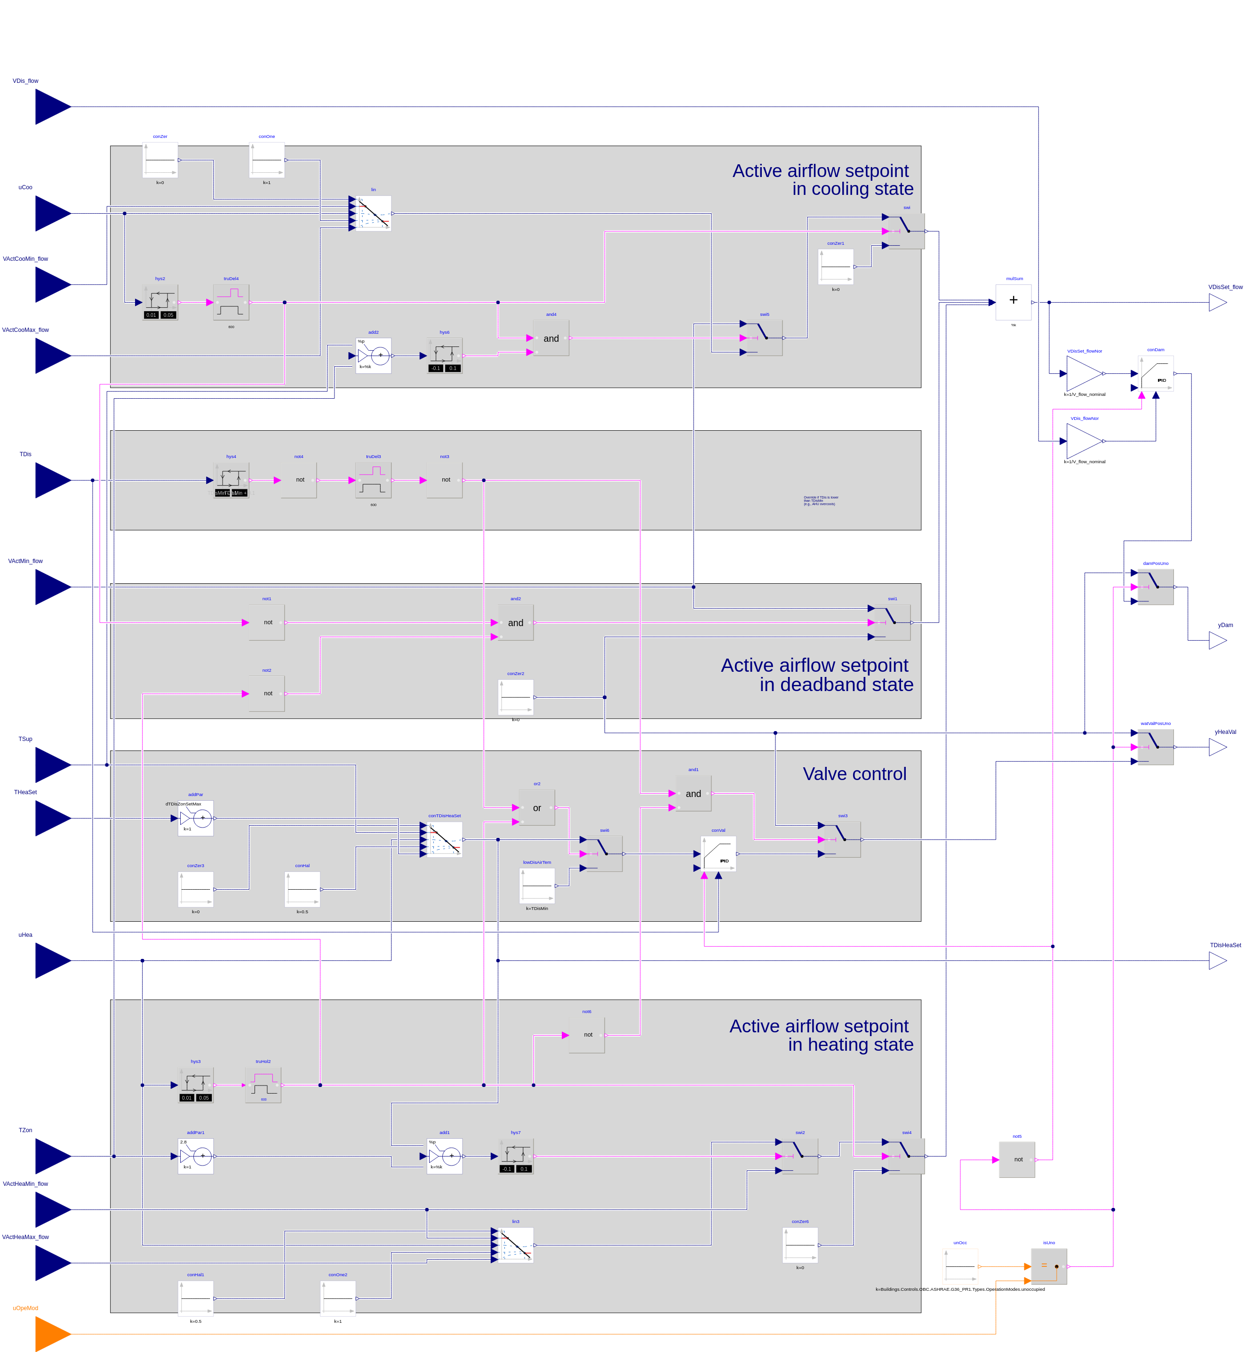

Generated through CDL export of [OpenBuildingControl](http://obc.lbl.gov), [Berkeley Lab](https://www.lbl.gov).