**Part 3**

***What is GitHub? When was it created? Why? By who? What similar platforms exist? Why would you use such a platform?***

GitHub is a hosting service for codes which let you collaborate easily with others. It was started back in October 2007 and launched in April 2008 by Tom Preston-Werner, PJ Hyett and Chris Wanstrath. Similarly to GitHub they have different product with offers approximately the same service. For instance, there is *BitBucket* which I used for my project. There is also *GitLab*, *SourceForge* whom offer a similar platform. I personally use such service because it makes it easier to manage, collaborate and track changes in your code. Furthermore, I can easily update the linked files on my sever without having to go through every single one via FileZilla.

**Part 4**

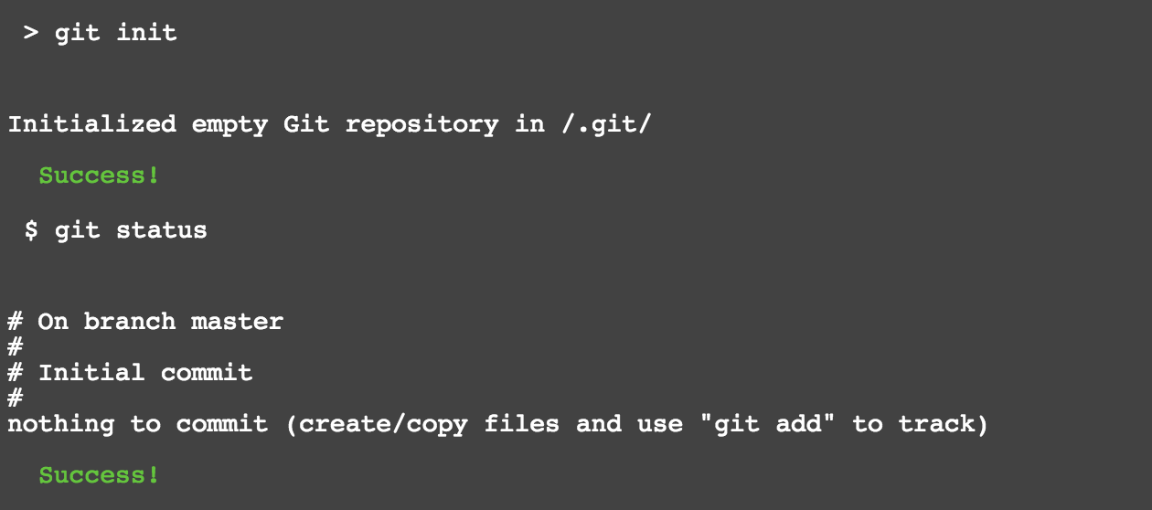

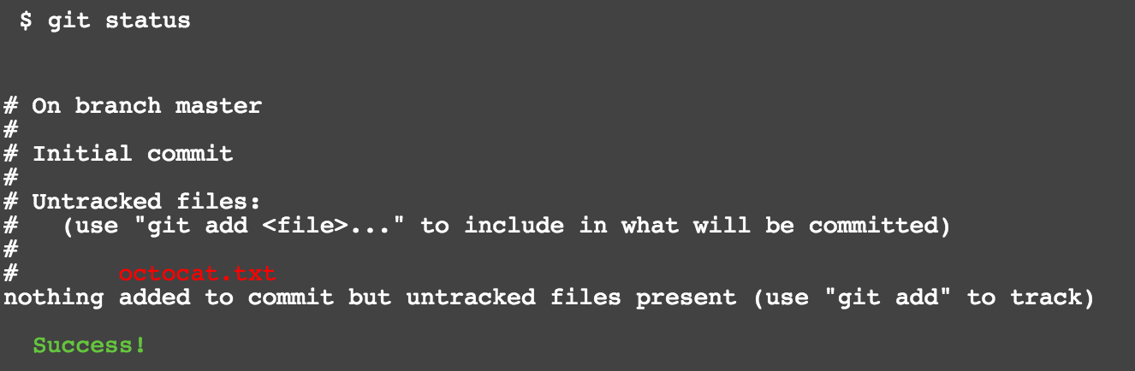

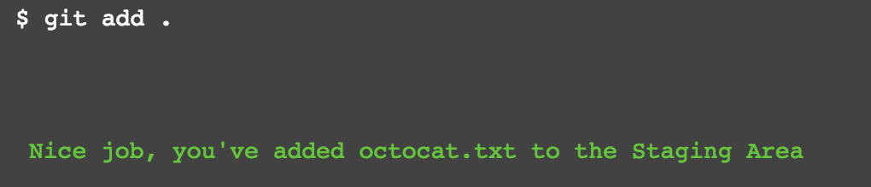

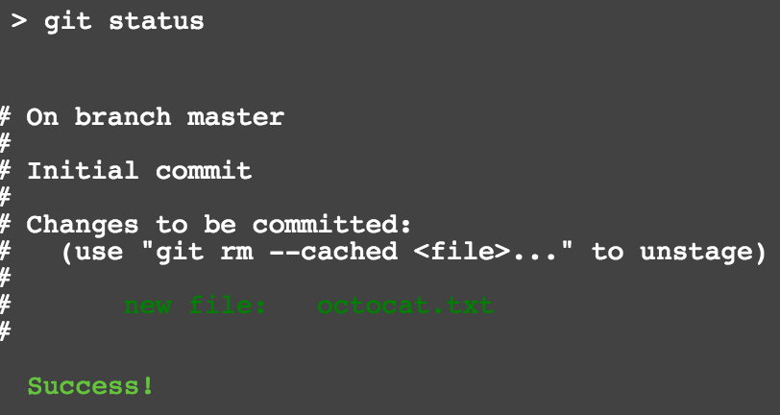

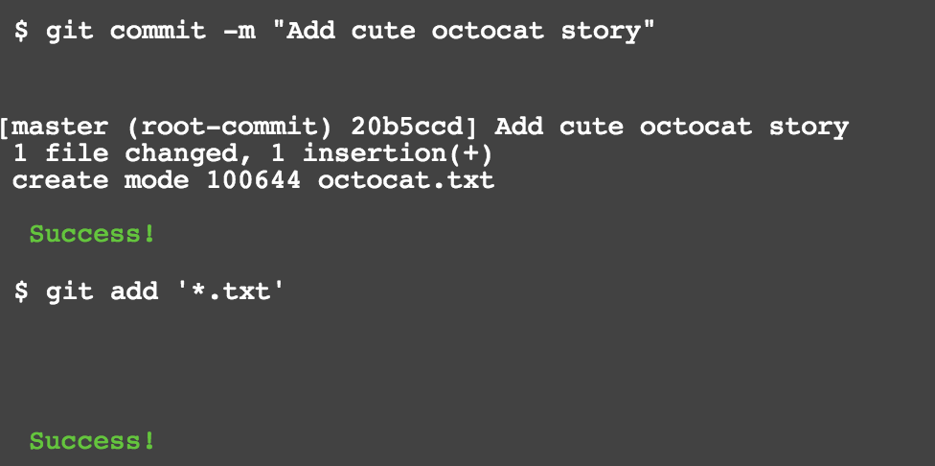

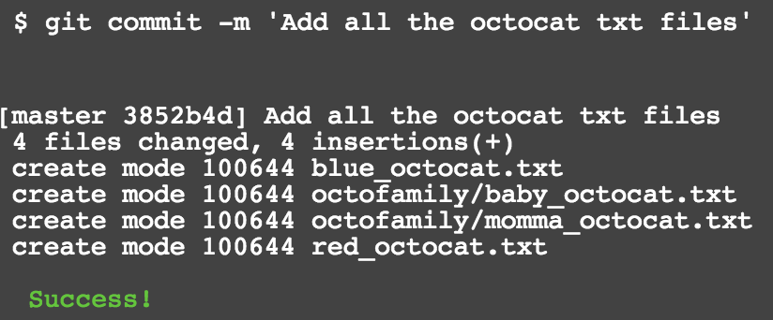

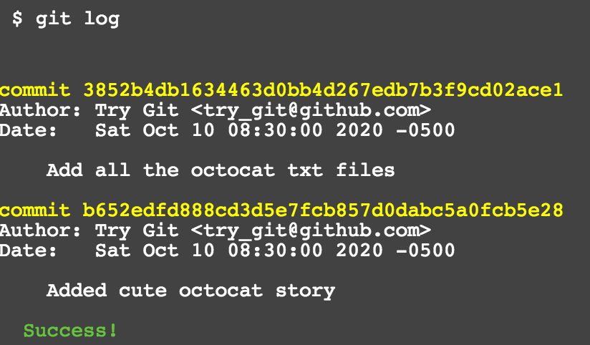

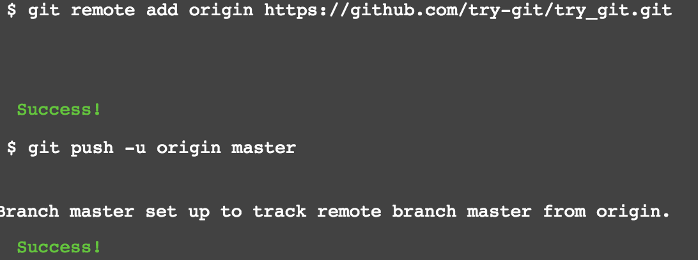

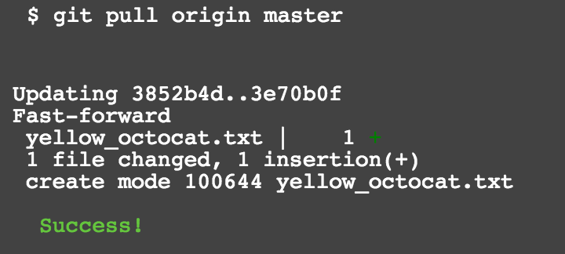

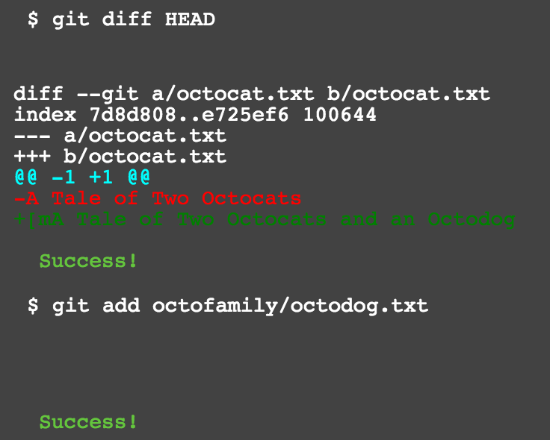



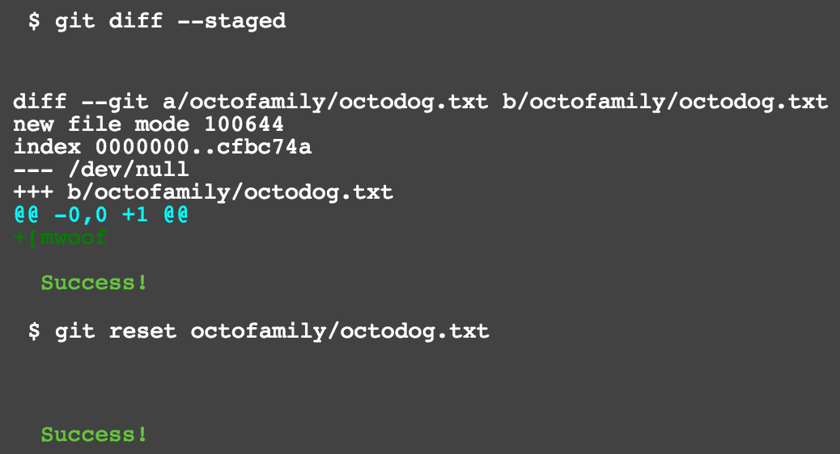

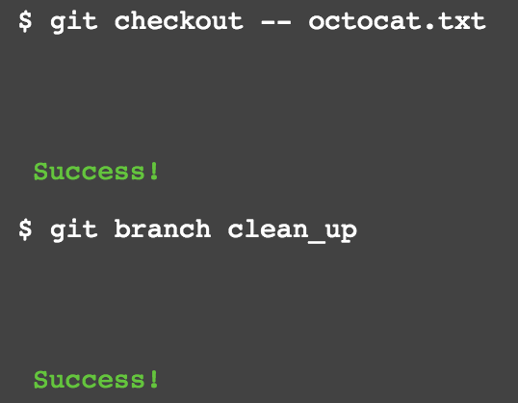

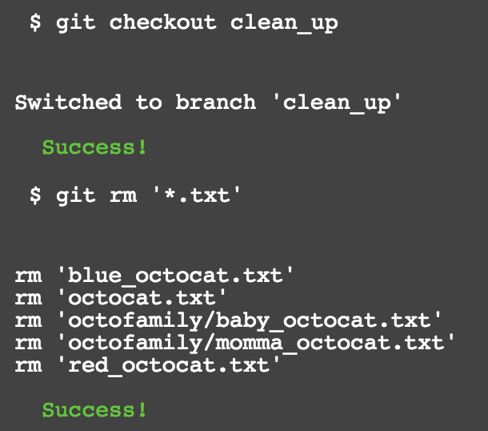

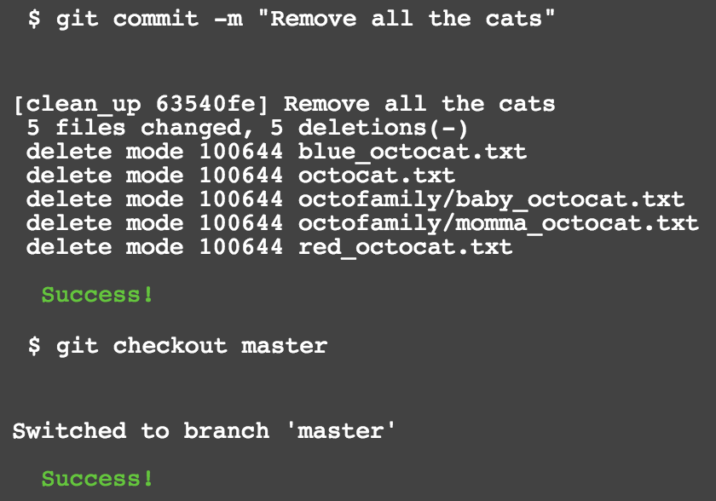

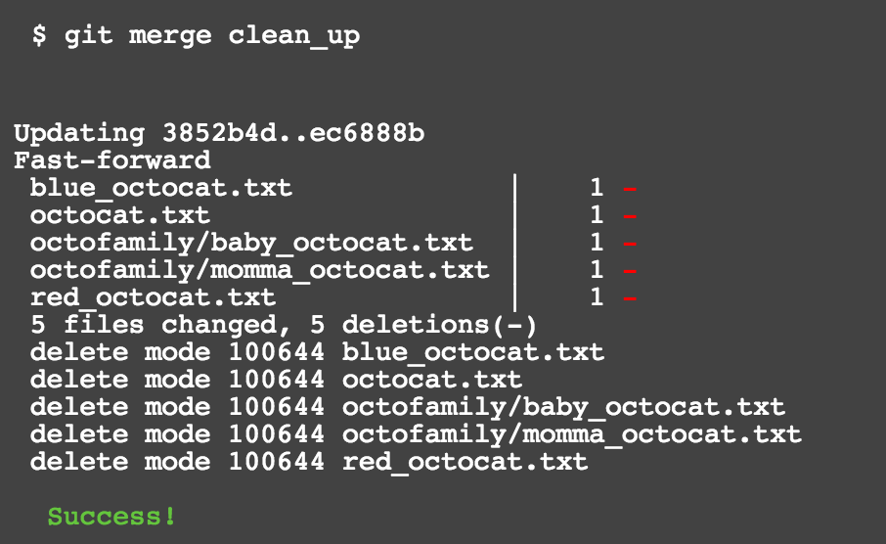

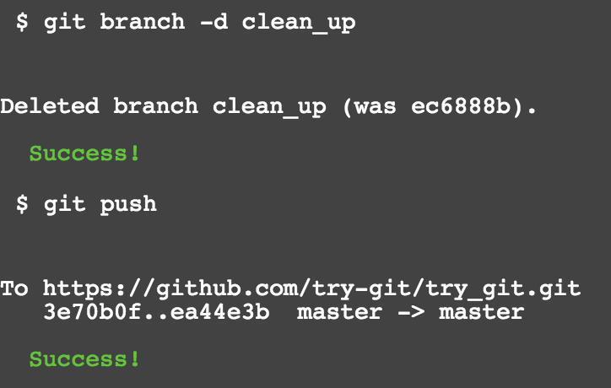

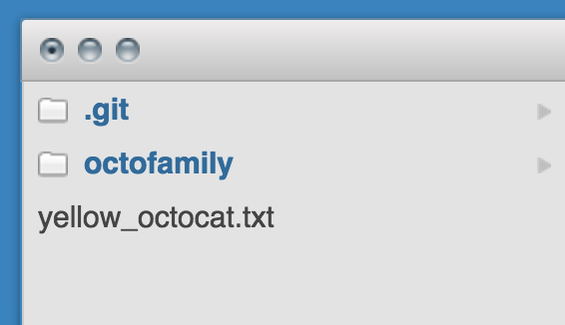



**Part 5**

* **Repository:** It is a directory which is often used as the root for a project. It can contain other folders and files.
* **Commit:** A commit is a saved change. It is usually associated with a message to describe the reason behind the change.
* **Push:** It sends your committed changes to a remote repository.
* **Branch:** It is a parallel version of your repository which can be modified without affecting the master branch.
* **Fork:** It a copy of a user’s repository residing on your account.
* **Merge:** It take the changes from a branch and apply them to another in the same directory.
* **Clone:** It is a copy of a repository on your PC
* **Pull:** It is the process of updating your copy with the latest changes.
* **Pull request:** It is a proposed change that an admin will have to review before adding it to the main branch

**Part 7**

I had to first create a fork on the project before I don’t have write access to it. Once I committed my changes, I had to send a pull request for it to be added to master branch.