实验报告
2018 年 5 月 12 日 成绩：
姓名 | hjs | 学号 | 16041321 | 班级 | 16052317
专业 | 计算机科学与技术 |  | 课程名称 | 《计算机组成原理与系统结构试验》
任课老师 | 张翔老师 | 指导老师 | 张翔老师 | 机位号 | 默认
实验序号 | 4 | 实验名称 | 《实验四 寄存器堆设计》
实验时间 | 2018/5/12 | 实验地点 | 1教211 | 实验设备号 | 个人电脑、Nexys3开发板
一、实验程序源代码
1.寄存器堆模块代码：
module Register_file(R_Addr_A,R_Addr_B,W_Addr,Write_Reg,W_Data,Clk,Reset,R_Data_A,R_Data_B);
input [4:0]R_Addr_A;
input [4:0]R_Addr_B;
input [4:0]W_Addr;
input Write_Reg;
input [31:0]W_Data;
input Clk;
input Reset;
output [31:0]R_Data_A;
output [31:0]R_Data_B;
reg [31:0]REG_Files[0:31];
reg [5:0]i;
initial//仿真过程中的初始化
begin
for(i=0;i<=31;i=i+1)
REG_Files[i]=0;
end
assign R_Data_A=REG_Files[R_Addr_A];
assign R_Data_B=REG_Files[R_Addr_B];
always@(posedge Clk or posedge Reset)
begin
if(Reset)
for(i=0;i<=31;i=i+1)
REG_Files[i]=0;
else
if(Write_Reg&&W_Addr!=0)
REG_Files[W_Addr]=W_Data;
end
endmodule

2.顶层电路模块代码：
module Top_Register_file(Addr,Write_Reg,C1,C2,Clk,Reset,LED);
input [4:0]Addr;
input [1:0]C1;//C1选择32位数据输出哪八位字节
input Write_Reg,C2,Clk,Reset;//C2选择读A/B端口的数据
output reg [7:0]LED;
wire [31:0]R_Data_A,R_Data_B;
reg [31:0]W_Data;
reg[4:0] A,B;
Register_file reg1(A,B,Addr,Write_Reg,W_Data,Clk,Reset,R_Data_A,R_Data_B);
always@(Addr or Write_Reg or C1 or C2 or R_Data_A or R_Data_B)
begin
A=0;
B=0;
LED=0;
W_Data=0;
if(!Write_Reg)//读操作Write_Reg=0
begin
if(!C2)
begin
A=Addr;
case(C1)
2'b00:LED=R_Data_A[7:0];
2'b01:LED=R_Data_A[15:8];
2'b10:LED=R_Data_A[23:16];
2'b11:LED=R_Data_A[31:24];
endcase
end
else
begin
B=Addr;
case(C1)
2'b00:LED=R_Data_B[7:0];
2'b01:LED=R_Data_B[15:8];
2'b10:LED=R_Data_B[23:16];
2'b11:LED=R_Data_B[31:24];
endcase
end
end
else//写操作
begin
case(C1)
2'b00:W_Data=32'h0000_0003;
2'b01:W_Data=32'h0000_0607;
2'b10:W_Data=32'hFFFF_FFFF;
2'b11:W_Data=32'h1111_1234;
endcase
end
end
endmodule

3.测试代码
module test;

// Inputs
reg [4:0] R_Addr_A;
reg [4:0] R_Addr_B;
reg [4:0] W_Addr;
reg Write_Reg;
reg [31:0] W_Data;
reg Clk;
reg Reset;

// Outputs
wire [31:0] R_Data_A;
wire [31:0] R_Data_B;

// Instantiate the Unit Under Test (UUT)
Register_file uut (
.R_Addr_A(R_Addr_A),
.R_Addr_B(R_Addr_B),
.W_Addr(W_Addr),
.Write_Reg(Write_Reg),
.W_Data(W_Data),
.Clk(Clk),
.Reset(Reset),
.R_Data_A(R_Data_A),
.R_Data_B(R_Data_B)
);

initial begin
// Initialize Inputs
R_Addr_A = 0;
R_Addr_B = 0;
W_Addr = 0;
Write_Reg = 0;
W_Data = 0;
Clk = 0;
Reset = 0;

// Wait 100 ns for global reset to finish
#100;
// Add stimulus here
#100;
R_Addr_A = 0;
R_Addr_B = 0;
W_Addr = 5'b00001;
Write_Reg = 1;
W_Data = 32'h1111_1111;
Clk = 1;
Reset = 0;

#100;
R_Addr_A = 0;
R_Addr_B = 0;
W_Addr = 5'b00001;
Write_Reg = 1;
W_Data = 32'h1111_1111;
Clk = 0;
Reset = 0;

#100;
R_Addr_A = 0;
R_Addr_B = 0;
W_Addr = 5'b00010;
Write_Reg = 1;
W_Data = 32'h2222_2222;
Clk = 1;
Reset = 0;

#100;
R_Addr_A = 5'b00001;
R_Addr_B = 5'b00010;
W_Addr = 0;
Write_Reg = 0;
W_Data = 0;
Clk = 0;
Reset = 0;

#100;
R_Addr_A = 5'b00001;
R_Addr_B = 5'b00010;
W_Addr = 0;
Write_Reg = 0;
W_Data = 0;
Clk = 0;
Reset = 1;

end

endmodule
二、仿真波形
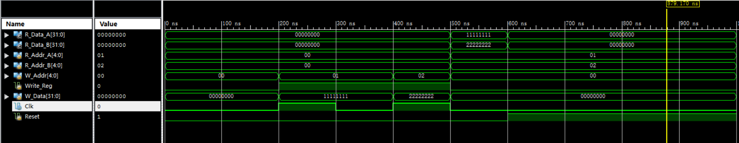
三、电路图
顶层电路模块

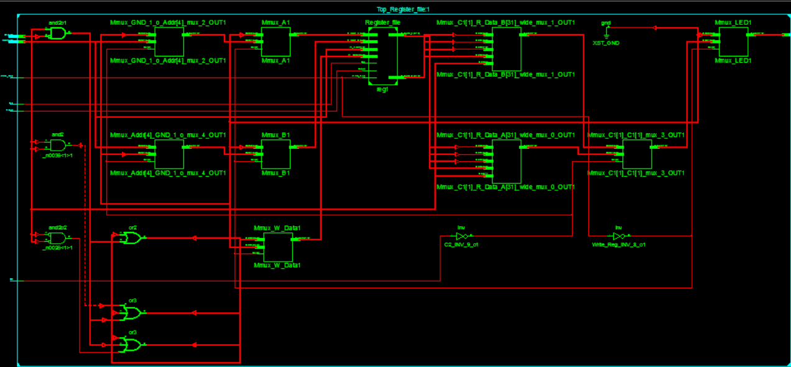
顶层电路内部结构：
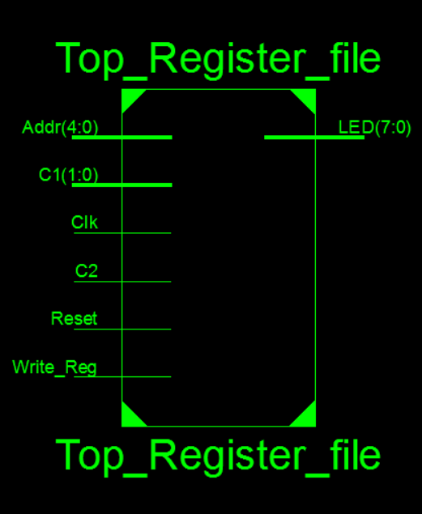

四、引脚配置（约束文件）
NET "Clk" LOC = C9;
NET "Reset" LOC = D9;
NET "Write_Reg" LOC = T5;
NET "C2" LOC = C4;

# PlanAhead Generated physical constraints

NET "LED[7]" LOC = T11;
NET "LED[6]" LOC = R11;
NET "LED[4]" LOC = M11;
NET "LED[3]" LOC = V15;
NET "LED[1]" LOC = V16;
NET "LED[0]" LOC = U16;
NET "LED[2]" LOC = U15;
NET "LED[5]" LOC = N11;
NET "Addr[0]" LOC = T10;
NET "Addr[2]" LOC = V9;
NET "Addr[3]" LOC = M8;
NET "Addr[4]" LOC = N8;
NET "C1[0]" LOC = U8;
NET "C1[1]" LOC = V8;
NET "Addr[1]" LOC = T9;

五、思考与探索
(1)实验四实验结果记录表
寄存器地址 写入数据 读出数据
$1 32'h0000_0003 32'h0000_0003
$2 32'h0000_0607 32'h0000_0607
$3 32'hFFFF_FFFF 32'hFFFF_FFFF
$4 32'h1111_1234 32'h1111_1234
$5 32'h0000_0003 32'h0000_0003
$6 32'h0000_0607 32'h0000_0607
$7 32'hFFFF_FFFF 32'hFFFF_FFFF
$8 32'h1111_1234 32'h1111_1234

