实验报告
2018 年 5 月 5 日 成绩：
姓名 | hjs | 学号 | 16041321 | 班级 | 16052317
专业 | 计算机科学与技术 |  | 课程名称 | 《计算机组成原理与系统结构试验》
任课老师 | 张翔老师 | 指导老师 | 张翔老师 | 机位号 | 默认
实验序号 | 7 | 实验名称 | 《实验七 取指令与指令译码实验》
实验时间 | 2018/5/30 | 实验地点 | 1教211 | 实验设备号 | 个人电脑+Nexy3开发板
一、实验程序源代码
顶层电路：
module top(input clk,input rst,input [1:0]C,output reg[7:0]LED);
wire [31:0]Inst_code;
pc pc_test(clk,rst,Inst_code);
always@(*)
begin
case(C)
2'b00:LED=Inst_code[7:0];
2'b01:LED=Inst_code[15:8];
2'b10:LED=Inst_code[23:16];
2'b11:LED=Inst_code[31:24];
endcase
end
endmodule

PC取指令电路
module pc(input clk,input rst,output wire[31:0]Inst_code);
reg [31:0]PC;
wire[31:0]PC_new;
initial
PC=32'h00000000;
Inst_ROM Inst_ROM1 (
.clka(clk),
.addra(PC[7:2]),
.douta(Inst_code)
);
assign PC_new=PC+4;
always@(posedge rst or negedge clk)
begin
if(rst)
PC=32'h00000000;
else
PC={24'h000000,PC_new[7:0]};
end
endmodule

测试代码：
module test;

// Inputs
reg clk;
reg rst;

// Outputs
wire [31:0] Inst_code;

// Instantiate the Unit Under Test (UUT)
pc uut (
.clk(clk),
.rst(rst),
.Inst_code(Inst_code)
);

initial begin
// Initialize Inputs
clk = 0;
rst = 0;

// Wait 100 ns for global reset to finish
#100;
clk = 1;
rst = 0;

#100;
clk = 0;
rst = 0;

#100;
clk = 1;
rst = 0;

#100;
clk = 0;
rst = 0;

#100;
clk = 1;
rst = 0;

#100;
clk = 0;
rst = 0;

#100;
clk = 1;
rst = 0;

#100;
clk = 0;
rst = 0;

// Add stimulus here

end

endmodule
二、仿真波形
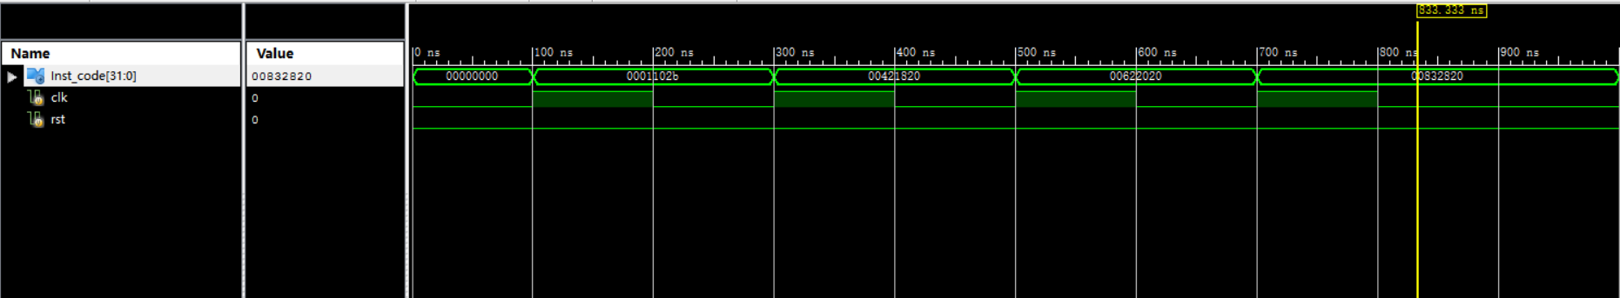
三、电路图
顶层电路模块

顶层电路内部结构：

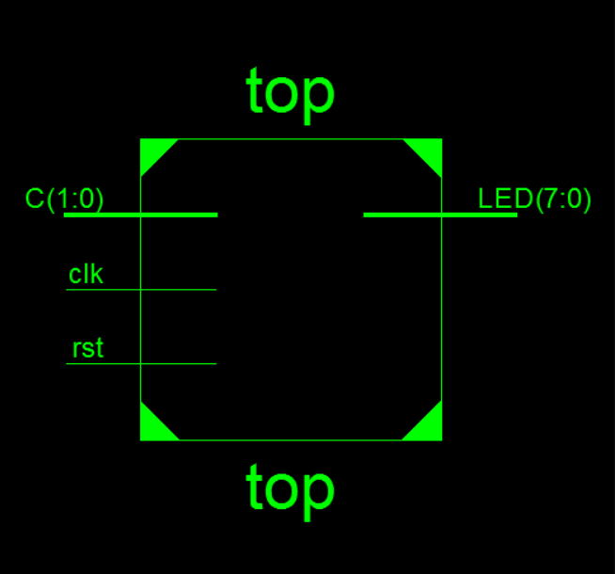
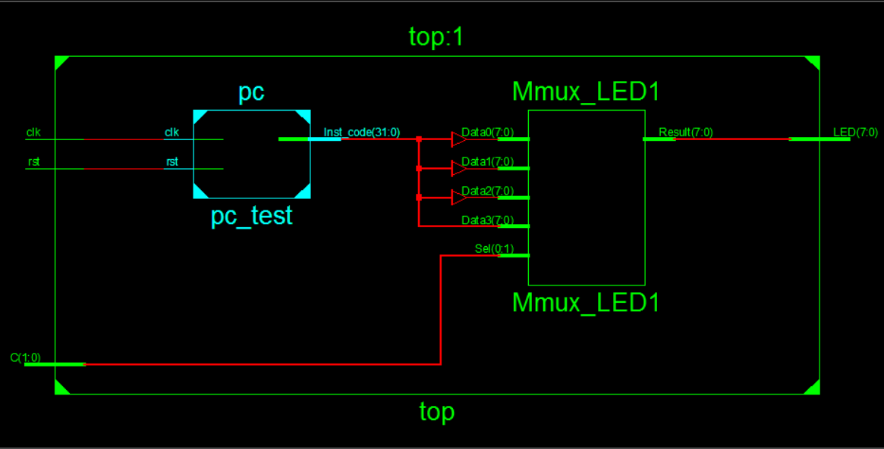

四、引脚配置（约束文件）
NET "LED[7]" LOC = T11;
NET "LED[6]" LOC = R11;
NET "LED[5]" LOC = N11;
NET "LED[4]" LOC = M11;
NET "LED[3]" LOC = V15;
NET "LED[2]" LOC = U15;
NET "LED[1]" LOC = V16;
NET "LED[0]" LOC = U16;
NET "C[1]" LOC = T9;
NET "C[0]" LOC = T10;
NET "clk" LOC = D9;
NET "rst" LOC = C9;
五、思考与探索
R0 (r0) = 00000000 R8 (t0) = 00007000 R16 (s0) = fffffff0 R24 (t8) = 00000000
R1 (at) = ffffffff R9 (t1) = ffff8fff R17 (s1) = 00000010 R25 (t9) = 00000000
R2 (v0) = 00000001 R10 (t2) = ffff8ffe R18 (s2) = 70000000 R26 (k0) = 00000000
R3 (v1) = 00000002 R11 (t3) = 00006ff2 R19 (s3) = 00020000 R27 (k1) = 00000000
R4 (a0) = 00000003 R12 (t4) = ffff900e R20 (s4) = 80000000 R28 (gp) = 00000000
R5 (a1) = 00000005 R13 (t5) = ffff800e R21 (s5) = 00000000 R29 (sp) = 7ffff364
R6 (a2) = 00000007 R14 (t6) = ffff9fff R22 (s6) = 00000000 R30 (s8) = 00000000
R7 (a3) = 0000000e R15 (t7) = 0000000f R23 (s7) = 00000000 R31 (ra) = 00000000

