实验报告
2018 年 6 月 1 日 成绩：
姓名 | hjs | 学号 | 16041321 | 班级 | 16052317
专业 | 计算机科学与技术 |  | 课程名称 | 《计算机组成原理与系统结构试验》
任课老师 | 张翔老师 | 指导老师 | 张翔老师 | 机位号 | 无
实验序号 | 9 | 实验名称 | 《实验九 实现R-I型指令的CPU设计实验》
实验时间 | 2018/6/2 | 实验地点 | 1教221 | 实验设备号 | 个人电脑
一、实验程序源代码
顶层RI型指令CPU模块测试文件：
module test;

// Inputs
reg rst;
reg clk;

// Outputs
wire ZF;
wire OF;
wire [31:0] F;
wire [31:0] M_R_Data;

// Instantiate the Unit Under Test (UUT)
TOP_RI_CPU uut (
.rst(rst),
.clk(clk),
.ZF(ZF),
.OF(OF),
.F(F),
.M_R_Data(M_R_Data)
);

initial begin
// Initialize Inputs
rst = 0;
clk = 0;

// Wait 100 ns for global reset to finish
#100;
clk=1;
// Add stimulus here

forever
begin
#50;
clk=~clk;
end
end

endmodule

顶层LED验证模块：
module TOP_LED(clk_100MHz,oclk,rst,SW,LED);
input clk_100MHz;
input oclk,rst;
input [3:0]SW;
output reg[7:0]LED;
wire rclk;
wire ZF,OF;
wire [31:0]F;
wire [31:0]M_R_Data;
xiaodou doudong(clk_100MHz,oclk,rclk);
TOP_RI_CPU(clk_100MHz,rst,rclk,ZF,OF,F,M_R_Data);
always@(*)
begin
case(SW)
3'b0000:LED=F[7:0];
3'b0001:LED=F[15:8];
3'b0010:LED=F[23:16];
3'b0011:LED=F[31:24];
3'b0100:LED=M_R_Data[7:0];
3'b0101:LED=M_R_Data[15:8];
3'b0110:LED=M_R_Data[23:16];
3'b0111:LED=M_R_Data[31:24];
3'b1111:begin LED[7:2]=0;LED[1]=OF;LED[0]=ZF;end
default:LED=0;
endcase
end
endmodule

顶层RI型指令CPU模块
module TOP_RI_CPU(input rst,input clk,output ZF,output OF,output [31:0]F,output [31:0]M_R_Data);
wire Write_Reg;
wire [31:0]Inst_code;
wire [4:0]rs;
wire [4:0]rt;
wire [4:0]rd;
wire [31:0]rs_data;
wire [31:0]rt_data;
wire [31:0]rd_data;
wire [31:0]imm_data;
wire [15:0]imm;
wire rd_rt_s;
wire imm_s;
wire Mem_Write;
wire alu_mem_s;
wire [31:0]W_Addr;
wire [31:0]W_Data;
wire [31:0]R_Data_A;
wire [31:0]R_Data_B;
wire [31:0]F;
wire [31:0]ALU_B;
wire [2:0]ALU_OP;
pc pc_connect(clk,rst,Inst_code);
OP_YIMA op(Inst_code,ALU_OP,rs,rt,rd,Write_Reg,imm,rd_rt_s,imm_s,rt_imm_s,Mem_Write,alu_mem_s);
assign W_Addr=(rd_rt_s)?rt:rd;
assign imm_data=(imm_s)?{{16{imm[15]}},imm}:{{16{1'b0}},imm};
Register_file R_connect(rs,rt,W_Addr,Write_Reg,W_Data,~clk,rst,R_Data_A,R_Data_B);
assign ALU_B=(rt_imm_s)?imm_data:R_Data_B;
ALU ALU_connect(R_Data_A,ALU_B,F,ALU_OP,ZF,OF);
wire clk_tmp;
wire d_outn;
reg d_out=0;
assign clk_tmp=clk^d_out;
assign d_outn=~d_out;
always@(posedge clk_tmp)
begin
d_out<=d_outn;
end
RAM_B Data_Mem (
.clka(clk_tmp), // input clka
.wea(Mem_Write), // input [0 : 0] wea
.addra(F[5:0]), // input [5 : 0] addra
.dina(R_Data_B), // input [31 : 0] dina
.douta(M_R_Data) // output [31 : 0] douta
);
assign W_Data=alu_mem_s?M_R_Data:F;
endmodule

PC取指令模块：
module pc(input clk,input rst,output [31:0]Inst_code);
reg [31:0]PC;
wire[31:0]PC_new;
initial
PC<=32'h00000000;
Inst_ROM Inst_ROM1 (
.clka(clk),
.addra(PC[7:2]),
.douta(Inst_code)
);
assign PC_new=PC+4;
always@(negedge clk or posedge rst)
begin
if(rst)
PC=32'h00000000;
else
PC={24'h000000,PC_new[7:0]};
end
endmodule

OP指令功能译码模块
module OP_YIMA(inst,ALU_OP,rs,rt,rd,Write_Reg,
imm,rd_rt_s,imm_s,rt_imm_s,Mem_Write,alu_mem_s);
input [31:0]inst;
output reg[2:0]ALU_OP;
output reg[4:0]rs;
output reg[4:0]rt;
output reg[4:0]rd;
output reg Write_Reg;
output reg[15:0]imm;
output reg rd_rt_s;
output reg imm_s;
output reg rt_imm_s;
output reg Mem_Write;
output reg alu_mem_s;
always@(*)
begin
//R型指令
if(inst[31:26]==6'b000000)
begin
rd=inst[15:11];
rt=inst[20:16];
rs=inst[25:21];
alu_mem_s=0;
Mem_Write=0;
rd_rt_s=0;
rt_imm_s=0;
Write_Reg=(inst[5:0]==0)?1'b0:1'b1;
case(inst[5:0])
6'b100000:ALU_OP=3'b100;
6'b100010:ALU_OP=3'b101;
6'b100100:ALU_OP=3'b000;
6'b100101:ALU_OP=3'b001;
6'b100110:ALU_OP=3'b010;
6'b100111:ALU_OP=3'b011;
6'b101011:ALU_OP=3'b110;
6'b000100:ALU_OP=3'b111;
endcase
end
//I型立即数寻址指令
if(inst[31:29]==3'b001)
begin
imm=inst[15:0];
rt=inst[20:16];
rs=inst[25:21];
Mem_Write=0;
rd_rt_s=1;
rt_imm_s=1;
alu_mem_s=0;
Write_Reg=1;
case(inst[31:26])
6'b001000:begin imm_s=1;ALU_OP=3'b100;end
6'b001100:begin imm_s=0;ALU_OP=3'b000;end
6'b001110:begin imm_s=0;ALU_OP=3'b010;end
6'b001011:begin imm_s=0;ALU_OP=3'b110;end
endcase
end
//I型取数/存数指令
if((inst[31:30]==2'b10)&&(inst[28:26]==3'b011))
begin
imm=inst[15:0];
rt=inst[20:16];
rs=inst[25:21];
rd_rt_s=1;
rt_imm_s=1;
imm_s=1;
case(inst[31:26])
6'b100011:begin alu_mem_s=1;Mem_Write=0;Write_Reg=1;ALU_OP=3'b100;end
6'b101011:begin Mem_Write=1; Write_Reg=0;ALU_OP=3'b100;end
endcase
end
end
endmodule

寄存器堆模块：
Module Register_file(R_Addr_A,R_Addr_B,W_Addr,Write_Reg,W_Data,Clk,Reset,R_Data_A,R_Data_B);
input [4:0]R_Addr_A;
input [4:0]R_Addr_B;
input [4:0]W_Addr;
input Write_Reg;
input [31:0]W_Data;
input Clk;
input Reset;
output [31:0]R_Data_A;
output [31:0]R_Data_B;
reg [31:0]REG_Files[0:31];
reg [5:0]i;
initial//仿真过程中的初始化
begin
for(i=0;i<=31;i=i+1)
REG_Files[i]=0;
end
assign R_Data_A=REG_Files[R_Addr_A];
assign R_Data_B=REG_Files[R_Addr_B];
always@(posedge Clk or posedge Reset)
begin
if(Reset)
for(i=0;i<=31;i=i+1)
REG_Files[i]=0;
else
if(Write_Reg&&W_Addr!=0)
REG_Files[W_Addr]=W_Data;
end
endmodule

ALU运算模块：
module ALU(A,B,F,ALU_OP,ZF,OF);
input [31:0]A,B;
input [2:0]ALU_OP;
output reg ZF,OF;
output reg[31:0]F;
reg C32;
always@(*)
begin
OF=1'b0;
C32=1'b0;
case(ALU_OP)
3'b000:F=A&B;
3'b001:F=A|B;
3'b010:F=A^B;
3'b011:F=~(A^B);
3'b100:begin {C32,F}=A+B;OF=A[31]^B[31]^F[31]^C32;end
3'b101:begin {C32,F}=A-B;OF=A[31]^B[31]^F[31]^C32;end
3'b110:
if(A<B)
F=1;
else
F=0;
3'b111:F=B<<A;
endcase
if(F==0)
ZF=1;
else
ZF=0;
end
endmodule

时钟按键消抖代码：
module xiaodou(
input clk_100MHz,
input BTN,
output reg BTN_Out
);
reg BTN1,BTN2;
wire BTN_Down;
reg [21:0] cnt;
reg BTN_20ms_1,BTN_20ms_2;
wire BTN_Up;

always @(posedge clk_100MHz)
begin
BTN1 <= BTN;
BTN2 <= BTN1;
end
assign BTN_Down = (~BTN2)&& BTN1 ; //从0到1的跳变

always @(posedge clk_100MHz)
begin
if (BTN_Down)
begin
cnt <= 22'b0;
BTN_Out <= 1'b1;
end
else cnt <= cnt+1'b1;
if (cnt==22'h20000) BTN_20ms_1 <= BTN;
BTN_20ms_2 <= BTN_20ms_1;
if (BTN_Up) BTN_Out <= 1'b0;
end

assign BTN_Up = BTN_20ms_2 && (~BTN_20ms_1);//从1到0

endmodule

二、仿真波形
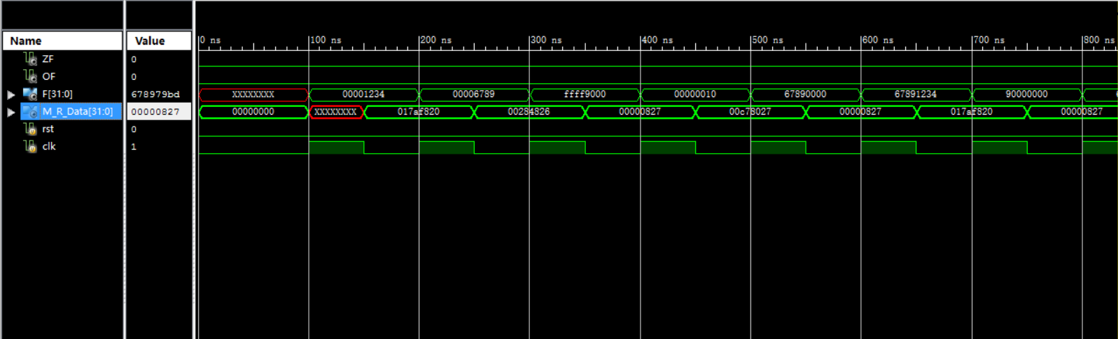

三、电路图

顶层电路模块

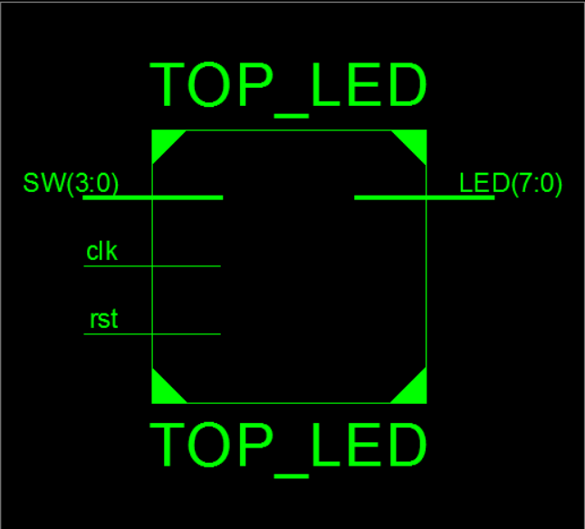
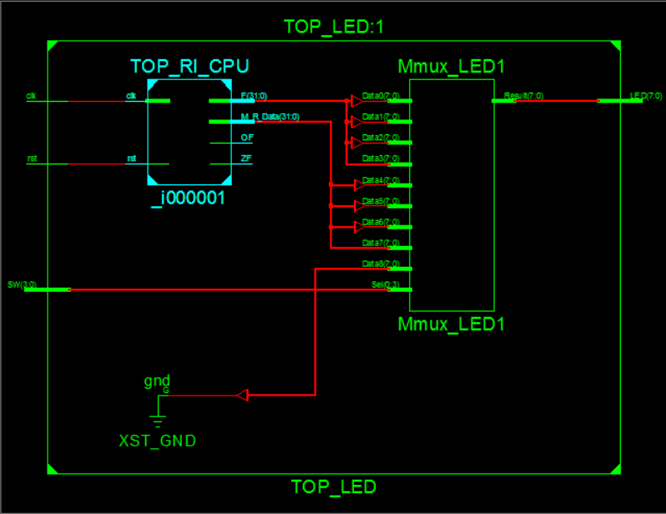
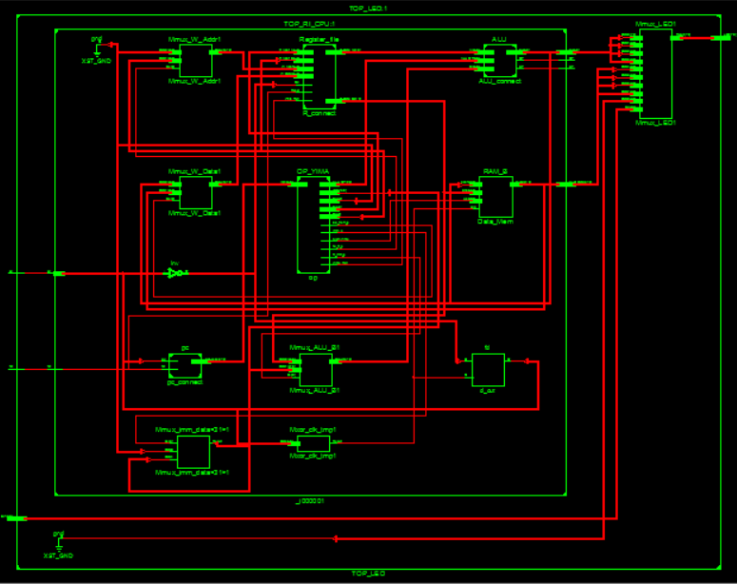
顶层电路内部结构

四、引脚配置（约束文件）
NET "LED[7]" LOC = T11;
NET "LED[6]" LOC = R11;
NET "LED[5]" LOC = N11;
NET "LED[4]" LOC = M11;
NET "LED[3]" LOC = V15;
NET "LED[2]" LOC = U15;
NET "LED[1]" LOC = V16;
NET "LED[0]" LOC = U16;
NET "SW[3]" LOC = M8;
NET "SW[2]" LOC = V9;
NET "SW[1]" LOC = T9;
NET "SW[0]" LOC = T10;
NET "rst" LOC = C4;
NET "clk_100MHz" LOC = V10;
NET "oclk" LOC = C9;
五、思考与探索
（1）R-I型指令CPU实验结果记录表
序号 指令 执行结果 标志 结论
1 38011234 0000_1234 0 0 正确
2 20026789 0000_6789 0 0 正确
3 20039000 FFFF_9000 0 0 正确
4 38040010 0000_0010 0 0 正确
5 00822804 6789_0000 0 0 正确
6 00253025 6789_1234 0 0 正确
7 00833804 9000_0000 0 0 正确
8 00464020 6789_79BD 0 0 正确
9 00414822, 0000_5555 0 0 正确
10 00225022 FFFF_AAAB 0 0 正确
11 206b7fff 0000_0FFF 0 0 正确
12 206c8000 FFFF_1000 0 0 正确
13 314dffff 0000_AAAB 0 0 正确
14 2c4e6788 0000_0000 0 0 正确
15 2c4f678a 0000_0001 0 0 正确
16 ac0c0014 0000_0FFF 0 0 正确

