**支持平板和手机**

运行Android系统的设备屏幕大小各不相同，系统会调整程序的UI的大小去适合每个屏幕。开发者需要做的就是将UI设计得更加灵活，为不同的屏幕提供不同的资源文件来对不同的屏幕进行优化。

平板电脑的屏幕比手机大得多，每次可以显示更多的内容，而手机只能分多次来显示。因此，即使可以调整手机程序的大小去适配平板电脑，这些并没有充分利用平板电脑的特点去增强用户体验。

Fragment能够将不同行为的UI组件分成不同的部分，允许开发者在平板电脑上将这些Fragment组合到具有多个窗格的单个Activity中，在手机上放到不同的Activity中，方便地为平板电脑和手机创建不同的布局。

eg：

在平板电脑大小的屏幕上，Activity A包含Fragment A和Fragment B。

在手机大小的屏幕上，Activity A只包含Fragment A。为了显示Fragment B，必须打开Activity B。

为了实现这一模型，很重要的一点就是把Fragment分成各自独立的部分。需要遵循两条原则：

（1）避免在一个Fragment中操纵另一个Fragment。

（2）将Fragment相关的代码全都放在Fragment中，而不是放在Activity中。

方法：为了避免在一个Fragment调用另外一个Fragment，增大耦合性，可先创建一个接口，然后Fragment中定义一个该接口，但在宿主Activity中实现这个接口。这样当Fragment接收到事件的时候，调用这个接口中的方法让Activity根据具体的配置做出响应。

fragment_b.xml 自己定义的Fragment

*<?***xml version="1.0" encoding="utf-8"***?>*<**LinearLayout xmlns:android="http://schemas.android.com/apk/res/android"  
 android:layout_width="match_parent"  
 android:layout_height="match_parent"  
 android:orientation="vertical"**>  
  
 <**TextView  
 android:id="@+id/text1"  
 android:layout_width="wrap_content"  
 android:layout_height="wrap_content"  
 android:text="TextView"  
 android:textAppearance="?android:attr/textAppearanceLarge"** />  
</**LinearLayout**>

FragmentB.java

**package** com.amaker.hjs.fragmentdemo.fragment;  
  
**import** android.os.Bundle;  
**import** android.support.v4.app.Fragment;  
**import** android.view.LayoutInflater;  
**import** android.view.View;  
**import** android.view.ViewGroup;  
**import** android.widget.TextView;  
  
**public class** FragmentB **extends** Fragment {  
 **private** TextView **text**;  
  
 @Override  
 **public** View onCreateView( LayoutInflater inflater, ViewGroup container, Bundle savedInstanceState) {  
  
 View view = inflater.inflate(R.layout.***fragment_b***,**null**);  
 **return** view;  
 }  
  
 @Override  
 **public void** onViewCreated(View view, Bundle savedInstanceState) {  
 **super**.onViewCreated(view, savedInstanceState);  
 **text**=view.findViewById(R.id.***text1***);  
 }  
  
 **public void** setText(String text){  
 **this**.**text**.setText(text);  
 }  
}

FragmentA.java

**package** com.amaker.hjs.fragmentdemo.fragment;  
  
  
**import** android.content.Context;  
**import** android.support.v4.app.ListFragment;  
**import** android.view.View;  
**import** android.widget.ArrayAdapter;  
**import** android.widget.ListView;  
  
**public class** FragmentA **extends** ListFragment {  
 **private** String[] **data**={**"北京"**,**"上海"**,**"广州"**,**"深圳"**,**"珠海"**,**"汕头"**,**"杭州"**,**"苏州"**};  
 **private** SelectedCityListener **listener**;  
 @Override  
 **public void** onAttach(Context context) {  
 **super**.onAttach(context);  
 setListAdapter(**new** ArrayAdapter<String>(  
 getActivity(),  
 android.R.layout.***simple_list_item_1***,  
 android.R.id.***text1***,  
 **data**));  
 }  
  
 @Override  
 **public void** onListItemClick(ListView l, View v, **int** position, **long** id) {  
 **listener**.selectedCity(**data**[position]);*//如果在这里做接口实现，由于点击事件后会操作FragmentB，不符合Fragment之间解耦合的原则。  
 // 因此不直接在这里做接口的实现，交给MainActivity去做接口的实现* **super**.onListItemClick(l, v, position, id);  
 }  
  
 *//把接口对象传进来* **public void** setOnSelectedCityListener(SelectedCityListener listener){  
 **this**.**listener**=listener;  
 }  
}

activity_selected.xml

*<?***xml version="1.0" encoding="utf-8"***?>*<**LinearLayout xmlns:android="http://schemas.android.com/apk/res/android"  
 android:layout_width="match_parent"  
 android:layout_height="match_parent"**>  
  
 <**fragment  
 android:id="@+id/fragment2"  
 android:name="com.amaker.hjs.fragmentdemo.fragment.FragmentB"  
 android:layout_width="match_parent"  
 android:layout_height="match_parent"** />  
</**LinearLayout**>

SelectedCityActivity.java

**package** com.amaker.hjs.fragmentdemo.fragment;  
  
**import** android.content.Intent;  
**import** android.os.Bundle;  
**import** android.support.v4.app.FragmentActivity;  
  
**public class** SelectedCityActivity **extends** FragmentActivity {  
 @Override  
 **protected void** onCreate(Bundle savedInstanceState) {  
 **super**.onCreate(savedInstanceState);  
 setContentView(R.layout.***activity_selected***);  
 Intent intent = getIntent();  
 String city = intent.getStringExtra(**"city"**);  
 *//通过FragmentManager，将FragmentB查找到* FragmentB fragment = (FragmentB) getSupportFragmentManager().findFragmentById(R.id.***fragment2***);  
 *//设置* fragment.setText(**"你所选择的城市是："**+city);  
 }  
}

SelectedCityListener.java

**package** com.amaker.hjs.fragmentdemo.fragment;  
  
**public interface** SelectedCityListener {  
 **public void** selectedCity(String city);  
}

activity_main.xml

*<?***xml version="1.0" encoding="utf-8"***?>  
<!--手机界面显示-->*<**LinearLayout xmlns:android="http://schemas.android.com/apk/res/android"  
 android:layout_width="match_parent"  
 android:layout_height="match_parent"  
 android:orientation="vertical"**>  
  
  
 <**fragment  
 android:id="@+id/fragment1"  
 android:name="com.amaker.hjs.fragmentdemo.fragment.FragmentA"  
 android:layout_width="match_parent"  
 android:layout_height="match_parent"**/>  
</**LinearLayout**>

activity_main.xml（land）

*<?***xml version="1.0" encoding="utf-8"***?>  
<!--手机横屏界面显示-->*<**LinearLayout xmlns:android="http://schemas.android.com/apk/res/android"  
 android:layout_width="fill_parent"  
 android:layout_height="fill_parent"  
 android:orientation="horizontal"**>  
  
  
 <**LinearLayout  
 android:layout_width="0dp"  
 android:layout_height="match_parent"  
 android:layout_weight="30"  
 android:orientation="vertical"  
 android:background="#FF0000"**>  
  
 <**fragment  
 android:id="@+id/fragment1"  
 android:name="com.amaker.hjs.fragmentdemo.fragment.FragmentA"  
 android:layout_width="match_parent"  
 android:layout_height="match_parent"** />  
 </**LinearLayout**>  
  
 <**LinearLayout  
 android:layout_width="0dp"  
 android:layout_height="match_parent"  
 android:layout_weight="70"  
 android:orientation="vertical"  
 android:background="#FFFF00"**>  
  
 <**fragment  
 android:id="@+id/fragment2"  
 android:name="com.amaker.hjs.fragmentdemo.fragment.FragmentB"  
 android:layout_width="match_parent"  
 android:layout_height="match_parent"** />  
 </**LinearLayout**>  
  
  
</**LinearLayout**>

MainActivity.java

**package** com.amaker.hjs.fragmentdemo.fragment;  
  
**import** android.content.Intent;  
**import** android.support.v4.app.FragmentActivity;  
**import** android.os.Bundle;  
**import** android.support.v4.app.FragmentManager;  
**import** android.widget.Toast;  
  
**public class** MainActivity **extends** FragmentActivity {  
  
 **private** FragmentA **mFragmentA**;  
 **private** FragmentB **mFragmentB**;  
 **private** FragmentManager **mFragmentManager**;  
 **private boolean isLand**;*//是否横屏* **private** SelectedCityListener **listener** = **new** SelectedCityListener() {  
 @Override  
 **public void** selectedCity(String city) {  
 Toast.*makeText*(MainActivity.**this**,city,Toast.***LENGTH_LONG***).show();  
 *//如果竖屏，跳转到另一个界面，并显示city* **if** (**isLand**==**false**){  
 Intent intent = **new** Intent(MainActivity.**this**,SelectedCityActivity.**class**);  
 intent.putExtra(**"city"**,city);  
 startActivity(intent);  
 }**else** {  
 *//如果横屏，使FragmentB显示City* **mFragmentB**.setText(**"您选中的是："**+city);  
 }  
 }  
 };  
  
 @Override  
 **protected void** onCreate(Bundle savedInstanceState) {  
 **super**.onCreate(savedInstanceState);  
 setContentView(R.layout.***activity_main***);  
 **mFragmentManager**=getSupportFragmentManager();  
 **mFragmentA**= (FragmentA) **mFragmentManager**.findFragmentById(R.id.***fragment1***);  
 **mFragmentA**.setOnSelectedCityListener(**listener**);  
  
 **mFragmentB**= (FragmentB) **mFragmentManager**.findFragmentById(R.id.***fragment2***);  
 **if** (**mFragmentB**==**null**){  
 **isLand**=**false**;  
 }**else**{  
 **isLand**=**true**;  
 }  
  
 }  
}

**使用ViewPager实现基本导航**

（1）TAB标题会滚动

（2）TAB标题固定，不随ViewPager而滚动

（1.1）直接View方式：

view1.xml

*<?***xml version="1.0" encoding="utf-8"***?>*<**LinearLayout xmlns:android="http://schemas.android.com/apk/res/android"  
 android:layout_width="match_parent"  
 android:layout_height="match_parent"  
 android:orientation="vertical"  
 android:background="#F00"**>  
  
</**LinearLayout**>

view2.xml

*<?***xml version="1.0" encoding="utf-8"***?>*<**LinearLayout xmlns:android="http://schemas.android.com/apk/res/android"  
 android:layout_width="match_parent"  
 android:layout_height="match_parent"  
 android:orientation="vertical"  
 android:background="#FF0"**>  
  
</**LinearLayout**>

view3.xml

*<?***xml version="1.0" encoding="utf-8"***?>*<**LinearLayout xmlns:android="http://schemas.android.com/apk/res/android"  
 android:layout_width="match_parent"  
 android:layout_height="match_parent"  
 android:orientation="vertical"  
 android:background="#00F"**>  
  
</**LinearLayout**>

view4.xml

*<?***xml version="1.0" encoding="utf-8"***?>*<**LinearLayout xmlns:android="http://schemas.android.com/apk/res/android"  
 android:layout_width="match_parent"  
 android:layout_height="match_parent"  
 android:orientation="vertical"  
 android:background="#000"**>  
  
</**LinearLayout**>

activity_main.xml

*<?***xml version="1.0" encoding="utf-8"***?>*<**RelativeLayout xmlns:android="http://schemas.android.com/apk/res/android"  
 xmlns:tools="http://schemas.android.com/tools"  
 android:layout_width="match_parent"  
 android:layout_height="match_parent"  
 tools:context=".MainActivity"**>  
  
 *<!--可以在ViewPager中放置多个View，也可以放置多个Fragment，推荐Fragment-->* <**android.support.v4.view.ViewPager  
 android:id="@+id/viewPager"  
 android:layout_width="match_parent"  
 android:layout_height="match_parent"**>  
  
 <**android.support.v4.view.PagerTabStrip  
 android:id="@+id/pagerTabStrip"  
 android:layout_width="wrap_content"  
 android:layout_height="wrap_content"**>  
  
 </**android.support.v4.view.PagerTabStrip**>  
 </**android.support.v4.view.ViewPager**>  
  
  
</**RelativeLayout**>

MainActivity.java

**package** com.amaker.hjs.fragmentdemo.fragment2;  
  
**import** android.os.Bundle;  
**import** android.support.v4.app.FragmentActivity;  
**import** android.support.v4.view.PagerAdapter;  
**import** android.support.v4.view.ViewPager;  
**import** android.view.LayoutInflater;  
**import** android.view.View;  
**import** android.view.ViewGroup;  
  
**public class** MainActivity **extends** FragmentActivity {  
  
 **private** View[] **views**;  
 **private** ViewPager **viewPager**;  
 **private** String[] **titles** = {**"View1"**,**"View2"**,**"View3"**};  
  
 @Override  
 **protected void** onCreate(Bundle savedInstanceState) {  
 **super**.onCreate(savedInstanceState);  
 setContentView(R.layout.***activity_main***);  
  
 init();  
  
 *//给ViewPager对象设置适配器PagerAdapter（抽象类）来放置views[]* **viewPager**.setAdapter(**new** MyAdapter());  
 }  
  
 **private void** init() {  
 **viewPager** = (ViewPager) findViewById(R.id.***viewPager***);  
 **views**=**new** View[3];  
 *//得到布局的解析器* LayoutInflater inflater = LayoutInflater.*from*(**this**);  
 *//得到View* **views**[0]=inflater.inflate(R.layout.***view1***,**null**);  
 **views**[1]=inflater.inflate(R.layout.***view2***,**null**);  
 **views**[2]=inflater.inflate(R.layout.***view3***,**null**);  
 }  
  
 **class** MyAdapter **extends** PagerAdapter{  
  
 @Override  
 **public int** getCount() {  
 **return views**.**length**;  
 }  
  
 @Override  
 **public boolean** isViewFromObject( View view, Object o) {  
 **return** view==o;  
 }  
  
  
 */**  
 * 注：要显示PagerTabStrip中间的title，则必须重写这一个方法  
 \** ***@param position*** *\** ***@return*** *\*/* @Override  
 **public** CharSequence getPageTitle(**int** position) {  
 **return titles**[position];  
 }  
  
  
 */**  
 * 实例化item  
 \** ***@param container*** *\** ***@param position*** *\** ***@return*** *\*/* @Override  
 **public** Object instantiateItem(ViewGroup container, **int** position) {  
 container.addView(**views**[position]);  
 **return views**[position];  
 }  
  
 */**  
 * 销毁item  
 \** ***@param container*** *\** ***@param position*** *\** ***@param object*** *\*/* @Override  
 **public void** destroyItem( View container, **int** position, Object object) {  
 **viewPager**.removeView(**views**[position]);  
 }  
  
 }  
}

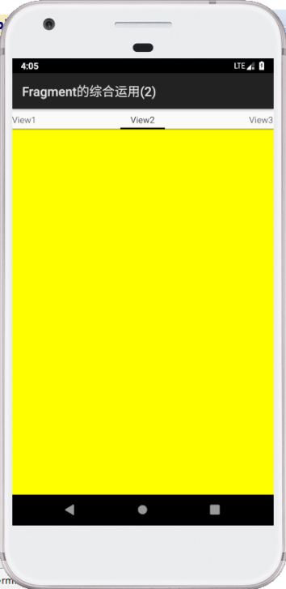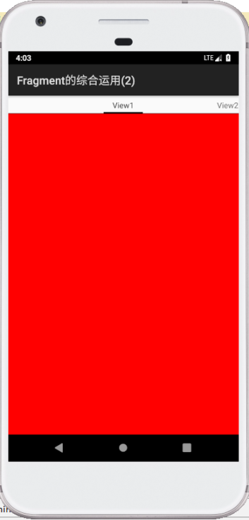

（1.2）Fragment关联上View方式：

view布局文件代码见（1.1）

MyFragment1.java

**package** com.amaker.hjs.fragmentdemo.fragment2;  
  
**import** android.os.Bundle;  
**import** android.support.annotation.NonNull;  
**import** android.support.annotation.Nullable;  
**import** android.support.v4.app.Fragment;  
**import** android.view.LayoutInflater;  
**import** android.view.View;  
**import** android.view.ViewGroup;  
  
**public class** MyFragment1 **extends** Fragment {  
 @Nullable  
 @Override  
 **public** View onCreateView(@NonNull LayoutInflater inflater, @Nullable ViewGroup container, @Nullable Bundle savedInstanceState) {  
 View view = inflater.inflate(R.layout.***view1***,**null**);  
 **return** view;  
 }  
}

MyFragment2.java

**package** com.amaker.hjs.fragmentdemo.fragment2;  
  
**import** android.os.Bundle;  
**import** android.support.annotation.NonNull;  
**import** android.support.annotation.Nullable;  
**import** android.support.v4.app.Fragment;  
**import** android.view.LayoutInflater;  
**import** android.view.View;  
**import** android.view.ViewGroup;  
  
**public class** MyFragment2 **extends** Fragment {  
 @Nullable  
 @Override  
 **public** View onCreateView(@NonNull LayoutInflater inflater, @Nullable ViewGroup container, @Nullable Bundle savedInstanceState) {  
 View view = inflater.inflate(R.layout.***view2***,**null**);  
 **return** view;  
 }  
}

MyFragment3.java

**package** com.amaker.hjs.fragmentdemo.fragment2;  
  
**import** android.os.Bundle;  
**import** android.support.annotation.NonNull;  
**import** android.support.annotation.Nullable;  
**import** android.support.v4.app.Fragment;  
**import** android.view.LayoutInflater;  
**import** android.view.View;  
**import** android.view.ViewGroup;  
  
**public class** MyFragment3 **extends** Fragment {  
 @Nullable  
 @Override  
 **public** View onCreateView(@NonNull LayoutInflater inflater, @Nullable ViewGroup container, @Nullable Bundle savedInstanceState) {  
 View view = inflater.inflate(R.layout.***view3***,**null**);  
 **return** view;  
 }  
}

MyFragment4.java

**package** com.amaker.hjs.fragmentdemo.fragment2;  
  
**import** android.os.Bundle;  
**import** android.support.annotation.NonNull;  
**import** android.support.annotation.Nullable;  
**import** android.support.v4.app.Fragment;  
**import** android.view.LayoutInflater;  
**import** android.view.View;  
**import** android.view.ViewGroup;  
  
**public class** MyFragment4 **extends** Fragment {  
 @Nullable  
 @Override  
 **public** View onCreateView(@NonNull LayoutInflater inflater, @Nullable ViewGroup container, @Nullable Bundle savedInstanceState) {  
 View view = inflater.inflate(R.layout.***view4***,**null**);  
 **return** view;  
 }  
}

Main2Activity.java

**package** com.amaker.hjs.fragmentdemo.fragment2;  
  
**import** android.graphics.Color;  
**import** android.os.Bundle;  
**import** android.support.annotation.Nullable;  
**import** android.support.v4.app.Fragment;  
**import** android.support.v4.app.FragmentActivity;  
**import** android.support.v4.app.FragmentManager;  
**import** android.support.v4.app.FragmentPagerAdapter;  
**import** android.support.v4.view.PagerTabStrip;  
**import** android.support.v4.view.ViewPager;  
  
  
**public class** Main2Activity **extends** FragmentActivity {  
  
 **private** Fragment[] **views**;  
 **private** ViewPager **viewPager**;  
 **private** String[] **titles**={**"Fragment1"**,**"Fragment2"**,**"Fragment3"**};  
 **private** PagerTabStrip **pagerTabStrip**;*//可以对PagerTabStrip做设置来使得界面更美观* @Override  
 **protected void** onCreate(Bundle savedInstanceState) {  
 **super**.onCreate(savedInstanceState);  
 setContentView(R.layout.***activity_main***);  
  
 init();  
  
 *//给ViewPager+Fragment对象设置适配器PagerAdapter（抽象类）来放置views[]* **viewPager**.setAdapter(**new** MyAdapter(getSupportFragmentManager()));  
 }  
  
 **private void** init() {  
 **viewPager** = (ViewPager) findViewById(R.id.***viewPager***);  
 **views**=**new** Fragment[3];  
 *//得到布局的解析器  
 //LayoutInflater inflater = LayoutInflater.from(this);  
 //得到View  
 //views[0]=inflater.inflate(R.layout.view1,null);  
 // views[1]=inflater.inflate(R.layout.view2,null);  
 //views[2]=inflater.inflate(R.layout.view3,null);* **views**[0]=**new** MyFragment1();  
 **views**[1]=**new** MyFragment2();  
 **views**[2]=**new** MyFragment3();  
  
 **pagerTabStrip**=(PagerTabStrip) findViewById(R.id.***pagerTabStrip***);  
 **pagerTabStrip**.setBackgroundColor(Color.***BLUE***);*//背景为蓝色* **pagerTabStrip**.setTextColor(Color.***YELLOW***);*//字体为黄色* **pagerTabStrip**.setTabIndicatorColor(Color.***GRAY***);*//选中时的指示条设置为灰色* }  
  
 **class** MyAdapter **extends** FragmentPagerAdapter{*//抽象类* **public** MyAdapter(FragmentManager fm) {  
 **super**(fm);  
 }  
  
 @Override  
 **public** Fragment getItem(**int** i) {  
 **return views**[i];  
 }  
  
 @Override  
 **public int** getCount() {  
 **return views**.**length**;  
 }  
  
 */**  
 * 要显示注：要显示PagerTabStrip中间的title，则必须重写这一个方法  
 \** ***@param position*** *\** ***@return*** *\*/* @Override  
 **public** CharSequence getPageTitle(**int** position) {  
 **return titles**[position];  
 }  
  
  
 }  
}

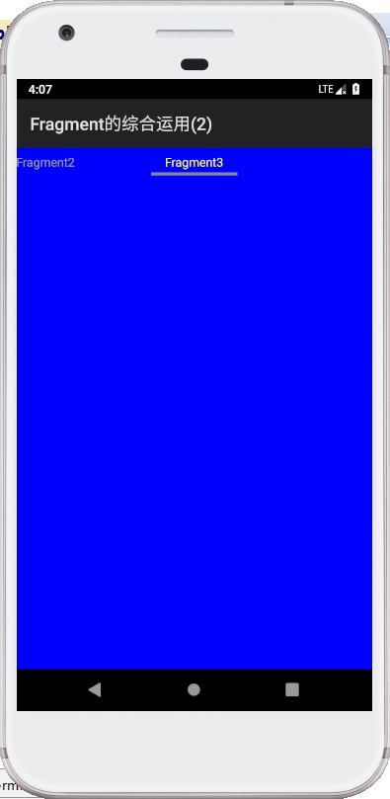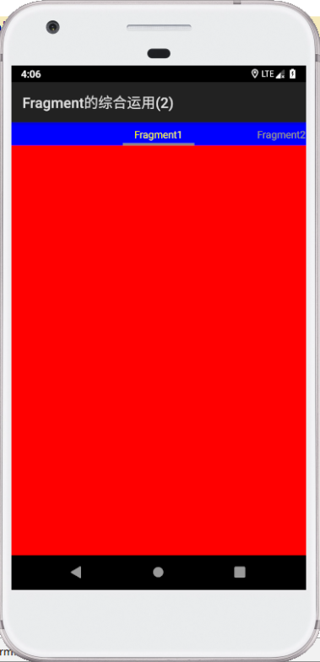

（2）

activity_demo.xml

*<?***xml version="1.0" encoding="utf-8"***?>*<**LinearLayout xmlns:android="http://schemas.android.com/apk/res/android"  
 android:layout_width="match_parent"  
 android:layout_height="match_parent"  
 android:orientation="vertical"**>  
  
 <**android.support.v4.view.ViewPager  
 android:id="@+id/viewPager1"  
 android:layout_width="match_parent"  
 android:layout_height="572dp"**>  
  
 </**android.support.v4.view.ViewPager**>  
 <**LinearLayout  
 android:id="@+id/tab_container_layout"  
 android:layout_width="match_parent"  
 android:layout_height="wrap_content"  
 android:orientation="horizontal"**>  
  
  
 <**TextView  
 android:id="@+id/textView1"  
 style="@style/tab_style"  
 android:layout_height="wrap_content"  
 android:text="微信"** />  
  
 <**TextView  
 android:id="@+id/textView2"  
 style="@style/tab_style"  
 android:layout_height="wrap_content"  
 android:text="通讯录"** />  
  
 <**TextView  
 android:id="@+id/textView3"  
 style="@style/tab_style"  
 android:layout_height="wrap_content"  
 android:text="发现"** />  
  
 <**TextView  
 android:id="@+id/textView4"  
 style="@style/tab_style"  
 android:layout_height="wrap_content"  
 android:text="我"** />  
  
 </**LinearLayout**>  
  
 <**TextView  
 android:id="@+id/textView5"  
 android:layout_width="match_parent"  
 android:layout_height="2dp"  
 android:background="#00F"** />  
  
  
  
</**LinearLayout**>

DemoActivity.java

**package** com.amaker.hjs.fragmentdemo.fragment2;  
  
**import** android.graphics.Color;  
**import** android.os.Bundle;  
**import** android.support.annotation.Nullable;  
**import** android.support.v4.app.Fragment;  
**import** android.support.v4.app.FragmentActivity;  
**import** android.support.v4.app.FragmentManager;  
**import** android.support.v4.app.FragmentPagerAdapter;  
**import** android.support.v4.view.ViewPager;  
**import** android.view.View;  
**import** android.widget.LinearLayout;  
**import** android.widget.TextView;  
  
**public class** DemoActivity **extends** FragmentActivity {  
 **private** TextView[] **tvTitles**;  
 **private** ViewPager **viewPager**;  
 **private** Fragment[] **fragments**;  
 **private** LinearLayout **tab_container_layout**;  
 **private** String[] **titles** = {**"微信"**,**"通讯录"**,**"发现"**,**"我"**};  
 @Override  
 **protected void** onCreate(@Nullable Bundle savedInstanceState) {  
 **super**.onCreate(savedInstanceState);  
 setContentView(R.layout.***activity_demo***);  
  
 init();  
  
 *//设置Viewpager适配器* **viewPager**.setAdapter(**new** MyAdpater(getSupportFragmentManager()));  
  
 }  
  
 **private void** init() {  
 **viewPager** = (ViewPager) findViewById(R.id.***viewPager1***);  
 *//设置滑动时的选项事件状态* **viewPager**.addOnPageChangeListener(**new** ViewPager.OnPageChangeListener() {  
  
 */**  
 *滚动状态发生变化的时候  
 \** ***@param i*** *\** ***@param v*** *\** ***@param i1*** *\*/* @Override  
 **public void** onPageScrolled(**int** i, **float** v, **int** i1) {  
  
 }  
  
 */**  
 *正在滚动时候的状态  
 \** ***@param i*** *\*/* @Override  
 **public void** onPageScrollStateChanged(**int** i) {  
  
 }  
  
 */**  
 *已经改变后的状态，当某一页已经被选中的情况下，选项卡要改变  
 \** ***@param i*** *\*/* @Override  
 **public void** onPageSelected(**int** i) {  
 selectedTitle(i);  
 }  
  
  
 });  
 **fragments** = **new** Fragment[4];  
 **fragments**[0]=**new** MyFragment1();  
 **fragments**[1]=**new** MyFragment2();  
 **fragments**[2]=**new** MyFragment3();  
 **fragments**[3]=**new** MyFragment4();  
 **tab_container_layout**=(LinearLayout)findViewById(R.id.***tab_container_layout***);  
 **int** count = **tab_container_layout**.getChildCount();  
 **tvTitles**=**new** TextView[count];  
 **for** (**int** i =0;i<count;i++){  
 **tvTitles**[i]= (TextView) **tab_container_layout**.getChildAt(i);  
 **tvTitles**[i].setText(**titles**[i]);  
 **tvTitles**[i].setTag(i);*//保存下程序员需要用到的变量  
  
 //设置该选项卡可被点击* **tvTitles**[i].setEnabled(**true**);  
 **tvTitles**[i].setOnClickListener(**new** View.OnClickListener() {  
 *//由于匿名内部类无法直接访问到外部非final的变量，所以需要将外部的变量保存到传进来的对象里* @Override  
 **public void** onClick(View v) {  
 **int** item = (Integer) v.getTag();  
 **viewPager**.setCurrentItem(item);  
 selectedTitle(item);  
 }  
 });  
 }  
 *//默认选中状态，不可被点击* **tvTitles**[0].setEnabled(**false**);  
 *//默认选中项为绿颜色* **tvTitles**[0].setBackgroundColor(Color.***GREEN***);  
 }  
  
 */**  
 * 选中后重新设置选项卡的选中及背景  
 \** ***@param index*** *\*/* **private void** selectedTitle(**int** index){  
 **for** (**int** i=0;i<**tvTitles**.**length**;i++){  
 **tvTitles**[i].setBackgroundColor(Color.***GRAY***);  
 **tvTitles**[i].setEnabled(**true**);  
 }  
 **tvTitles**[index].setBackgroundColor(Color.***GREEN***);  
 **tvTitles**[index].setEnabled(**false**);  
  
 }  
  
 **class** MyAdpater **extends** FragmentPagerAdapter {  
 **public** MyAdpater(FragmentManager fm) {  
 **super**(fm);  
 }  
  
 @Override  
 **public** Fragment getItem(**int** i) {  
 **return fragments**[i];  
 }  
  
 @Override  
 **public int** getCount() {  
 **return fragments**.**length**;  
 }  
 }  
}

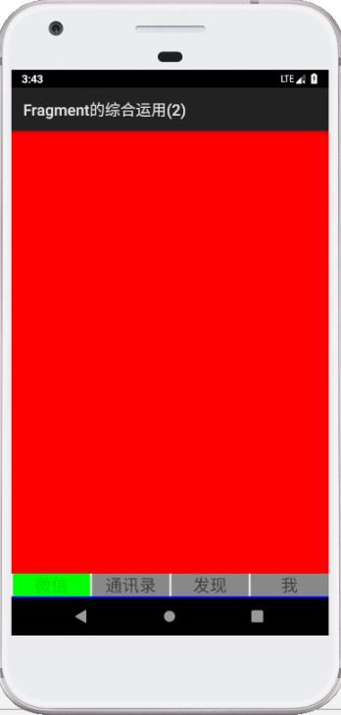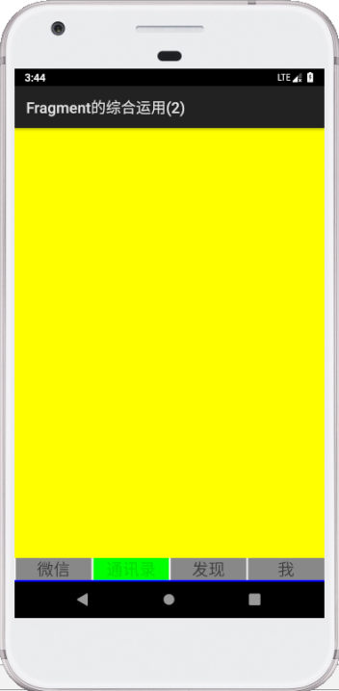

**ViewPager实现程序欢迎界面**

activity_demo.xml

*<?***xml version="1.0" encoding="utf-8"***?>*<**RelativeLayout xmlns:android="http://schemas.android.com/apk/res/android"  
 android:layout_width="match_parent"  
 android:layout_height="match_parent"**>  
  
  
 <**android.support.v4.view.ViewPager  
 android:id="@+id/viewPager2"  
 android:layout_width="match_parent"  
 android:layout_height="match_parent"  
 android:layout_alignParentStart="true"  
 android:layout_alignParentTop="true"  
 android:layout_marginStart="0dp"  
 android:layout_marginTop="0dp"**></**android.support.v4.view.ViewPager**>  
  
 *<!--指示-->* <**LinearLayout  
 android:layout_alignParentLeft="true"  
 android:layout_alignParentBottom="true"  
 android:layout_width="match_parent"  
 android:layout_height="wrap_content"  
 android:gravity="center_horizontal"  
 android:layout_marginBottom="20dp"  
 android:id="@+id/dot_layout"**>  
 <**ImageView  
 android:layout_width="wrap_content"  
 android:layout_height="wrap_content"  
 android:background="@drawable/dot"**/>  
  
 <**ImageView  
 android:layout_width="wrap_content"  
 android:layout_height="wrap_content"  
 android:background="@drawable/dot"**/>  
  
 <**ImageView  
 android:layout_width="wrap_content"  
 android:layout_height="wrap_content"  
 android:background="@drawable/dot"**/>  
  
 <**ImageView  
 android:layout_width="wrap_content"  
 android:layout_height="wrap_content"  
 android:background="@drawable/dot"**/>  
 </**LinearLayout**>  
  
</**RelativeLayout**>

Demo2Activity.java

**package** com.amaker.hjs.fragmentdemo.fragment2;  
  
**import** android.graphics.Color;  
**import** android.os.Bundle;  
**import** android.support.annotation.Nullable;  
**import** android.support.v4.app.Fragment;  
**import** android.support.v4.app.FragmentActivity;  
**import** android.support.v4.app.FragmentManager;  
**import** android.support.v4.app.FragmentPagerAdapter;  
**import** android.support.v4.view.ViewPager;  
**import** android.view.View;  
**import** android.widget.ImageView;  
**import** android.widget.LinearLayout;  
  
**public class** Demo2Activity **extends** FragmentActivity {  
 **private** ImageView[] **imgTitles**;  
 **private** ViewPager **viewPager**;  
 **private** Fragment[] **fragments**;  
 **private** LinearLayout **dot_layout**;  
  
 @Override  
 **protected void** onCreate(@Nullable Bundle savedInstanceState) {  
 **super**.onCreate(savedInstanceState);  
 setContentView(R.layout.***activity_demo2***);  
 init();  
 *//设置Viewpager适配器* **viewPager**.setAdapter(**new** MyAdpater(getSupportFragmentManager()));  
 }  
  
 **private void** init() {  
 **viewPager** = (ViewPager) findViewById(R.id.***viewPager2***);  
 *//设置滑动时的选项事件监听* **viewPager**.addOnPageChangeListener(**new** ViewPager.OnPageChangeListener() {  
  
  
 */**滚动状态发生变化的时候  
 \** ***@param i*** *\** ***@param v*** *\** ***@param i1*** *\*/* @Override  
 **public void** onPageScrolled(**int** i, **float** v, **int** i1) { }  
  
  
 */**正在滚动时候的状态  
 \** ***@param i*** *\*/* @Override  
 **public void** onPageScrollStateChanged(**int** i) { }  
  
  
 */**已经改变后的状态，当某一页已经被选中的情况下，选项卡要改变  
 \** ***@param i*** *\*/* @Override  
 **public void** onPageSelected(**int** i) {  
 selectedImage(i);  
 }  
 });  
  
 **fragments** = **new** Fragment[4];  
 **fragments**[0]=**new** MyFragment1();  
 **fragments**[1]=**new** MyFragment2();  
 **fragments**[2]=**new** MyFragment3();  
 **fragments**[3]=**new** MyFragment4();  
  
 **dot_layout** =(LinearLayout)findViewById(R.id.***dot_layout***);  
 **int** count = **dot_layout**.getChildCount();  
 **imgTitles**=**new** ImageView[count];  
  
 *//遍历一下容器中的所有子控件* **for** (**int** i =0;i<count;i++){  
 **imgTitles**[i]= (ImageView) **dot_layout**.getChildAt(i);  
  
 *//保存下程序员需要用到的变量* **imgTitles**[i].setTag(i);  
  
 *//先初始化每一个选项卡可被点击* **imgTitles**[i].setEnabled(**true**);  
  
 *//选项卡单击，用户希望换一个选项* **imgTitles**[i].setOnClickListener(**new** View.OnClickListener() {  
 *//由于匿名内部类无法直接访问到外部非final的变量，所以之前需要将外部的变量进行setTag保存到传进来的对象里* @Override  
 **public void** onClick(View v) {  
 **int** item = (Integer) v.getTag();  
 **viewPager**.setCurrentItem(item);  
 selectedImage(item);  
 }  
 });  
 }  
 *//默认选中状态，不可被点击* **imgTitles**[0].setEnabled(**false**);  
 }  
  
 */**  
 * 更改ImageView的Enable状态  
 \** ***@param index*** *\*/* **private void** selectedImage(**int** index){  
 **for** (**int** i = 0;i<**imgTitles**.**length**;i++){  
 **imgTitles**[i].setEnabled(**true**);  
 }  
 **imgTitles**[index].setEnabled(**false**);*//不可以对这一项再进行单击了* }  
 */**  
 * 选中后重新设置选项卡的选中及背景  
 * //@param index  
 */  
  
 //这里不需要再用到这个方法来实现选中后更改显示，在dot.xml文件里有定义了，但是我们仍需要定义改变该选项的Enable状态的方法  
 // private void selectedTitle(int index){  
 // for (int i=0;i<imgTitles.length;i++){  
 // imgTitles[i].setBackgroundColor(Color.GRAY);  
 //imgTitles[i].setEnabled(true);  
 //}  
 //imgTitles[index].setBackgroundColor(Color.GREEN);  
 //imgTitles[index].setEnabled(false);  
 //}* **class** MyAdpater **extends** FragmentPagerAdapter {  
 **public** MyAdpater(FragmentManager fm) {  
 **super**(fm);  
 }  
  
 @Override  
 **public** Fragment getItem(**int** i) {  
 **return fragments**[i];  
 }  
  
 @Override  
 **public int** getCount() {  
 **return fragments**.**length**;  
 }  
 }  
}

styles.xml

<**resources**>  
  
 *<!-- Base application theme. -->* <**style name="AppTheme" parent="Theme.AppCompat.Light.DarkActionBar"**>  
 *<!-- Customize your theme here. -->* <**item name="colorPrimary"**>@color/colorPrimary</**item**>  
 <**item name="colorPrimaryDark"**>@color/colorPrimaryDark</**item**>  
 <**item name="colorAccent"**>@color/colorAccent</**item**>  
 </**style**>  
  
 <**style name="tab_style"**>  
 <**item name="android:layout_width"**>0dp</**item**>  
 <**item name="android:layout_weight"**>1</**item**>  
 <**item name="android:gravity"**>center</**item**>  
 <**item name="android:textSize"**>22sp</**item**>  
 <**item name="android:background"**>#999</**item**>  
 <**item name="android:layout_marginLeft"**>2dp</**item**>  
 </**style**>  
  
</**resources**>

drawable/dot.xml

*<?***xml version="1.0" encoding="utf-8"***?>*<**selector xmlns:android="http://schemas.android.com/apk/res/android"**>  
 *<!-- 方式1：可以用这种方式来根据当前状态是否获得焦点，获得焦点则显示的大一点的pot-->  
 <!-- <item android:state_focused="true" android:drawable="@drawable/middlepot1"></item>  
 <item android:state_focused="false" android:drawable="@drawable/smallpot1"></item>-->  
 <!--方式2：根据当前状态是否处于激活状态，非激活表示已经被选中，则显示大一点的pot-->* <**item android:state_enabled="true" android:drawable="@drawable/pot2"**></**item**>  
 <**item android:state_enabled="false" android:drawable="@drawable/pot1"**></**item**>  
</**selector**>

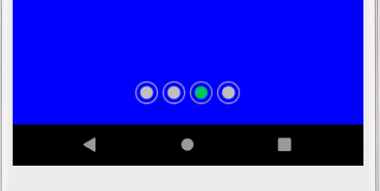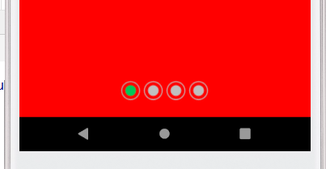

**添加Tab到ActionBar**

使用ActionBar来创建tab步骤：

（1）启用NAVIGATION_MODE_TABS

（2）创建几个ActionBar.Tab的实例

（3）对每个实例实现ActionBar.TabListenner接口

错误1出现：

**（19）mActionBar**.setNavigationMode(ActionBar.***NAVIGATION_MODE_TABS***);

关键错误提示信息：

Caused by: java.lang.NullPointerException: Attempt to invoke virtual method 'void android.app.ActionBar.setNavigationMode(int)' on a null object reference

at com.amaker.hjs.fragmentdemo.fragment2.Demo3Activity.onCreate(Demo3Activity.java:19)

改正：在AndroidManifest.xml文件中删去：

**android:theme="@style/AppTheme"**

即可。

错误2出现：

@Override  
**public void** onTabSelected(Tab tab, FragmentTransaction ft) {  
（94） **viewPager**.setCurrentItem(tab.getPosition());  
}

关键错误提示信息：

Caused by: java.lang.NullPointerException: Attempt to invoke virtual method 'void android.support.v4.view.ViewPager.setCurrentItem(int)' on a null object reference

at com.amaker.hjs.fragmentdemo.fragment2.Demo3Activity$TabClickListener.onTabSelected(Demo3Activity.java:94)

原因是在setContentView(R.layout.***activity_demo3***)显示Activity之前，viewPager是为空的

修正：

@Override  
**public void** onTabSelected(Tab tab, FragmentTransaction ft) {  
 **if** (**viewPager**==**null**) {*//这里原因是在Activity显示之前，viewPager是为空的，而在Activity创建时，给ActionBar添加的事件监听会触发，调用到这个viewPager* **return**;  
 }  
 **viewPager**.setCurrentItem(tab.getPosition());  
}

activity_demo3.xml

*<?***xml version="1.0" encoding="utf-8"***?>*<**LinearLayout xmlns:android="http://schemas.android.com/apk/res/android"  
 android:layout_width="match_parent"  
 android:layout_height="match_parent"  
 android:orientation="vertical"**>  
 <**android.support.v4.view.ViewPager  
 android:layout_width="match_parent"  
 android:layout_height="match_parent"  
 android:id="@+id/viewPager3"**>  
 </**android.support.v4.view.ViewPager**>  
  
</**LinearLayout**>

Demo3Activity.java

**package** com.amaker.hjs.fragmentdemo.fragment2;  
  
**import** android.app.ActionBar;  
**import** android.app.ActionBar.Tab;  
**import** android.app.FragmentTransaction;  
**import** android.os.Bundle;  
**import** android.support.v4.app.Fragment;  
**import** android.support.v4.app.FragmentActivity;  
**import** android.support.v4.app.FragmentManager;  
**import** android.support.v4.app.FragmentPagerAdapter;  
**import** android.support.v4.view.ViewPager;  
  
  
**public class** Demo3Activity **extends** FragmentActivity {  
 **private** ActionBar **mActionBar**;  
 **private** ViewPager **viewPager**;  
 *//数据源* **private** Fragment[] **fragments** = {**new** MyFragment1(),**new** MyFragment2(),**new** MyFragment3(),**new** MyFragment4()};  
  
  
  
 @Override  
 **protected void** onCreate( Bundle savedInstanceState) {  
 **super**.onCreate(savedInstanceState);  
 setContentView(R.layout.***activity_demo3***);  
  
 *//获得ActionBar的实例* **mActionBar**= getActionBar();  
 *//设置导航模式* **mActionBar**.setNavigationMode(ActionBar.***NAVIGATION_MODE_TABS***);  
 TabClickListener listener = **new** TabClickListener();  
  
 *//创建Tab实例* Tab tab1 = **mActionBar**.newTab();  
 tab1.setText(**"扫一扫"**);  
 *//这里可以不用保存下索引，因为tab有一个方法tab.getPosition可以获得索引值  
 //tab1.setTag(0);  
 //设置监听* tab1.setTabListener(listener);  
  
 ActionBar.Tab tab2 = **mActionBar**.newTab();  
 tab2.setText(**"付钱"**);  
 tab2.setTabListener(listener);  
 tab2.setTabListener(listener);  
  
 ActionBar.Tab tab3 = **mActionBar**.newTab();  
 tab3.setText(**"收钱"**);  
 tab3.setTabListener(listener);  
 tab3.setTabListener(listener);  
  
 ActionBar.Tab tab4 = **mActionBar**.newTab();  
 tab4.setText(**"卡包"**);  
 tab4.setTabListener(listener);  
 tab4.setTabListener(listener);  
  
 *//将Tab添加到ActionBar对象中* **mActionBar**.addTab(tab1);  
 **mActionBar**.addTab(tab2);  
 **mActionBar**.addTab(tab3);  
 **mActionBar**.addTab(tab4);  
  
 **viewPager**=(ViewPager)findViewById(R.id.***viewPager3***);  
 **viewPager**.setAdapter(**new** MyAdapter(getSupportFragmentManager()));*//这里的参数必须是SupportFragmentManager  
  
 //滑动换页时设置事件监听* **viewPager**.setOnPageChangeListener(**new** ViewPager.OnPageChangeListener() {  
 @Override  
 **public void** onPageScrolled(**int** i, **float** v, **int** i1) {  
 }  
  
 @Override  
 **public void** onPageSelected(**int** i) {  
 Tab tab = **mActionBar**.getTabAt(i);  
 **mActionBar**.selectTab(tab);  
  
 }  
  
 @Override  
 **public void** onPageScrollStateChanged(**int** i) {  
  
 }  
 });  
 }  
  
  
 **class** MyAdapter **extends** FragmentPagerAdapter {  
 **public** MyAdapter(FragmentManager fm) {  
 **super**(fm);  
 }  
  
 @Override  
 **public** Fragment getItem(**int** i) {  
 **return fragments**[i];  
 }  
  
 @Override  
 **public int** getCount() {  
 **return fragments**.**length**;  
 }  
 }  
  
  
 */*给tab增加事件监听，tab切换的时候回调这些方法*/* **class** TabClickListener **implements** ActionBar.TabListener{  
  
 */**  
 * Tab处于选中状态中  
 \** ***@param tab*** *\** ***@param ft*** *\*/* @Override  
 **public void** onTabSelected(Tab tab, FragmentTransaction ft) {  
 **if** (**viewPager**==**null**) {*//这里原因是在Activity显示之前，viewPager是为空的，而在Activity创建时，给ActionBar添加的事件监听会触发，调用到这个viewPager* **return**;  
 }  
 **viewPager**.setCurrentItem(tab.getPosition());  
 }  
  
 */**  
 * Tab处于非选中状态中  
 \** ***@param tab*** *\** ***@param ft*** *\*/* @Override  
 **public void** onTabUnselected(Tab tab, FragmentTransaction ft) {  
 }  
  
 */**  
 * Tab释放的过程中要完成的工作  
 \** ***@param tab*** *\** ***@param ft*** *\*/* @Override  
 **public void** onTabReselected(Tab tab, FragmentTransaction ft) {  
 }  
 }  
}

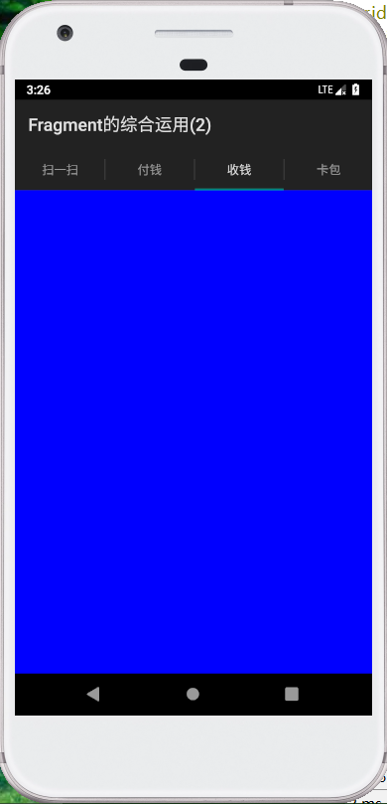

**创建抽屉式导航（navigation drawer）**

创建一个DrawLayout

处理导航的点击事件

activity_demo4.xml

*<?***xml version="1.0" encoding="utf-8"***?>*<**android.support.v4.widget.DrawerLayout  
 xmlns:android="http://schemas.android.com/apk/res/android"  
 android:layout_width="match_parent"  
 android:layout_height="match_parent"  
 android:id="@+id/layout"**>

<**FrameLayout  
 android:id="@+id/main_container_layout"  
 android:layout_width="match_parent"  
 android:layout_height="match_parent"**>  
</**FrameLayout**>

<**ListView  
 android:id="@+id/left_list"  
 android:layout_width="240dp"  
 android:layout_height="match_parent"  
 android:layout_gravity="start"  
 android:background="#111"**>  
 </**ListView**>

</**android.support.v4.widget.DrawerLayout**>

Demo4Activity.java

**package** com.amaker.hjs.fragmentdemo.fragment2;  
  
**import** android.os.Bundle;  
**import** android.support.v4.app.Fragment;  
**import** android.support.v4.app.FragmentActivity;  
**import** android.support.v4.app.FragmentManager;  
**import** android.support.v4.app.FragmentTransaction;  
**import** android.support.v4.widget.DrawerLayout;  
**import** android.view.View;  
**import** android.widget.AdapterView;  
**import** android.widget.ArrayAdapter;  
**import** android.widget.ListView;  
  
**public class** Demo4Activity **extends** FragmentActivity {  
 **private** DrawerLayout **layout**;*//DrawerLayout在布局文件中，必须是布局的根元素* **private** ListView **left_list**;  
 **private** String[] **titles**={**"MyFragment1—Red"**,**"MyFragment2-Yellow"**,**"MyFragment3-Blue"**,**"MyFragment4-Black"**};  
 **private** Fragment[] **fragments**={**new** MyFragment1(),**new** MyFragment2(),**new** MyFragment3(),**new** MyFragment4()};  
 **private** FragmentManager **fm**;  
  
 @Override  
 **protected void** onCreate(Bundle savedInstanceState) {  
 **super**.onCreate(savedInstanceState);  
 setContentView(R.layout.***activity_demo4***);  
  
 **layout**=(DrawerLayout) findViewById(R.id.***layout***);  
  
 **fm**=getSupportFragmentManager();  
  
 **left_list**=(ListView)findViewById(R.id.***left_list***);  
  
 **left_list**.setAdapter(**new** ArrayAdapter<String>(  
 Demo4Activity.**this**,  
 android.R.layout.***simple_list_item_1***,  
 android.R.id.***text1***,  
 **titles**));  
  
 **left_list**.setOnItemClickListener(**new** AdapterView.OnItemClickListener() {  
 @Override  
 **public void** onItemClick(AdapterView<?> parent, View view, **int** position, **long** id) {  
 Fragment f = **fragments**[position];  
 FragmentTransaction ft = **fm**.beginTransaction();  
 ft.replace(R.id.***main_container_layout*** , f);  
 ft.commit();  
 **layout**.closeDrawer(**left_list**);*//当点击触发Fragment被添加到FrameLayout布局中后，将left_list关闭* }  
 });  
 }  
}

