GridView

显示文本内容

显示图片与文本

AndroidManifest.xml

…...

<**activity android:name=".MainActivity"**>*<!--这里可以更改默认Activity启动项-->*

…...

activity_main.xml

*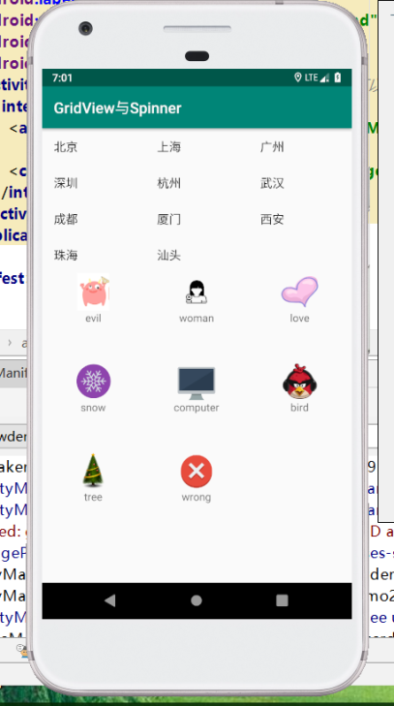<?***xml version="1.0" encoding="utf-8"***?>*<**RelativeLayout xmlns:android="http://schemas.android.com/apk/res/android"  
 xmlns:tools="http://schemas.android.com/tools"  
 android:layout_width="match_parent"  
 android:layout_height="match_parent"  
 tools:context=".MainActivity"**>  
  
 <**GridView  
 android:id="@+id/gridView1"  
 android:layout_width="match_parent"  
 android:layout_height="wrap_content"  
 android:numColumns="3"** />

<**GridView  
 android:id="@+id/gridView2"  
 android:layout_width="match_parent"  
 android:layout_height="wrap_content"  
 android:numColumns="3"  
 android:layout_below="@+id/gridView1"  
 android:layout_alignParentLeft="true"  
 android:verticalSpacing="50dp"** />*<!--控件垂直距离相隔50dp-->*</**RelativeLayout**>

grid_item.xml

*<?***xml version="1.0" encoding="utf-8"***?>*<**LinearLayout xmlns:android="http://schemas.android.com/apk/res/android"  
 xmlns:app="http://schemas.android.com/apk/res-auto"  
 android:layout_width="match_parent"  
 android:layout_height="match_parent"  
 android:gravity="center_horizontal"  
 android:orientation="vertical"**>  
  
 <**ImageView  
 android:id="@+id/img"  
 android:layout_width="50dp"  
 android:layout_height="50dp"  
 app:srcCompat="@drawable/a"** />  
  
 <**TextView  
 android:id="@+id/text1"  
 android:layout_width="wrap_content"  
 android:layout_height="wrap_content"  
 android:text="TextView"** />  
</**LinearLayout**>

MainActivity.java

**package** com.amaker.hjs.gridviewdemo.gridviewspinner;  
  
**import** android.app.Activity;  
**import** android.support.v7.app.AppCompatActivity;  
**import** android.os.Bundle;  
**import** android.view.LayoutInflater;  
**import** android.view.View;  
**import** android.view.ViewGroup;  
**import** android.widget.AdapterView;  
**import** android.widget.ArrayAdapter;  
**import** android.widget.BaseAdapter;  
**import** android.widget.GridView;  
**import** android.widget.ImageView;  
**import** android.widget.TextView;  
**import** android.widget.Toast;  
  
**public class** MainActivity **extends** AppCompatActivity {  
 **private static final** String[] ***data***={**"北京"**,**"上海"**,**"广州"**,**"深圳"**,**"杭州"**,**"武汉"**,**"成都"**,**"厦门"**,**"西安"**,**"珠海"**,**"汕头"**};  
 **private** GridView **gridView**; *//仅有文字的GridView* **private** GridView **gridView2**; *//有图片也有文字的GridView* @Override  
 **protected void** onCreate(Bundle savedInstanceState) {  
 **super**.onCreate(savedInstanceState);  
 setContentView(R.layout.***activity_main***);  
  
 **gridView**=(GridView)findViewById(R.id.***gridView1***);  
 *//系统自带的ArrayAdapter* ArrayAdapter<String> adapter = **new** ArrayAdapter<String>(  
 **this**,  
 android.R.layout.***simple_list_item_1***,  
 android.R.id.***text1***,  
 ***data*** );  
 **gridView**.setAdapter(adapter);*//设置适配器  
  
 //gridView子项添加事件监听* **gridView**.setOnItemClickListener(**new** AdapterView.OnItemClickListener() {  
 @Override  
 **public void** onItemClick(AdapterView<?> parent, View view, **int** position, **long** id) {  
 Toast.*makeText*(MainActivity.**this**,***data***[position],Toast.***LENGTH_LONG***).show();  
 }  
 });  
  
  
  
 **gridView2** = (GridView)findViewById(R.id.***gridView2***);  
 **gridView2**.setAdapter(**new** MyAdapter());  
  
 }  
  
 *//创建我们自己的MyAdapter* **class** MyAdapter **extends** BaseAdapter{  
  
 */*定义数据源*/  
 //1.定义图片资源* **private int**[] **imgResId**={  
 R.drawable.***a***,  
 R.drawable.***b***,  
 R.drawable.***c***,  
 R.drawable.***d***,  
 R.drawable.***e***,  
 R.drawable.***f***,  
 R.drawable.***g***,  
 R.drawable.***h*** };  
  
 *//2.定义文字资源* **private** String[] **names**={  
 **"evil"**,  
 **"woman"**,  
 **"love"**,  
 **"snow"**,  
 **"computer"**,  
 **"bird"**,  
 **"tree"**,  
 **"wrong"** };  
  
 @Override  
 **public int** getCount() {  
 **return names**.**length**;  
 }  
  
 @Override  
 **public** Object getItem(**int** position) {  
 **return** position;  
 }  
  
 @Override  
 **public long** getItemId(**int** position) {  
 **return** position;  
 }  
  
 @Override  
 **public** View getView(**int** position, View convertView, ViewGroup parent) {  
 View view;  
 ViewHolder holder;  
 *//convertView缓存提高效率* **if** (convertView==**null**){  
 view = LayoutInflater.*from*(MainActivity.**this**).inflate(R.layout.***grid_item***,**null**);  
 holder = **new** ViewHolder();  
 *//第一次* holder.**image** = (ImageView)view.findViewById(R.id.***img***);  
 holder.**tv** = (TextView)view.findViewById(R.id.***text1***);  
 view.setTag(holder);  
 }**else** {  
 view = convertView;  
 holder = (ViewHolder) view.getTag();  
 }  
 ImageView image = holder.**image**;  
 TextView text = holder.**tv**;  
 image.setImageResource(**imgResId**[position]);  
 text.setText(**names**[position]);  
 **return** view;  
 }  
 }  
  
 *//定义持有者,持有着ImageView和TextView资源* **class** ViewHolder{  
 ImageView **image**;  
 TextView **tv**;  
 }  
}

------------------------------------------------------分割线---------------------------------------------------

AndroidManifest.xml

<**activity android:name=".DemoActivity"**>*<!--这里可以更改默认Activity启动项-->*

activity_demo.xml

*<?***xml version="1.0" encoding="utf-8"***?>*<**LinearLayout xmlns:android="http://schemas.android.com/apk/res/android"  
 android:layout_width="match_parent"  
 android:layout_height="match_parent"  
 android:orientation="vertical"**>  
  
 <**LinearLayout  
 android:layout_width="match_parent"  
 android:layout_height="wrap_content"  
 android:orientation="horizontal"**>  
  
 <**Button  
 android:id="@+id/btnAdd"  
 android:layout_width="wrap_content"  
 android:layout_height="wrap_content"  
 android:text="添加学生"** />  
  
 <**EditText  
 android:id="@+id/etStudentName"  
 android:layout_width="match_parent"  
 android:layout_height="wrap_content"  
 android:ems="10"  
 android:inputType="textPersonName"  
 android:text="Name"** />  
  
 </**LinearLayout**>  
  
 <**GridView  
 android:id="@+id/gridStudents"  
 android:layout_width="match_parent"  
 android:layout_height="match_parent"  
 android:numColumns="3"**/>  
  
  
</**LinearLayout**>

DemoActivity.java

**package** com.amaker.hjs.gridviewdemo.gridviewspinner;  
  
**import** android.app.Activity;  
**import** android.os.Bundle;  
**import** android.view.View;  
**import** android.widget.ArrayAdapter;  
**import** android.widget.Button;  
**import** android.widget.EditText;  
**import** android.widget.GridView;  
  
**import** java.util.ArrayList;  
**import** java.util.List;  
  
*//用Activity自身去做事件监听的实现，即DemoActivity既是一个活动，又是一个监听器***public class** DemoActivity **extends** Activity **implements** View.OnClickListener {  
 *//声明控件* **private** Button **btnAdd**;  
 **private** EditText **etStudentName**;  
 **private** GridView **gridStudent**;  
  
 *//数据源* List<String > **studentNames** = **new** ArrayList<String>();  
  
 *//适配器* ArrayAdapter<String> **adapter**;  
  
 @Override  
 **protected void** onCreate(Bundle savedInstanceState){  
 **super**.onCreate(savedInstanceState);  
 *//关联Activity活动布局文件* setContentView(R.layout.***activity_demo***);  
 *//关联控件* initControl();  
 **adapter** = **new** ArrayAdapter<String>(**this**,android.R.layout.***simple_list_item_1***,android.R.id.***text1***,**studentNames**);  
 **gridStudent**.setAdapter(**adapter**);  
 }  
 **private void** initControl(){  
 **btnAdd**=(Button)findViewById(R.id.***btnAdd***);  
 **etStudentName**=(EditText)findViewById(R.id.***etStudentName***);  
 **gridStudent** = (GridView)findViewById(R.id.***gridStudents***);  
  
 **btnAdd**.setOnClickListener(**this**);*//事件监听为DemoActivity，所以用this* }  
  
 */**  
 * 添加学生  
 \** ***@param v*** *\*/* @Override  
 **public void** onClick(View v) {  
 String name = **etStudentName**.getText().toString().trim();*//得到学生名字并去掉空格* **studentNames**.add(name);  
  
 *//如何动态更改界面数据？即如何通知选项控件我们的数据onClick后已经有所改动了？  
 //通过适配器发出通知来更新GridView* **adapter**.notifyDataSetChanged();  
  
 *//即每次更改我只需要更改配置adapter的数据源：studentNames，然后通过adapter来发出通知，就可以在界面上动态地更改显示信息  
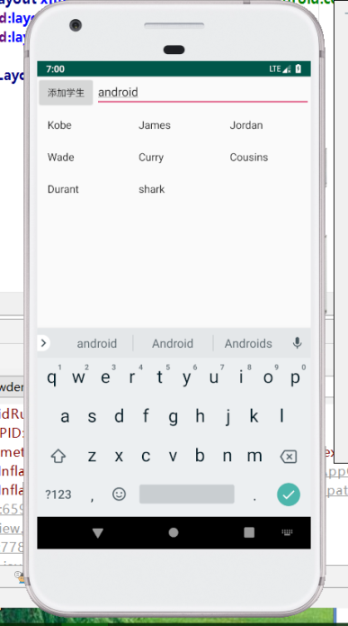* }  
}

Spinner

两种设置数据源的方式

（1）适配器

（2）直接在布局文件设置属性（资源文件）

显示下拉内容

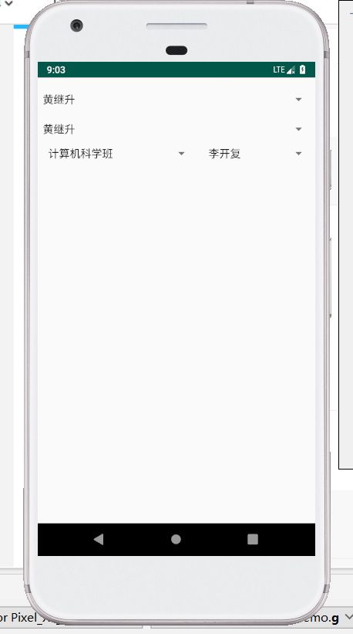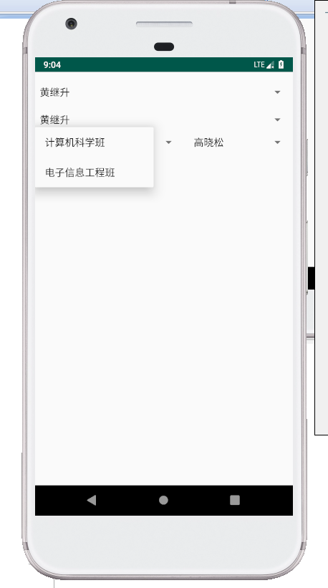

AndroidManifest.xml

……

<**activity android:name=".Demo2Activity"**>*<!--这里可以更改默认Activity启动项-->*

……

activity_demo2.xml

*<?***xml version="1.0" encoding="utf-8"***?>*<**LinearLayout xmlns:android="http://schemas.android.com/apk/res/android"  
 android:layout_width="match_parent"  
 android:layout_height="match_parent"  
 android:orientation="vertical"**>  
  
 <**Spinner  
 android:id="@+id/spinner1"  
 android:layout_width="match_parent"  
 android:layout_height="wrap_content"** />  
  
 <**Spinner  
 android:id="@+id/spinner2"  
 android:layout_width="match_parent"  
 android:layout_height="wrap_content"  
 android:entries="@array/str_data"**/>  
  
 <**LinearLayout  
 android:layout_width="match_parent"  
 android:layout_height="wrap_content"  
 android:orientation="horizontal"**>  
  
 <**Spinner  
 android:id="@+id/spnGrade"  
 android:layout_width="wrap_content"  
 android:layout_height="wrap_content"  
 android:layout_weight="1"** />  
  
 <**Spinner  
 android:id="@+id/spnStudent"  
 android:layout_width="wrap_content"  
 android:layout_height="wrap_content"  
 android:layout_weight="1"** />  
 </**LinearLayout**>  
</**LinearLayout**>

Demo2Activity.java

**package** com.amaker.hjs.gridviewdemo.gridviewspinner;  
  
**import** android.app.Activity;  
**import** android.os.Bundle;  
**import** android.view.View;  
**import** android.widget.AdapterView;  
**import** android.widget.ArrayAdapter;  
**import** android.widget.Spinner;  
**import** java.util.ArrayList;  
**import** java.util.HashMap;  
**import** java.util.List;  
**import** java.util.Map;  
  
**public class** Demo2Activity **extends** Activity {  
 *//数据源1* **private** String[] **data**={  
 **"黄继升"**,  
 **"马化腾"**,  
 **"萧远山"**,  
 **"慕容博"**,  
 **"风清扬"** };  
 **private** Spinner **spinner**;  
  
  
 *//数据源2  
 //班级列表* **private** List<String> **gradeList** = **new** ArrayList<String>();  
 *//班级和学生的映射* **private** Map<String,List<String>> **studentMap** = **new** HashMap<String, List<String>>();  
 *//选中班级后的学生列表* **private** List<String> **selectedStudents** = **new** ArrayList<String>();  
 *//学生列表的适配器  
 //private ArrayAdapter<String> stuAdapter;* **private** Spinner **spnGrade**,**spnStudent**;  
  
  
 @Override  
 **protected void** onCreate(Bundle savedInstanceState) {  
 **super**.onCreate(savedInstanceState);  
 setContentView(R.layout.***activity_demo2***);  
  
 **spinner** = (Spinner) findViewById(R.id.***spinner1***);  
 *//第一种方式* **spinner**.setAdapter(**new** ArrayAdapter<String>(  
 **this**,  
 android.R.layout.***simple_dropdown_item_1line***, *//下拉式的子项目控件布局* android.R.id.***text1***,  
 **data** ));  
  
  
 fillData(); *//先将数据源进行填充数据* **spnGrade** = (Spinner) findViewById(R.id.***spnGrade***);  
 **spnStudent** = (Spinner) findViewById(R.id.***spnStudent***);  
  
 **spnGrade**.setAdapter(**new** ArrayAdapter<String>(  
 **this**,  
 android.R.layout.***simple_list_item_1***,  
 android.R.id.***text1***,  
 **gradeList** ));  
  
 *//注意，由于stuAdapter会被匿名内部类访问到，如果在局部方法里声明，就必须申明为final，不然就外放到外部类作为成员变量。* **final** ArrayAdapter<String> stuAdapter = **new** ArrayAdapter<String>(**this**, android.R.layout.***simple_list_item_1***, android.R.id.***text1***, **selectedStudents**);  
 **spnStudent**.setAdapter(stuAdapter);  
  
 *//Spinner中项被选中* **spnGrade**.setOnItemSelectedListener(**new** AdapterView.OnItemSelectedListener() {  
 @Override  
 **public void** onItemSelected(AdapterView<?> parent, View view, **int** position, **long** id) {  
 *//第一次打开Activity就会被调用到  
 //Toast.makeText(Demo2Activity.this,gradeList.get(position),Toast.LENGTH_LONG).show();  
  
 //spnStudent更新显示* **selectedStudents**.clear();*//先清空列表* String selectGrade = **gradeList**.get(position);  
 **selectedStudents**.addAll(**studentMap**.get(selectGrade)); *//当前选中班级对应的学生集合整体一次性添加进来  
  
 //数据源更改了，适配器进行通知* stuAdapter.notifyDataSetChanged();  
 }  
  
 @Override  
 **public void** onNothingSelected(AdapterView<?> parent) {  
  
 }  
 });  
 }  
  
 *//这里先将数据源写死，后期我们可以从数据库中去拿，从xml文件中做解析，都可以* **private void** fillData(){  
 **gradeList**.add(**"计算机科学班"**);  
 **gradeList**.add(**"电子信息工程班"**);  
  
 List<String> stuCs = **new** ArrayList<String>();  
 stuCs.add(**"马化腾"**);  
 stuCs.add(**"李开复"**);  
  
 List<String> stuEe = **new** ArrayList<String>();  
 stuEe.add(**"李健"**);  
 stuEe.add(**"高晓松"**);  
  
 **studentMap**.put(**gradeList**.get(0),stuCs);  
 **studentMap**.put(**gradeList**.get(1),stuEe);  
 }  
}