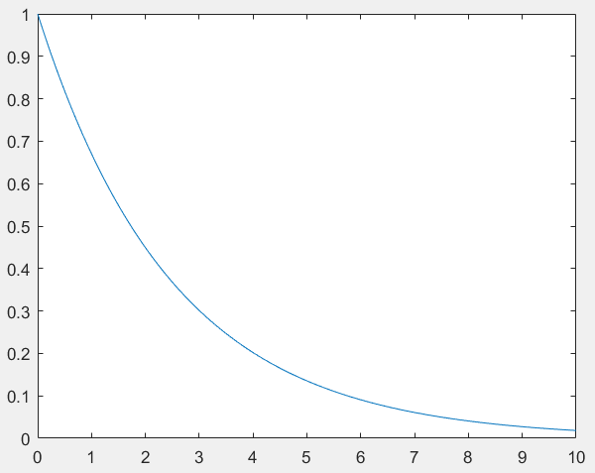（1）clear all;

close all;

t= 0:0.01:10;

A=1;

a=-0.4;

ft=A\*exp(a\*t);

plot(t,ft);

（2）clear all;

close all;

t=-3:0.001:3;

ft=tripuls(t,4,0.5);

plot(t,ft);

ft1=tripuls(t,4,1);

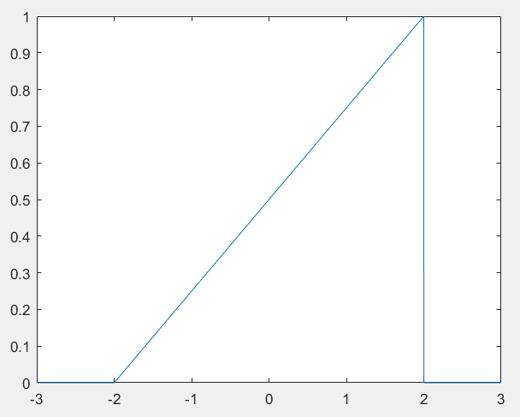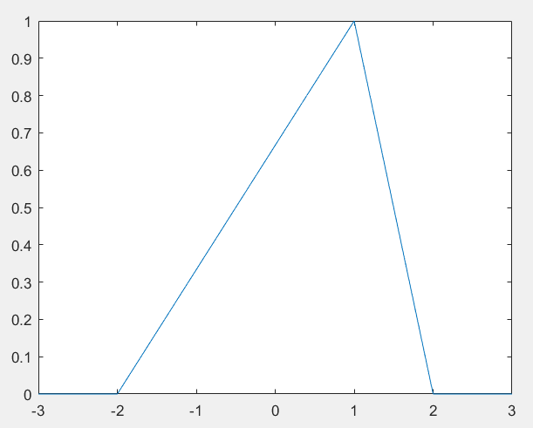 figure,plot(t,ft1);

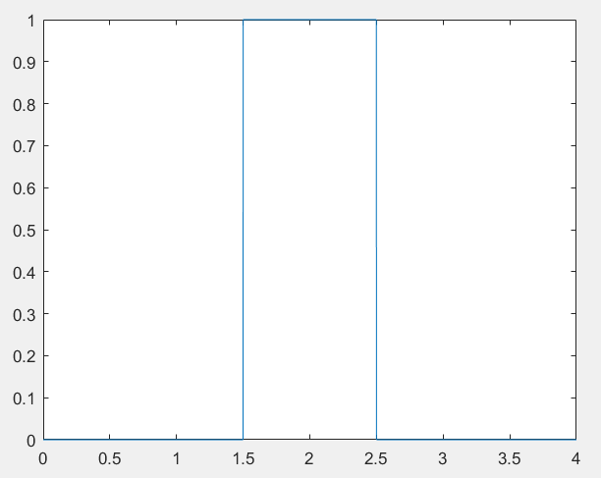

（3）clear all;

close all;

t=0:0.001:4;

T=1;

Ft=rectpuls(t-2\*T,T);

plot(t,Ft);

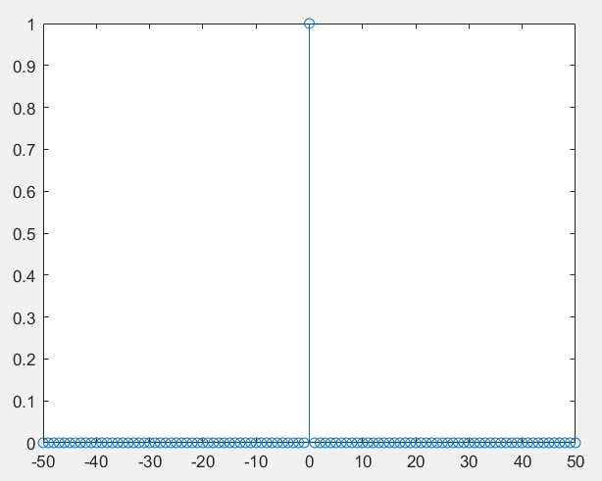（4）clear all;

close all;

k=-50:50;

delta=[zeros(1,50),1,zeros(1,50)];

stem(k,delta);

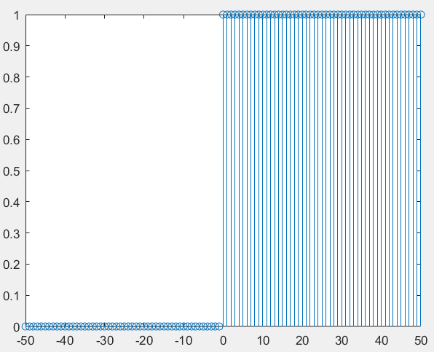

（5）clear all;

close all;

k=-50:50;

uk=[zeros(1,50),ones(1,51)];

stem(k,uk);

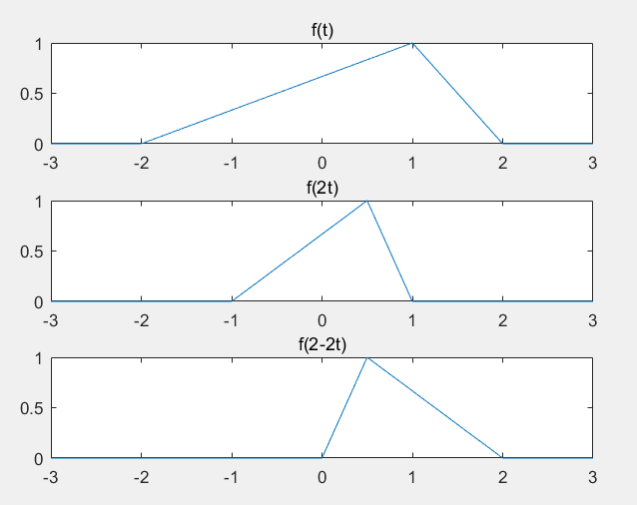（6）clear all;

close all;

t=-3:0.001:3;

ft=tripuls(t,4,0.5);

subplot(3,1,1);

plot(t,ft);

title('f(t)');

ft1=tripuls(2\*t,4,0.5);

subplot(3,1,2);

plot(t,ft1);

title('f(2t)');

ft2=tripuls((2-2\*t),4,0.5);

subplot(3,1,3);

plot(t,ft2);

title('f(2-2t)');

（7）clear all;

close all;

h=0.001;

t=-3:h:3;

ft=tripuls(t,4,0.5);

subplot(3,1,1);

plot(t,ft);

title('f(t)');

y1=diff(ft)\*1/h;

subplot(3,1,2);

plot(t(1:length(t)-1),y1);

title('the differentiation of f(t)');

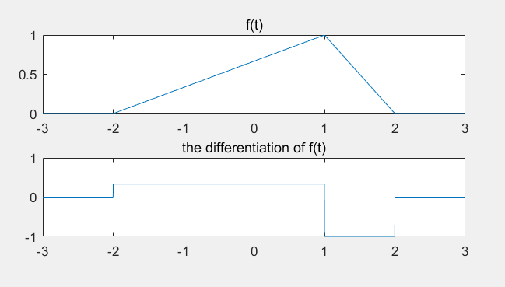

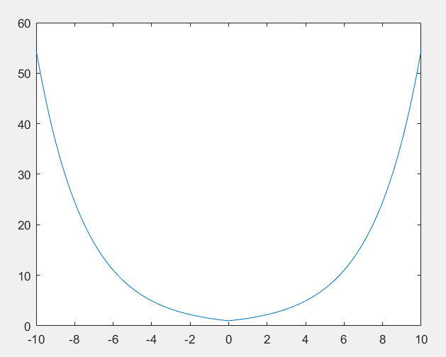

（8）clear all;

close all;

t= -10:0.01:10;

A=1;

a=-0.4;

ft=A\*exp(abs(a\*t));

plot(t,ft);

（9）clear all;

close all;

t= -1:0.01:4;

A=0.5;

a=-2;

t0=0;

t1=1;

h=0.01;

ut=stepfun(t,t0);

ft=A\*exp(a\*t);

ht=ft.\*ut;

axis([-1,4,-0.5,1.5]);

subplot(3,1,1);

plot(t,ht);

title('f(t)');

xt=stepfun(t,t1);

bt=A\*exp(a\*(t-1));

qt=xt.\*bt;

subplot(3,1,2);

plot(t,qt);

title('f(t-1)');

rt=diff(ht)\*1/h;

subplot(3,1,3);

plot(t(1:length(t)-1),rt);

title('the differentiation of f(t)')

