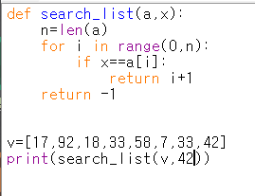

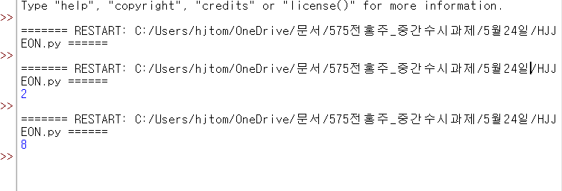

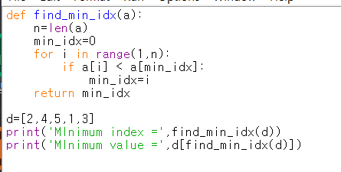

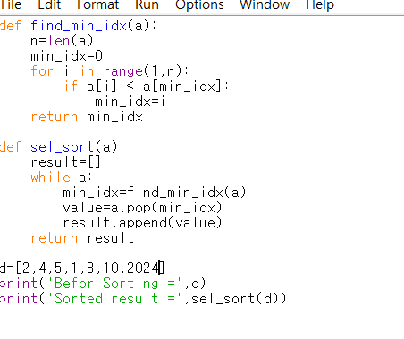

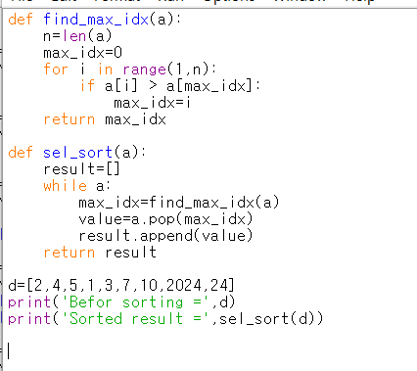

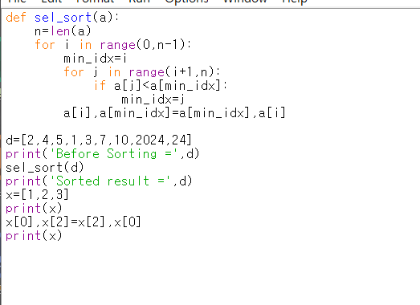

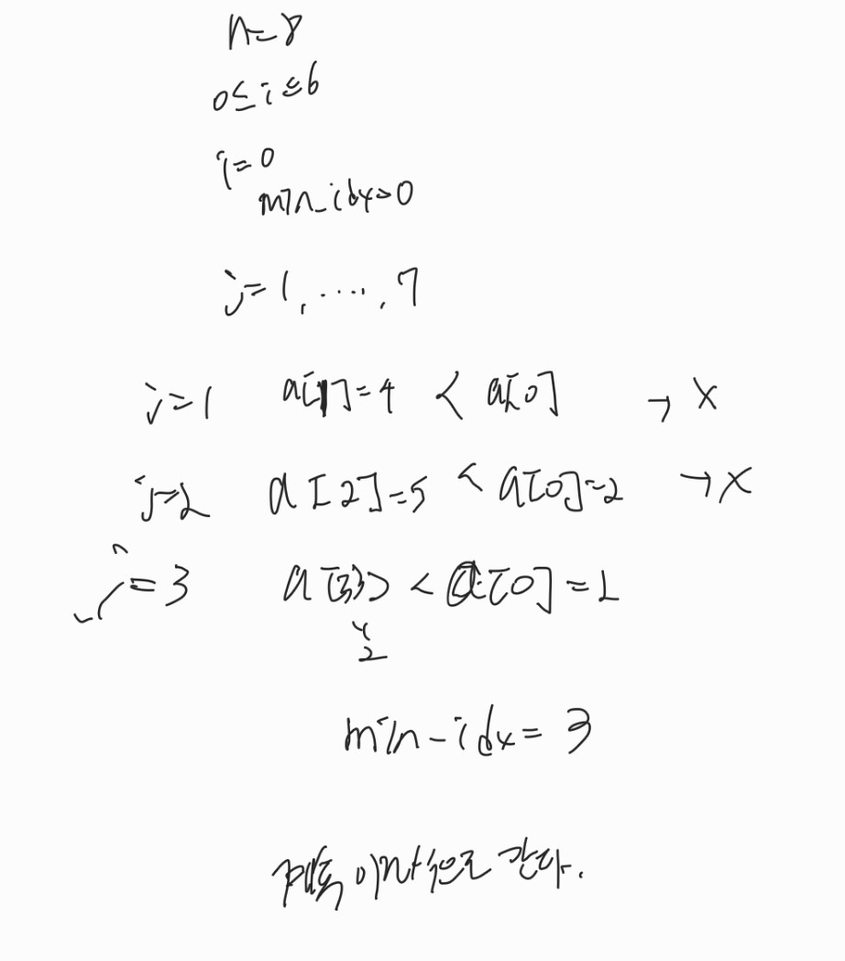

Type "help", "copyright", "credits" or "license()" for more information.

======= RESTART: C:/Users/hjtom/OneDrive/문서/575전홍주_중간수시과제/5월24일/HJJEON.py ======

======= RESTART: C:/Users/hjtom/OneDrive/문서/575전홍주_중간수시과제/5월24일/HJJEON.py ======

2

======= RESTART: C:/Users/hjtom/OneDrive/문서/575전홍주_중간수시과제/5월24일/HJJEON.py ======

8

====== RESTART: C:/Users/hjtom/OneDrive/문서/575전홍주_중간수시과제/5월24일/HJJEON2.py ======

5

====== RESTART: C:/Users/hjtom/OneDrive/문서/575전홍주_중간수시과제/5월24일/HJJEON2.py ======

0

====== RESTART: C:/Users/hjtom/OneDrive/문서/575전홍주_중간수시과제/5월24일/HJJEON2.py ======

3

====== RESTART: C:/Users/hjtom/OneDrive/문서/575전홍주_중간수시과제/5월24일/HJJEON2.py ======

3

MInimum value = 1

====== RESTART: C:/Users/hjtom/OneDrive/문서/575전홍주_중간수시과제/5월24일/HJJEON2.py ======

MInimum index = 3

MInimum value = 1

====== RESTART: C:/Users/hjtom/OneDrive/문서/575전홍주_중간수시과제/5월24일/HJJEON3.py ======

Maximum index = 2

Maximum value = 5

====== RESTART: C:\Users\hjtom\OneDrive\문서\575전홍주_중간수시과제\5월24일\HJJEON2.py ======

Befor Sorting = [2, 4, 5, 1, 3, 10, 2024]

Sorted result = [1, 2, 3, 4, 5, 10, 2024]

====== RESTART: C:\Users\hjtom\OneDrive\문서\575전홍주_중간수시과제\5월24일\HJJEON2.py ======

Befor Sorting = [2, 4, 5, 1, 3, 10, 2024]

Sorted result = [1, 2, 3, 4, 5, 10, 2024]

====== RESTART: C:\Users\hjtom\OneDrive\문서\575전홍주_중간수시과제\5월24일\HJJEON3.py ======

Befor sorting = [2, 4, 5, 1, 3, 7, 10, 2024, 24]

Sorted result = [2024, 24, 10, 7, 5, 4, 3, 2, 1]

====== RESTART: C:/Users/hjtom/OneDrive/문서/575전홍주_중간수시과제/5월24일/HJJEON4.py ======

Before Sorting = [2, 4, 5, 1, 3, 7, 10, 2024, 24]

Sorted result = None

====== RESTART: C:/Users/hjtom/OneDrive/문서/575전홍주_중간수시과제/5월24일/HJJEON4.py ======

Before Sorting = [2, 4, 5, 1, 3, 7, 10, 2024, 24]

Sorted result = [2, 4, 5, 1, 3, 7, 10, 2024, 24]

====== RESTART: C:/Users/hjtom/OneDrive/문서/575전홍주_중간수시과제/5월24일/HJJEON4.py ======

Before Sorting = [2, 4, 5, 1, 3, 7, 10, 2024, 24]

Sorted result = None

====== RESTART: C:/Users/hjtom/OneDrive/문서/575전홍주_중간수시과제/5월24일/HJJEON4.py ======

Before Sorting = [2, 4, 5, 1, 3, 7, 10, 2024, 24]

Sorted result = None

====== RESTART: C:/Users/hjtom/OneDrive/문서/575전홍주_중간수시과제/5월24일/HJJEON4.py ======

Before Sorting = [2, 4, 5, 1, 3, 7, 10, 2024, 24]

Sorted result = [2, 4, 5, 1, 3, 7, 10, 2024, 24]

====== RESTART: C:/Users/hjtom/OneDrive/문서/575전홍주_중간수시과제/5월24일/HJJEON4.py ======

Before Sorting = [2, 4, 5, 1, 3, 7, 10, 2024, 24]

Sorted result = [2, 4, 5, 1, 3, 7, 10, 2024, 24]

Traceback (most recent call last):

File "C:/Users/hjtom/OneDrive/문서/575전홍주_중간수시과제/5월24일/HJJEON4.py", line 14, in <module>

x[1,2,3]

NameError: name 'x' is not defined

====== RESTART: C:/Users/hjtom/OneDrive/문서/575전홍주_중간수시과제/5월24일/HJJEON4.py ======

Before Sorting = [2, 4, 5, 1, 3, 7, 10, 2024, 24]

Sorted result = [2, 4, 5, 1, 3, 7, 10, 2024, 24]

[1, 2, 3]

[3, 2, 1]

====== RESTART: C:/Users/hjtom/OneDrive/문서/575전홍주_중간수시과제/5월24일/HJJEON4.py ======

Before Sorting = [2, 4, 5, 1, 3, 7, 10, 2024, 24]

Sorted result = [1, 2, 3, 4, 5, 7, 10, 24, 2024]

[1, 2, 3]

[3, 2, 1]