kinem_cat has two functionalities, bin analysis and coordinate analysis. Bin

analysis is used to normalize steps and look at certain properties during

a step cycle. Coordinate analysis is used to find the coordinate of each step

of a recording and to find the stride lengths and step duration times.

To process **MULTIPLE** files, the VZ text files should be organized in folders as such:

ALL TEXT FILES \ Recording day 1, Recording day 2, ... \ Task1, Task2, \ VZ Text Files

The names for the folders above are placeholders.

Example:

'ALL TEXT FILES' \ '7.21.13', '7.22.13', '7.23.13'... \ 'Rocks', 'Flat' \ 'Toe.txt', 'Wrist.txt' ...

When prompted to select a folder, select the folder holding all of the recording dates (Example: ‘All Text Files’)

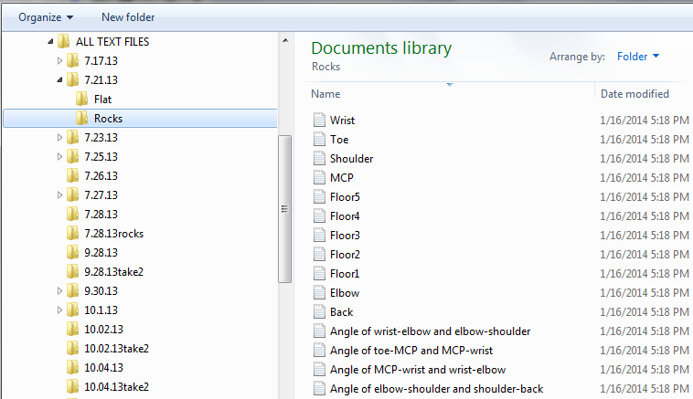

To process **ONE** file, the VZ text files should be organized as such:

Recording day \ Task1, Task 2 \ VZ Text Files

Example: ‘7.21.13’ \ ‘Rocks’, ‘Flat’ \ ‘Toe.txt’,’Wrist.txt’…

When prompted to select a folder, select the folder with the tasks (Example: ‘7.21.13’)