<https://gist.githubusercontent.com/moradology/d87b8c99ee075e48cccb4d6b741cca7a/raw/43300714934d4dbd028d9d86b90244a89cad45cd/drones.csv>

Filter:



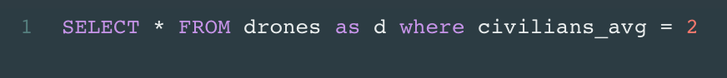



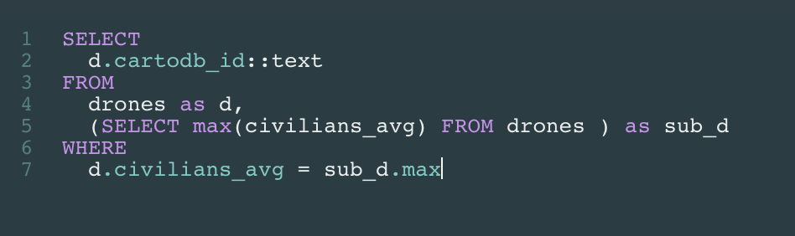

Time Zone:

Unix time

Draw lines:

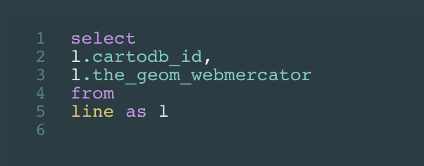

Do the buffer:

