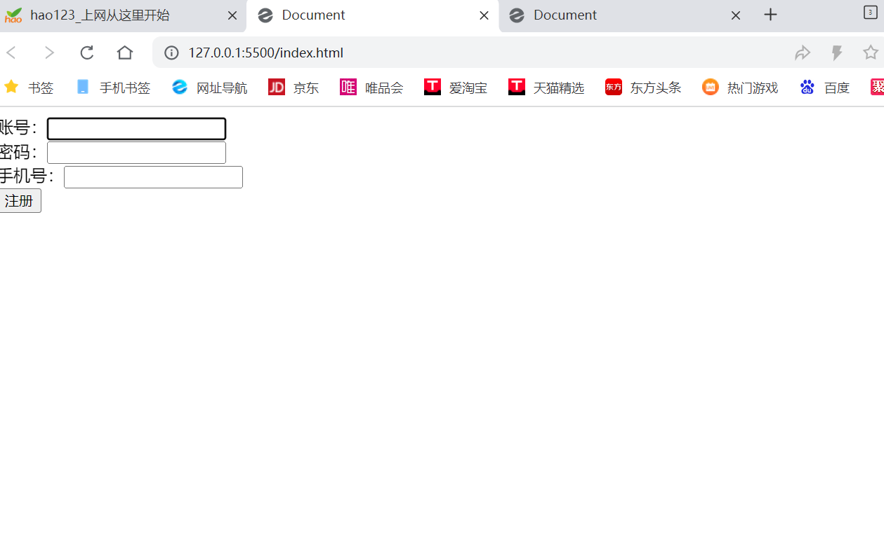

<!DOCTYPE html>

<html lang="en">

<head>

    <meta charset="UTF-8">

    <meta name="viewport" content="width=device-width, initial-scale=1.0">

    <title>Document</title>

</head>

<body>

    账号：<input type="text" id="name"><br>

    密码：<input type="password" id="password"><br>

    手机号：<input type="text" id="sjh"><br>

    <button id="getData">注册</button>

    <script>

        document.querySelector("#getData").onclick = function () {

            var uname = document.getElementById("name").value;

            var Password = document.getElementById("password").value;

            var Sjh = document.getElementById("sjh").value;

            console.log(uname);

            console.log(Password);

            console.log(Sjh);

            localStorage.setItem("uname", uname)

            localStorage.setItem("Password", Password)

            localStorage.setItem("Sjh", Sjh)

        }

    </script>

</body>

</html>

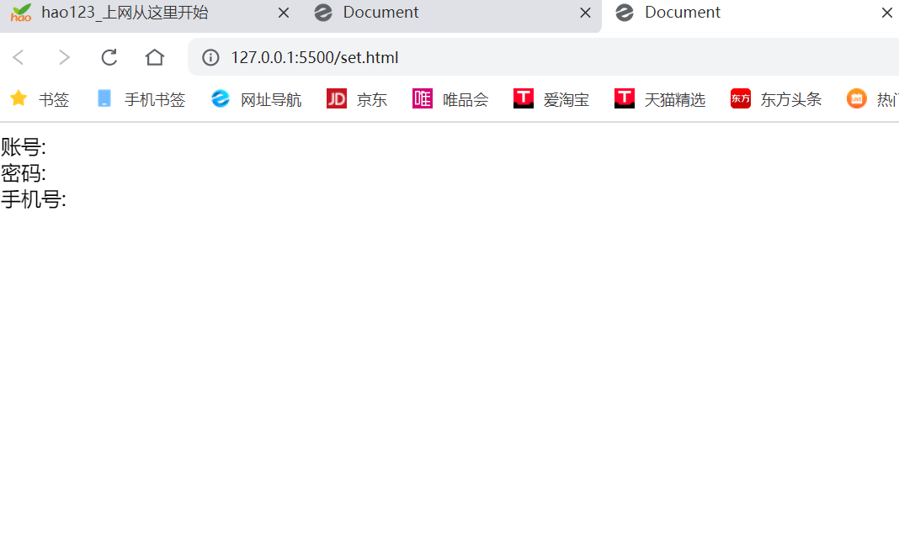

<!DOCTYPE html>

<html lang="en">

<head>

    <meta charset="UTF-8">

    <meta name="viewport" content="width=device-width, initial-scale=1.0">

    <title>Document</title>

</head>

<body>

    <span>账号:</span>

    <span id="setName"></span><br>

    <span>密码:</span>

    <span id="setPassword"></span><br>

    <span>手机号:</span>

    <span id="setSjh"></span>

    <script>

        var newname = document.getElementById("setName");

        window.addEventListener("storage", function (e) {

            newname.innerHTML = localStorage.getItem("uname");

        })

        var newpassword = document.getElementById("setPassword");

        window.addEventListener("storage", function (e) {

            newpassword.innerHTML = localStorage.getItem("Password");

        })

        var newsjh = document.getElementById("setSjh");

        window.addEventListener("storage", function (e) {

            newsjh.innerHTML = localStorage.getItem("Sjh");

        })

    </script>

</body>

</html>