AgentLasso Competitive Landscape

Products in the Market Offering Comparable Capabilities

Executive Summary
Yes — there is an active and increasingly crowded market of products offering capabilities that overlap with AgentLasso, including the two you named (agentgateway.dev and Maxim's Bifrost) and roughly a dozen others. AgentLasso sits at a convergence zone where two waves are colliding on the same "tool-call chokepoint": AI/LLM gateways extending downstream into Model Context Protocol (MCP) tool governance, and AI-security/guardrail platforms extending into the tool layer that content scanners miss 1.
By mid-2026 the MCP-gateway market had already stratified into two tiers: "Open-source projects like Bifrost, ToolHive, and agentgateway focus on performance and developer experience. Enterprise platforms like TrueFoundry, Composio, and Lunar MCPX add governance, compliance, and managed operations." 2.
The headline conclusion: no single competitor replicates AgentLasso's full combination, but on almost every individual capability there is a strong — often better-resourced — competitor. AgentLasso's clearest, and essentially unique, differentiator is its per-tool-call 0–100 risk score mapped to a three-tier allow / intervene / block decision, with an automated human-in-the-loop "intervene" band. Every competitor's tool-call decision is effectively binary (allow/deny or flag/block). AgentLasso's most exposed flanks are performance benchmarks, LLM-provider breadth, enterprise backing, shipped identity auth, and compliance attestations — all areas where the leading competitors are ahead.
This analysis frames AgentLasso as the complete solution — the core Guard library plus the Agent Gateway (sidecar) and its control plane — and benchmarks it against the field.

What AgentLasso Does (Reference Frame)
AgentLasso positions itself as a runtime safety and reliability layer that "intercepts every tool call an AI agent makes, scores its risk, and enforces safety policies — regardless of which framework the agent runs on" AgentLasso README. Enforcement is moved out of the agent entirely: "The agent never calls tools directly. It calls the sidecar. The sidecar validates the call against policies, and if allowed, proxies it to the real tool endpoint" AgentLasso architecture.
Its ten capability dimensions form the comparison frame:
- Tool-call policy enforcement — a Guard engine validates every call, with "0-100 risk scores with configurable thresholds (allow / intervene / block)" AgentLasso README{evidence: "Risk scoring — 0-100 risk scores with configurable thresholds (allow / intervene / block)"} and glob-based block/allow lists with true hot-reload AgentLasso architecture.
- Three deployment modes from one image — per-pod sidecar, shared multi-agent gateway, and global NAT/transparent proxy, where "All three modes use the same Docker image and the same APIs" AgentLasso architecture.
- Control plane — pushes tools, policy, quota, MCP servers, and agent-auth dynamically: "Instead of hardcoding tools and policies into the sidecar, the control plane pushes configuration to it dynamically" AgentLasso architecture.
- LLM gateway — six providers with smart routing, fallback chains, A/B experiments, and four-way quota enforcement (rate / budget / model allowlist / max-tokens) where "quotas control HOW MUCH" AgentLasso architecture.
- MCP support, OpenTelemetry observability, per-agent auth, language-agnostic HTTP integration, Apache-2.0 open-core licensing, and intent caching round out the frame.

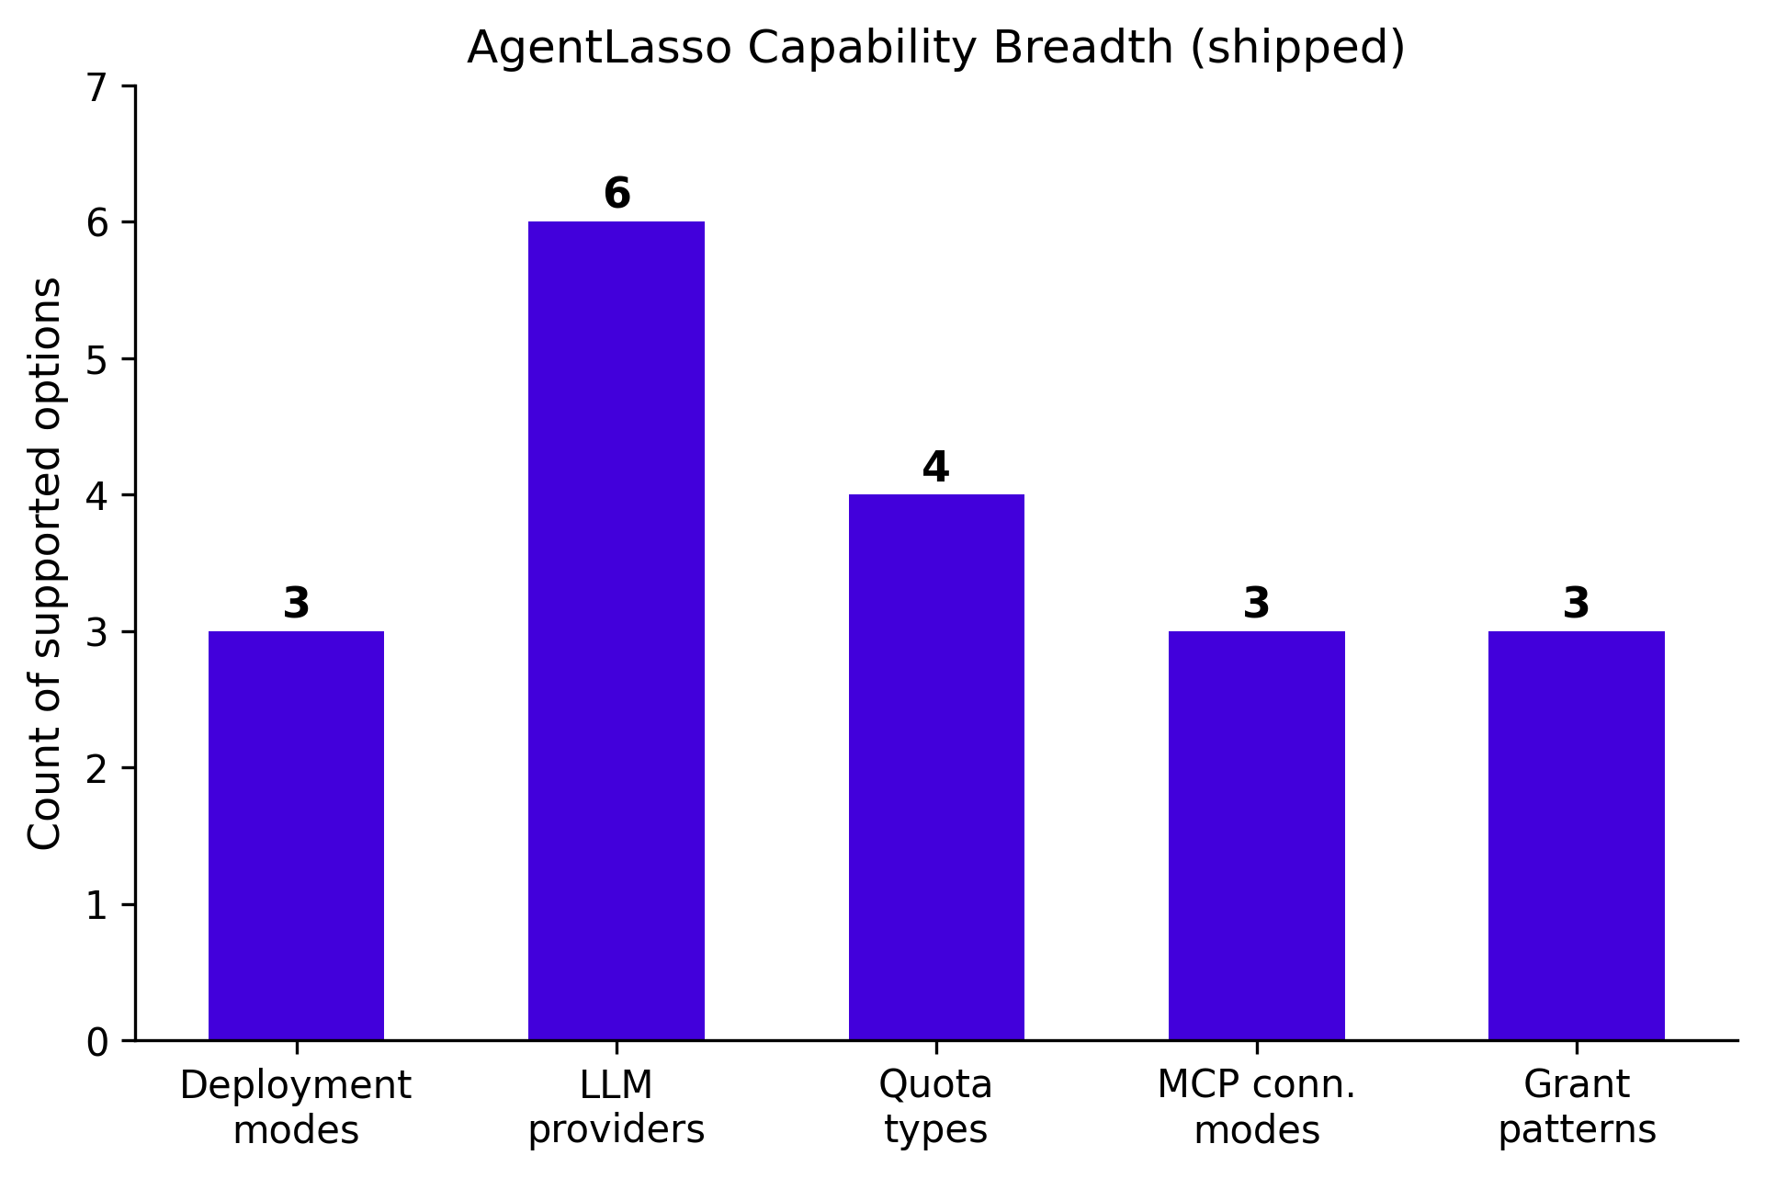
Figure 1: AgentLasso's shipped capability breadth: 3 deployment modes, 6 LLM providers, 4 quota-enforcement types, 3 MCP connection modes, and 3 agent-auth grant patterns.
Two maturity caveats matter for the comparison: AgentLasso is Beta AgentLasso pyproject, and two notable capabilities — JWT-based agent auth and template/auto intent caching — are explicitly planned, not shipped.

The Two Named Competitors

agentgateway.dev — the closest architectural competitor
agentgateway is "the first and only data plane built from the ground up for AI agents, governing and securing communication across agent-to-agent, agent-to-tool and agent-to-LLM interactions" 3. Originated by Solo.io and now a Linux Foundation project, it is a Rust-built HTTP/gRPC proxy. It governs tool access with "fine-grained, CEL-based RBAC rules, down to the individual tool name," hiding disallowed tools entirely 4. It routes to "major LLM providers (OpenAI, Anthropic, Gemini, Bedrock, and more) through a unified OpenAI-compatible API with budget and spend controls" 5.

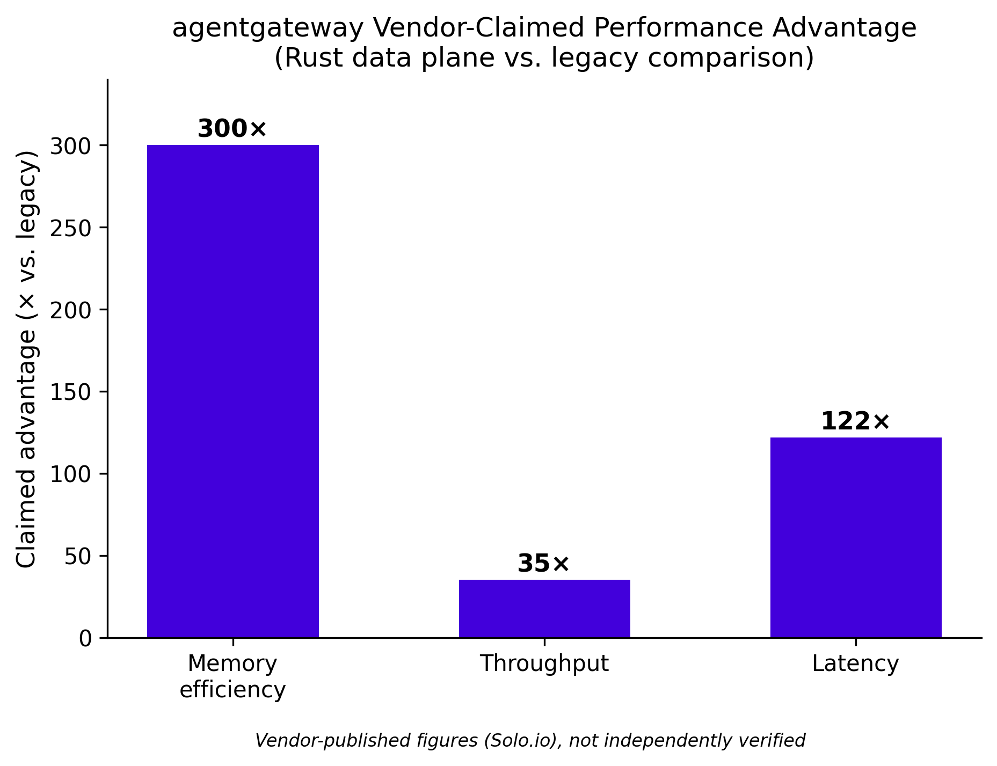
Figure 2: agentgateway's vendor-claimed performance advantages (memory, throughput, latency) of its Rust data plane vs. a legacy comparison. Figures are Solo.io-published and not independently verified.
Where it leads AgentLasso: native A2A support, broader provider routing, mature auth (OAuth on-behalf-of flows that "prevent confused deputy attacks" 6), published performance figures, and the strongest institutional backing, with "contributors from leading organizations such as Amazon Web Services (AWS), Cisco, Huawei, IBM, Microsoft, Red Hat, Shell and Zayo" 3. Its decisioning, however, is binary allow/deny — it has no risk-scored intervene tier — and it assumes Kubernetes / Gateway-API platform sophistication.

Bifrost (Maxim AI) — the closest LLM+MCP+cost competitor
Bifrost is a unified plane that "unifies LLM routing, MCP tool execution, and agent infrastructure behind one governed plane, with 11 microseconds of overhead per request at 5,000 RPS in sustained benchmarks" 7. Built in Go, it unifies "23+ providers (OpenAI, Anthropic, AWS Bedrock, Google Vertex, and more) through a single OpenAI-compatible API" 8, with hierarchical "virtual keys, teams, and customer budgets" 8 and built-in semantic caching.
Where it leads AgentLasso: raw provider breadth, semantic caching, enterprise compliance ("SOC 2 Type II, HIPAA, GDPR, and ISO 27001" 7), and headline performance. Its safety model, though, is "suggestion, not execution" — it "never automatically executes tool calls unless Agent Mode is explicitly enabled" 9 — rather than a risk-scored enforcement decision. One important caveat: Bifrost's performance numbers are vendor self-benchmarked and not independently verified.

The Broader Field
Beyond the two named products, the landscape splits into two overlapping categories.
AI/LLM & MCP gateways (infrastructure-first): Kong AI Gateway, Portkey, LiteLLM, Cloudflare AI Gateway, TrueFoundry, Lunar MCPX, ToolHive, LangDB, and Helicone. Of these, the closest direct overlaps with AgentLasso's tool-governance core are ToolHive (Stacklok/Red Hat), an "enterprise-grade open source (Apache 2.0) platform for running and managing Model Context Protocol (MCP) servers" that "enforces identity and access policy per request" 10 with a Cedar-based authorization engine 11, and Lunar MCPX (Lunar.dev), where "Agent Access Control gives you per-agent scope at the gateway layer, so each agent only sees the tools it needs for its job" 12.
Agent runtime governance / guardrails (security-first): Lakera Guard, NeuralTrust, Invariant Labs, and Lasso Security. Two matter most here. Lakera Guard (now part of Check Point) is the closest functional competitor on runtime tool-call control — its "Tool Allow/Deny List enforces which tools an agent may call at runtime, at the moment of tool invocation" 13, and its June-2026 update lets policies "configure detectors on agent interaction points, including tool calls and tool responses" 14 — but it delivers this as one detector within a content/prompt-injection API, not a scored allow/intervene/block engine. Lasso Security's MCP Gateway is the closest on naming and security intent (and a genuine source of market confusion): an open-source proxy that "acts as a proxy and orchestrator for all MCP interactions, embedding critical security, governance, and monitoring capabilities" 15. It is the one competitor that also uses "risk score" language, but it scores the agent, not the call: "Get a risk score for each agent based on permissions, actions, tool descriptions... If an agent triggers a high risk score, manage or block it instantly" 16.

Capability Comparison
The matrix below compares AgentLasso against the six closest-overlap competitors. Legend: ✔ strong/native · ◑ partial/adjacent · ✖ absent.

Governance & Safety Enforcement
Dimension | AgentLasso | agentgateway | Bifrost | Lakera Guard | Lasso Sec. MCP GW | ToolHive | Lunar MCPX
Tool-call policy enforcement | ✔ every call | ✔ CEL RBAC per tool | ✔ per virtual key | ✔ allow/deny at invocation | ✔ proxy governs all MCP | ✔ per-request Cedar | ✔ per-agent scope
Risk scoring (0–100 numeric) | ✔ per tool call | ✖ | ✖ | ◑ sensitivity | ◑ per- agent | ✖ | ✖
Three-tier allow/intervene/block | ✔ ≤30 / ≤70 / >70 | ◑ binary | ◑ suggest + allow-lists | ◑ flag/block | ◑ block high-risk agent | ◑ allow/deny/modify | ◑ allow/deny
Human-in-the-loop intervene tier | ✔ intervention gateway | ✖ | ◑ suggestion mode | ✖ | ✖ | ◑ webhook | ✖
Anomaly detection (loop/drift/hallucination) | ✔ core library | ✖ | ◑ add-ons | ✔ prompt-attack | ✔ behavioral | ✖ | ✖
Bypass-proof (no direct agent→tool path) | ✔ architectural | ✔ credential isolation | ✔ credential isolation | ◑ inline screening | ✔ proxy | ✔ container isolation | ✔ middleware

Protocols, Routing & Cost
Dimension | AgentLasso | agentgateway | Bifrost | Lakera Guard | Lasso Sec. MCP GW | ToolHive | Lunar MCPX
MCP support | ✔ embedded/remote/stdio | ✔ federation + OpenAPI→MCP | ✔ client+server aggregation | ◑ screens calls | ✔ MCP-native | ✔ lifecycle + proxy | ✔ multi-server
A2A support | ✖ | ✔ native | ◑ agents framing | ✖ | ✖ | ✖ | ✖
LLM multi-provider routing | ✔ 6 providers | ✔ ~20 providers | ✔ 23+ / 1000+ models | ✖ | ✖ | ✖ | ✖
Quota / budget / cost controls | ✔ 4-way | ✔ denial-of-wallet | ✔ hierarchical budgets | ✖ | ✖ | ✖ | ◑ metrics
Semantic / intent caching | ◑ exact-match | ◑ proxy caching | ✔ semantic cache | ✖ | ✖ | ✖ | ◑ dynamic selection

Deployment, Control Plane, Observability & Maturity
Dimension | AgentLasso | agentgateway | Bifrost | Lakera Guard | Lasso Sec. MCP GW | ToolHive | Lunar MCPX
Deployment modes | ✔ sidecar/shared/NAT (1 image) | ✔ VM/container/K8s | ✔ single binary, in-VPC | ◑ managed API | ◑ self-host proxy | ◑ local + K8s | ◑ self-host
Zero-agent-code transparent mode | ✔ Istio/Envoy/DNS | ◑ URL repoint | ◑ drop-in proxy | ✔ no prompt changes | ◑ compatible | ◑ proxy | ◑ middleware
Control plane & hot-reload | ✔ /config push | ✔ xDS controller | ✔ web UI | ◑ policy console | ◑ config-driven | ✔ K8s operator | ✔ central control
Observability / tracing | ✔ OTel + live viewer | ✔ OTel stack | ✔ Prometheus + OTel | ✔ screening logs | ✔ audit | ✔ platform | ✔ full visibility
Agent auth | ◑ deny-by-default (JWT planned) | ✔ JWT/OAuth OBO | ✔ virtual keys + SSO | ◑ detector | ◑ plugin-based | ✔ OIDC + Cedar | ✔ per-agent ACL
Licensing / backing | Apache-2.0, indie | Apache-2.0, Linux Foundation | Apache-2.0, Maxim AI | Commercial, Check Point | MIT, Lasso Security | Apache-2.0, Stacklok/Red Hat | OSS + commercial
Maturity | Beta | v1.2–1.3 OSS + enterprise | Vendor-benchmarked | Production | Launched May 2026 | Active, K8s lineage | Production

Where AgentLasso Is Differentiated
The risk-scored intervene tier is genuinely rare. AgentLasso is the only product in this set that assigns a numeric 0–100 risk score to every individual tool call and maps it to a three-way decision — allow, intervene (human review), block — as a built-in gateway behavior. Every competitor's tool-call decision is effectively binary. The market does have graded tiering, but only as conceptual CISO frameworks where "Agent actions fall into four tiers by reversibility, data sensitivity, and blast radius" 17, or as per-agent SDK primitives. The automated human-in-the-loop intervene band for medium-risk actions is AgentLasso's sharpest technical wedge.

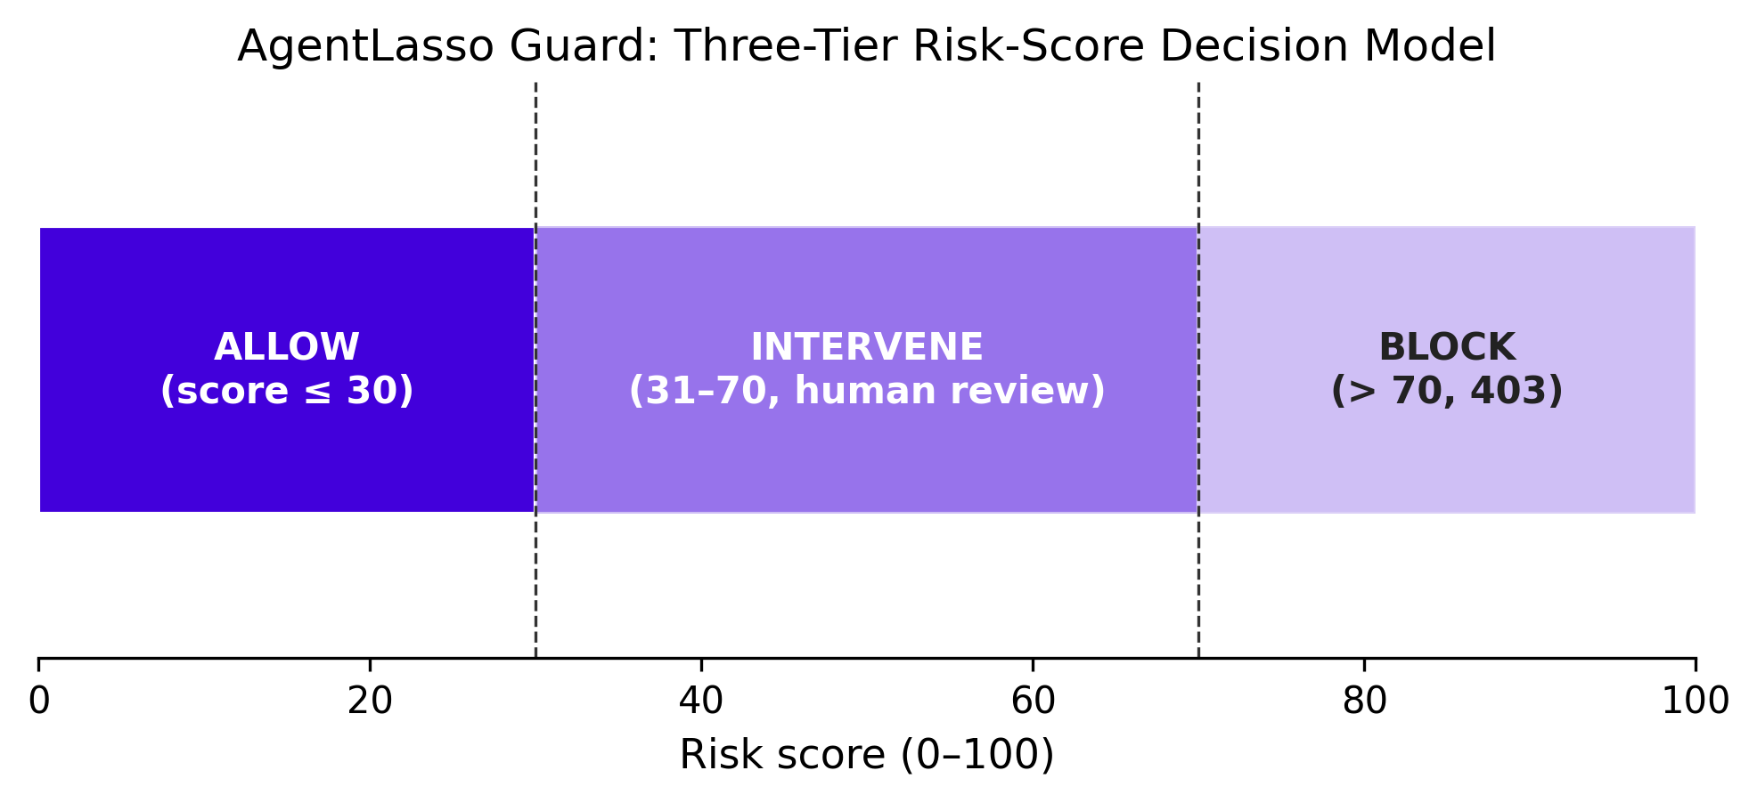
Figure 3: AgentLasso's Guard policy engine maps a 0–100 risk score to three enforcement tiers: allow (≤30), intervene/human-review (31–70), and block (>70).
Three deployment modes from a single image, spanning strong-isolation sidecar to zero-agent-config enterprise NAT proxy, is not fully matched by any single competitor — each is strong on only a subset of that spectrum. Zero-agent-code transparent mode (DNS/service-mesh routing where "the agent doesn't even know the sidecar exists") is matched only in spirit by Lakera's no-prompt-changes deployment, which is an inline API rather than a network-transparent proxy. Finally, behavioral-safety depth (loop/drift/hallucination/contradiction detection, circuit breaker, checkpoint/rollback) bundled with the gateway is something gateway-first competitors do not carry natively.

Where AgentLasso Overlaps Heavily (Table Stakes)
MCP proxying, multi-provider LLM routing, cost/budget governance, per-agent/per-tool authorization, and OpenTelemetry observability are now baseline expectations matched feature-for-feature across the field. AgentLasso has parity on these axes but not leadership — they should be treated as table stakes, not selling points.

Where Competitors Are Ahead
- Performance benchmarks — agentgateway (Rust) and Bifrost (Go) both publish hard throughput/latency numbers; AgentLasso, a Python Beta, publishes none. (Note: competitors' figures are self-benchmarked.)
- Provider breadth — Bifrost (23+) and agentgateway (~20) dwarf AgentLasso's 6 providers.
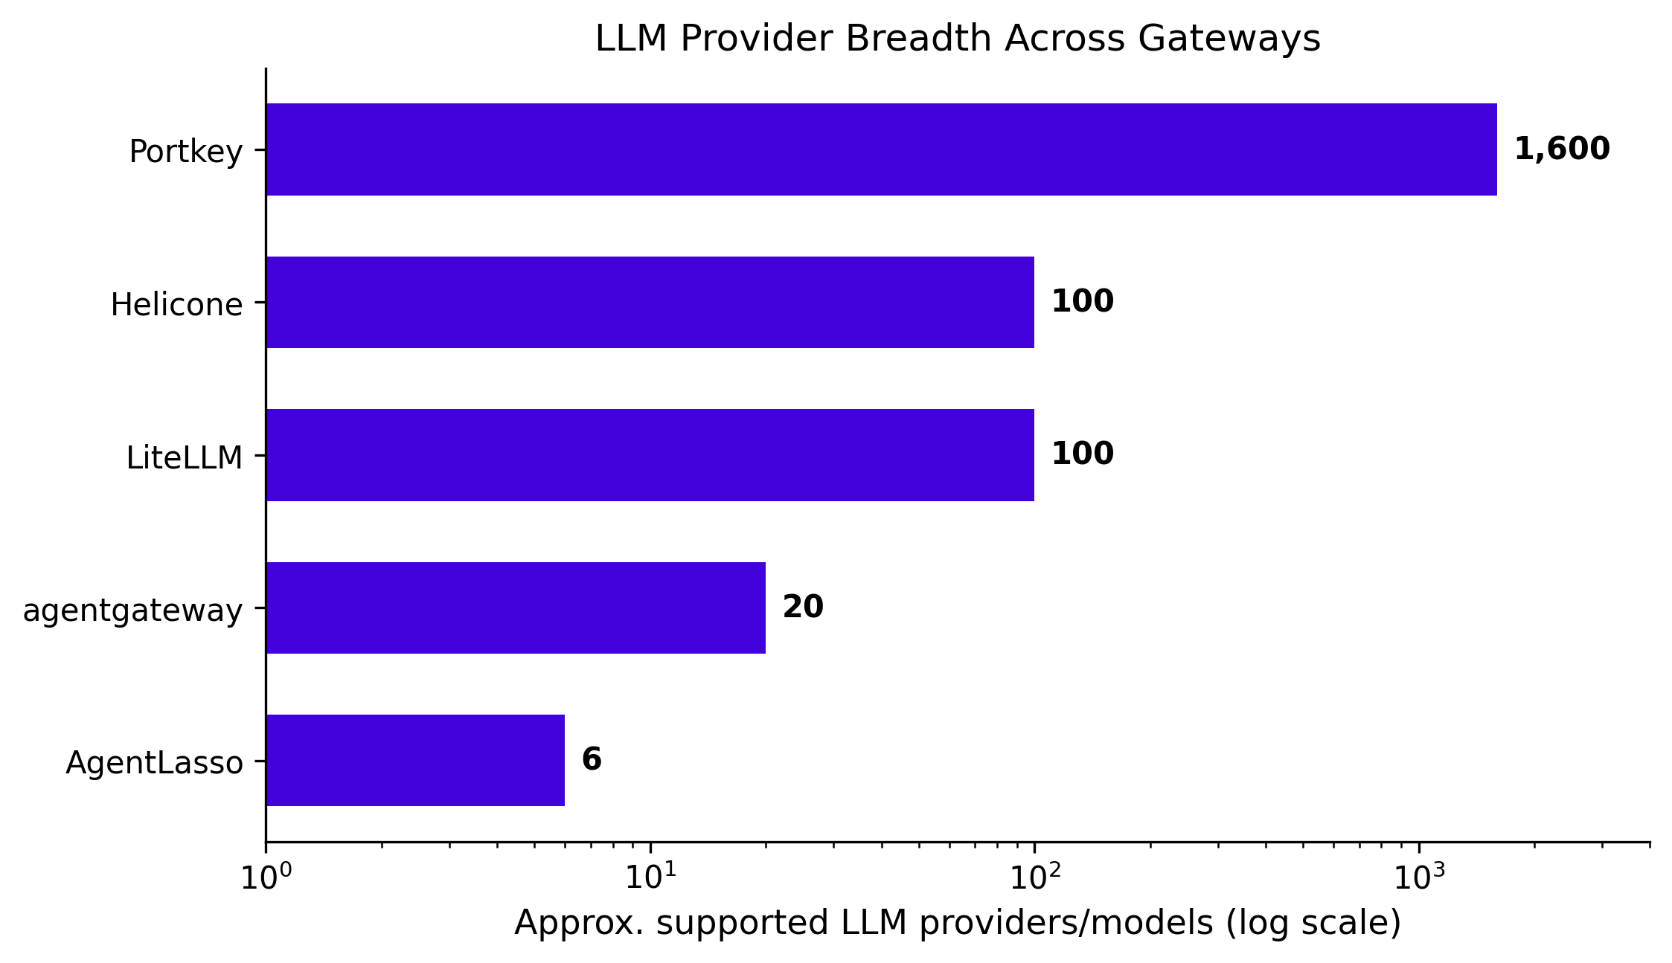
Figure 4: Approximate breadth of LLM provider/model support across gateways. AgentLasso (6 providers) and agentgateway (~20) prioritize governance depth over raw catalog size, while Portkey emphasizes catalog breadth (1,600+).
- Enterprise backing — agentgateway has Linux Foundation governance and AWS/Cisco/IBM/Microsoft/Red Hat contributors; ToolHive is "built by the team behind Kubernetes and is maintained by both Stacklok and Red Hat" 18; Lakera is inside Check Point. AgentLasso is an indie project.
- Shipped identity auth — agentgateway, ToolHive, and Bifrost ship JWT/OAuth/SSO today; AgentLasso's JWT auth is explicitly planned, not shipped.
- Compliance attestations — Bifrost aligns to SOC 2 / HIPAA / GDPR / ISO 27001; AgentLasso has none.

Market Positioning & Defensible Niche
On AgentLasso's core — enforcing policy on the individual tool invocation — the nearest neighbors are not the LLM routers but the tool-governance products. The four closest head-to-head competitors are: agentgateway (architecture), Lakera Guard (runtime tool-call control), Lasso Security MCP Gateway (security intent plus name-confusion risk), and Bifrost (LLM+MCP+cost bundle). ToolHive and Lunar MCPX round out the direct-overlap tier on per-agent MCP authorization but lack risk scoring, an intervene tier, or an LLM-routing layer.
AgentLasso is best understood as a safety-first agent runtime layer rather than an infrastructure gateway. Its defensible position is the combination that no single competitor replicates: a per-tool-call risk score driving a three-tier decision with an automated human-in-the-loop intervene band; three deployment modes (including zero-agent-code transparent NAT) from one image; behavioral-safety depth bundled with the gateway; delivered with one-line HTTP integration on an Apache-2.0 open core.
The strategic risk is that AgentLasso's overlapping capabilities are precisely where better-funded, better-benchmarked, institutionally-backed competitors are strongest. The recommended play: lead with the risk-scored intervene tier and behavioral-safety layer as the wedge, treat gateway/routing/cost features as parity table-stakes, and close the credibility gaps that most threaten enterprise adoption — published performance benchmarks, shipped JWT/identity auth, and compliance attestations. AgentLasso's natural buyer is a team that wants agent-action safety with a graded human-review tier dropped in with zero code — a distinct persona from agentgateway's platform/SRE buyer standardizing many agents at scale 4.

References
[1] https://futureagi.com/blog/agent-runtime-guardrails/
[2] https://www.requesty.ai/blog/mcp-gateway-comparison-2026-enterprise-scalability-security
[3] https://www.linuxfoundation.org/press/linux-foundation-welcomes-agentgateway-project-to-accelerate-ai-agent-adoption-while-maintaining-security-observability-and-governance
[4] https://blog.kubesimplify.com/controlling-mcp-tools-with-agentgateway-on-kubernetes
[5] https://raw.githubusercontent.com/agentgateway/agentgateway/main/README.md
[6] https://www.solo.io/blog/aaif-announcement-agentgateway
[7] https://www.getmaxim.ai/articles/mcp-gateway-the-key-to-governed-enterprise-ai-at-scale/
[8] https://github.com/maximhq/bifrost
[9] https://www.getmaxim.ai/articles/best-mcp-gateway-in-2026-how-bifrost-cuts-token-usage-by-50/
[10] https://raw.githubusercontent.com/stacklok/toolhive/main/README.md
[11] https://stacklok.com/blog/mcp-access-governance-starts-with-rbac/
[12] https://docs.lunar.dev/mcpx/access_control_list/
[13] https://docs.lakera.ai/docs/agent-behavior-defense
[14] https://docs.lakera.ai/changelog/2026-06-01
[15] https://lasso.security/resources/lasso-releases-first-open-source-security-gateway-for-mcp
[16] https://lasso.security/use-cases/agentic-ai-risk-management
[17] https://www.thoughtwavesoft.com/insights/ciso-agentic-approval-gates-framework
[18] https://stacklok.com/download/

