Business Requirements Document (BRD)

Online Coffee ordering app

Project/Initiative

February 2018

Version 1.00

Hk & Hk Technologies.

# Document Revisions

|  |  |  |
| --- | --- | --- |
| Date | Version Number | Document Changes |
| 05/02/2018 | 0.1 | Initial Draft |
| 06/02/2018 | 0.2 | Approvals from stake holders |
| 08/02/2018 | 0.3 | Modified Functionality chart for detailed purpose |
|  |  |  |
|  |  |  |
|  |  |  |
|  |  |  |
|  |  |  |
|  |  |  |

# Approvals

|  |  |  |  |  |
| --- | --- | --- | --- | --- |
| **Role** | **Name** | **Title** | **Signature** | **Date** |
| Project Sponsor | Syed Shahzaib | Shareholder at Café Mini |  |  |
| Business Owner | Musa Raza | Owner at Café Mini |  |  |
| Project Manager | Mohd. Haseeb | PM at Hk tech. |  |  |
| System Architect | Ahmed osama | Lead Architect at Hk tech. |  |  |
| Development Lead | Hamza Khan | Lead Developer at Hk tech. |  |  |
| User Experience Lead | Arbab Ahmed | Lead Designer at Hk tech. |  |  |
| Quality Lead | Faeez siddiqui | QA lead at Hk tech. |  |  |
| Content Lead | Asra Iqbal | TL content team at Hk tech. |  |  |

# Introduction

## Project Summary

### Objectives

* Deliver a high Quality and user friendly system for customers in their home to order coffee.
* Avoid duplication of orders and provide high end profit to the owner of the business.
* Searching facility for customers to locate their nearest branch and no wondering for maps or any other app.
* Provide log for business owner to track their business progress and analyze their profit via chart of sales.

### Background

Timely and accurate ordering system with full synchronization will reduce levels of efforts across the customer base by eliminating the need to leave their homes for their favorite cup of heaven. The sole purpose is to provide a user friendly system so that anyone who is able to read can use the app to obtain the service provide by business owner.

#### Business Drivers

* Customers are looking for faster mediums to order their favorite food with nearly 90% of users has an android phone in their palm most of the time.
* Business Owner Mr. Musa Raza aims to bring his business to reach most of the people in the city and the perfect way to do it is to bring it on their hands.

## Project Scope

### In Scope Functionality

* Signup functionality for users with authentication of mobile number
* Login functionality using the above credentials
* Search by flavor, price, most ordered.
* Place order by selecting required flavor and toppings.
* Generate receipt saved in the apps-memory as order history.
* Owner can generate sales log and sales chart by month week or day.
* Owner can see total order pending currently

### Out of Scope Functionality

* Text message to user that their order is on their way
* Credit card payment method

## System Perspective

### Assumptions

* Users don’t use this sort of application already as it is not so popular.

### Constraints

* Once placed orders can’t be modified or deleted after five minutes of placing time.
* Owner has allotted very little time for completion of the project

### Risks

* Previously approved development projects may limit availability of development and QA resources, necessitating outsourcing or additional budget requisitions to meet the anticipated timeline.

### Issues

* N/A

# Business Process Overview

## Current Business Process (As-Is)

At any point during or after deployment of web apps or web sites (internal or external) to support business activities, development/support teams.

1. Manual order of operations.

.

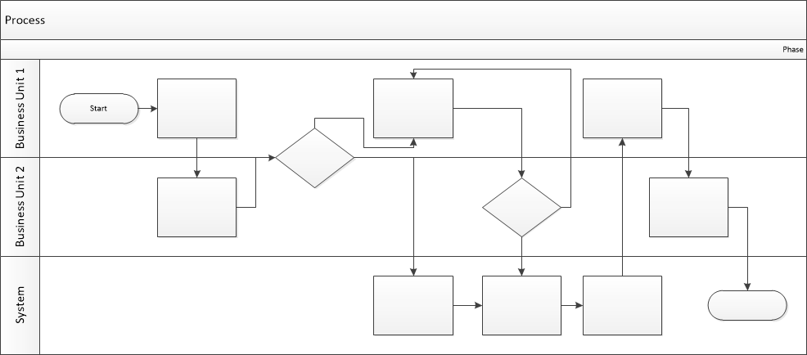

## Proposed Business Process (To-Be)

1. User Logins and searches for flavors.
2. If flavor is found the order is placed
3. Café Mini validates that all fields have been completed.
4. Café mini confirms the order
5. User confirms order.



# Business Requirements

The requirements in this document are prioritized as follows:

|  |  |  |
| --- | --- | --- |
| **Value** | **Rating** | **Description** |
| 1 | Critical | This requirement is critical to the success of the project. The project will not be possible without this requirement. |
| 2 | High | This requirement is high priority, but the project can be implemented at a bare minimum without this requirement. |
| 3 | Medium | This requirement is somewhat important, as it provides some value but the project can proceed without it. |
| 4 | Low | This is a low priority requirement, or a “nice to have” feature, if time and cost allow it. |
| 5 | Future | This requirement is out of scope for this project, and has been included here for a possible future release. |

## Functional Requirements

| **Req#** | **Priority** | **Description** | **Rationale** | **Use Case Reference** | **Impacted Stakeholders** |
| --- | --- | --- | --- | --- | --- |
| **General / Base Functionality** | | | | | |
| FR-G-001 | 1 | A new user database shall be created with their records and password secured. |  |  | Development team  Data base Team |
| FR-G-002 | 1 | A user shall be identified with a unique identifier name combination | ID+Name eliminates duplicate widget name records |  | Back end team Data Base Team |
| **Security Requirements** | | | | | |
| FR-S-001 | 1 | User creation shall be limited to users with unique mobile number | This will lead to only one account per mobile |  | Development Team |
| **Reporting Requirements** | | | | | |
| FR-R-001 | 2 | The system shall generate a weekly ,Daily ,Monthly Report of Sales | Owner will have more control over business and profit |  | Development  Team |
|  |  |  |  |  |  |
| **Usability Requirements** | | | | | |
| FR-U-001 | 1 | User interface for the Café Mini app shall be responsive, allowing for proper display on tablet, laptop, and desktop devices. | Users with different devices should be impressed with its usability and great user experience |  | Design Team /UI Team |
| **Audit Requirements** | | | | | |
| FR-A-001 | 1 | Any kind of order shall be appended with user ID and date/time stamp. | Users as well as audit teams will have proper records |  | Development Team |

## Non-Functional Requirements

|  |  |
| --- | --- |
| **ID** | **Requirement** |
| NFR-001 | The Café mini app shall accommodate up to 500 users concurrently at this point in time. |
| NFR-002 | The Café mini app shall be available for users In the play store with free download option and free sign-up |
| NFR-003 |  |
| NFR-004 |  |
| NFR-005 |  |

# Appendices

## List of Acronyms

N/A

## Glossary of Terms

N/A

## Related Documents

N/A