Use Cases
for
<The Café Mini>
Version 1.0 approved
Prepared by <Muhammad Hamza Khan >
<AbstractSolutionz>
<15/4/2018>
Revision History

Name | Date | Reason For Changes | Version
Order Use case | 15/4/18 | Initial | 1.0

Use Case Identification

Use Case ID
UID-001

Use Case Name
- Place an order for food

Use Case History

Created By

Muhammad Hamza Khan

Date Created

15/April/2018.

Last Updated By

Muhammad Hamza Khan

Date Last Updated
25/April/2018

Use Case Definition

Actor
- Customer of the Café.

Description
End users of the Application interacts with this app to order food or drinks they want online
The order should place successfully and an order receipt shall be displayed.
Restaurant Staff make use of this feature to see the order placed by customer and prepare for the rest.

Preconditions
- User’s identity has been authenticated.
- User’ location has been accessed

Postconditions
Describe the state of the system at the conclusion of the use case execution. Number each postcondition. Examples:
- Order has been placed and updated in the database.
- A message has been sent to user regarding his/her order.

Priority
HIGH – since this is one of the core features of the application.

Frequency of Use
High

Normal Course of Events
- Order use case is initiated by the end user
- Get GPS location of the user
- If GPS access succesfull continue
- If GPS access fail – see alternative course of events
- Show list of items screen
- On selected item show customize order screen
- Select place order operation
- Select confirm order operation and display receipt
- Generate SMS for the user
- Order use case end.

- BASIC FLOW DIAGRAM:

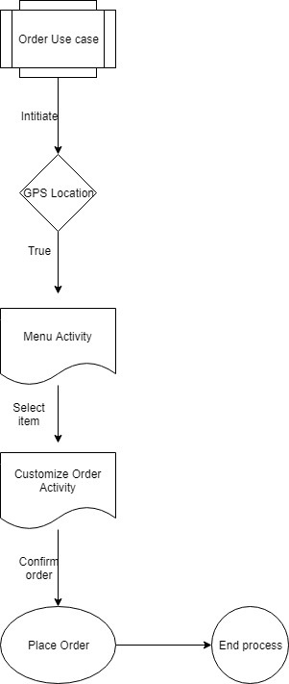

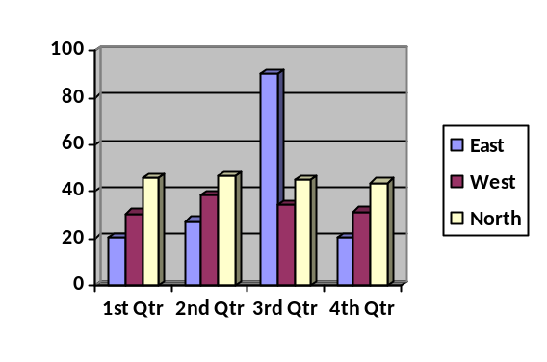
- Related Requirements:
System shall provide Custom order placements Module.

Alternative Course
- Order use case initiated
- Get GPS location of the user
- If GPS location Failure
- Generate error cannot locate destination of the order kindly allow access to location
- Order use case ends

- ALTERNATE FLOW DIAGRAM:

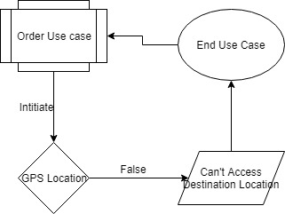

- Related Requirements:
System shall provide custom order placements module
- Related Business Rules:
User can cancel order latest by 5 minutes of placement.

Use Case Diagram

System Boundary
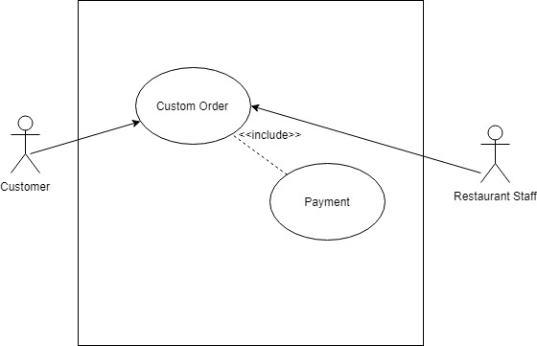

Related Information

Includes
- Payment Use Case.

Special Requirements
- System shall provide login module
- System shall provide Custom order placement module

Assumptions
- User is already registered and logged in by his/her account
- Device has an internet Connection

Secondary Actor
- Restaurant Staff

UI information

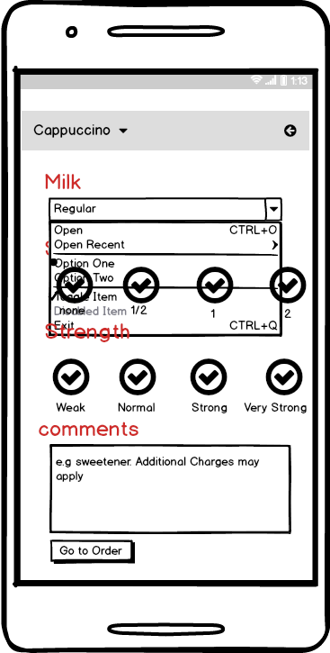
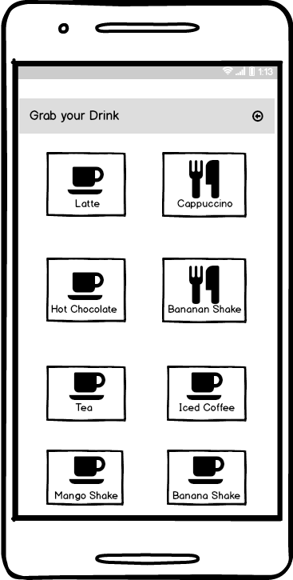
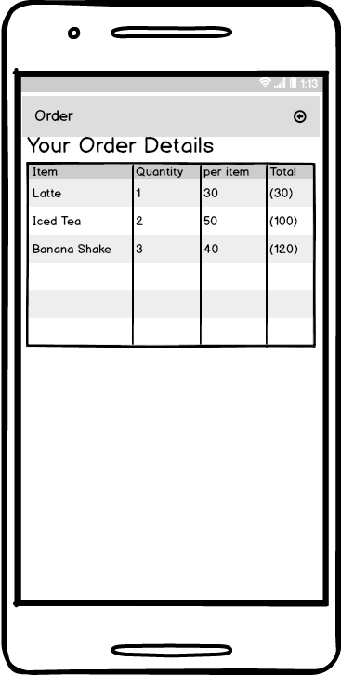
Use Case Template
Use Case ID: | UID-001
Use Case Name: | Place an order for food
Created By: | Hamza Khan | Last Updated By: | Hamza Khan
Date Created: | 15/April/2018 | Date Last Updated: | 24/April/2018

Actor: | User
Description: | User can order food/drink by the application
Preconditions: | User is logged in
Postconditions: | Order is placed
Priority: | High
Frequency of Use: | High
Normal Course of Events: | As shown above
Alternative Courses: | As shown above
Includes: | Payment Use case
Special Requirements: | User shall be logged in
Assumptions: | Device has an internet Connection

